1、

A.

00001001 111100

B.

VPN 0x09

TLB index 0x01

TLB tag 0x02

TLB hit? N

Page fault? N

PPN 0x17

C.

010111 111100

D.

Byte offset 0x0

Cache index 0xf

Cache tag 0x17

Cache hit? N

Cache byte returned -

2、

A.

00001110 101001

B.

VPN 0x0e

TLB index 0x02

TLB tag 0x03

TLB hit? N

Page fault? N

PPN 0x11

C.

010001 101001

D.

Byte offset 0x1

Cache index 0xa

Cache tag 0x11

Cache hit? N

Cache byte returned -

3、

A.

00000001 000000

B.

VPN 0x01

TLB index 0x01

TLB tag 0x00

TLB hit? N

Page fault? Y

PPN -

C.-

D.-

4、

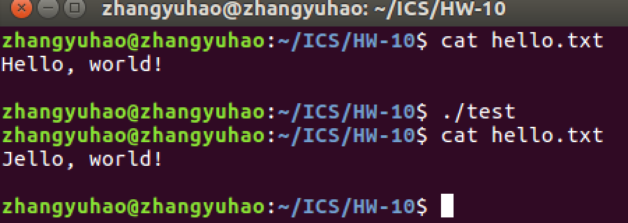

#include<unistd.h>

#include<sys/mman.h>

#include<stdio.h>

#include<fcntl.h>

int main()

{

int fd=open("hello.txt",O_RDWR,0);

char *buf;

buf=mmap(NULL,1,PROT_WRITE,MAP_SHARED,fd,0);

buf[0]='J';

munmap(buf,1);

close(fd);

}