A Major Project Synopsis on

**PAYBUDDY: A DIGITAL TRANSACTION WEBSITE**

Submitted to Manipal University, Jaipur

Towards the partial fulfillment for the Award of the Degree of

**MASTER OF COMPUTER APPLICATIONS**

2023-2025

by

**KULDEEP SINGH**

(23FS20MCA00076)



Under the guidance of

Dr. Monika Vishwakarma

**Department of Computer Applications**

**School of AIML, IoT&IS, CCE, DS and Computer Applications**

**Faculty of Science, Technology and Architecture**

**Manipal University Jaipur**

**Jaipur, Rajasthan**

**2025**

**1.Introduction:**

Paybuddy is an online digital transaction websitedesigned to connect people and make effortless payments and link bank accounts seamless payments. Unlike traditional networking transaction processes that emphasize handling money through physical means, helping students, professionals, business, and other people from different sectors to make transactions handy and effortless.

Quick processing of payments and fund transfers. Real-time tracking of the status of a transaction, including pending, completed, or canceled states. Users can load funds, view balance, and make transactions directly through their digital wallet.

By integrating modern web technologie**s** such as React.js, Node.js, Express.js, and MongoDB, paybuddy offers an intuitive, user-friendly interface with features like user registration, security,secure payment gateway, integration with digital wallets and much more.

**Why Choose Paybuddy?**

* **For business and Professionals**:
* Convenience and accessibility.
* Increased security and global reach.
* Expand your reach and be cost effective etc.
* **For Banks:**
* Increased transparency.
* Cost effective and enhanced customer support.
* Improved record keeping and automation and efficiency.

**2.Problem Statement:**

* To develop a digital transaction website that provides a secure, user-friendly, and scalable platform that allows businesses and consumers to perform transactions efficiently while ensuring data privacy and regulatory compliance and seamless. The idea of creating the website was to create a UI that is simple and engages users. The website will aim to solve these problems which are listed below.
* **Security Concerns**: Users worry about the safety of their financial information during online transactions. Cybersecurity threats such as fraud, hacking, and data breaches are persistent issues.
* **User Experience**: Current digital transaction platforms often have complex and non-intuitive user interfaces, leading to difficulty in navigation and longer processing times.
* **Lack of Integration**: Users need a platform that integrates multiple payment methods (e.g., credit cards, bank transfers, digital wallets) in one unified interface. Many existing solutions fail to provide seamless integration across platforms.
* **Customer Support**: Lack of efficient customer service for resolving issues related to transactions, leading to user frustration

**3.Motivation:**

* Many people struggle with cash problems, digital transaction solves that problem effectively.
* Helps keep the record for business and individuals.
* This platform will help people around the globe to transfer money effectively and efficiently with the enhancing increased security.

**4.Methodology:**

* **Creating the UI using React.js. The frontend will include different components:**
* **Home Page** – Shows all the tabs and functions of the website, basic overview of website.
* **Dashboard** – Personal User profile and overview of Users all the functions and activities.
* **Login and Sign-Up Component. -** Users can sign-in and Log-in their credentials.
* **Make digital transactions and Check Balance** – Connect and communicate with matched users, and to other users with UPI linked bank accounts.
* **Backend Development using Node.js & Express.js:**
* **Authentication:** Open Authorization and email-based login.
* **Fetch and Axios APIs for Integration:** Offer APIs for businesses to integrate your transaction
* **Zod and JWT:** We have used Json Web tokens and Zod validation for security and using Razor pay free payment gateway.
* **Data Management:** Stores user profiles, activity logs, past transaction and other activities.
* ⁠**Database Implementation using MongoDB:**
* **User Profiles** – Stores User profiles and makes it easier to make transactions.
* **Matches & Connections** – Saves previous transaction and balance history.
* **Fast Data Fetching**: Data is fetched and made available instantly providing seamless working of website.

**5.DevelopmentFlow:**

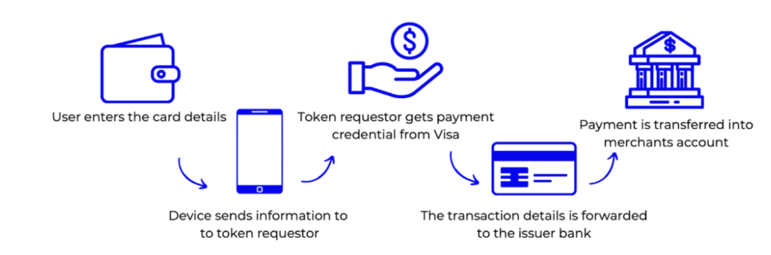

**6. Requirements for proposed work:**

* **Software Requirement:**
* Operating System: Windows 7 and Upgraded version.
* User Interface: ReactJS.
* Database: MongoDB
* Backend: NodeJS with ExpressJS
* Front-end: ReactJs, Tailwind, ZOD validation.
* **Hardware Requirement:**
* Hardware Processor: Intel i3 or better
* RAM: 4GB (minimum)
* Hard Disk: 20 GB Hard Disk Space

**7.Bibliography/ References**

1. O'Connor, J. T. (2019)**.** *Digital Payments: The Future of Transactions*. New York: Springer.
2. This book covers the evolution of digital payment systems, their security, and future trends in digital transactions.
3. Payment Systems Report**. (2023).** "The Growth of Digital Payments in Emerging Markets." Retrieved from <https://www.paymentsystemsreport.com>.
4. This source provides insights into how digital payment methods are being adopted in emerging markets.
5. National Cybersecurity Institute**. (2022).** "Securing Digital Transactions: Best Practices." Retrieved from <https://www.nationalcybersecurityinstitute.org>
6. A useful online resource offering best practices and security tips for securing digital transactions.
7. R. Raj, "Building AI-Driven Web Applications," Springer, 2021.
8. E. Brown, Learning JavaScript Design Patterns, O'Reilly Media, 2018.
9. M. Haverbeke, Eloquent JavaScript: A Modern Introduction to Programming, No Starch Press, 2020.
10. K. S. Raghunandan, "Real-time Collaboration and AI-based Matchmaking," IEEE Transactions on Web Intelligence, vol. 14, no. 2, pp. 145-157, 2022.
11. D. Crockford, JavaScript: The Good Parts, O'Reilly Media, 2008.
12. B. Stroustrup, Programming: Principles and Practice Using C++, Addison-Wesley, 2014.
13. D. K. Chappelle, "MongoDB in Large-Scale Applications," ACM Computing Surveys, vol. 53, no. 3, pp. 22-34, 2020.