MEALMITRA
Bridging the Gap Between Agriculture and Nutrition
PROJECT REPORT
SDG 2 – Zero Hunger
District-level analysis of agricultural productivity,
child malnutrition and socioeconomic conditions
Prepared using the executed analysis in 01_Data_Understanding.ipynb

Executive Summary
MealMitra examines whether districts with higher agricultural productivity also experience better child nutrition outcomes. The project combines district-level crop-yield information with child nutrition and socioeconomic indicators from NFHS-5. It uses descriptive analysis, Pearson and Spearman correlation, multiple linear regression, variance inflation factor (VIF), principal component analysis (PCA), Random Forest regression and district prioritisation.
The integrated dataset contains 562 matched district records. Crop-yield indicators for rice, wheat and maize were derived from district-level observations for 2017–2021. The analysis found weak negative correlations between the selected crop yields and malnutrition indicators. Socioeconomic indicators, particularly women's education and improved sanitation, showed stronger negative correlations with stunting. In the multivariable regression models, women's education and sanitation were statistically significant negative predictors for all three nutrition outcomes; rice yield was not statistically significant in any of the models.
Random Forest models achieved R² values of 0.461 for stunting, 0.173 for wasting and 0.468 for underweight on the recorded test splits. The district classification identified 44 districts (7.83% of the 562 records) in the high-rice-yield/high-stunting category. These results indicate that agricultural productivity alone does not adequately describe district differences in child nutrition. The findings are observational and do not establish causation or directly measure household food access.

Project at a Glance
Item | Description
Project name | MealMitra
Theme | SDG 2 – Zero Hunger
Geographic unit | District-level analysis in India
Main datasets | District crop production; NFHS-5 nutrition and household indicators; UPAG food-grain data loaded during data understanding
Integrated analysis records | 562 matched districts
Main methods | EDA, correlation, OLS regression, VIF, PCA, Random Forest, district prioritisation
Dashboard | Streamlit interactive dashboard

1. Introduction
Agricultural production and nutritional outcomes are related but are not interchangeable measures. A district may produce substantial quantities of crops while children in that district continue to experience stunting, wasting or underweight. Food availability at an aggregate level does not by itself establish that households can access, afford, prepare or consume a sufficiently diverse diet.
MealMitra investigates the district-level relationship between agricultural productivity and child malnutrition, while considering selected socioeconomic conditions. The project is aligned with Sustainable Development Goal 2 (Zero Hunger), which concerns ending hunger, achieving food security, improving nutrition and promoting sustainable agriculture.

2. Problem Statement
Despite India's agricultural production and food-distribution programmes, child malnutrition remains a serious challenge in several regions. This project investigates the gap between agricultural output and nutritional outcomes by analysing district-level crop production and child malnutrition indicators alongside available food-related data. Through regional comparisons, statistical analysis and district prioritisation, the project identifies areas where relatively high agricultural productivity coexists with poor nutritional outcomes and highlights regions that may require closer investigation and more targeted nutrition and food-access interventions.

3. Objectives
- Understand and prepare district-level crop production and NFHS-5 nutrition datasets.
- Integrate crop-yield and nutrition indicators using normalised state and district names.
- Examine relationships between rice, wheat and maize yields and child stunting, wasting and underweight.
- Study the association of women's education, sanitation, clean cooking fuel and electricity with nutrition outcomes.
- Use regression and machine-learning models to examine explanatory and predictive patterns.
- Identify districts with both relatively high rice yield and high stunting for further investigation.
- Present the results through an interactive Streamlit dashboard.

4. Data Sources and Variables
The uploaded analysis notebook loads three source files:
Dataset file | Rows × columns | Role in the notebook
01_district_crop_production.csv | 74,242 × 8 | District crop area, production and yield observations.
02_nfhs5_district_nutrition_health.csv | 706 × 109 | NFHS-5 district nutrition and household/social indicators.
upag_district_foodgrains.csv.gz | 719,427 × 7 | UPAG food-grain records loaded and inspected during data understanding.

The principal variables used in the integrated analysis are:
Category | Variables | Meaning
Agriculture | Rice, Wheat, Maize | District average crop yields, aggregated from crop observations in 2017–2021.
Nutrition outcomes | Stunting, Wasting, Underweight | NFHS-5 percentages for children under five.
Socioeconomic predictors | Women_Education | Women aged 15–49 with 10 or more years of schooling (%).
Socioeconomic predictors | Sanitation | Population living in households using an improved sanitation facility (%).
Socioeconomic predictors | Clean_Fuel | Households using clean fuel for cooking (%).
Socioeconomic predictors | Electricity | Population living in households with electricity (%).

The UPAG dataset was loaded and inspected, but the final crop–nutrition integrated model described in the notebook is built from the district crop-production file and NFHS-5 data. The report therefore does not claim that UPAG distribution variables were included in the final regression or Random Forest models.

5. Data Preparation and Methodology

5.1 Initial inspection and cleaning
The notebook inspected dataset dimensions, column names, data types, missing values, duplicate records and numerical summaries. The crop dataset contained no missing values or duplicate records. The NFHS-5 dataset contained no missing values at the initial whole-dataset check, and no duplicate records were reported. The UPAG file contained 1,164 missing values in its Value field and no duplicate records. Crop area, production and yield checks found no zero or negative values in the checked fields. A consistency check comparing recorded yield with Production divided by Area found zero records with a difference greater than 0.01.

5.2 Crop aggregation
Crop records were restricted to crop years 2017–2021. Rice, wheat and maize were selected. The notebook calculated the mean recorded yield for each state–district–crop combination and pivoted the result so each crop became a separate column. These are arithmetic averages across available district-year-season records, not production-weighted averages.

5.3 Nutrition preparation and district matching
NFHS-5 nutrition columns were converted to numeric values using pandas to_numeric with errors='coerce'. State and district names were normalised by trimming whitespace, converting to lowercase, replacing '&' with 'and' and removing spaces. The crop and nutrition datasets were inner-joined on the normalised state and district keys, with one-to-one validation.
Matching summary | Count
Agricultural district keys | 710
NFHS-5 district keys | 706
Matched district keys | 562
Agricultural keys without NFHS match | 148
NFHS keys without agricultural match | 144

The resulting integrated dataset contained 562 rows and 12 columns before socioeconomic variables were added. It contained 19 missing rice-yield values, 97 missing wheat-yield values, 15 missing maize-yield values and one missing value in each of the three nutrition outcomes. After socioeconomic indicators were left-merged, the integrated dataset contained 562 rows and 18 columns.

5.4 Analytical methods
- Exploratory data analysis: descriptive statistics, distributions, histograms and boxplots.
- Pearson correlation: measures linear association between pairs of numeric variables.
- Spearman correlation: measures monotonic association using ranks.
- Pearson correlation tests: p-values were calculated for crop–nutrition pairs.
- Multiple linear regression (OLS): five predictors—rice yield, women's education, sanitation, clean fuel and electricity—were fitted separately for stunting, wasting and underweight.
- VIF: used to assess multicollinearity among the five regression predictors.
- PCA: four socioeconomic indicators were standardised and reduced to principal components.
- Random Forest regression: 100 trees, 80/20 train-test split and random_state=42; performance evaluated using MAE, RMSE and R².
- District prioritisation: rice yield and stunting were each divided at their 67th percentile; a descriptive average of the three nutrition outcomes was also calculated.

6. Exploratory Data Analysis
The notebook examined crop-yield distributions and crop-level production summaries, including the highest-yielding records and state-wise average rice yield. NFHS-5 distributions were examined using boxplots for stunting, wasting, severe wasting and underweight. After numeric conversion, each of these four nutrition indicators had one missing value.
The boxplots were used to compare medians, spread and potential outliers across districts. The notebook retained the observed values rather than automatically removing potential outliers. This is appropriate for exploratory regional analysis because unusually high or low district values may represent genuine disparities that merit investigation.

7. Correlation Analysis
The Pearson crop-yield versus nutrition correlations from the integrated dataset are summarised below.
Crop yield | Stunting | Wasting | Underweight
Rice | -0.2104 | -0.1085 | -0.1256
Wheat | -0.1134 | -0.1369 | -0.1125
Maize | -0.1248 | +0.0073 | +0.0022

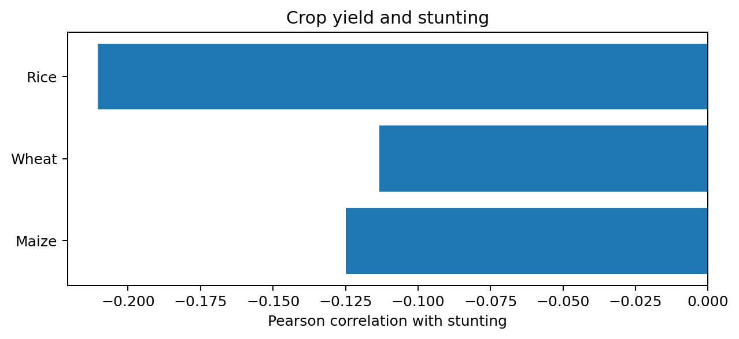
Figure 1. Pearson correlations between crop yield and stunting in the integrated data.
The crop–nutrition coefficients are weak in magnitude. Rice shows the largest negative correlation with stunting among the three selected crops (r = -0.2104). The Spearman results show a similar overall pattern, with weaker negative rank correlations for crop yields and nutrition outcomes. Maize has almost no linear correlation with wasting (r = 0.0073) or underweight (r = 0.0022).
Crop–nutrition pair | Pearson r | p-value | Available districts
Rice – Stunting | -0.210 | <0.000001 | 542
Rice – Wasting | -0.109 | 0.0115 | 542
Rice – Underweight | -0.126 | 0.0034 | 542
Wheat – Stunting | -0.113 | 0.0145 | 464
Wheat – Wasting | -0.137 | 0.0031 | 464
Wheat – Underweight | -0.112 | 0.0154 | 464
Maize – Stunting | -0.125 | 0.0035 | 546
Maize – Wasting | +0.007 | 0.8650 | 546
Maize – Underweight | +0.002 | 0.9592 | 546

The notebook prints the Rice–Stunting p-value as 0.0 at four decimal places; the more precise output is 0.0000007712. Statistical significance does not make a weak association strong or causal. Multiple comparisons and potential dependence between districts should be considered.

7.1 Socioeconomic correlation with stunting
Socioeconomic indicator | Pearson correlation with stunting
Women's education | -0.5689
Improved sanitation | -0.5221
Clean cooking fuel | -0.4429
Electricity access | -0.4246

All four socioeconomic indicators have moderate negative bivariate correlations with stunting in the notebook results. Women's education has the strongest magnitude among these four indicators, followed by improved sanitation. These are observational associations and may reflect other correlated social and economic conditions.

8. Multiple Linear Regression
Separate OLS models were fitted for stunting, wasting and underweight using rice yield, women's education, sanitation, clean fuel and electricity as predictors. Each model used 542 complete observations.
Outcome | R² | Adjusted R² | Overall model p-value
Stunting | 0.4330 | 0.4277 | 8.64 × 10⁻⁶⁴
Wasting | 0.1578 | 0.1499 | 2.23 × 10⁻¹⁸
Underweight | 0.4272 | 0.4219 | 1.31 × 10⁻⁶²

For the stunting model, women's education (coefficient = -0.1973, p < 0.001), sanitation (coefficient = -0.1435, p < 0.001) and electricity (coefficient = -0.4084, p < 0.001) were statistically significant negative conditional associations. Rice yield (p = 0.7444) and clean fuel (p = 0.2973) were not statistically significant in this model.
Predictor | Stunting coefficient (p) | Wasting coefficient (p) | Underweight coefficient (p)
Rice | -0.1257 (0.7444) | -0.3549 (0.2836) | +0.5246 (0.2259)
Women's education | -0.1973 (<0.001) | -0.1098 (<0.001) | -0.2105 (<0.001)
Sanitation | -0.1435 (<0.001) | -0.1087 (<0.001) | -0.2783 (<0.001)
Clean fuel | -0.0180 (0.2973) | +0.0368 (0.0131) | +0.0047 (0.8092)
Electricity | -0.4084 (<0.001) | +0.0244 (0.6682) | -0.0985 (0.1865)

Women's education and sanitation were statistically significant negative predictors in all three fitted models. Electricity was significant only for stunting. Clean fuel had a small positive coefficient in the wasting model (p = 0.0131); this conditional association should not be interpreted as evidence that clean fuel increases wasting. It may reflect confounding, model specification or other features of the observational data. Rice yield was not statistically significant in any of the three models.
The reported OLS standard errors are non-robust, as stated in the notebook output. The stunting model also reports a large condition number (3.06 × 10³), so numerical scaling and possible model diagnostics deserve consideration. Regression coefficients are conditional associations, not causal effects.

9. Multicollinearity Analysis (VIF)
Predictor | VIF | Notebook interpretation
Rice | 1.341 | Acceptable
Women's education | 2.128 | Acceptable
Sanitation | 1.646 | Acceptable
Clean fuel | 2.018 | Acceptable
Electricity | 1.205 | Acceptable

All predictor VIF values are below 5. Under the guideline used in the notebook, this indicates no potential multicollinearity concern among the selected predictors. VIF is a diagnostic guideline and does not establish that all regression assumptions are met.

10. Principal Component Analysis
Component | Explained variance | Cumulative variance
PC1 | 59.00% | 59.00%
PC2 | 18.87% | 77.87%
PC3 | 13.34% | 91.21%
PC4 | 8.79% | 100.00%

PCA was applied to women's education, sanitation, clean fuel and electricity after standardisation. The first two components explain 77.87% of the total variance. PC1 has positive loadings across all four indicators and can be interpreted as a broad shared socioeconomic-development pattern in this dataset. PC2 is strongly influenced by electricity and contrasts it with the other indicators. PCA is used here as an exploratory dimensionality-reduction analysis.

11. Random Forest Regression
Random Forest regression models were fitted separately for the three nutrition outcomes. Each model used the same five predictors and an 80/20 train-test split with random_state=42. The model used 100 trees.
Outcome | MAE | RMSE | R² | Test samples
Stunting | 5.045 | 6.621 | 0.461 | 109
Wasting | 4.452 | 5.470 | 0.173 | 109
Underweight | 6.023 | 7.775 | 0.468 | 109

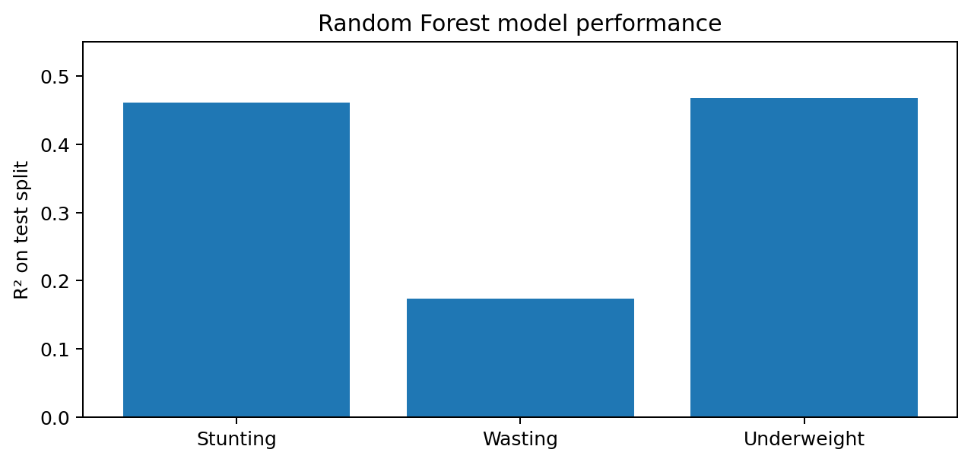
Figure 2. Random Forest R² values recorded for the three nutrition outcomes.
The underweight model had the highest R² (0.468), closely followed by stunting (0.461). Wasting had the lowest R² (0.173), indicating weaker predictive performance for that outcome. Underweight had the largest MAE and RMSE in percentage-point units, so the highest R² does not mean it had the smallest prediction errors.
For the stunting model, a mean-prediction baseline recorded MAE = 7.624 and R² = -0.019, while Random Forest recorded MAE = 5.045 and R² = 0.461 on the same split. This comparison suggests improvement over that simple baseline for the recorded test split.
The notebook uses a single random train-test split. No cross-validation or state-held-out evaluation is recorded. Performance may therefore vary across splits and should not be presented as a guarantee of generalisation to unseen regions.

12. District Prioritisation
The notebook used the 67th percentile of rice yield and the 67th percentile of stunting as thresholds to classify districts into four categories. This produces relative, sample-dependent groups rather than fixed national policy thresholds.
District category | District count | Share
Low agriculture + Low stunting | 242 | 43.06%
Low agriculture + High stunting | 141 | 25.09%
High agriculture + Low stunting | 135 | 24.02%
High agriculture + High stunting | 44 | 7.83%

The high-agriculture/high-stunting group contains 44 districts, equivalent to 7.83% of the 562 district records. These districts were treated as potential agriculture–nutrition paradox regions for further investigation.
Rank | State | District | Priority score
1 | Bihar | Arwal | 45.10
2 | Gujarat | Tapi | 43.37
3 | Bihar | Jehanabad | 43.20
4 | Telangana | Adilabad | 42.40
5 | Bihar | Aurangabad | 40.93
6 | Bihar | Rohtas | 40.00
7 | Bihar | Kaimur (Bhabua) | 39.53
8 | Bihar | Buxar | 39.37
9 | Karnataka | Koppal | 39.33
10 | Andhra Pradesh | Kurnool | 37.83
11 | Bihar | Lakhisarai | 37.80
12 | Uttar Pradesh | Sonbhadra | 37.20
13 | Telangana | Jogulamba Gadwal | 36.23
14 | Uttar Pradesh | Fatehpur | 35.63
15 | Karnataka | Raichur | 34.57

The priority score is the arithmetic mean of stunting, wasting and underweight percentages. It is a descriptive ranking aid, not a validated composite nutrition index. The ranking above is restricted to the high-rice-yield/high-stunting group; it is not a ranking of the highest-malnutrition districts across all of India.

12.1 State-level pattern
State | Districts | Average stunting | Average wasting | Average underweight | Average rice yield
Bihar | 37 | 42.41 | 24.45 | 41.83 | 2.23
Meghalaya | 10 | 42.30 | 14.21 | 25.62 | 2.50
Uttar Pradesh | 69 | 39.64 | 17.92 | 32.49 | 2.71
Jharkhand | 19 | 39.17 | 22.32 | 38.97 | 2.52
Gujarat | 28 | 37.56 | 25.68 | 39.12 | 2.39
Assam | 30 | 36.01 | 20.01 | 31.16 | 2.04
Madhya Pradesh | 49 | 35.65 | 19.11 | 33.29 | 1.83
Karnataka | 18 | 35.12 | 19.08 | 31.20 | 2.74

These are the top entries shown in the notebook's state summary sorted by average stunting. Ladakh appears in the notebook output with one district and a missing average rice yield.

13. Interactive Dashboard
A Streamlit dashboard was created to make the district-level results accessible through an interactive interface. The dashboard includes an overview of matched districts and nutrition indicators, nutrition and agriculture charts, rice-yield versus stunting scatter analysis, socioeconomic indicators, district prioritisation, a state filter and a downloadable filtered dataset. Analytical sections present the recorded correlation, regression, VIF, PCA and Random Forest results from the executed notebook.
The dashboard is a presentation layer over the cleaned and integrated data. It does not independently retrain the models; the model metrics and statistical findings displayed are the recorded outputs of the analysis notebook.

14. Conclusion
The district-level analysis found that crop yields for rice, wheat and maize have weak negative correlations with the selected child malnutrition indicators. In contrast, women's education, sanitation, clean cooking fuel and electricity showed stronger negative bivariate associations with stunting. In the OLS models, women's education and sanitation were statistically significant negative conditional associations for stunting, wasting and underweight, while rice yield was not statistically significant in any of the three models.
The district prioritisation exercise identified 44 districts that fall above the selected 67th-percentile thresholds for both rice yield and stunting. These locations illustrate why aggregate agricultural productivity should not be treated as a direct proxy for child nutrition. The results support a broader view that nutrition outcomes need to be examined alongside household and social conditions. Because the study is observational and district-based, it cannot establish why these disparities occur or prove that any particular intervention will change nutrition outcomes.

15. Recommendations
- Use district-level nutrition indicators to identify areas for closer programme review and targeted follow-up.
- Consider women's education and sanitation alongside agricultural indicators when designing nutrition-related interventions.
- Pair agricultural productivity initiatives with investigation of household food affordability, access, dietary diversity and care conditions.
- Improve the integration of agricultural, nutrition, food-distribution and household-level datasets to examine the pathway from production to consumption.
- Use the district-priority list as a screening tool for further investigation, not as a definitive allocation formula.
- Repeat model evaluation with cross-validation and geographic holdout tests before using predictions for operational decisions.

16. Limitations
- District-level aggregation can hide differences between households and individuals; results should not be interpreted as individual-level relationships.
- The analysis is observational. Correlations and regression coefficients do not demonstrate causation.
- Crop yield measures agricultural productivity, not household food availability, affordability, access, dietary diversity or actual consumption.
- Although the UPAG food-grain dataset was loaded and inspected, the final integrated regression and Random Forest models use crop-yield and NFHS-5 socioeconomic indicators; the report does not claim to estimate PDS effectiveness.
- District name matching yielded 562 matched keys, leaving unmatched records from both source datasets. Crop and outcome missingness also means sample sizes vary across pairwise correlations.
- The regression output uses non-robust standard errors and reports a large condition number for the stunting model.
- Random Forest performance is based on a single 80/20 random split and has not been confirmed through cross-validation or geographic holdout testing.
- The district priority score is an unvalidated equal-weight average of three percentages, and the thresholds are sample-relative 67th percentiles.
- The notebook attempted geospatial mapping, but the district-boundary matching and rendering were not completed successfully. Therefore, no completed district choropleth is claimed in this report.

17. Future Scope
- Integrate district-level food distribution, PDS offtake, procurement and access measures with clearly documented time periods and geographic keys.
- Add household food security, poverty, food prices, dietary diversity, maternal health and child-care indicators where reliable data are available.
- Complete and validate district boundary matching before publishing choropleth maps.
- Evaluate models using repeated cross-validation and state- or region-held-out testing.
- Investigate non-linear relationships and interactions while maintaining transparent model interpretation.
- Update the analysis when comparable, more recent district-level nutrition data become available.

18. Tools and Technologies
Tool / library | Use in project
Python | Data analysis and workflow implementation.
Pandas and NumPy | Data loading, cleaning, transformation, aggregation and integration.
Matplotlib and Seaborn | Exploratory plots and statistical visualisations.
SciPy | Pearson correlation testing.
Statsmodels | Ordinary least squares regression and VIF diagnostics.
Scikit-learn | Standardisation, PCA, train-test split, Random Forest and evaluation metrics.
Streamlit | Interactive dashboard.

19. Reproducibility and Project Files
The principal analysis is documented in 01_Data_Understanding.ipynb. The dashboard reads the cleaned district-level export NIErnaya_dashboard_data.csv and presents selected analysis outputs. For reproducibility, retain the raw source files, executed notebook, cleaned dashboard CSV, dashboard source code and any figures used in the final submission together in the project folder.

References / Data Sources
- District crop production dataset: 01_district_crop_production.csv (as loaded in the analysis notebook).
- NFHS-5 district nutrition and household indicators: 02_nfhs5_district_nutrition_health.csv (as loaded in the analysis notebook).
- UPAG district food-grain dataset: upag_district_foodgrains.csv.gz (loaded and inspected in the analysis notebook).
- Executed project analysis: 01_Data_Understanding.ipynb.
Before formal external publication, add the original dataset publisher, release/version, access date and official citations for each source file. Those provenance details are not fully documented in the uploaded notebook and have not been invented here.

