Trent Wells, Regan O’Donnell

Advanced Computer Programming

Project 5

User’s Manual

1. The submission includes:
   1. Maven project runnable in Eclipse
   2. wellsTodonnellRUsersManual.docx (this file)
   3. wellsTodonnellRProject5UML.jpg
2. Running the program- Import this project into eclipse. The Server.java file will need to be run first in order to set up the server. Next, run the Client.java file to connect to the server.
3. User input- When the user runs the Maven project, a GUI will appear with drop-down menus to select an instrument type, instrument brand, maximum cost, and location.
4. Output-
   1. The client program will display the GUI noted above:

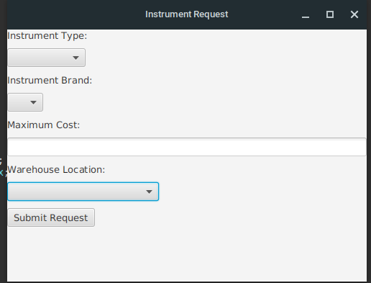

* 1. After the submit button is pressed, a dialog box will appear containing all relevant instruments from the search:

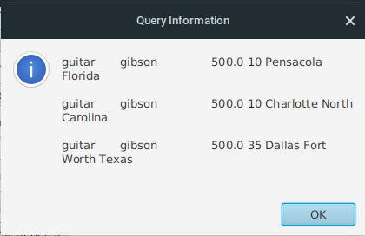

1. Problems- The only problem with this program is that the server must be closed manually by pressing the red square button in eclipse.