Overview:
In this practical, we were asked to write a compiler, to translate a small fragment of the Logo programming language into the PostScript language. We successfully translated Logo into PostScript, and generated code in the form of .gs files. We also implemented a comprehensive error system, that checks not only for parsing errors, but also for unrecognised variable and procedure names. Finally, we attempted to write our own fractals in Logo, with moderate success.

Design:

Lexer
Initially, we read our Logo code character by character, skipping whitespaces and using the first character after the whitespace to search for the token. However, we decided this was not a good implementation. It required us to use many conditionals to check possible configurations without white space, for example LEVEL>1, and made the code harder to read, especially since a new character had to be retrieved in multiple locations in the lexer.
Therefore, we decided to process the file, separating special symbols like ( or > with spaces. In this way, we were able to use a Scanner object to simply read one token at a time, without worrying about the problems previously mentioned. The consequence to this was that we could no longer track the line number of the tokens because we ignore new lines together with whitespaces and tabs. To solve this, we replaced all “\n” (newline) with our own representation of new line, N_E_W_L_I_N_E .Every time the lexer comes across this string, it will ignore it but increase the line number.
In both implementations, we used a switch statement to check whether or not the token was a grammatical part of the language, like IF or PROC or if it was an identity or number. To distinguish between the two, we tried to parse the string as an integer, returning an integer token if the parse was valid, an identity token otherwise. We created a class for every grammatical token, as it made it easier for the Parser to process different token subclasses.

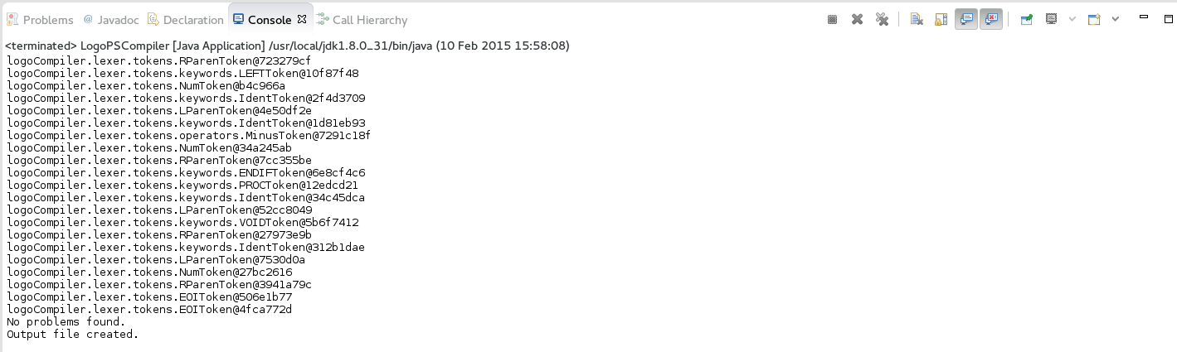Screenshot 1: Each Token being printed on creation for debugging purposes.

We made a new class called Dictionary which stores all the keywords and deals with passing the correct tokens to the lexer. This makes the lexer much cleaner and easier to work with. In addition, if the compiler ever has to be extended in the future, it would be easy to simply go into the dictionary and add new keywords to it.

Parser
We started on the parser by using if statements in the Proc class to check for instances of certain tokens, so we can easily check if the stream of tokens follows this pattern. If it does not we can give appropriate error messages. We continued to do this for every statement inside Proc, going all the way down to expressions. For expressions, we implemented the Fraser and Hanson system of precedence which was provided, to generate code for them in the appropriate order.

To handle errors, we decided to simply print them to the default system error stream, since it's likely that a compiler would be run from the console. We added errors for unexpected and expected tokens, as well as unrecognised variable and procedure names, which are checked after the grammar check.

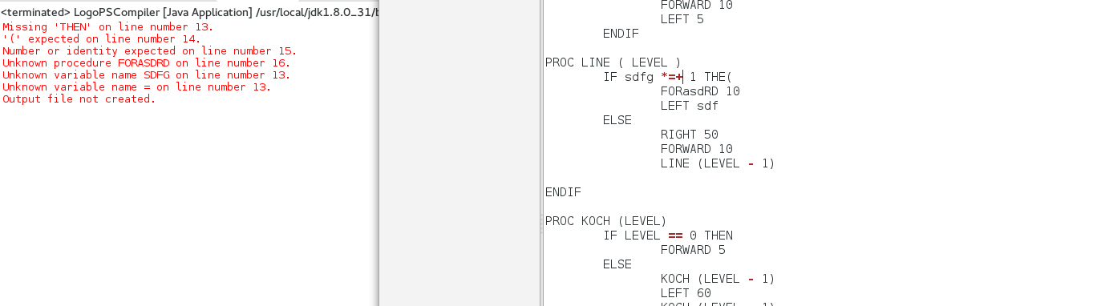Screenshot 2: Error Handling

Code Generation
From looking at the PostScript code, we were not sure about how to use the Arg register. Looking online, we first tried to use local variables with dict. It worked but we were told to only use the stack, so we tried again with Arg multiple times, but we got a stack overflow error because of the way the Logo was recursive.
Searching online, we found sample PostScript code and the commands they used. dup duplicates the top value of the stack and puts it on the stack. This lets us be able to keep a value on the stack while using another value to be used for the recursive procedures. This makes it so there is still the same variable on the stack that is not lost. For our final submission, we replaced dup with the Arg equivalent.

Testing:
To test that the lexer works, we have the tokens print themselves so we see that we are in fact getting the right stream of tokens. We also printed out the string that was read by the scanner so we can see if the right string has been taken by the lexer.

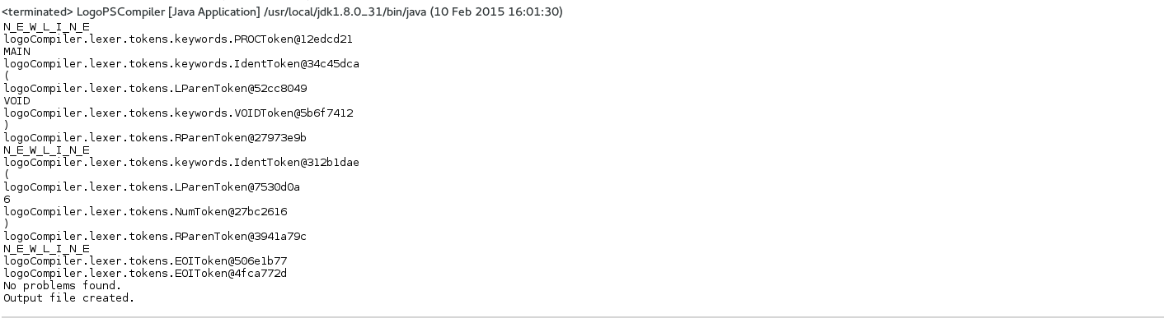Screenshot 3: Token generation along with the String read by the Scanner

For code generation testing, we had to first try manually translating the Logo into PostScript ourselves and compare it to what our compiler produced. The difficulty was in understanding PostScript ourselves to try and write it. After we got it working, adding the code generation to the compiler was quite easy.

Evaluation:
In regards to the initial specification, we believe we have successfully completed all requirements, and produced valid PostScript code that renders the required fractal designs. One small bug that we were unable to fix was that the line numbers written on the errors are sometimes inconsistent with the file numbers of the file.
Given more time, we would add more rigorous error checking, as well as learning to properly utilize the stack to optimize our PostScript code.

Conclusion:
Our compiler is able to compiler correct Logo code into working PostScript, it also gives error messages if something is wrong with the Logo code and a line number of where the error occurred. We also wrote our own Logo programs, which compiled into PostScript successfully. We believe this satisfies the initial specification.

