**Blog**

Name: Yuliana Serna



Hello Friends!

My name is **Yuliana Serna.** I am from **Popayan-Colombia**. I am **19** years old. I am **single**. I am a **software learner**. I speak **english**. In my free time I **listen to music and I like to draw.** My parents are **Othniel** and **Sandra.** They are from **Popayan.** My dad is **farmer** and my mom is a **housewife.**  I live in **Popayan**.

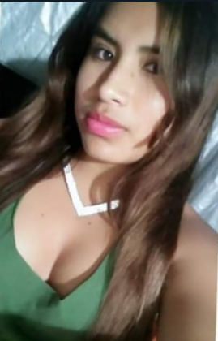

**Blog**

Name: Yuliana Serna



I have a brother. His name is Mathias. He is a student. He is 4 years old and he is single.