**National Cheng Kung University**

**Department of Electrical Engineering**

***Introduction to VLSI CAD (Spring 2024)***

**Lab Session 3**

**Design of ALU and Multiplication Using Verilog Coding**

|  |  |  |  |
| --- | --- | --- | --- |
| Name | Student ID | | |
| 劉冠妤 | E24116152 | | |
| Practical Sections: | | Points | Marks |
| Prob A | | 30 |  |
| Prob B | | 30 |  |
| Prob C | | 20 |  |
| Report | | 15 |  |
| File hierarchy, naming…etc. | | 5 |  |
| Notes | | | |

**Due Date: 15:00, March 13, 2024 @ moodle**

**Deliverables**

1. All Verilog codes including testbenches for each problem should be uploaded.

NOTE: Please **DO NOT** include source code in the paper report!

1. All homework requirements should be uploaded in this file hierarchy or you will not get the full credit.

NOTE: Please **DO NOT** upload waveforms!

1. Important! TA will use the command in Appendix A to check your design under SoC Lab environment, if your code can not be recompiled by TA successfully using the commands, you will not get the full credit.
2. **If you upload a dead body which we can’t even compile you will get NO credit!**
3. **All Verilog file should get at least 90% superLint Coverage.**
4. **File hierarchy should not be changed; it may cause** your code can not be recompiled by TA successfully using the autograding commands

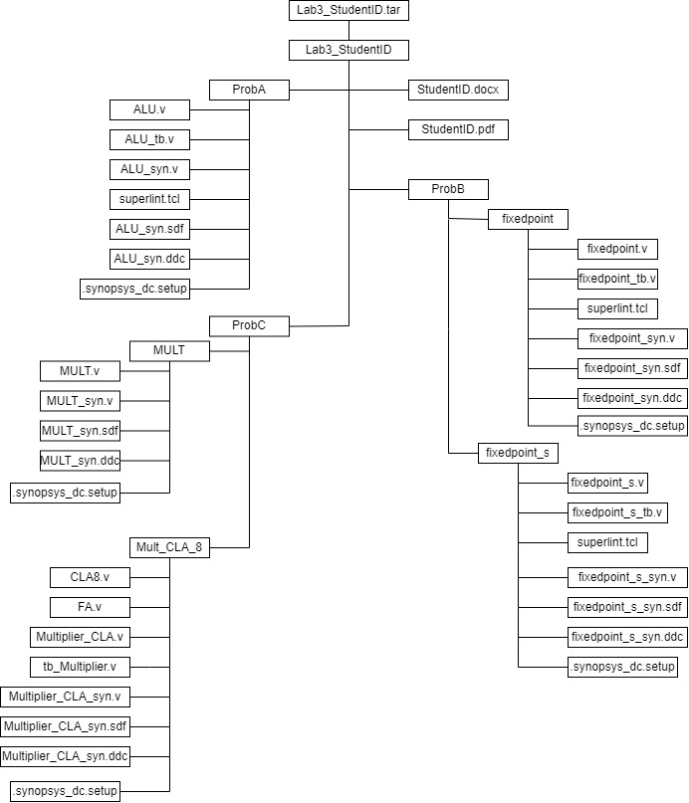

Fig.1 File hierarchy for Homework submission

Prob A: Arithmetic Logic Unit

**Design your Verilog code with the following specifications:**

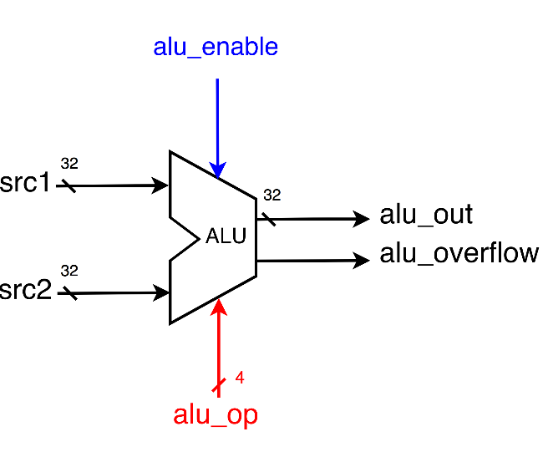

1. Based on the reference code, please implement the following operations.

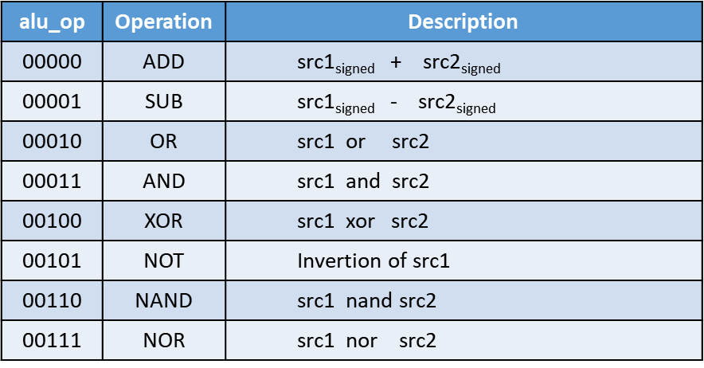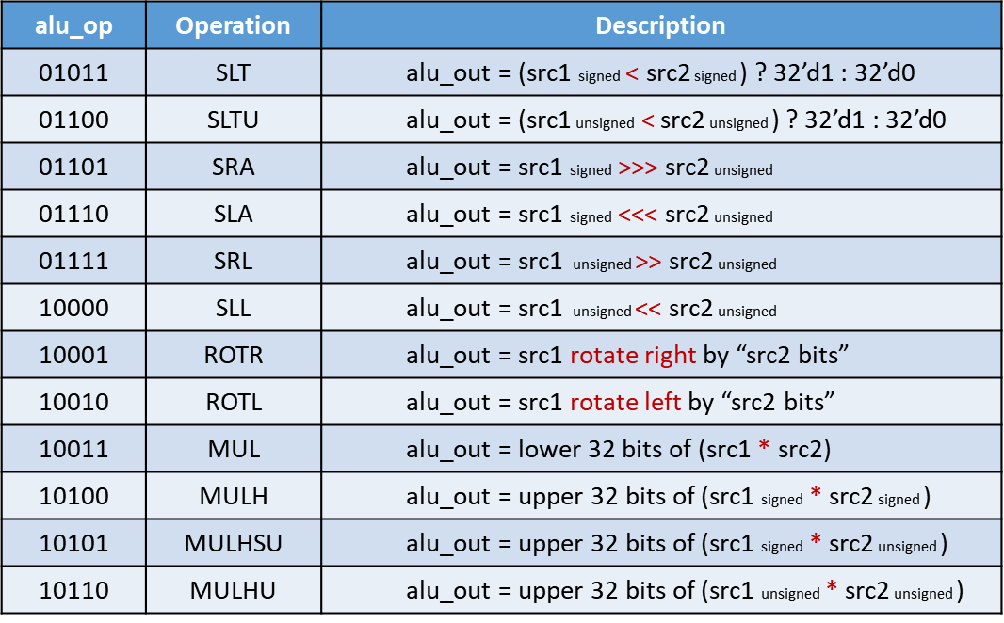

* 1. The frame code and testbench are given. Follow the frame code to finish this homework. The decimal part should be rounded.
  2. Follow the PPT file to synthesize your code.

**After you synthesize your design, you may have some information about the circuit. Fill in the following form.**

|  |  |  |
| --- | --- | --- |
| **Timing (slack)** | **Area (total cell area)** | **Power (total)** |
| **0.0** | **3961.820251** | **3.8089mW** |

**Please attach your design waveforms.**

|  |
| --- |
| Your simulation result on the terminal. |
|  |
| Your waveform (RTL & Synthesis) : |
| complete RTL waveform:  local RTL waveform:  local Synthesis waveform: |
| SuperLint Coverage |
| Warning lines = 1  Total lines = 120  Coverage percentage = 99.167% |

Prob B-1: Practice fixed point

**Design your Verilog code with the following specifications:** Number format: unsigned numbers.

* 1. The frame code and testbench are given. Follow the frame code to finish this homework. The decimal part should be rounded.
  2. Follow the PPT file to synthesize your code.

**After you synthesize your design, you may have some information about the circuit. Fill in the following form.**

|  |  |  |
| --- | --- | --- |
| **Timing (slack)** | **Area (total cell area)** | **Power (total)** |
| **0.01** | **79.418881** | **5.7229×10-5W** |

**Please attach your design waveforms.**

|  |
| --- |
| Your simulation result on the terminal. |
|  |
| Your waveform (RTL & Synthesis) : |
| RTL waveform:  Synthesis waveform: |
| SuperLint Coverage |
| Warning lines = 0  Total lines = 17  Coverage percentage = 100% |

Prob B-2: Practice fixed point (signed)

**Design your Verilog code with the following specifications:** Number format: signed numbers.

1. The frame code and testbench are given. Follow the frame code to finish this homework. The decimal part should be rounded.
2. Follow the PPT file to synthesize your code.

**After you synthesize your design, you may have some information about the circuit. Fill in the following form**

|  |  |  |
| --- | --- | --- |
| **Timing (slack)** | **Area (total cell area)** | **Power (total)** |
| **0.0** | **104.250243** | **8.0239×10-2W** |

**Please attach your design waveforms.**

|  |
| --- |
| Your simulation result on the terminal. |
|  |
| Your waveform (RTL & Synthesis) : |
| RTL waveform:  Synthesis waveform: |
| SuperLint Coverage |
| Warning lines = 3  Total lines = 31  Coverage percentage = 90.32% |

Prob C: Performance comparison

**Synthesize the 8*8-bit CLA multiplier implemented in Lab2 and the given 8*8-bit multiplier separately.**

You should answer the following questions:

**1. Determine the lowest achievable clock period for both, along with the corresponding area and power consumption.**

|  |  |  |  |  |
| --- | --- | --- | --- | --- |
|  | **Clock period** | **Timing (slack)** | **Area (total cell area)** | **Power (total)** |
| **CLA multiplier** | **0.50** | **0.0** | **221.667845** | **0.1572mW** |
| **“*”operator** | **0.40** | **0.0** | **74.908801** | **5.0555×10-2W** |

**2. Considering clock period and area, which structure has the better performance.**

The "*" operator structure has better performance because its clock period is smaller than that of the CLA multiplier, and its total cell area is almost one-third of the total cell area of ​​the CLA multiplier, which means that it has better performance.

**At last, please write the lessons learned from this lab session, or some suggestions for this lab session. Thank you.**

From this class I learned implementation of combinational logic and design of an Arithmetic Logic Unit (ALU), Multiplication of Fixed Point Number and the most impressive thing is Synthesis of Combinational Logic. After several implementations in the computer classroom A, I am now more proficient in operating these programs. However, I still often encounter problems with instructions that need to be repeated many times because the process is not planned well or details are missed. I also encountered a puzzling problem. The contents of the newly purchased USB suddenly became garbled after a few uses. My other USB could not be read at all on the SOC lab computers, and I still cannot enter the soc lab with my student ID card. Although the process is a bit cumbersome, it feels great to discuss it with friends and go to the computer classroom together.

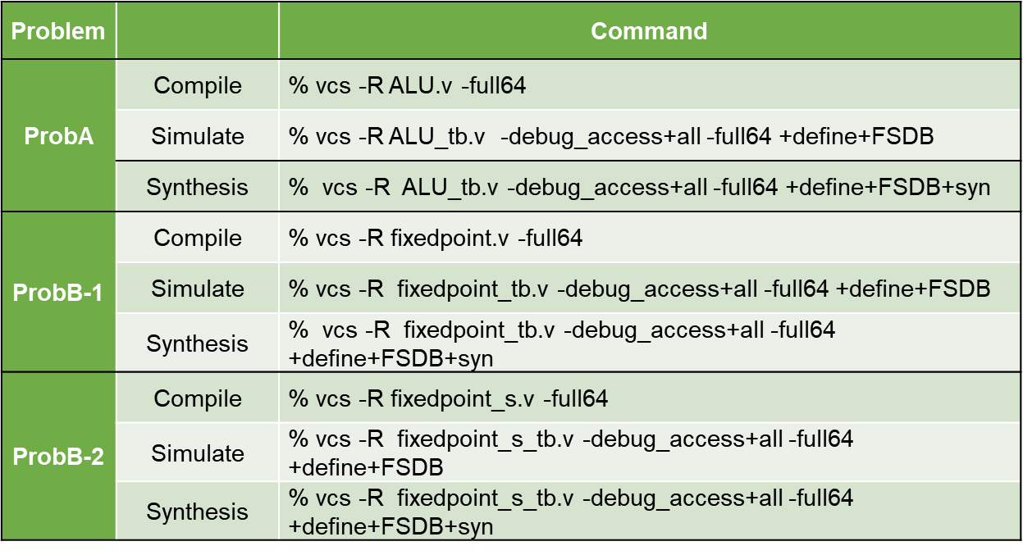

Appendix A : Commands we will use to check your homework