

**PROJECT REPORT**

**IN**

**DEPARTMENT OF COMPUTER SCIENCE**

**ON**

**PROJECT**

**SUBMITTED IN PARTIAL FULFILMENT OF THE DEGREE**

**OF**

**BE(CSE)**

**Under the Guidance of: Submitted By:**

**Name: Mr. Himanshu Sharma Name:**

**Designation: IP Incharge Anmoldeep Singh (2111981041)**

**DECLARATION**

We hereby declare that the project work titled, “**READIFY**” submitted as part of Bachelor’s degree in CSE, at Chitkara University, Himachal Pradesh, is an authentic record of our own work carried out under the supervision of Mr. Himanshu Sharma.

**Signature(s):**

**Contents**

Title Page No.

1. **Declaration** 2
2. **Acknowledgment** 4
3. **Introduction** 5
   1. Project Category 5
4. **Abstract** 6
5. **Work Done** 6
   1. Overview 6
   2. Purpose 6
   3. Overall Description 7
      1. Function 7
      2. Operating Environment 7
   4. External Interface Requirements 7
6. **Diagrams** 8
   1. ER Diagram 8
   2. Activity Diagram 9
7. **Conclusion And Future Scope** 10
   1. Conclusion 10
   2. Future Scope 10
8. **References** 10
9. **Snapshot** 11-13
10. **Source Code** 14-16
    1. NodeJS
    2. React App

**ACKNOWLEDGEMENT**

We have made efforts in this project. However, it would not have been possible without the kind support and help of many individuals and organizations. We would like to extend our sincere thanks to all of them.

We are highly indebted to Mr. Himanshu Sharma for their guidance and constant supervision as well as for providing necessary information regarding the project & also for their support in completing the project.

We would like to express our gratitude towards our parents & members of the CSE Department for their kind cooperation and encouragement which helped us in the completion of this project. We would like to express our special gratitude and thanks to industry persons for giving us such attention and time.

Our thanks and appreciation also go to our colleagues in developing the project and the people who have willingly helped us out with their abilities.

**Project Title: READIFY**

**Introduction**: In today's fast-paced world, access to quality literature is essential for personal growth and enrichment. With READIFY, we're revolutionizing the way readers discover and purchase books. Our project is a comprehensive MERN stack application that offers users a vast collection of books across various categories, ensuring that everyone can find something that piques their interest.

By simply browsing through our intuitive interface, users can explore a plethora of books spanning genres such as fiction, non-fiction, self-help, and more. With a dedicated paid book section, readers can access premium content and support their favourite authors while indulging in their literary pursuits.

In this project, we'll dive deep into the intricacies of building a robust bookstore application. From integrating payment gateways for secure transactions to implementing algorithms for personalized book recommendations, we'll cover it all. Our goal is to create a seamless and enjoyable experience for book enthusiasts, allowing them to easily navigate through our extensive library and find their next literary adventure.

Whether you're searching for the latest bestseller, exploring niche genres, or simply looking to expand your reading horizons, READIFY has you covered. Join us on this journey as we redefine the bookstore experience and empower readers to immerse themselves in the captivating world of literature.

Top of Form

**Project Category: E-commerce and Digital Libraries**

The Readify project falls under the category of e-commerce and digital libraries, aiming to enhance the reading experience for users through a comprehensive bookstore website. By leveraging the power of the MERN stack, Readify provides a seamless platform where book enthusiasts can explore, purchase, and indulge in their literary passions with ease. With its wide range of categories and a dedicated paid book section, Readify caters to diverse interests and preferences, ensuring that every reader finds something to engage and inspire them. Through its intuitive interface and advanced features, Readify sets out to revolutionize the way users discover, access, and enjoy their favorite books, making the journey of literary exploration both enriching and delightful.

**Abstract:**

The “Readify” project represents a pioneering endeavor in the realm of e-commerce and digital libraries, designed to elevate the reading experience for users through a sophisticated bookstore website. Leveraging the capabilities of the MERN stack, Readify offers a seamlessly integrated platform where book enthusiasts can effortlessly explore, purchase, and immerse themselves in a diverse array of literary works. With an extensive selection of categories and a dedicated paid book section, Readify caters to the varied interests and preferences of readers, ensuring that every individual discovers content that resonates with them. Through its intuitive user interface and advanced functionalities, Readify aims to redefine the landscape of book discovery and consumption, empowering users to embark on a journey of literary exploration that is both enriching and delightful.

**Work Done:**

**Overview:**

Readify is an innovative project that combines e-commerce functionalities with digital library features to create a dynamic bookstore website. Leveraging the capabilities of the MERN stack, Readify offers users an immersive platform to explore, purchase, and engage with a vast array of books. From fiction to non-fiction, self-help to romance, Readify caters to diverse literary tastes with its extensive collection of titles. The inclusion of a dedicated paid book section adds value by providing access to premium content and supporting authors.

**Purpose:**

1. Comprehensive Book Collection: Curates an extensive selection of books, including free offerings and premium titles, catering to diverse literary interests and preferences
2. Seamless User Experience: Provides a user-friendly platform for effortless exploration and access to books, whether free or paid, enhancing the overall reading experience
3. Informed Reading Choices: Empowers book lovers to make informed decisions about their reading selections by offering detailed descriptions and reviews for each title
4. Targeting Diverse Audiences: Serves the needs of casual readers, avid enthusiasts, and literary professionals alike, ensuring a wide-ranging appeal
5. Utilization of Advanced Technologies: Incorporates cutting-edge technologies to optimize book recommendations, improve search functionalities, and enhance overall website performance
6. Promoting Literary Engagement: Aims to foster a culture of reading and literary appreciation by providing access to a vast library of books and encouraging exploration and discovery within the literary world.

**Overall Description:**

1. **Product Function:**

Product Function: Enables users to explore a wide range of books across various genres and categories. Facilitates seamless navigation through the bookstore website, allowing users to discover, preview, and access detailed information about each book. Offers a dedicated paid section for premium books, providing exclusive content and supporting authors.

1. **Operating Environment:**

This project work on following:

* Operating System: Windows 10, Windows 11
* Text Editor: Visual Studio Code
* Technologies Used:
* HTML
* CSS
* MongoDB
* Express
* React
* NodeJS

**External Interface Requirement:**

1. **User Interface:**

* The "Readify" project will provide a clean and intuitive user interface, allowing users to discover, preview, and access detailed information about each book. Offers a dedicated paid section for premium books, providing exclusive content and supporting authors.

1. **Software Interface:**

* The "Readify" project is designed to be a web-based application, primarily accessible through popular web browsers such as Google Chrome, Mozilla Firefox, Microsoft Edge, and Safari.
* The application will be developed using a combination of HTML, CSS and MERN stack ensuring cross-platform compatibility and seamless functioning across different operating systems and devices.

1. **Communication Interface:** The “Readify” will provide users with real-time updates on available books and related information. Ensure that the application updates book availability and stock levels in real-time, reflecting accurate information to users.

**ER-Diagram:**

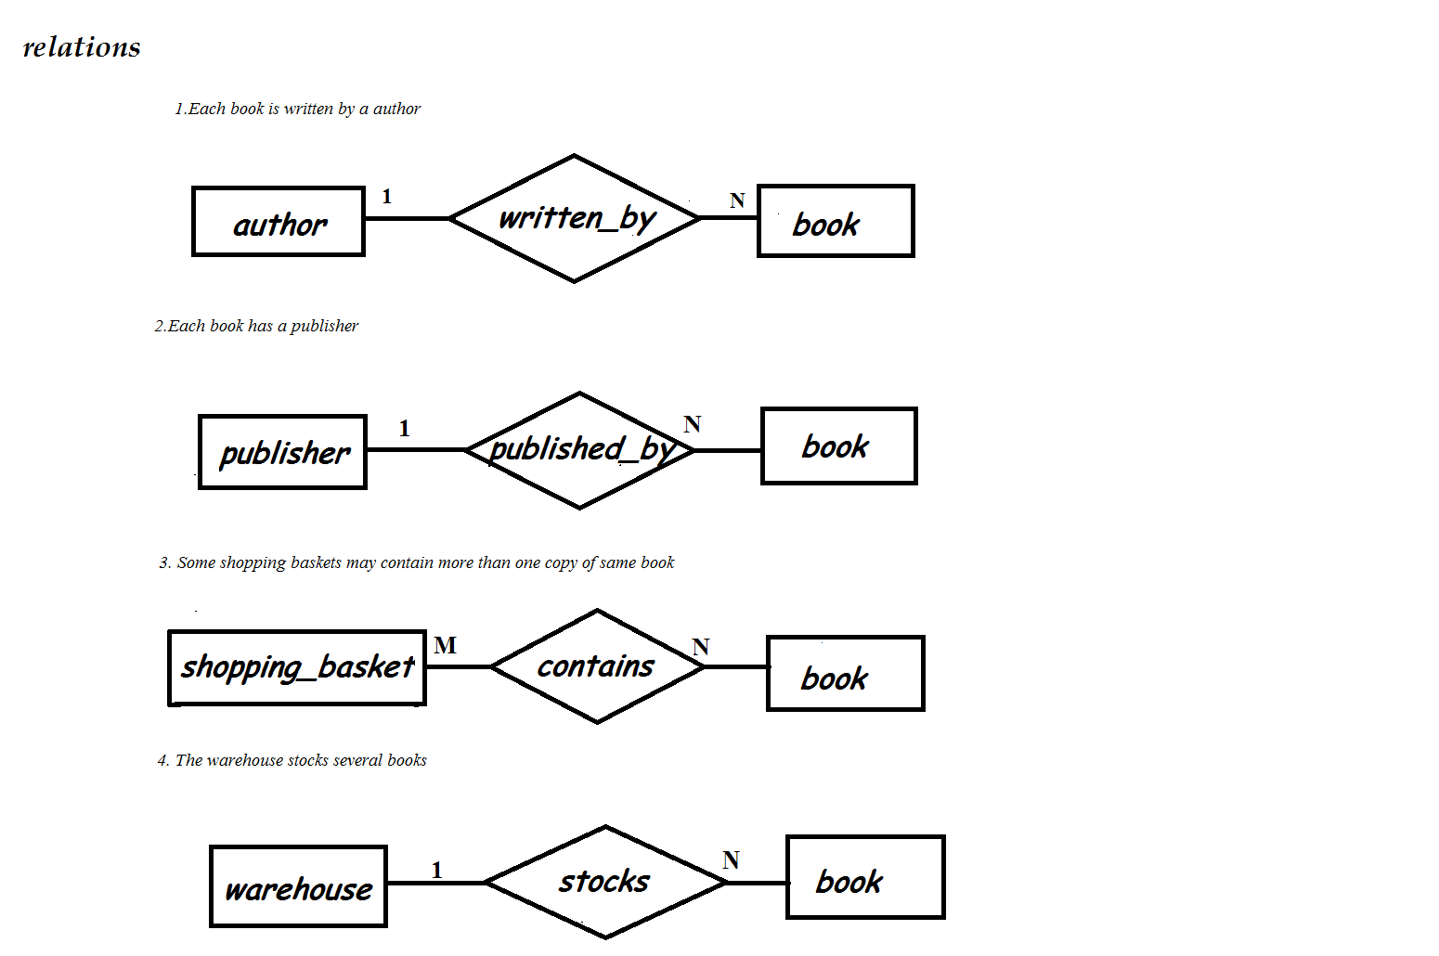

Figure 1: E-R Diagram

* **Activity Diagram:**



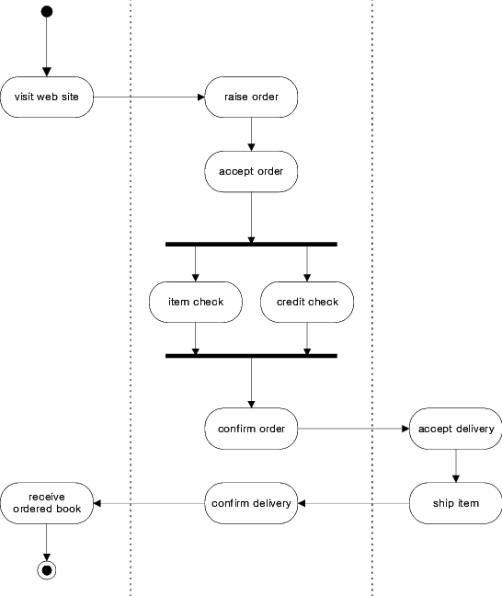

Figure 7: Activity Diagram

**CONCLUSION AND FUTURE SCOPE**

**CONCLUSION:**

The "Readify" project has achieved its goal of creating a captivating and user-centric bookstore website that offers an unparalleled experience to book lovers. By seamlessly blending e-commerce functionalities with digital library features, this project has provided users with a rich and diverse collection of books across various genres, all accessible for free. Additionally, the inclusion of a dedicated paid section for premium books adds value to the platform, offering users the opportunity to access exclusive content and support their favorite authors. In summary, the success of the "Readify" project underscores the profound impact that such a platform can have on fostering a love for literature and enhancing the reading experience for individuals worldwide. This project exemplifies the transformative power of technology in democratizing access to knowledge and enriching the lives of users through the joy of reading.

**FUTURE SCOPE**:

As the "Readify" project continues to evolve, there are several areas of potential expansion and enhancement that can be explored:

* Expanding Data Sources: The project can explore integrating with additional data sources to provide users with a more comprehensive and diverse range of Books collection.
* Personalized Features: The application can introduce personalized features, such as allowing users to create and manage a Wishlist of their favorite books. Additionally, users can enjoy the convenience of adding books to their cart for seamless purchasing. This customization enables users to curate their reading experience and easily access their preferred titles whenever they desire.
* Mobile Integration: Developing a mobile application or integrating the "Readify" project with popular mobile reading apps can further enhance the accessibility and convenience for users on the go.

**REFERENCES:**

1. [**https://www.w3schools.com/**](https://www.w3schools.com/)
2. [**daisyUI — Tailwind CSS Components**](daisyUI%20—%20Tailwind%20CSS%20Components%20(%20version%204%20update%20is%20here%20).html)
3. [**https://www.youtube.com/**](https://www.youtube.com/)

**SNAPSHOTS:**

The home page will look like this.

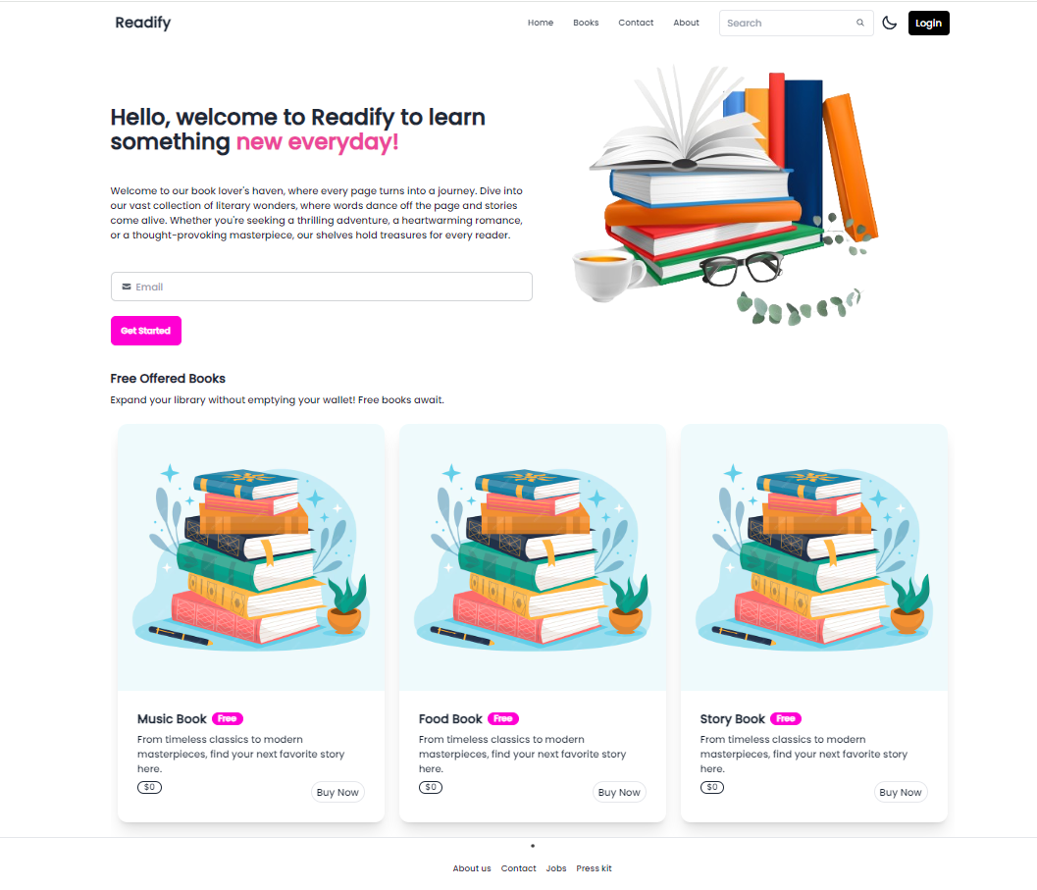

Books Page:

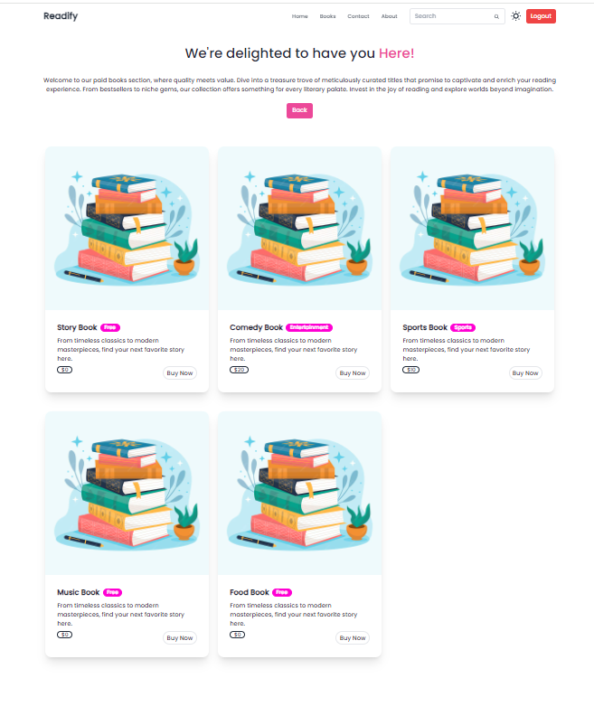

Contact Us:

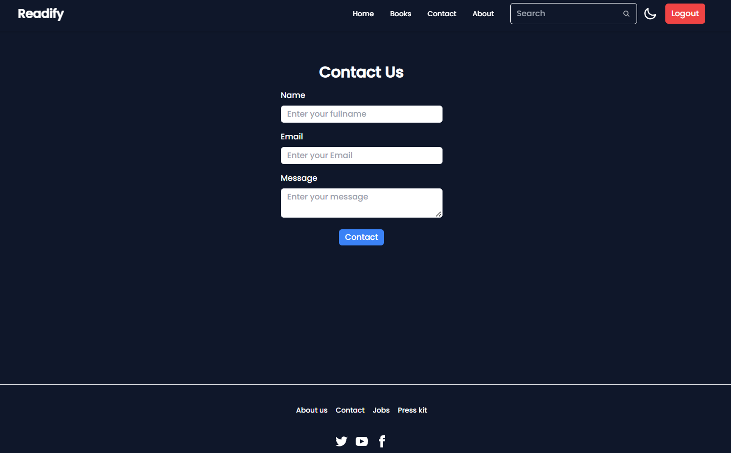

* **Source Code:**

**index.js**

import express from "express";

import mongoose from "mongoose";

import dotenv from "dotenv";

import cors from "cors";

import bookRoute from "./route/book.route.js"

import userRoute from "./route/user.route.js";

const app = express();

app.use(cors());

app.use(express.json());

dotenv.config();

const PORT = process.env.PORT || 4000;

const URI = process.env.MongoDBURI;

//connect to MongoDb

try{

mongoose.connect(URI, {

useNewUrlParser: true,

useUnifiedTopology: true,

});

console.log("Connected to mongoDB");

} catch(error){

console.log("Error: ", error);

}

//defining routes

app.use("/book", bookRoute);

app.use("/user", userRoute)

app.listen(PORT, () => {

console.log(`Example app listening on port ${PORT}`);

});

* **app.jsx**

import React from 'react'

import Home from './Home/Home'

import {Navigate, Route, Routes} from "react-router-dom"

import Courses from './Courses/Courses';

import Signup from './components/Signup';

import ContactUs from './ContactUs/ContactUs';

import {Toaster} from "react-hot-toast";

import { useAuth } from './context/AuthProvider';

function App() {

const [authUser, setAuthUser] = useAuth();

console.log(authUser);

return (

<>

<div className = "dark:bg-slate-900 dark:text-white">

<Routes>

<Route path='/' element={<Home/>}/>

<Route path='/course' element={authUser ? <Courses/> : <Navigate to="/signup"/>}/>

<Route path='/signup' element={<Signup/>}/>

<Route path='/contact' element={<ContactUs/>}/>

</Routes>

<Toaster/>

</div>

</>

)}

export default App

* **home.jsx**

import React from 'react'

import Navbar from '../components/Navbar'

import Banner from '../components/Banner';

import Freebook from '../components/Freebook';

import Footer from '../components/Footer';

function Home() {

return (

<>

<Navbar/>

<Banner/>

<Freebook/>

<Footer/>

</>

)

export default Home

* **main.jsx**

import React from 'react'

import ReactDOM from 'react-dom/client'

import App from './App.jsx'

import './index.css'

import { BrowserRouter } from 'react-router-dom' //Browser router- used to wrap the entire react application

import AuthProvider from './context/AuthProvider.jsx'

ReactDOM.createRoot(document.getElementById('root')).render(

<BrowserRouter>

<AuthProvider>

<div className='dark:bg-slate-900 dark:text-white'>

<App />

</div>

</AuthProvider>

</BrowserRouter>

)

* **index.css**

@import url('https://fonts.googleapis.com/css2?family=Fredoka:wght@300..700&family=Poppins:wght@500&display=swap');

@tailwind base;

@tailwind components;

@tailwind utilities;

body{

font-family: 'Poppins', sans-serif;

}