|  |  |
| --- | --- |
| 网络信息中心Studio可视化软件部署 | |
| 白皮书 | |
| 文档版本 | **1.0** |
| 发布日期 | **2021-12-27** |

**版本控制**

|  |  |  |  |  |  |  |  |
| --- | --- | --- | --- | --- | --- | --- | --- |
| 序号 | 版本号 | 修改的页码及条目 | 修改说明 | 修改 | 审核 | 批准 | 生效日期 |
| 1 | V1 | 全文 | 创建 | 孙锦文 |  |  | 2021/12/27 |
|  |  |  |  |  |  |  |  |
|  |  |  |  |  |  |  |  |
|  |  |  |  |  |  |  |  |
|  |  |  |  |  |  |  |  |

1. 插件部署

1、下载二进制安装包 [https://github.com/osc/frame-renderer](https://github.com/osc/frame-renderer" \o "https://github.com/osc/frame-renderer" \t "https://tickets.computing.sjtu.edu.cn/" \l "ticket/zoom/_blank)

2、安装包路径 172.16.0.110:/root/test\_gui/\*.rpm

3、安装插件 rpm -ivh \*.rpm

1. 自定义插件

(以安装AlphaFold为例)

1、frame-renderer 目录结构

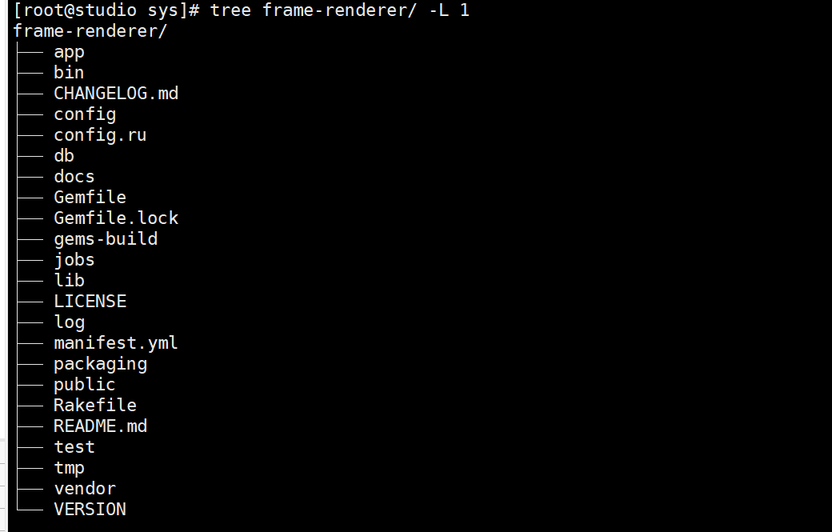

2、下面罗列要修改的文件

1. app 所有的静态文件，

Assets 样式文件不做修改。

Controller 软件后台代码，修改后台业务逻辑，在project\_controller.rb scripts\_controller.rb

Helper 工具类，需要增添相应的函数 scripts\_helper.rb

Def version\_label(project){ /\*按格式修改\*/ }

Models 作业模板类，修改 maya\_project.rb maya\_script.rb project\_factory.rb project.rb script.rb

Maya\_script.rb 可以自定义脚本文件名称，读取文件的后缀名、脚本文件路径等。

Project\_factory.rb 定义AlphaFold的业务逻辑，修改 new\_project() xxx\_project() 函数

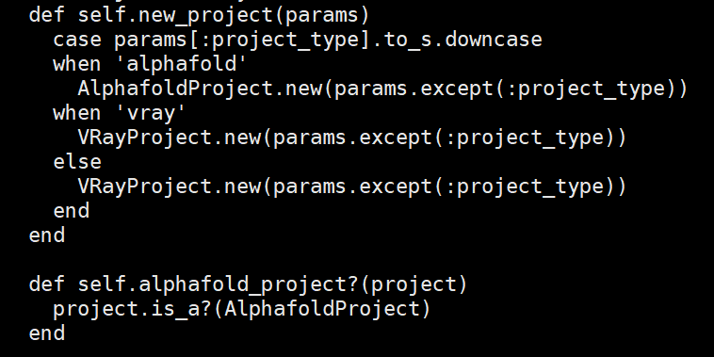

1. Views 静态页面按前端展示内容进行修改。

|  |
| --- |
| projects目录下《show.html.erb》  <div class="page-header" >  <h2><%= @project.name %></h2>  <p><%= @project.description %></p>  </div>  <script>pollSubmissions('<%= @project.id %>')</script>  <div style="display:inline-block">  <%= link\_to '返回', projects\_path, class: "btn btn-info" %>  <%= link\_to '编辑', edit\_project\_path(@project), class: "btn btn-warning" %>  <%= link\_to "打开文件目录", OodAppkit.files.url(path: @project.directory).to\_s,  class: 'btn btn-primary btn-sm', :target => '\_blank' %>  </div>  <br><br>  <div id="script-list-view" class="panel panel-default">  <div class="panel-body" >  <table id="script-list-table" class="table data-table" >  <thead>  <tr>  <th>名称</th>  <th>模板</th>  <th>文件</th>  <th>编号</th>  <th>状态</th>  <th>操作</th>  </tr>  </thead>  <tbody>  <% @project.scripts.each do |script| %>  <tr class="script-row" >  <td><%= script.name %></td>  <td><%= script.frames %></td>  <td><%= script.file.nil? ? "not selected" : File.basename(script.file) %></td>  <td><div id="script-<%= script.id %>-job-id"><%= script.latest\_job\_id %></div></td>  <td id="status\_label\_<%= script.id %>">  <%= status\_label(script.latest\_status, script.id) %>  </td>  <td>  <%= link\_to "提交", project\_script\_submit\_path(@project, script), :method => :put,  class: 'btn btn-success btn-sm', id: "submit-button-" + script.id.to\_s %>  <%= link\_to "停止", project\_script\_stop\_job\_path(@project, script, script.latest\_id),  :method => :delete, class: 'btn btn-danger btn-sm disabled', id: "stop-button-" + script.id.to\_s, disabled: "disabled" %>  <%= link\_to "编辑", edit\_project\_script\_path(@project, script), :method => :get, class: 'btn btn-info btn-sm'%>  <%= link\_to "删除", project\_script\_path(@project, script),  :method => :delete, class: 'btn btn-danger btn-sm', data: {confirm: "Are you sure?"} %>  <%= link\_to "查看作业结果", project\_script\_path(@project, script), :method => :get, class: 'btn btn-primary btn-sm'%>  </td>  </tr>  <% end %>  <tbody>  </table>  </div>  </div>  <%= link\_to '创建新的作业', new\_project\_script\_path(@project), class: "btn btn-primary" %>  <br><br>  <% if thumbnails(@project.directory).size > 0 %>  <div id="thumbnail-list-view" class="panel panel-default">  <div class="panel-body" >  <table id="thumbnail-list-table" class="table data-table" >  <thead>  <tr>  <th>File</th>  <th>Image</th>  </tr>  </thead>  <%= %>  <tbody>  <% images(@project.directory).each do |image| %>  <tr>  <td>  <%-  basename = File.basename(image)  dir = File.dirname(image)  -%>  <%= link\_to(basename, "/pun/sys/files/fs#{dir}/#{url\_encode(basename)}?download=1") %>  <td>  <img  class="d-block w-100 thumbnail-zoom"  src="/pun/sys/files/api/v1/fs<%= image\_to\_thumbnail(@project.directory, image) %>"  onClick="window.open(this.src)"  >  </td>  </tr>  <% end %>  </tbody>  </table>  <div>  </div>  <% end %> |
| Projects 路径下的《new.html.erb》  <div class="page-header" >  <h2>新建项目</h2>  </div>  <div>  在新建项目之前，请确保你的脚本文件已上传到服务器 <br>  你可以按照 <a href="https://docs.hpc.sjtu.edu.cn/studio/alphafold-gui.html">此文档</a>上的说明操作.  <br><br>  <% if Configuration.sftp\_host %>  如果您已经安装了 SFTP 客户端，您可以单击  <a href="sftp://<%= ENV["USER"] %>@<%= Configuration.sftp\_host %><%= @project.directory %>/">此处</a> 打开它.  <br><br>  <% end %>  </div>  <%= render 'form' %> |
| Projects 路径下的 index.html.erb  <div class="page-header" >  <h2>个人项目</h2>  </div>  <div>  <div class="btn-group open">  <a data-method="get"  data-toggle="tooltip"  title="Create a new Project"  href="<%= new\_project\_path %>">  <button type="button" id="new\_job\_button" class="btn btn-primary" > 新建项目</button></a>  </div>  </div>  <br>  <br>  <h3>项目</h3>  <div id="submission-list-view" class="panel panel-default">  <div class="panel-body" >  <table id="submission-list-table" class="table data-table" >  <thead>  <tr>  <th>项目名称</th>  <th>操作</th>  <tr>  </thead>  <tbody>  <% @projects.each do |project| %>  <tr>  <td><%= link\_to project.name, project\_path(project) %></td>  <td><%= link\_to '进行中...', project\_path(project), class: 'btn btn-success btn-sm' %>  <td><%= link\_to '编辑', edit\_project\_path(project), class: 'btn btn-info btn-sm' %>  <td><%= link\_to '删除', project\_path(project), :method => :delete,  data: {confirm: "Are you sure?"}, class: 'btn btn-danger btn-sm' %>  <tr>  <% end %>  </tbody>  </div>  </div> |
| Projects 路径下的 \_form.html.erb  <%= bootstrap\_form\_for @project do |form| %>  <div class="panel panel-default">  <div class="panel-heading">  项目详情  </div>  <div class="panel-body", role="main">  <%= form.select :project\_type, ['Alphafold', 'VRay'], required: true,label:"项目类型(必录项)" %>  <%= form.text\_field :name, label: 'name', required: true,label:"项目名称(必录项)" %>  <%= form.text\_area :description, label: '描述(非必录项)' %>  <%= form.text\_field :directory,  label: '目录', 'data-filepicker': 'true',  'data-target\_file\_type': 'dirs' %>  </div>  </div>  <p>  <%= form.submit '保存', class: 'btn btn-primary' %>  <%= form.button '重置', type: :reset, class: 'btn btn-default' %>  <%= link\_to '返回', projects\_path, class: 'btn btn-default' %>  <p>  <% end %> |
| Projects 路径下的 edit.html.erb  <div class="page-header" >  <h2>编辑项目 <%= @project.name %></h2>  </div>  <div>  <div class="btn-group open">  <%= button\_to 'Delete',  project\_path(@project),  method: :delete,  data: { confirm: 'Are you sure?' },  class: "btn btn-danger",  id: "delete\_project\_button"  %>  </div>  </div>  <br>  <%= render 'form' %> |
| Scripts 路径下的\_form.html.erb 文件  <%= bootstrap\_form\_for [@project, @script] do |form| %>  <div class="panel panel-default">  <div class="panel-heading">  编辑作业脚本  </div>  <div class="panel-body", role="main">  <%= form.text\_field :name, required: true,label:"名称(必录项)" %>  <%= form.select :version, @script.available\_versions, required: true, label: "#{version\_label(@project)} 版本号" %>  <%= form.hidden\_field :frames,  required: false, placeholder: '1-100',value:'1-1',  pattern: '\d+-\d+', help: "Must be in the form startframe-endframe" %>  <%= form.hidden\_field :camera, required: false, placeholder: 'camera1' %>  <%= form.select :file, @project.scenes, required: true,label:"脚本文件" %>  <%= form.hidden\_field :accounting\_id, required: false, label: 'Chargeback project',  help: 'the project to charge to',  placeholder: 'PZS0714' %>  <!-- hidden cluster field becuase of #17. We're only initially supporting one cluster, which is the  default cluster. -->  <%= form.hidden\_field :cluster, value: @script.cluster %>  <%= form.number\_field :nodes, required: true, min: 1,label:"核数(必录项)" %>  <!-- <%= form.select :renderer, @script.renderers, required: false %>-->  <%= form.text\_field :extra, required: false,  label: '其他参数(非必录项)',  placeholder: '',  help: ("#{link\_to 'Help Docs', 'https://docs.hpc.sjtu.edu.cn/studio/alphafold-gui.html'}").html\_safe %>  <%= form.number\_field :walltime, required: true, help: '以小时为单位计算', min: 1,label:'最大运行时长(必录项)' %>  <!-- <%= form.hidden\_field :email, label: 'Email when finished' %>-->  <!-- <%= form.hidden\_field :skip\_existing, label: 'Do not render existing frames' %>-->  </div> <!-- main panel body -->  </div> <!-- outer panel -->  <p>  <%= form.submit '保存', class: 'btn btn-primary' %>  <%= form.button '重置', type: :reset, class: 'btn btn-default' %>  <%= link\_to '返回', project\_path(@project), class: 'btn btn-default' %>  <p>  <% end %> |
| Scripts 路径下的 show.html.erb页面  <div class="page-header" >  <h2><%= @script.name %></h2> <!-- but also title type header -->  </div>  <script>pollForUpdates('<%= @project.id %>', '<%= @script.id %>')</script>  <%= link\_to '返回', project\_path(@project), class: "btn btn-info" %><br><br>  <h3>所有作业运行结果= @script.name%></h3>  <div id="script-list-view" class="panel panel-default">  <div class="panel-body" >  <table id="past-jobs-table" class="table data-table" >  <tbody>  <% @script.jobs.each do |job| %>  <tr><td>  <!-- the button to minimize the job results -->  <button  id="job-<%= job.id %>-button"  class="job-result-button job-result-button-<%= normalize\_css\_str(job.status) %>"  onclick="toggle('job-<%= job.id %>-container')"  job\_id="<%= job.id %>"  job\_status="<%= job.status %>"  >  <%= job.job\_id %> [<%= job.status %>]  </button>  <!-- containter for the job results div so it can toggle -->  <div id="job-<%= job.id %>-container" style="display: none;">  <!-- the job results div -->  <div id="job-<%= job.id %>-info" >  <table class="table table-condensed table-striped">  <tbody>  <tr>  <td>作业</td>  <td><%= job.job\_id %></td>  </tr>  <tr>  <td>输出文件</td>  <td>  <a href="<%= '/pun/sys/files/fs' + (job&.directory || @project.directory + '/batch\_jobs/' + job.job\_id) %>">打开文件目录</a></td>  </tr>  <tr>  <td>创建时间</td>  <td><%= local\_time(job.created\_at) %></td>  </tr>  <tr>  <td>最后更新时间</td>  <td><%= local\_time(job.updated\_at) %></td>  </tr>  </tbody>  </table>  </div> <!-- job info div -->  </div> <!-- toggle/hide container -->  </td></tr>  <% end %>  </tbody>  </table>  </div>  </div> |

1. bin 可执行文件

|  |
| --- |
| ENV['RAILS\_RELATIVE\_URL\_ROOT'] ||= '/pun/sys/frame-renderer' if ENV['RAILS\_ENV'] == 'production' |

替换为

|  |
| --- |
| ENV['RAILS\_RELATIVE\_URL\_ROOT'] ||= '/pun/sys/alphafold' if ENV['RAILS\_ENV'] == 'production' |

1. config 环境配置文件

Configuration\_singleton.rb

|  |
| --- |
| root ||= "~/#{ENV['OOD\_PORTAL'] || 'ondemand'}/data/#{ENV['APP\_TOKEN'] || 'sys/frame-renderer'}" |

替换为

|  |
| --- |
| root ||= "~/#{ENV['OOD\_PORTAL'] || 'ondemand'}/data/#{ENV['APP\_TOKEN'] || 'sys/alphafold'}" |

initialzers文件中的init\_db\_types.rb

|  |
| --- |
| if File.exist?(db) && !File.zero?(db) && columns\_exist?  Project.where(type: nil).update\_all(type: 'MayaProject')  Script.where(type: nil).update\_all(type: 'MayaScript')  end |

替换为

|  |
| --- |
| if File.exist?(db) && !File.zero?(db) && columns\_exist?  Project.where(type: nil).update\_all(type: 'AlphafoldProject')  Script.where(type: nil).update\_all(type: 'AlphafoldScript')  end |

1. jobs/video\_jobs/maya\_submit.sh.erb slurm提交作业脚本模板，

|  |
| --- |
| #!/bin/bash  # set the resources requests. because it's Slurm, we just use --exclusive  # instead of caring about cores  #SBATCH --job-name=session  #SBATCH --partition=dgx2  #SBATCH -N 1  #SBATCH --ntasks-per-node=1  #SBATCH --cpus-per-task=<%= 6\*nodes %>  #SBATCH --gres=gpu:<%= nodes %>  #SBATCH --output=%j.out  #SBATCH --error=%j.err  #  echo "starting at $(date)"  <%  groups = OodSupport::Process.groups.map(&:name)  %>  RENDERER="<%= renderer %>"  EXTRA\_ARGS="<%= extra %>"  PRJ\_DIR="<%= project\_dir %>"  SKIP\_EXISTING="-skipExistingFrames <%= skip\_existing %>"  SCRIPT\_FILE="<%=file%>"  TYPE="<%= type%>"  echo $PRJ\_DIR  echo $SCRIPT\_FILE  echo "AlphaFold start at $(date)"  cp $SCRIPT\_FILE ./test.fasta  echo "true-1011"  module purge  module load alphafold  module list  echo $PWD  run\_af2 $PWD --preset=casp14 test.fasta --max\_template\_date=2021-09-12  echo "AlphaFold ended at $(date)"  [ -n "$SLURM\_ARRAY\_TASK\_ID" ] || SLURM\_ARRAY\_TASK\_ID=1  #echo "executing: ${CMD[@]} <%= Shellwords.escape(file) %>"  echo "on host: $(hostname)"  echo "with modules:"  module list  echo "ended at $(date)"  echo "ended with status $STATUS"  exit $STATUS |

1. packaging 环境配置文件

|  |
| --- |
| %global repo\_name frame\_renderer  %global app\_name frame\_renderer |

替换为

|  |
| --- |
| %global repo\_name alphafold  %global app\_name alphafold |

1. Public/assets 公共配置文件

将application-297033af578b628352b99f89d6735fc57fc8ad8b456300b46c0ed745fdfb6146.js 文件中的 frame\_renderer 替换为 alphafold

1. /var/www/ood/apps/sys/alphafold 该路径下，新增 icon.png logo文件
2. 常见问题汇总
3. A problem occurred while initializing your data for this app

问题原因：本地数据库文件被删除，和远程服务器里的缓存数据不匹配。

本地数据库： ondemand/data/sys/

解决措施： 删除数据库文件，若有重要信息记得备份。

删除远程服务器缓存

|  |
| --- |
| rm -rf /var/tmp/ondemand-nginx/hpcsjw/ |

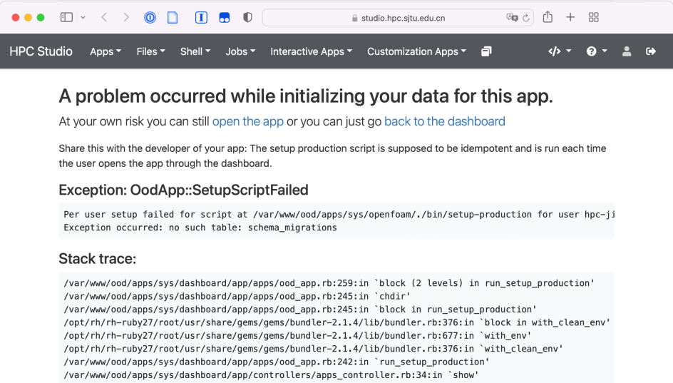

1. We’re sorry,but something went wrong.

问题原因：①、静态页面修改后与缓存文件不一致。

②、后台代码有误。

解决措施：针对原因一： 清除远程缓存文件即可。

|  |
| --- |
| rm -rf /var/tmp/ondemand-nginx/hpcsjw/ |

针对原因二： 查看日志文件 /var/log/ondemand-nginx/hpcsjw/error.log

根据提示的信息进行修改逻辑后台代码。