《高级网页设计I》
网页元素设计 项目报告
学 号：24002120323 姓 名：杨阳
班级 | 商务24003
项目选题名称 | 潮汐

实施过程
- 项目需求与实现
选取的三处效果中要求至少两处要有图片或图表，如果用到图标，可暂时用图片代替，可到iconfont.cn下载任意png图标，图片、图标不要求完全和原图相同。
首页原图:
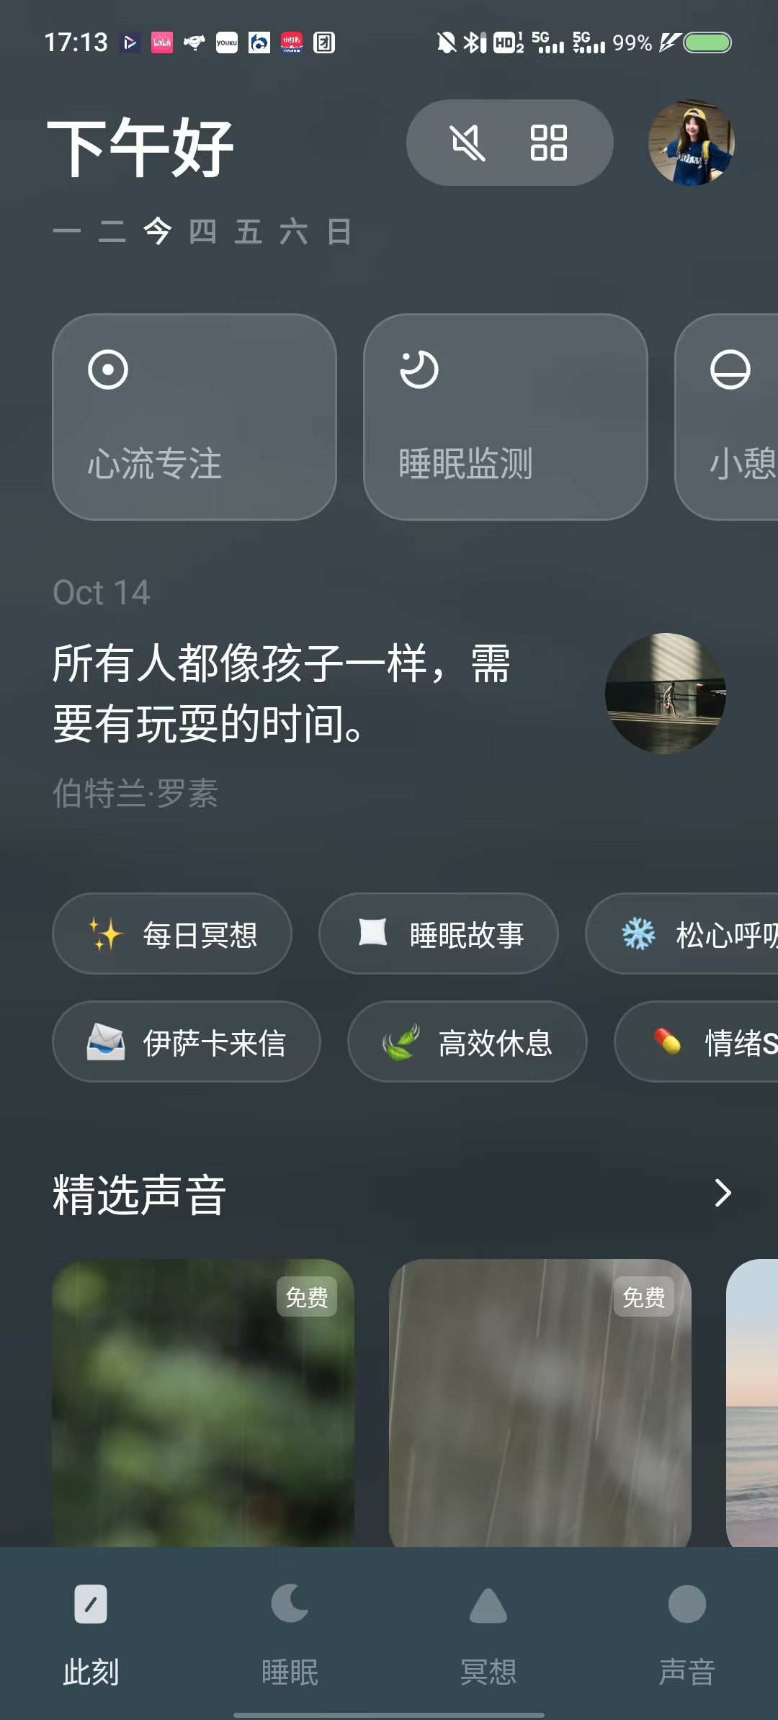

首页实现图：

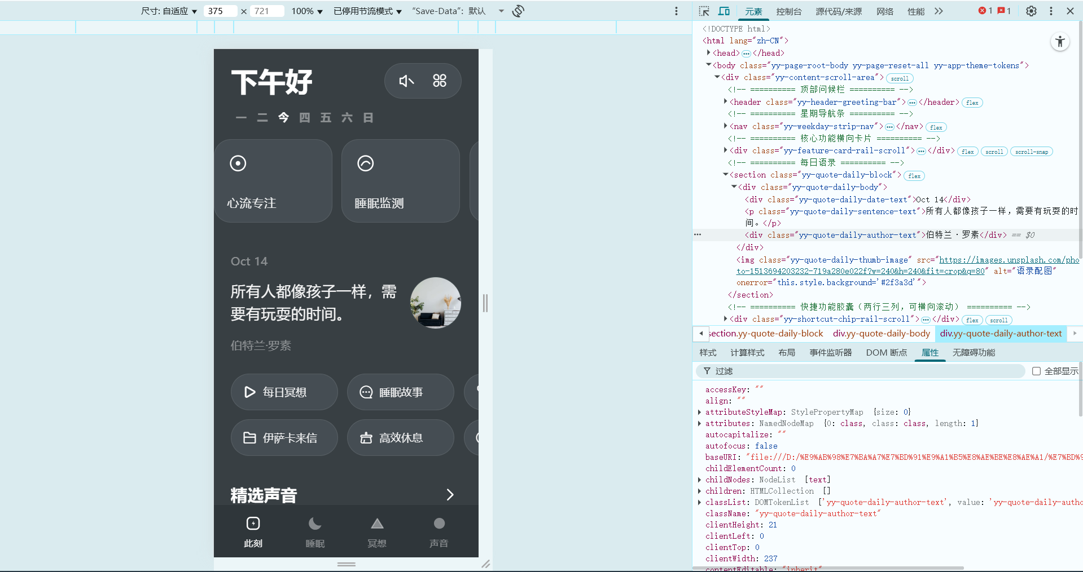
睡眠页面原图:
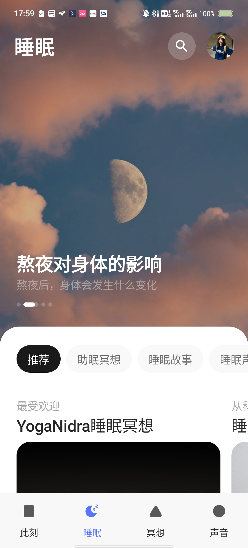

睡眠页面实现图：
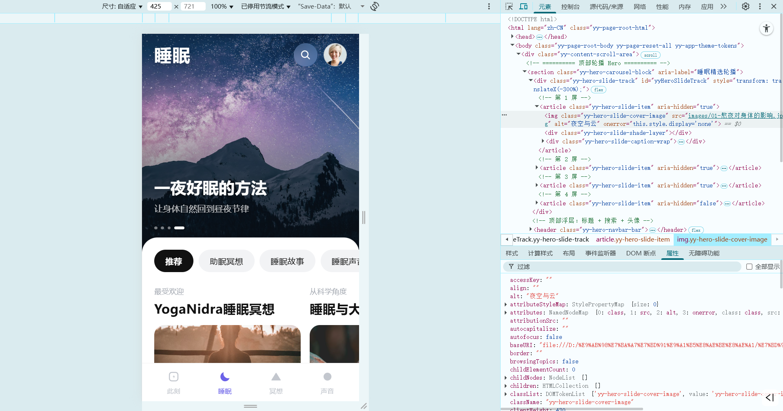
详情页原图:
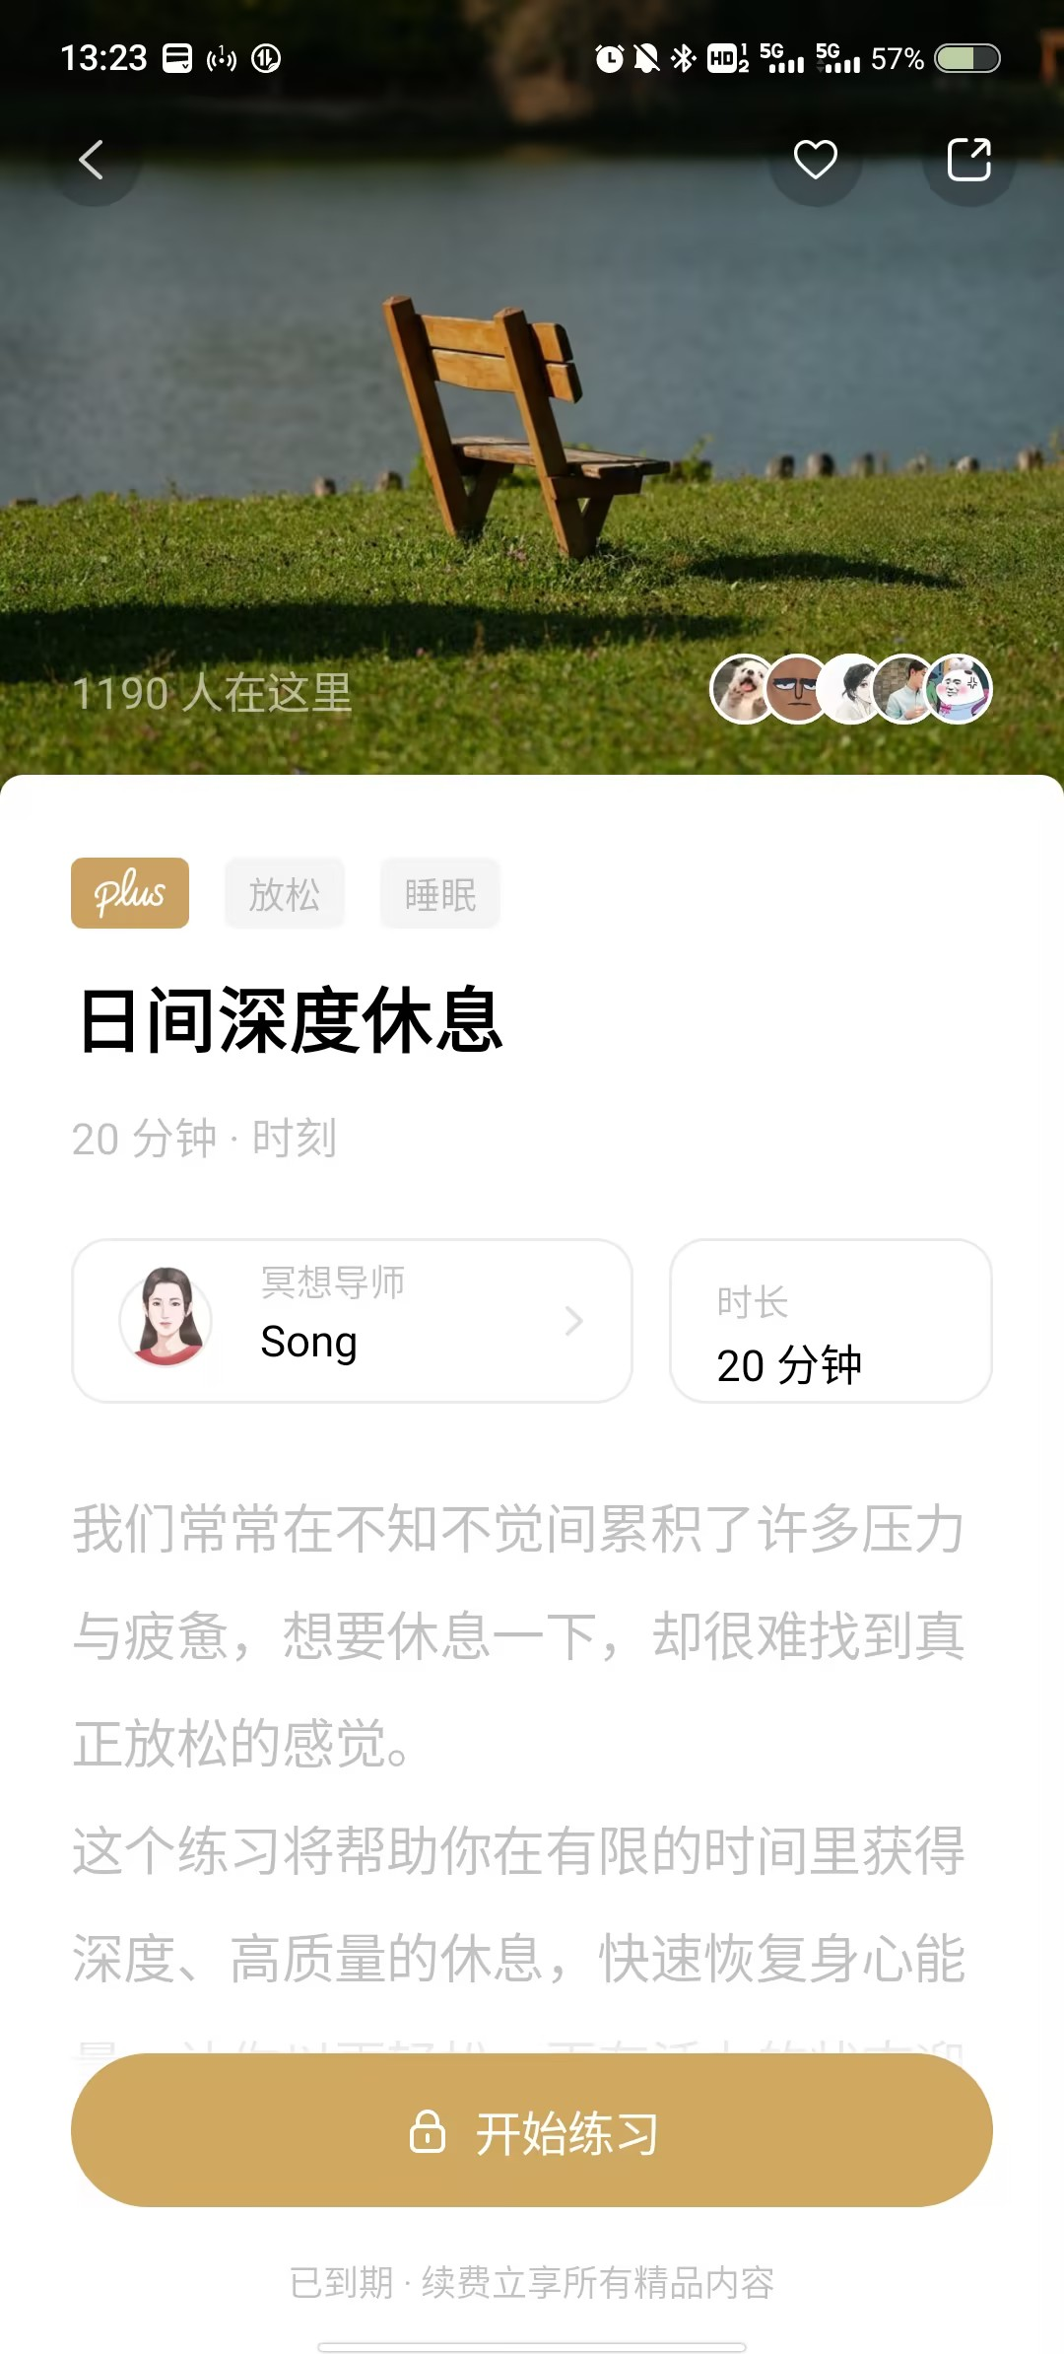
详情页实现图：
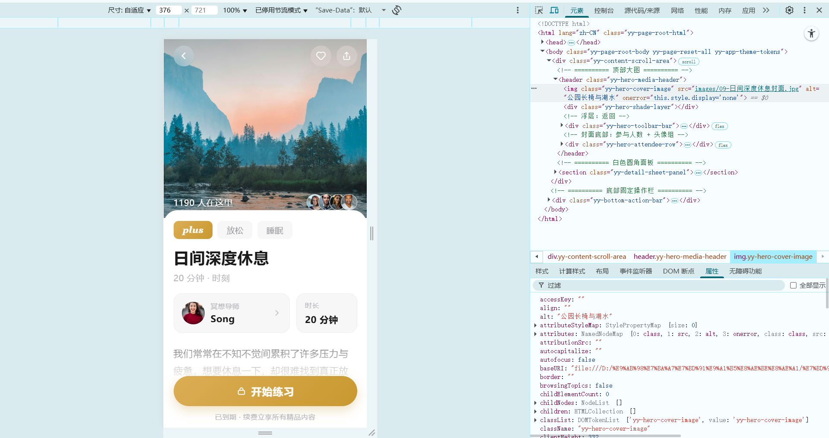

- 项目代码
要求：代码中要包含学号或姓名，或者类名中包括姓名缩写，原则上不建议使用id选择器，原则上要设计全局css。
网页元素1核心代码）：
//顶部「下午好」+ 星期条
<header class="yy-header-greeting-bar">
<h1 class="yy-header-greeting-text">下午好</h1>
<div class="yy-header-action-group">
<div class="yy-header-toolbar-pill">
<button class="yy-header-icon-button"><svg class="yy-header-icon-svg" viewBox="0 0 24 24" fill="none" stroke="currentColor" stroke-width="1.9" stroke-linecap="round" stroke-linejoin="round"><path d="M11.2 4.6 6.6 8.4H3.2v7.2h3.4l4.6 3.8V4.6Z"/><path d="M15.4 9.4 21 15"/></svg></button>
<button class="yy-header-icon-button"><i class="iconfont icon-classification yy-header-icon-glyph"></i></button>
</div>
<img class="yy-header-user-avatar" src="https://i.pravatar.cc/160?img=47" alt="用户头像">
</div>
</header>
<nav class="yy-weekday-strip-nav">
<span class="yy-weekday-strip-day-item">一</span>
<span class="yy-weekday-strip-day-item">二</span>
<span class="yy-weekday-strip-day-item yy-is-today">今</span>
<span class="yy-weekday-strip-day-item">四</span>
<span class="yy-weekday-strip-day-item">五</span>
<span class="yy-weekday-strip-day-item">六</span>
<span class="yy-weekday-strip-day-item">日</span>
</nav>
//核心功能横向卡片（三张结构相同，仅图标与标题不同）
<div class="yy-feature-card-rail-scroll">
<div class="yy-feature-card-item">
<svg class="yy-feature-card-icon-svg" viewBox="0 0 24 24" fill="none" stroke="currentColor" stroke-width="1.6"><circle cx="12" cy="12" r="8.4"/><circle cx="12" cy="12" r="2.6" fill="currentColor" stroke="none"/></svg>
<span class="yy-feature-card-title-text">心流专注</span>
</div>
<div class="yy-feature-card-item">
<span class="yy-feature-card-title-text">睡眠监测</span>
</div>
<div class="yy-feature-card-item">
<span class="yy-feature-card-title-text">小憩</span>
</div>
</div>
//每日语录
<section class="yy-quote-daily-block">
<div class="yy-quote-daily-body">
<div class="yy-quote-daily-date-text">Oct 14</div>
<p class="yy-quote-daily-sentence-text">所有人都像孩子一样，需要有玩耍的时间。</p>
<div class="yy-quote-daily-author-text">伯特兰·罗素</div>
</div>
<img class="yy-quote-daily-thumb-image" src="https://images.unsplash.com/photo-1513694203232-719a280e022f?w=240&h=240&fit=crop&q=80" alt="语录配图">
</section>
//快捷功能胶囊（两行三列，可横向滚动）
<div class="yy-shortcut-chip-rail-scroll">
<div class="yy-shortcut-chip-column-group">
<button class="yy-shortcut-chip-button">
<i class="iconfont icon-btn_play yy-shortcut-chip-icon-glyph"></i>
<span class="yy-shortcut-chip-label-text">每日冥想</span>
</button>
<button class="yy-shortcut-chip-button">
<i class="iconfont icon-wenjian yy-shortcut-chip-icon-glyph"></i>
<span class="yy-shortcut-chip-label-text">伊萨卡来信</span>
</button>
</div>
<!-- 第 2、3 列结构相同 -->
</div>
//精选声音（横滑图片卡 + 免费角标）
<section class="yy-sound-section-block">
<div class="yy-sound-section-header-row">
<h2 class="yy-sound-section-heading-text">精选声音</h2>
<button class="yy-sound-section-more-button"><svg class="yy-sound-section-icon-svg" viewBox="0 0 24 24" fill="none" stroke="currentColor" stroke-width="2.2" stroke-linecap="round" stroke-linejoin="round"><path d="M9 4l8 8-8 8"/></svg></button>
</div>
<div class="yy-sound-card-rail-scroll">
<div class="yy-sound-card-item">
<img class="yy-sound-card-cover-image" src="https://images.unsplash.com/photo-1441974231531-c6227db76b6e?w=400&h=400&fit=crop&q=80" alt="雨林">
<span class="yy-sound-card-badge">免费</span>
</div>
<!-- 另两张结构相同 -->
</div>
</section>
//底部固定标签栏（四项结构相同，首项为选中态）
<nav class="yy-tabbar-bottom-nav">
<button class="yy-tabbar-item yy-is-active"><span class="yy-tabbar-label-text">此刻</span></button>
<button class="yy-tabbar-item"><span class="yy-tabbar-label-text">睡眠</span></button>
<button class="yy-tabbar-item"><span class="yy-tabbar-label-text">冥想</span></button>
<button class="yy-tabbar-item"><span class="yy-tabbar-label-text">声音</span></button>
</nav>
Css:
/* 设计变量：配色集中管理，改主题只动这一处 */
.yy-app-theme-tokens{
--yy-color-bg-page:#383f43;
--yy-color-bg-nav:#2f363a;
--yy-color-glass:rgba(255,255,255,.075);
--yy-color-glass-border:rgba(255,255,255,.09);
--yy-color-text-primary:#ffffff;
--yy-color-text-muted:rgba(255,255,255,.42);
--yy-radius-card:24px;
--yy-safe-area-bottom:env(safe-area-inset-bottom,0px);
}
/* 移动端滚动容器：dvh 解决地址栏伸缩、padding 避让固定标签栏 */
.yy-content-scroll-area{
position:relative;
width:100%;
height:100vh;
height:100dvh;
overflow-y:auto;
overflow-x:hidden;
-webkit-overflow-scrolling:touch;
padding:calc(var(--yy-safe-area-top) + 14px) 0 calc(var(--yy-safe-area-bottom) + 104px);
}
/* 问候栏：两端对齐 + 毛玻璃胶囊 */
.yy-header-greeting-bar{display:flex;align-items:center;justify-content:space-between;gap:10px;padding:6px 24px 0;}
.yy-header-greeting-text{font-size:38px;font-weight:700;line-height:1.15;}
.yy-header-toolbar-pill{
display:flex;
align-items:center;
gap:4px;
height:50px;
padding:0 10px;
border-radius:999px;
background:var(--yy-color-glass);
border:1px solid var(--yy-color-glass-border);
backdrop-filter:blur(18px) saturate(140%);
-webkit-backdrop-filter:blur(18px) saturate(140%);
}
/* 星期条：今日高亮 */
.yy-weekday-strip-nav{display:flex;align-items:center;padding:16px 24px 0;}
.yy-weekday-strip-day-item{font-size:15px;font-weight:600;color:var(--yy-color-text-muted);width:30px;text-align:center;}
.yy-weekday-strip-day-item.yy-is-today{color:var(--yy-color-text-primary);font-weight:700;}
/* 横滑卡片轨道：定宽不伸缩 + scroll-snap 吸附 */
.yy-feature-card-rail-scroll{display:flex;gap:13px;overflow-x:auto;scroll-snap-type:x mandatory;-webkit-overflow-scrolling:touch;padding:22px 24px 4px;}
.yy-feature-card-item{
scroll-snap-align:start;
flex:0 0 168px;
height:118px;
border-radius:var(--yy-radius-card);
background:var(--yy-color-glass);
border:1px solid var(--yy-color-glass-border);
backdrop-filter:blur(20px) saturate(140%);
-webkit-backdrop-filter:blur(20px) saturate(140%);
display:flex;
flex-direction:column;
justify-content:space-between;
padding:18px 18px 16px;
}
/* 语录区 */
.yy-quote-daily-block{display:flex;align-items:center;gap:16px;padding:40px 24px 0;}
.yy-quote-daily-sentence-text{font-size:21px;line-height:1.55;color:rgba(255,255,255,.95);}
.yy-quote-daily-thumb-image{width:74px;height:74px;border-radius:50%;object-fit:cover;flex-shrink:0;}
/* 快捷胶囊：列分组保证「先左右、后上下」的阅读顺序 */
.yy-shortcut-chip-rail-scroll{display:flex;gap:13px;overflow-x:auto;padding:30px 24px 0;}
.yy-shortcut-chip-column-group{display:flex;flex-direction:column;gap:13px;flex:0 0 auto;}
.yy-shortcut-chip-button{
display:flex;
align-items:center;
gap:9px;
width:152px;
height:52px;
padding:0 16px;
border-radius:999px;
background:var(--yy-color-glass);
border:1px solid var(--yy-color-glass-border);
backdrop-filter:blur(18px) saturate(140%);
}
.yy-shortcut-chip-label-text{font-size:15px;color:rgba(255,255,255,.93);white-space:nowrap;}
/* 精选声音：图片卡 + 毛玻璃角标 */
.yy-sound-section-header-row{display:flex;align-items:center;justify-content:space-between;padding:0 24px;}
.yy-sound-section-heading-text{font-size:23px;font-weight:700;}
.yy-sound-card-rail-scroll{display:flex;gap:13px;overflow-x:auto;scroll-snap-type:x mandatory;padding:16px 24px 4px;}
.yy-sound-card-item{position:relative;scroll-snap-align:start;flex:0 0 168px;height:168px;border-radius:20px;overflow:hidden;}
.yy-sound-card-cover-image{width:100%;height:100%;object-fit:cover;display:block;}
.yy-sound-card-badge{position:absolute;top:10px;right:10px;padding:3px 9px;border-radius:8px;font-size:12px;color:#fff;background:rgba(255,255,255,.26);backdrop-filter:blur(8px);}
/* 底部固定标签栏：选中项图标与文字同时点亮 */
.yy-tabbar-bottom-nav{
position:fixed;
left:0;
right:0;
bottom:0;
z-index:10;
display:flex;
justify-content:space-around;
padding:12px 12px calc(var(--yy-safe-area-bottom) + 10px);
background:var(--yy-color-bg-nav);
}
.yy-tabbar-item{flex:1;display:flex;flex-direction:column;align-items:center;gap:7px;}
.yy-tabbar-item.yy-is-active .yy-tabbar-icon-svg,
.yy-tabbar-item.yy-is-active .yy-tabbar-label-text{color:var(--yy-color-text-primary);}
网页元素2核心代码：
//顶部轮播 Hero（4 屏自动轮播 + 圆点切换 + 手势滑动）
<section class="yy-hero-carousel-block">
<div class="yy-hero-slide-track" id="yyHeroSlideTrack">
<article class="yy-hero-slide-item">
<img class="yy-hero-slide-cover-image" src="images/01-熬夜对身体的影响.jpg" alt="夜空与云">
<div class="yy-hero-slide-shade-layer"></div>
<div class="yy-hero-slide-caption-wrap">
<h2 class="yy-hero-slide-title-text">熬夜对身体的影响</h2>
<p class="yy-hero-slide-subtitle-text">熬夜后，身体会发生什么变化</p>
</div>
</article>
<!-- 第 2~4 屏结构相同，仅图片与文案不同 -->
</div>
<header class="yy-hero-navbar-bar">
<h1 class="yy-hero-page-title-text">睡眠</h1>
<div class="yy-hero-action-group">
<button class="yy-hero-search-button"><svg class="yy-hero-icon-svg" viewBox="0 0 24 24" fill="none" stroke="currentColor" stroke-width="2.2" stroke-linecap="round"><circle cx="10.8" cy="10.8" r="6.6"/><path d="M15.6 15.6 20.4 20.4"/></svg></button>
<img class="yy-hero-user-avatar" src="images/08-用户头像.jpg" alt="用户头像">
</div>
</header>
<div class="yy-hero-dot-indicator-row">
<button class="yy-hero-dot-item yy-is-active"></button>
<button class="yy-hero-dot-item"></button>
<button class="yy-hero-dot-item"></button>
<button class="yy-hero-dot-item"></button>
</div>
</section>
//白色圆角面板（上沿压住 Hero 30px）
<section class="yy-panel-sheet-board">
<div class="yy-filter-chip-rail-scroll">
<button class="yy-filter-chip-button yy-is-selected">推荐</button>
<button class="yy-filter-chip-button">助眠冥想</button>
<button class="yy-filter-chip-button">睡眠故事</button>
<button class="yy-filter-chip-button">睡眠声音</button>
<button class="yy-filter-chip-button">白噪音</button>
<button class="yy-filter-chip-button">睡眠科普</button>
</div>
<div class="yy-collection-rail-scroll">
<div class="yy-collection-item-block">
<span class="yy-collection-eyebrow-label">最受欢迎</span>
<h3 class="yy-collection-title-text">YogaNidra睡眠冥想</h3>
<div class="yy-collection-cover-card">
<img class="yy-collection-cover-image" src="images/05-YogaNidra睡眠冥想.jpg" alt="YogaNidra睡眠冥想">
</div>
</div>
<!-- 另两组结构相同 -->
</div>
</section>
//底部固定标签栏（四项结构相同，睡眠为当前页选中态）
<nav class="yy-tabbar-bottom-nav">
<button class="yy-tabbar-item"><span class="yy-tabbar-label-text">此刻</span></button>
<button class="yy-tabbar-item yy-is-active"><span class="yy-tabbar-label-text">睡眠</span></button>
<button class="yy-tabbar-item"><span class="yy-tabbar-label-text">冥想</span></button>
<button class="yy-tabbar-item"><span class="yy-tabbar-label-text">声音</span></button>
</nav>
Css:
/* 设计变量 */
.yy-app-theme-tokens{
--yy-color-bg-page:#ffffff;
--yy-color-chip-bg:#f2f3f5;
--yy-color-chip-active-bg:#111111;
--yy-color-text-primary:#111111;
--yy-color-text-muted:#a8adb5;
--yy-color-tabbar-active:#6b62e8;
--yy-radius-sheet:30px;
--yy-safe-area-bottom:env(safe-area-inset-bottom,0px);
}
/* 滚动容器：底部为固定标签栏预留空间 */
.yy-content-scroll-area{
position:relative;
width:100%;
height:100vh;
height:100dvh;
overflow-y:auto;
overflow-x:hidden;
-webkit-overflow-scrolling:touch;
padding:0 0 calc(var(--yy-safe-area-bottom) + 92px);
}
/* 轮播：轨道 4 屏靠 translateX 位移，单屏 flex:0 0 100% */
.yy-hero-carousel-block{position:relative;width:100%;height:58vh;min-height:430px;overflow:hidden;background:#141821;}
.yy-hero-slide-track{
display:flex;
width:100%;
height:100%;
transform:translateX(0);
transition:transform .55s cubic-bezier(.33,.72,.28,1);
will-change:transform;
}
.yy-hero-slide-item{position:relative;flex:0 0 100%;width:100%;height:100%;overflow:hidden;}
.yy-hero-slide-cover-image{position:absolute;inset:0;z-index:0;width:100%;height:100%;object-fit:cover;display:block;}
/* 暗色渐变：保证白色标题在任意图片上可读 */
.yy-hero-slide-shade-layer{
position:absolute;
inset:0;
z-index:1;
background:linear-gradient(180deg, rgba(10,14,22,.34) 0%, rgba(10,14,22,.06) 26%, rgba(10,14,22,.34) 58%, rgba(10,14,22,.78) 100%);
}
/* bottom 需大于面板压边高度，否则文案与圆点会被白色面板盖住 */
.yy-hero-slide-caption-wrap{position:absolute;left:24px;right:24px;bottom:74px;z-index:2;}
.yy-hero-slide-title-text{font-size:31px;font-weight:800;line-height:1.28;color:#fff;text-shadow:0 2px 14px rgba(0,0,0,.32);}
.yy-hero-slide-subtitle-text{margin-top:10px;font-size:16.5px;line-height:1.5;color:rgba(255,255,255,.76);}
/* 顶部浮层：标题 + 毛玻璃搜索钮 + 头像 */
.yy-hero-navbar-bar{
position:absolute;
left:0;
right:0;
top:0;
z-index:4;
display:flex;
align-items:center;
justify-content:space-between;
gap:12px;
padding:calc(var(--yy-safe-area-top) + 18px) 24px 0;
}
.yy-hero-page-title-text{font-size:34px;font-weight:800;color:#fff;text-shadow:0 2px 12px rgba(0,0,0,.3);}
.yy-hero-search-button{
width:46px;
height:46px;
display:flex;
align-items:center;
justify-content:center;
border:none;
border-radius:50%;
color:#fff;
background:rgba(255,255,255,.20);
backdrop-filter:blur(14px) saturate(150%);
-webkit-backdrop-filter:blur(14px) saturate(150%);
}
.yy-hero-user-avatar{width:46px;height:46px;border-radius:50%;object-fit:cover;border:1.5px solid rgba(255,255,255,.72);}
/* 轮播圆点：当前项拉长为胶囊 */
.yy-hero-dot-indicator-row{position:absolute;left:24px;bottom:46px;z-index:4;display:flex;align-items:center;gap:7px;}
.yy-hero-dot-item{width:6px;height:6px;padding:0;border:none;border-radius:999px;background:rgba(255,255,255,.45);transition:width .3s ease;}
.yy-hero-dot-item.yy-is-active{width:20px;background:#fff;}
/* 白色圆角面板：负 margin 压住 Hero 下沿 */
.yy-panel-sheet-board{
position:relative;
z-index:3;
margin-top:-30px;
min-height:calc(42vh + 30px);
padding-top:22px;
background:var(--yy-color-bg-page);
border-radius:var(--yy-radius-sheet) var(--yy-radius-sheet) 0 0;
}
/* 分类筛选胶囊：选中态黑底白字 */
.yy-filter-chip-rail-scroll{display:flex;gap:10px;overflow-x:auto;padding:2px 24px 0;}
.yy-filter-chip-button{
flex:0 0 auto;
height:44px;
padding:0 22px;
border:none;
border-radius:999px;
background:var(--yy-color-chip-bg);
color:var(--yy-color-text-primary);
font-size:16px;
font-weight:500;
white-space:nowrap;
}
.yy-filter-chip-button.yy-is-selected{background:var(--yy-color-chip-active-bg);color:#fff;font-weight:600;}
/* 合集横滑轨道：scroll-padding 让出左内边距，否则首列文字被裁 */
.yy-collection-rail-scroll{
display:flex;
gap:18px;
overflow-x:auto;
scroll-snap-type:x mandatory;
scroll-padding:0 24px;
padding:28px 24px 10px;
}
.yy-collection-item-block{flex:0 0 76%;scroll-snap-align:start;display:flex;flex-direction:column;}
.yy-collection-eyebrow-label{font-size:14px;color:var(--yy-color-text-muted);}
.yy-collection-title-text{margin-top:9px;font-size:25px;font-weight:800;line-height:1.28;}
.yy-collection-cover-card{margin-top:16px;width:100%;aspect-ratio:16 / 11;border-radius:20px;overflow:hidden;background:#1c1f24;}
.yy-collection-cover-image{width:100%;height:100%;object-fit:cover;display:block;}
/* 底部固定标签栏：选中项为蓝紫主色 */
.yy-tabbar-bottom-nav{
position:fixed;
left:0;
right:0;
bottom:0;
z-index:20;
display:flex;
justify-content:space-around;
padding:12px 12px calc(var(--yy-safe-area-bottom) + 10px);
background:#ffffff;
border-top:1px solid rgba(0,0,0,.05);
}
.yy-tabbar-item{flex:1;display:flex;flex-direction:column;align-items:center;gap:7px;border:none;background:none;}
.yy-tabbar-label-text{font-size:13px;color:#c3c7ce;}
.yy-tabbar-item.yy-is-active .yy-tabbar-icon-svg,
.yy-tabbar-item.yy-is-active .yy-tabbar-label-text{color:var(--yy-color-tabbar-active);}
网页元素3核心代码：
//顶部大图（返回 / 收藏 / 分享 浮层 + 参与人数头像组）
<header class="yy-hero-media-header">
<img class="yy-hero-cover-image" src="images/09-日间深度休息封面.jpg" alt="公园长椅与湖水">
<div class="yy-hero-shade-layer"></div>
<div class="yy-hero-toolbar-bar">
<button class="yy-hero-back-button"><svg class="yy-hero-icon-svg" viewBox="0 0 24 24" fill="none" stroke="currentColor" stroke-width="2.4" stroke-linecap="round" stroke-linejoin="round"><path d="M14.6 5.6 8.2 12l6.4 6.4"/></svg></button>
<div class="yy-hero-action-group">
<button class="yy-hero-action-button"><i class="iconfont icon-love yy-hero-icon-glyph"></i></button>
<button class="yy-hero-action-button"><svg class="yy-hero-icon-svg" viewBox="0 0 24 24" fill="none" stroke="currentColor" stroke-width="1.9" stroke-linecap="round" stroke-linejoin="round"><path d="M12 15.2V4.4"/><path d="M8.4 7.8 12 4.2l3.6 3.6"/><path d="M5.4 12.6v5.6a2 2 0 0 0 2 2h9.2a2 2 0 0 0 2-2v-5.6"/></svg></button>
</div>
</div>
<div class="yy-hero-attendee-row">
<span class="yy-hero-attendee-count-text">1190 人在这里</span>
<div class="yy-hero-attendee-avatar-stack">
<img class="yy-hero-attendee-avatar-image" src="images/10-参与用户头像1.jpg" alt="参与者头像">
<img class="yy-hero-attendee-avatar-image" src="images/11-参与用户头像2.jpg" alt="参与者头像">
<img class="yy-hero-attendee-avatar-image" src="images/12-参与用户头像3.jpg" alt="参与者头像">
<img class="yy-hero-attendee-avatar-image" src="images/13-参与用户头像4.jpg" alt="参与者头像">
</div>
</div>
</header>
//白色圆角面板（标签 + 标题 + 导师卡 / 时长卡 + 正文）
<section class="yy-detail-sheet-panel">
<div class="yy-tag-chip-row">
<button class="yy-tag-chip-button yy-is-plus">plus</button>
<button class="yy-tag-chip-button">放松</button>
<button class="yy-tag-chip-button">睡眠</button>
</div>
<h1 class="yy-detail-title-text">日间深度休息</h1>
<p class="yy-detail-meta-text">20 分钟 · 时刻</p>
<div class="yy-info-card-row">
<div class="yy-info-card-item yy-is-teacher">
<img class="yy-info-card-teacher-avatar-image" src="images/14-冥想导师Song.jpg" alt="冥想导师 Song">
<span class="yy-info-card-teacher-body">
<span class="yy-info-card-label-text">冥想导师</span>
<span class="yy-info-card-name-text">Song</span>
</span>
<svg class="yy-info-card-arrow-svg" viewBox="0 0 24 24" fill="none" stroke="currentColor" stroke-width="2.4" stroke-linecap="round" stroke-linejoin="round"><path d="M9.4 5.6 15.8 12l-6.4 6.4"/></svg>
</div>
<div class="yy-info-card-item yy-is-duration">
<span class="yy-info-card-label-text">时长</span>
<span class="yy-info-card-value-text">20 分钟</span>
</div>
</div>
<div class="yy-description-paragraph-flow">
<p class="yy-description-paragraph-text">我们常常在不知不觉间累积了许多压力与疲惫，想要休息一下，却很难找到真正放松的感觉。</p>
<p class="yy-description-paragraph-text">这个练习将帮助你在有限的时间里获得深度、高质量的休息，以更清晰的头脑回到接下来的事情里。</p>
</div>
</section>
//底部固定操作栏（金色主按钮 + 已到期提示）
<div class="yy-bottom-action-bar">
<div class="yy-bottom-action-scrim"></div>
<button class="yy-start-practice-button">
<svg class="yy-start-practice-icon-svg" viewBox="0 0 24 24" fill="none" stroke="currentColor" stroke-width="2" stroke-linecap="round" stroke-linejoin="round"><rect x="4.6" y="10.4" width="14.8" height="9.6" rx="2.6"/><path d="M8.4 10.4V8.2a3.6 3.6 0 0 1 7.2 0v2.2"/></svg>
开始练习
</button>
<p class="yy-membership-hint-text">已到期 · 续费立享所有精品内容</p>
</div>
Css:
/* 设计变量 */
.yy-app-theme-tokens{
--yy-color-bg-page:#ffffff;
--yy-color-bg-card:#f7f7f8;
--yy-color-border-card:#ececee;
--yy-color-text-primary:#1a1a1a;
--yy-color-text-muted:#b5b5b9;
--yy-color-gold-start:#dcae55;
--yy-color-gold-end:#c9982f;
--yy-radius-sheet:26px;
--yy-radius-card:16px;
--yy-safe-area-bottom:env(safe-area-inset-bottom,0px);
}
/* 滚动容器：底部为固定操作栏预留空间 */
.yy-content-scroll-area{
position:relative;
width:100%;
height:100vh;
height:100dvh;
overflow-y:auto;
overflow-x:hidden;
-webkit-overflow-scrolling:touch;
padding-bottom:calc(var(--yy-safe-area-bottom) + 150px);
}
/* 顶部大图 + 暗色渐变 */
.yy-hero-media-header{position:relative;width:100%;height:46vh;min-height:330px;overflow:hidden;background:#4c5a44;}
.yy-hero-cover-image{position:absolute;inset:0;z-index:0;width:100%;height:100%;object-fit:cover;display:block;}
.yy-hero-shade-layer{
position:absolute;
inset:0;
z-index:1;
background:linear-gradient(180deg, rgba(0,0,0,.22) 0%, rgba(0,0,0,0) 32%, rgba(0,0,0,0) 62%, rgba(0,0,0,.26) 100%);
}
/* 浮层：返回箭头 + 收藏 / 分享 毛玻璃圆钮 */
.yy-hero-toolbar-bar{
position:absolute;
left:0;
right:0;
top:0;
z-index:3;
display:flex;
align-items:center;
justify-content:space-between;
padding:calc(var(--yy-safe-area-top) + 12px) 18px 0;
}
.yy-hero-back-button,
.yy-hero-action-button{
width:38px;
height:38px;
display:flex;
align-items:center;
justify-content:center;
border:none;
border-radius:50%;
color:#fff;
background:rgba(255,255,255,.18);
backdrop-filter:blur(14px) saturate(150%);
-webkit-backdrop-filter:blur(14px) saturate(150%);
}
.yy-hero-action-group{display:flex;align-items:center;gap:10px;}
/* 封面底部：参与人数 + 重叠头像组 */
.yy-hero-attendee-row{
position:absolute;
left:18px;
right:18px;
bottom:14px;
z-index:3;
display:flex;
align-items:center;
justify-content:space-between;
gap:12px;
}
.yy-hero-attendee-count-text{font-size:16px;font-weight:500;color:#fff;text-shadow:0 1px 10px rgba(0,0,0,.36);}
.yy-hero-attendee-avatar-stack{display:flex;align-items:center;flex-shrink:0;}
.yy-hero-attendee-avatar-image{width:30px;height:30px;border-radius:50%;object-fit:cover;border:1.5px solid rgba(255,255,255,.85);}
/* 每张头像左侧压住前一张 */
.yy-hero-attendee-avatar-image + .yy-hero-attendee-avatar-image{margin-left:-9px;}
/* 白色圆角面板：上边缘压住大图 */
.yy-detail-sheet-panel{
position:relative;
z-index:2;
margin-top:-14px;
padding:20px 18px 0;
background:var(--yy-color-bg-page);
border-radius:var(--yy-radius-sheet) var(--yy-radius-sheet) 0 0;
}
/* 标签胶囊：plus 为金底白字 */
.yy-tag-chip-row{display:flex;align-items:center;gap:9px;}
.yy-tag-chip-button{
height:33px;
padding:0 17px;
border:none;
border-radius:9px;
background:var(--yy-color-bg-card);
color:#9a9a9e;
font-size:15px;
font-weight:500;
}
.yy-tag-chip-button.yy-is-plus{
background:linear-gradient(135deg, var(--yy-color-gold-start) 0%, var(--yy-color-gold-end) 100%);
color:#fff;
font-family:Georgia,"Times New Roman",serif;
font-style:italic;
font-size:17px;
font-weight:700;
}
/* 标题与副信息 */
.yy-detail-title-text{margin-top:16px;font-size:29px;font-weight:800;line-height:1.25;color:var(--yy-color-text-primary);}
.yy-detail-meta-text{margin-top:10px;font-size:16px;color:var(--yy-color-text-muted);}
/* 导师卡 / 时长卡：导师卡占剩余宽度，时长卡定宽 */
.yy-info-card-row{display:flex;align-items:stretch;gap:12px;margin-top:18px;}
.yy-info-card-item{
display:flex;
align-items:center;
gap:11px;
padding:13px 15px;
border-radius:var(--yy-radius-card);
background:var(--yy-color-bg-card);
border:1px solid var(--yy-color-border-card);
}
.yy-info-card-item.yy-is-teacher{flex:1 1 auto;min-width:0;}
.yy-info-card-item.yy-is-duration{flex:0 0 33%;flex-direction:column;align-items:flex-start;justify-content:center;gap:7px;}
.yy-info-card-label-text{font-size:13px;color:var(--yy-color-text-muted);}
.yy-info-card-teacher-avatar-image{width:42px;height:42px;border-radius:50%;object-fit:cover;flex-shrink:0;}
.yy-info-card-teacher-body{display:flex;flex-direction:column;justify-content:center;gap:4px;flex:1 1 auto;min-width:0;}
.yy-info-card-name-text,
.yy-info-card-value-text{font-size:17px;font-weight:600;color:var(--yy-color-text-primary);}
.yy-info-card-arrow-svg{width:17px;height:17px;flex-shrink:0;color:#c9c9cd;}
/* 正文说明 */
.yy-description-paragraph-flow{margin-top:22px;}
.yy-description-paragraph-text{font-size:17.5px;line-height:1.85;color:#5c5c60;}
.yy-description-paragraph-text + .yy-description-paragraph-text{margin-top:17px;}
/* 底部固定操作栏 + 白色渐隐遮罩 */
.yy-bottom-action-bar{
position:fixed;
left:0;
right:0;
bottom:0;
z-index:10;
padding:0 18px calc(var(--yy-safe-area-bottom) + 12px);
pointer-events:none;
}
.yy-bottom-action-scrim{
position:absolute;
left:0;
right:0;
bottom:0;
height:170px;
background:linear-gradient(180deg, rgba(255,255,255,0) 0%, rgba(255,255,255,.86) 42%, #ffffff 74%);
}
.yy-start-practice-button{
position:relative;
z-index:1;
width:100%;
height:56px;
display:flex;
align-items:center;
justify-content:center;
gap:9px;
border:none;
border-radius:999px;
pointer-events:auto;
background:linear-gradient(135deg, var(--yy-color-gold-start) 0%, var(--yy-color-gold-end) 100%);
box-shadow:0 8px 20px rgba(201,152,47,.28);
color:#fff;
font-size:19px;
font-weight:600;
letter-spacing:1px;
}
.yy-membership-hint-text{position:relative;z-index:1;margin-top:11px;text-align:center;font-size:13px;color:var(--yy-color-text-muted);}
- 测试与发布
给出不同视口、不同浏览器下的测试截图，给出在服务器端（云、gitee、github、远程主机、自建服务器如wamp、ftp+www）发布的截图（可选）。
网页元素一测试图：
Microsoft Edge浏览器：
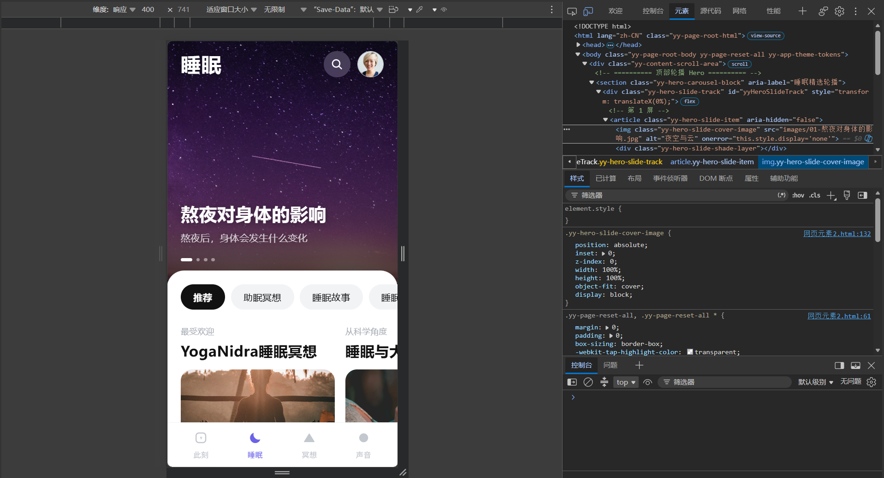
chrome浏览器：
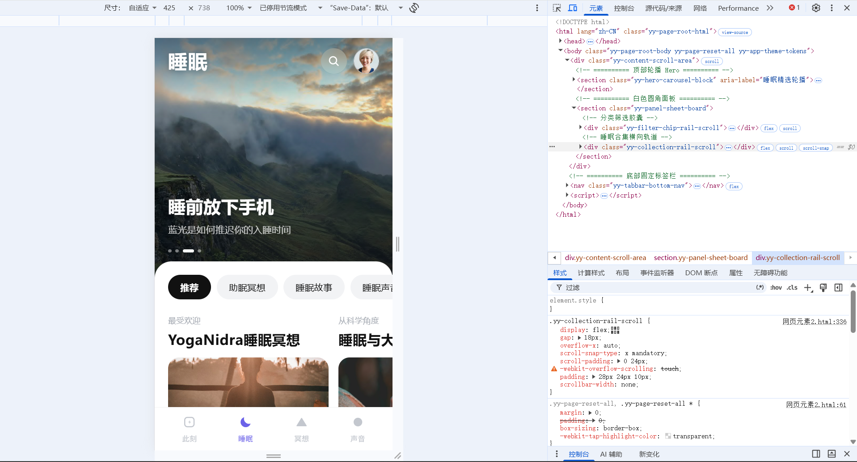

网页元素一发布图（如果有）：
https://playful-bavarois-9c97f3.netlify.app
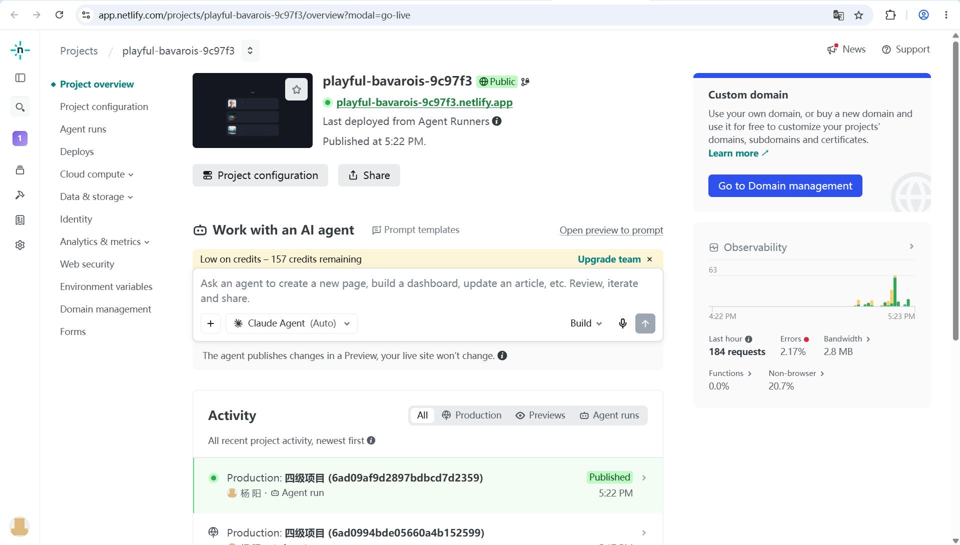

项目总结
这次项目我做的是潮汐 App 的三个移动端页面——首页「此刻」、睡眠页与「日间深度休息」详情页，全部用 HTML、CSS 和原生 JavaScript 完成，从拆解结构、还原视觉到调试交互完整走了一遍流程。
收获最大的是布局与交互部分：横向卡片和两行三列的快捷胶囊用 flex 配合 scroll-snap 做吸附滚动，靠定宽不伸缩的卡片在右侧露出下一张来提示可以滑动；睡眠页的轮播没有借助插件，而是用轨道位移配合定时器、圆点和触摸手势实现；另外也学会了用 CSS 变量统一管理配色、用 100dvh 与安全区适配解决移动端地址栏伸缩和刘海屏问题，素材也一律先下载到本地再引用。
踩过的坑集中在层级和留白上：底部固定栏没预留内边距会压住末尾内容，白色面板用负 margin 压住主图后又把圆点指示器盖住了，横向滚动容器带左右内边距时还得补上 scroll-padding，否则第一列会被裁掉；另外图标字体路径写错会让整屏图标消失——这些问题都是真正打开页面才发现的。
AI 使用方面：本次用 WorkBuddy 作为开发辅助工具，主要用它生成页面结构与样式初稿、提供轮播等交互的实现思路、协助排查样式异常。选题方向、视觉风格、代码的审阅修改和最终效果验证都由我完成，AI 给出的代码也需要逐段核对与调整。

