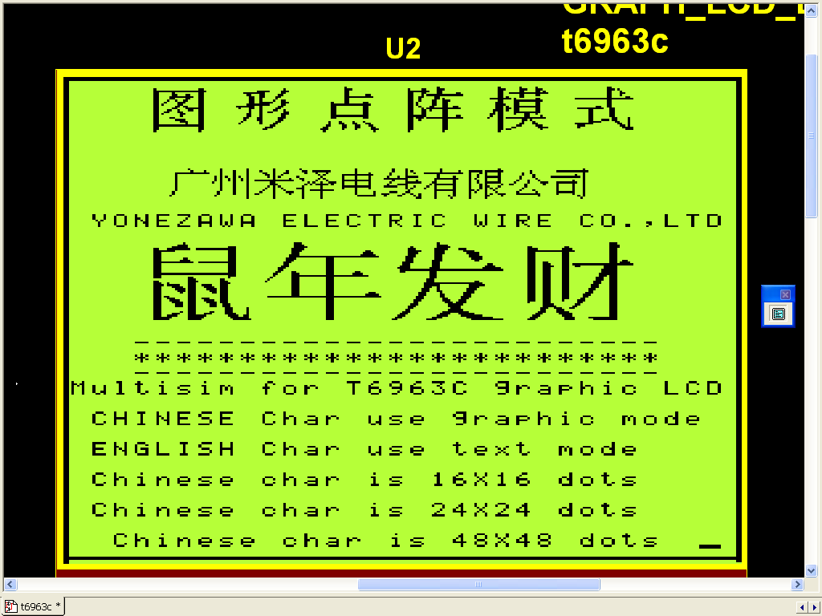
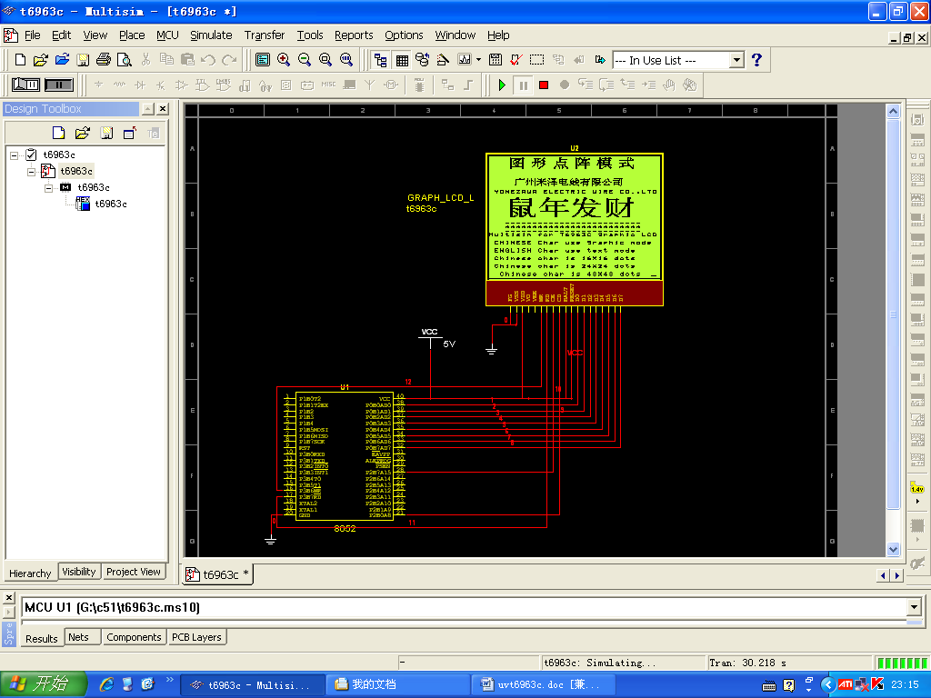
#include<reg51.h>
#include<absacc.h>
#define uchar unsigned char
#define LCDCOM XBYTE [0x7100]
#define LCDDAT XBYTE [0x7000]
/*状态判别STA0和STA1*/
void t_st01(void)
{
do{
ACC=LCDCOM;
}while(ACC&&0x03!=0x03);
}
/*状态判别STA3*/
void t_st3(void)
{
do{
ACC=LCDCOM;
}while(ACC&&0x08!=0x08);
}
/*带一个参数的指令*/
void c1d(char dat1,char com1d)
{
t_st01();
LCDDAT=dat1;
t_st01();
LCDCOM=com1d;
}
/*带两个参数的指令*/
void c2d(char dat21,char dat22,char com2d)
{
t_st01();
LCDDAT=dat21;
t_st01();
LCDDAT=dat22;
t_st01();
LCDCOM=com2d;
}
/*T6963C初始化程序*/
void init(void)
{
t_st01();
LCDCOM=0x9f;
t_st01();
LCDCOM=0xa1;
c2d(0x00,0xf8,0x40); /*text home address*/
c2d(0x20,0x00,0x41); /*text area columns*/
c2d(0x00,0x00,0x42); /*graphic home address*/
c2d(0x20,0x00,0x43); /*graphic area columns*/
c2d(0x00,0xf8,0x22); /*set offset register*/
t_st01();
LCDCOM=0x80;
}
/*英文字符显示*/
void Auto_write(char tl,char th,char code *str)
{
c2d(tl,th,0x24);
t_st01();
LCDCOM=0xb0;
do
{
t_st3();
LCDDAT=((int)*str)-0x20;
str++;
}while(*str!='\0');
t_st3();
LCDCOM=0xb2;
}

void ch16(char chx,char chy,char code *chd16)
{
uchar thx,thy,n;
uchar pushchy=chy;
int chhome;
n=0x00;
do
{
chhome=chx+chy*0x20;
chy++;
thx=chhome%0x100;
thy=chhome/0x100;
c2d(thx,thy,0x24);
c1d(*(chd16+n),0xc0);
if(n==0x0f)
{
chx++;
chy=pushchy;
}
n++;
}while(n<0x020);
}
void ch24(char ch24x,char ch24y,char code *chd24)
{
uchar th24x,th24y,n24;
uchar pushch24y=ch24y;
int ch24home;
n24=0x00;
do
{
ch24home=ch24x+ch24y*0x20;
ch24y++;
th24x=ch24home%0x100;
th24y=ch24home/0x100;
c2d(th24x,th24y,0x24);
c1d(*(chd24+n24),0xc0);

if((n24==23)||(n24==47))
{
ch24x++;
ch24y=pushch24y;
}
n24++;
}while(n24<72);
}
void ch48(char ch48x,char ch48y,char code *chd48)
{
uchar th48x,th48y;
uchar pushch48y=ch48y;
int ch48home,n48,y20;
n48=0x00;
do
{ y20=0x20*ch48y;
ch48home=ch48x+y20;
ch48y++;
th48x=ch48home%0x100;
th48y=ch48home/0x100;
c2d(th48x,th48y,0x24);
c1d(*(chd48+n48),0xc0);

if((n48==47)||(n48==95)||(n48==143)||(n48==191)||(n48==239))
{
ch48x++;
ch48y=pushch48y;
}

n48++;
}while(n48<288);
}
void rec(void)
{
uchar con,ah,al,al1,ah1,con1l,con1h;
int arr,arr1,con1;
for(arr=0x00;arr<8192;arr+=0x20)
{ if(arr==0x00)
{ arr1=0x00;}

arr1=arr-1;
ah=arr/0x100;
al=arr%0x100;
ah1=arr1/0x100;
al1=arr1%0x100;
c2d(al,ah,0x24);
c1d(0xc0,0xc0);
c2d(al1,ah1,0x24);
c1d(0x03,0xc0);
}
for(con=0x00;con<64;con++)
{
c2d(con,0x00,0x24);
c1d(0xff,0xc0);
}

for(con1=0x1f80;con1<0x1fc0;con1++)
{ con1l=con1%0x100;
con1h=con1/0x100;
c2d(con1l,con1h,0x24);
c1d(0xff,0xc0);
}
}

void main()
{
char code *yone=" YONEZAWA ELECTRIC WIRE CO.,LTD";
char code guang[32]={0x01,0x00,0x3F,0x20,0x20,0x20,0x20,0x20,0x20,0x20,0x20,0x20,0x40,0x40,0x80,0x00,0x00,0x84,0xFE,0x00,0x00,0x00,0x00,0x00,0x00,0x00,0x00,0x00,0x00,0x00,0x00,0x00};
char code zhou[32]={0x10,0x10,0x10,0x10,0x54,0x52,0x52,0x90,0x10,0x10,0x10,0x10,0x20,0x20,0x40,0x00,0x04,0x84,0x84,0x84,0xA4,0x94,0x94,0x84,0x84,0x84,0x84,0x84,0x84,0x84,0x04,0x04};
char code mi[32]={0x01,0x21,0x19,0x0D,0x05,0x01,0xFF,0x03,0x03,0x05,0x09,0x11,0x21,0xC1,0x01,0x01,0x00,0x08,0x18,0x20,0x40,0x04,0xFE,0x00,0x80,0x40,0x20,0x10,0x0E,0x04,0x00,0x00};
char code ze[32]={0x40,0x33,0x11,0x00,0x80,0x60,0x21,0x0A,0x15,0x20,0xE0,0x27,0x20,0x20,0x20,0x20,0x00,0xF8,0x10,0xA0,0x40,0xA0,0x10,0x4E,0xF4,0x40,0x40,0xFC,0x40,0x40,0x40,0x40};
char code dian[32]={0x02,0x02,0x02,0x7F,0x42,0x42,0x7F,0x42,0x42,0x7F,0x42,0x02,0x02,0x02,0x01,0x00,0x00,0x00,0x10,0xF8,0x10,0x10,0xF0,0x10,0x10,0xF0,0x10,0x00,0x04,0x04,0xFC,0x00};
char code xian[32]={0x08,0x08,0x10,0x10,0x22,0x7F,0x08,0x10,0x23,0x7C,0x00,0x00,0x1C,0xE0,0x43,0x00,0x40,0x50,0x48,0x40,0x7C,0xC0,0x44,0x7E,0xC0,0x48,0x50,0x20,0x60,0x92,0x0A,0x06};
char code you[32]={0x02,0x02,0xFF,0x04,0x04,0x0F,0x08,0x18,0x2F,0x48,0x88,0x0F,0x08,0x08,0x08,0x08,0x00,0x04,0xFE,0x00,0x10,0xF8,0x10,0x10,0xF0,0x10,0x10,0xF0,0x10,0x10,0x50,0x20};
char code xian1[32]={0x00,0x7D,0x45,0x49,0x49,0x51,0x49,0x49,0x45,0x45,0x45,0x69,0x51,0x41,0x41,0x41,0x08,0xFC,0x08,0x08,0xF8,0x08,0x08,0xF8,0x04,0x88,0x50,0x20,0x10,0x4E,0x84,0x00};
char code gong[32]={0x00,0x00,0x04,0x04,0x08,0x08,0x11,0x21,0xC2,0x02,0x04,0x08,0x10,0x1F,0x00,0x00,0x00,0x80,0x80,0x40,0x40,0x20,0x10,0x0E,0x04,0x00,0x00,0x40,0x20,0xF0,0x10,0x00};
char code si[32]={0x00,0x3F,0x00,0x00,0xFF,0x00,0x00,0x3F,0x20,0x20,0x20,0x20,0x3F,0x20,0x00,0x00,0x08,0xFC,0x08,0x48,0xE8,0x08,0x88,0xC8,0x88,0x88,0x88,0x88,0x88,0x88,0x28,0x10};
char code tu[72]={0x00,0x20,0x3F,0x30,0x30,0x30,0x30,0x31,0x32,0x34,0x30,0x30,0x31,0x33,0x34,0x30,0x30,0x30,0x30,0x30,0x3F,0x30,0x30,0x20,0x00,0x00,0xFF,0x40,0x63,0xFF,0xC3,0x26,0x1C,0x18,0x36,0x63,0x91,0x18,0x0C,0x08,0xC0,0x3C,0x0E,0x02,0xFF,0x00,0x00,0x00,0x00,0x18,0xFC,0x18,0x18,0x98,0x18,0x18,0x18,0x18,0x18,0xF8,0x98,0x18,0x18,0x18,0x18,0x18,0x18,0x18,0xF8,0x18,0x18,0x10};
char code xing[72]={0x00,0x00,0x00,0x0F,0x06,0x03,0x03,0x03,0x03,0x07,0x7F,0x23,0x02,0x02,0x06,0x06,0x0C,0x08,0x10,0x20,0x00,0x00,0x00,0x00,0x00,0x00,0x7C,0xF0,0x30,0x30,0x20,0x21,0x3E,0xFC,0x20,0x20,0x21,0x26,0x20,0x20,0x60,0x60,0x20,0x21,0x03,0x0E,0x18,0x00,0x00,0x10,0x38,0x30,0x60,0xC0,0x80,0x30,0x38,0x30,0x60,0xC0,0x90,0x18,0x38,0x30,0x70,0x60,0xC0,0x80,0x00,0x00,0x00,0x00};
char code dian1[72]={0x00,0x00,0x00,0x00,0x00,0x00,0x00,0x00,0x04,0x07,0x06,0x06,0x06,0x06,0x06,0x07,0x06,0x00,0x08,0x08,0x18,0x30,0x70,0x20,0x20,0x38,0x30,0x30,0x30,0x3F,0x30,0x30,0x30,0xFF,0x00,0x00,0x00,0x00,0x00,0xFF,0x00,0x00,0x84,0xC6,0x63,0x63,0x42,0x00,0x00,0x00,0x00,0x00,0x30,0xF8,0x00,0x00,0x60,0xF0,0x60,0x60,0x60,0x60,0x60,0xE0,0x60,0x00,0x40,0x30,0x18,0x0C,0x0E,0x04};
char code zheng[72]={0x00,0x21,0x3F,0x31,0x31,0x33,0x32,0x32,0x34,0x34,0x32,0x31,0x31,0x31,0x31,0x3F,0x37,0x32,0x30,0x30,0x30,0x30,0x30,0x20,0x04,0x87,0xC6,0x86,0x7F,0x0C,0x0D,0x19,0x19,0x19,0x31,0x7F,0xA1,0x81,0x81,0x81,0x7F,0x01,0x01,0x01,0x01,0x01,0x01,0x01,0x00,0x00,0x00,0x0C,0xFE,0x00,0x00,0xC0,0x80,0x80,0x98,0xFC,0x80,0x80,0x80,0x8C,0xFE,0x80,0x80,0x80,0x80,0x80,0x80,0x00};
char code mu[72]={0x08,0x0E,0x0C,0x0C,0x0C,0x0D,0x7F,0x0C,0x1C,0x1E,0x1D,0x1D,0x3D,0x2C,0x6C,0x4C,0x8D,0x0C,0x0C,0x0C,0x0C,0x0C,0x0D,0x08,0x08,0x0E,0x0C,0xFF,0x0C,0x0C,0xA0,0x3F,0x30,0x30,0x3F,0xB0,0x30,0x3F,0x23,0x03,0xFF,0x06,0x04,0x0C,0x18,0x60,0x80,0x00,0x20,0x38,0x34,0xFE,0x30,0x00,0x30,0xF8,0x30,0x30,0xF0,0x30,0x30,0xF0,0x20,0x08,0xFC,0x80,0x40,0x60,0x38,0x1E,0x08,0x00};
char code shi[72]={0x00,0x00,0x00,0x00,0x00,0x00,0x7F,0x00,0x00,0x00,0x00,0x3F,0x03,0x03,0x03,0x03,0x03,0x03,0x03,0x7F,0x38,0x20,0x00,0x00,0x06,0x07,0x06,0x06,0x06,0x06,0xFF,0x06,0x06,0x06,0x66,0xF3,0x03,0x03,0x03,0x03,0x01,0x1D,0xE0,0x00,0x00,0x00,0x00,0x00,0x00,0x40,0x20,0x30,0x20,0x0C,0xFE,0x00,0x00,0x00,0x00,0x00,0x00,0x00,0x00,0x00,0x84,0x84,0xC4,0x64,0x34,0x1E,0x0E,0x00};
char code su[288]={0x00,0x00,0x00,0x00,0x00,0x00,0x00,0x00,0x00,0x00,0x00,0x00,0x00,0x00,0x00,0x00,0x00,0x00,0x00,0x00,0x00,0x00,0x00,0x00,0x00,0x00,0x00,0x00,0x00,0x00,0x00,0x00,0x00,0x00,0x00,0x00,0x00,0x00,0x00,0x00,0x00,0x00,0x00,0x00,0x00,0x00,0x00,0x00,0x00,0x00,0x00,0x00,0x00,0x31,0x3F,0x38,0x38,0x38,0x38,0x38,0x3F,0x38,0x38,0x38,0x38,0x38,0x3F,0x38,0x38,0x00,0x30,0x39,0x3D,0x38,0x38,0x38,0x38,0x38,0x3B,0x39,0x38,0x38,0x38,0x38,0x38,0x38,0x38,0x38,0x39,0x3F,0x3F,0x7E,0x78,0x30,0x00,0x00,0x00,0x00,0x04,0x1E,0x7E,0xFF,0xC0,0x00,0x00,0x00,0x06,0x0F,0xFF,0x00,0x00,0x00,0x00,0x00,0xFF,0x00,0x01,0x01,0x01,0x01,0xF1,0x79,0x3D,0x1D,0x09,0x01,0x01,0xC1,0xF1,0x79,0x39,0x39,0x01,0x01,0x09,0x71,0xE1,0x81,0x01,0x01,0x00,0x00,0x00,0x00,0x00,0x00,0x00,0x00,0x00,0x3F,0x00,0x00,0x00,0x00,0x00,0x00,0x9F,0x00,0x00,0x00,0x00,0x00,0xFF,0x00,0x80,0xC0,0xE0,0xC0,0xCF,0xC7,0xC3,0xC1,0xC0,0xC0,0xC0,0xCE,0xC7,0xC3,0xC1,0xC1,0xC0,0xC0,0xC1,0xC7,0xFC,0xF8,0xF0,0xE0,0xC0,0x00,0x00,0x00,0x00,0x00,0x00,0x00,0x03,0xFF,0x03,0x03,0x03,0x03,0x03,0x03,0xFF,0x03,0x03,0x03,0x03,0x03,0xFF,0x03,0x02,0x18,0x1C,0x1E,0x1C,0x9C,0xDC,0xDC,0xDC,0x1C,0x1C,0x1C,0x9C,0xDC,0xCE,0xCE,0x07,0x07,0x87,0x07,0x03,0x01,0x00,0x00,0x00,0x00,0x00,0x00,0x00,0x00,0x00,0x00,0x80,0x80,0x80,0x80,0x80,0x80,0x80,0x80,0x80,0x80,0x80,0x80,0x80,0x80,0x80,0x80,0x00,0x00,0x00,0x00,0x00,0x00,0x00,0x00,0x00,0x00,0x00,0x00,0x00,0x00,0x00,0x00,0x04,0x04,0x04,0x84,0xCC,0xFC,0xFE,0x7E,0x3F,0x0F,0x00,0x00};
char code nian[288]={0x00,0x00,0x00,0x00,0x00,0x00,0x00,0x00,0x00,0x00,0x00,0x00,0x00,0x00,0x00,0x00,0x00,0x00,0x01,0x01,0x02,0x04,0x08,0x00,0x00,0x00,0x00,0x00,0x00,0x00,0x07,0x00,0x00,0x00,0x00,0x00,0x00,0x00,0x00,0x00,0x00,0x00,0x00,0x00,0x00,0x00,0x00,0x00,0x00,0x00,0x01,0x01,0x01,0x03,0x03,0x03,0x07,0x07,0x0F,0x0E,0x1C,0x18,0x38,0x70,0x60,0xC3,0x83,0x03,0x03,0x03,0x03,0x03,0x03,0x03,0x03,0x03,0x03,0x03,0xFF,0x00,0x00,0x00,0x00,0x00,0x00,0x00,0x00,0x00,0x00,0x00,0x00,0x00,0x00,0x00,0x00,0x00,0x00,0x00,0xC0,0xE0,0xF0,0xE0,0xC0,0x80,0x80,0xFF,0x00,0x00,0x00,0x00,0x00,0x00,0x00,0x00,0x80,0xFF,0x80,0x80,0x80,0x80,0x80,0x80,0x80,0x80,0x80,0x80,0xFF,0x00,0x00,0x00,0x00,0x00,0x00,0x00,0x00,0x00,0x00,0x00,0x00,0x00,0x00,0x00,0x00,0x00,0x00,0x00,0x00,0x00,0x00,0x00,0x00,0x00,0x00,0xFF,0x1C,0x1C,0x1C,0x1C,0x1C,0x1C,0x1C,0x1C,0x1C,0xFF,0x1C,0x1C,0x1C,0x1C,0x1C,0x1C,0x1C,0x1C,0x1C,0x1C,0xFF,0x1C,0x1C,0x1C,0x1C,0x1C,0x1C,0x1C,0x1C,0x1C,0x1C,0x1C,0x1C,0x1C,0x1C,0x1C,0x18,0x00,0x00,0x00,0x00,0x00,0x00,0x00,0x00,0x00,0x00,0xFF,0x00,0x00,0x00,0x00,0x00,0x00,0x00,0x03,0x07,0xFF,0x00,0x00,0x00,0x00,0x00,0x00,0x00,0x00,0x00,0x00,0xFF,0x00,0x00,0x00,0x00,0x00,0x00,0x00,0x00,0x00,0x00,0x00,0x00,0x00,0x00,0x00,0x00,0x00,0x00,0x00,0x00,0x00,0x00,0x00,0x30,0x78,0xFC,0xFE,0x00,0x00,0x00,0x00,0x00,0x00,0x00,0x00,0x80,0xE0,0x00,0x00,0x00,0x00,0x00,0x00,0x00,0x00,0x1C,0x3E,0xFF,0x00,0x00,0x00,0x00,0x00,0x00,0x00,0x00,0x00,0x00,0x00,0x00,0x00,0x00,0x00,0x00,0x00};
char code fa[288]={0x00,0x00,0x00,0x00,0x00,0x00,0x00,0x00,0x00,0x00,0x00,0x00,0x00,0x00,0x01,0x03,0x01,0x01,0x00,0x00,0x00,0x00,0x00,0x00,0x00,0x00,0x00,0x00,0x00,0x00,0x00,0x00,0x00,0x00,0x00,0x00,0x00,0x00,0x00,0x01,0x03,0x07,0x0C,0x18,0x30,0x20,0x00,0x00,0x00,0x00,0x00,0x00,0x10,0x38,0x3E,0x3C,0x38,0x78,0x70,0x70,0xF0,0xE0,0xE0,0xE0,0xFF,0x80,0x00,0x00,0x00,0x00,0x00,0x00,0x00,0x00,0x01,0x01,0x03,0x03,0x07,0x07,0x0E,0x0C,0x1C,0x38,0x30,0x60,0xE0,0xC0,0x80,0x00,0x00,0x01,0x0F,0x7C,0x00,0x00,0x00,0x00,0x04,0x07,0x07,0x0F,0x0F,0x0F,0x0E,0x0E,0x0E,0x1E,0x1C,0x1C,0x1C,0x3C,0xFF,0x38,0x38,0x38,0x38,0x70,0x70,0xFF,0xFC,0xE4,0xC4,0xC6,0x82,0x83,0x03,0x01,0x01,0x00,0x00,0x00,0x00,0x00,0x01,0x03,0x07,0x1E,0x78,0xE0,0x80,0x00,0x00,0x00,0x00,0x00,0x00,0x80,0xC0,0x87,0x01,0x00,0x00,0x00,0x00,0x00,0x00,0x00,0x00,0x00,0xFF,0x00,0x00,0x00,0x00,0x00,0x00,0xFF,0x00,0x00,0x00,0x00,0x01,0x01,0x03,0x83,0xC7,0xEF,0x7E,0x7C,0x3C,0x7E,0xFF,0xC7,0x83,0x00,0x00,0x00,0x00,0x00,0x00,0x00,0x00,0x00,0x00,0x00,0x00,0x00,0xE0,0xF8,0x78,0x7C,0x3C,0x18,0x00,0x00,0x01,0x03,0xFF,0x00,0x00,0x00,0x00,0x00,0x18,0xFC,0x7E,0x78,0xF0,0xE0,0xE0,0xC0,0xC0,0x80,0x00,0x00,0x00,0x00,0x00,0x00,0x80,0xE0,0xFC,0xFF,0x3F,0x0F,0x03,0x00,0x00,0x00,0x00,0x00,0x00,0x00,0x00,0x00,0x00,0x00,0x00,0x00,0x00,0x00,0x00,0xC0,0xE0,0xF8,0xFC,0x00,0x00,0x00,0x00,0x00,0x00,0x00,0x00,0x00,0x00,0x00,0x00,0x00,0x00,0x00,0x00,0x00,0x00,0x00,0x00,0x00,0x00,0x00,0x00,0xC0,0xFC,0xF0,0xC0,0x00,0x00,0x00};
char code chai[288]={0x00,0x00,0x00,0x00,0x01,0x01,0x01,0x01,0x01,0x01,0x01,0x01,0x01,0x01,0x01,0x01,0x01,0x01,0x01,0x01,0x01,0x01,0x01,0x01,0x01,0x01,0x01,0x01,0x01,0x01,0x01,0x01,0x01,0x01,0x00,0x00,0x00,0x00,0x00,0x00,0x00,0x00,0x01,0x03,0x06,0x08,0x00,0x00,0x00,0x00,0x00,0x00,0x80,0xE0,0xFF,0xC0,0xC0,0xC0,0xC0,0xC0,0xC6,0xC7,0xC7,0xC7,0xC7,0xC7,0xC7,0xC7,0xC7,0xC7,0xC7,0xC7,0xC7,0xC7,0xC7,0xC7,0xC7,0xC7,0xC7,0xC7,0xC7,0x07,0x07,0x07,0x0E,0x0C,0x1C,0x38,0x70,0xE0,0xC0,0x00,0x00,0x00,0x00,0x00,0x00,0x00,0x00,0x00,0x06,0x0F,0xFF,0x0E,0x0E,0x0E,0x0E,0x0E,0x0E,0x0E,0x8E,0x0E,0x0E,0x0E,0x0E,0x0E,0x0E,0x0E,0x0E,0x0E,0x0E,0x0E,0x0E,0x0E,0x0E,0x0E,0x0E,0x0E,0x08,0x00,0x80,0xC0,0x71,0x38,0x3E,0x1F,0x0F,0x07,0x07,0x03,0x00,0x00,0x00,0x00,0x00,0x00,0x00,0x00,0x00,0x00,0x80,0x00,0x00,0x00,0x00,0x00,0x00,0xFF,0x60,0x00,0x00,0x00,0x00,0x00,0x00,0x00,0x00,0x00,0x01,0x01,0x03,0x03,0x07,0x0E,0x0C,0x18,0x38,0x30,0x60,0xC0,0x80,0x00,0x00,0x00,0x00,0x83,0x80,0x00,0x00,0x00,0x00,0x00,0x00,0x00,0x03,0x03,0x03,0x03,0x03,0x03,0x03,0x03,0x03,0x03,0x03,0xFF,0x0F,0x0F,0x73,0xE3,0xE3,0xC3,0xC3,0x83,0x03,0x03,0x03,0x03,0x03,0x03,0x03,0x03,0x03,0x03,0x03,0x03,0x03,0x03,0xFF,0xFF,0x3F,0x1F,0x0E,0x00,0x00,0x00,0x00,0x80,0xC0,0xC0,0x80,0x80,0x80,0x80,0x80,0x80,0x98,0xBC,0xFE,0x80,0x80,0x80,0x80,0x80,0x80,0x80,0x80,0x80,0x80,0x80,0x80,0x80,0x80,0x80,0x80,0x80,0x80,0x80,0x80,0x80,0x80,0x80,0x80,0x80,0x80,0x80,0x80,0x80,0x80,0x00,0x00,0x00,0x00};

init( );
c2d(0x1e,0x1e,0x21);
rec();
Auto_write(0x20,0xf9,yone);
ch48(0x03,0x55,su);
ch48(0x09,0x55,nian);
ch48(0x0f,0x55,fa);
ch48(0x15,0x55,chai);
Auto_write(0x60,0xfa," ------------------------- ");
Auto_write(0x20,0xfa," ------------------------- ");
Auto_write(0x40,0xfa," ************************* ");
Auto_write(0x80,0xfa,"Multisim for T6963C graphic LCD");
Auto_write(0xc0,0xfa," CHINESE Char use graphic mode");
Auto_write(0x00,0xfb," ENGLISH Char use text mode");
Auto_write(0x40,0xfb," Chinese char is 16X16 dots");
Auto_write(0x80,0xfb," Chinese char is 24X24 dots");
Auto_write(0xc0,0xfb," Chinese char is 48X48 dots");
ch16(0x05,0x30,guang);
ch16(0x07,0x30,zhou);
ch16(0x09,0x30,mi);
ch16(0x0b,0x30,ze);
ch16(0x0d,0x30,dian);
ch16(0x0f,0x30,xian);
ch16(0x11,0x30,you);
ch16(0x13,0x30,xian1);
ch16(0x15,0x30,gong);
ch16(0x17,0x30,si);

ch24(0x04,0x05,tu);
ch24(0x08,0x05,xing);
ch24(0x0c,0x05,dian1);
ch24(0x10,0x05,zheng);
ch24(0x14,0x05,mu);
ch24(0x18,0x05,shi);

while(1);

}

