目 录
第一章 L298N电机驱动模块图···························································2
1.1 实物图·············································································2
1.2 原理图·············································································2
1.3 各种电机实物接线图·································································2
1.4 各种电机原理图·····································································4
1.5 模块接口说明·······································································4

第一章 L298N电机驱动模块图
1.1 实物图
图片拍的不清晰，没有数码相机，我用QQ摄像头拍的。
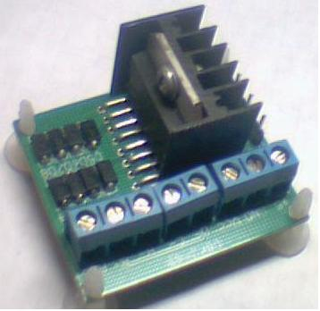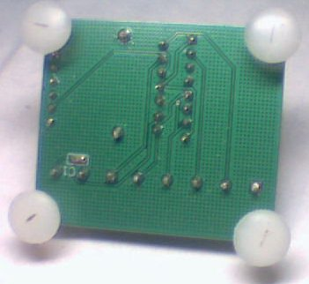
正面 背面

1.2 原理图
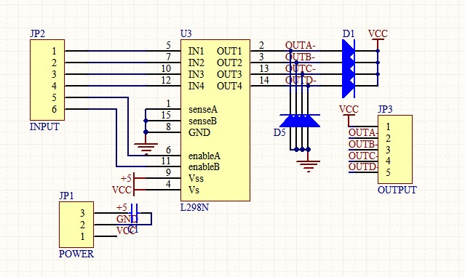

1.3 各种电机实物接线图
直流电机实物接线图
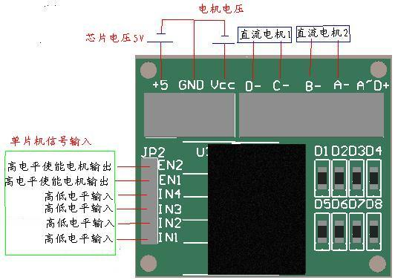

4相步进电机实物接线图
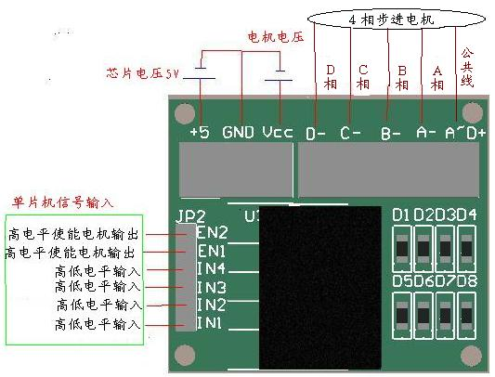

3相步进电机实物接线图
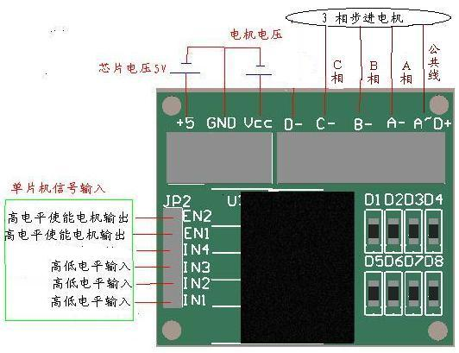
  - 各种电机原理图
直流电机原理图 步进电机原理图
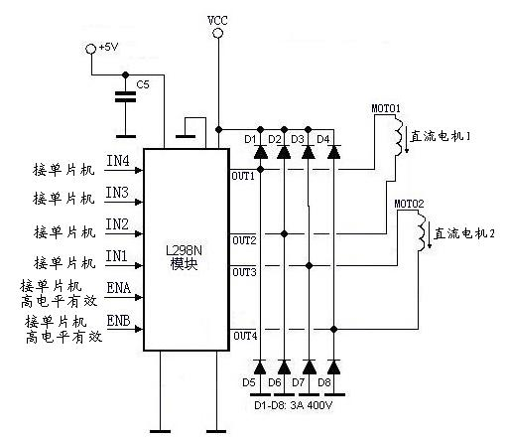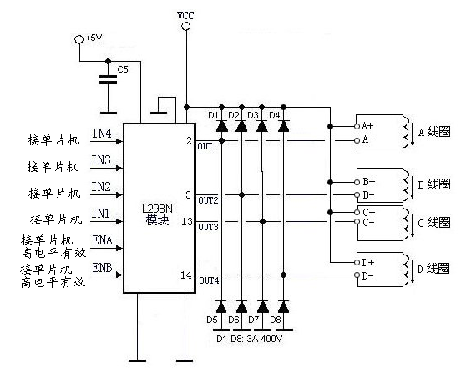
1.5 模块接口说明
+5V：芯片电压5V。
VCC：电机电压，最大可接50V。
GND：共地接法。
A-~D-：输出端，接电机。
A~D+ ：为步进电机公共端，模块上接了VCC。
EN1、EN2：高电平有效，EN1、EN2分别为 IN1和IN2、IN3和IN4的使能端。
IN1~ IN4：输入端，输入端电平和输出端电平是对应的。

