ASSIGNMENT 1
SOFTWARE ENGINEERING ASSIGNMENT
MODULE 1 : SDLC
1) What is software? What is software engineering?
Ans. Software is a set of instructions, data or programs used to operate computers and execute specific tasks. It is the opposite of hardware, which describes the physical aspects of a computer. Software is a generic term used to refer to applications, scripts and programs that run on a device.
Software engineering is defined as a process of analyzing user requirements and then designing, building, and testing software application which will satisfy those requirements.
2) Explain types of software.
Ans. Among the various categories of software, the most common types include the following:
Application software: The most common type of software, application software is a computer software package that performs a specific function for a user, or in some cases, for another application. An application can be self-contained, or it can be a group of programs that run the application for the user. Examples of modern applications include office suites, graphics software, databases and database management programs, web browsers, word processors, software development tools, image editors and communication platforms.
System software: These software programs are designed to run a computer's application programs and hardware. System software coordinates the activities and functions of the hardware and software. In addition, it controls the operations of the computer hardware and provides an environment or platform for all the other types of software to work in. The OS is the best example of system software; it manages all the other computer programs. Other examples of system software include the firmware, computer language translators and system utilities.
Driver software: Also known as device drivers, this software is often considered a type of system software. Device drivers control the devices and peripherals connected to a computer, enabling them to perform their specific tasks. Every device that is connected to a computer needs at least one device driver to function. Examples include software that comes with any nonstandard hardware, including special game controllers, as well as the software that enables standard hardware, such as USB storage devices, keyboards, headphones and printers.
Middleware: The term middleware describes software that mediates between application and system software or between two different kinds of application software. For example, middleware enables Microsoft Windows to talk to Excel and Word. It is also used to send a remote work request from an application in a computer that has one kind of OS, to an application in a computer with a different OS. It also enables newer applications to work with legacy ones.
Programming software: Computer programmers use programming software to write code. Programming software and programming tools enable developers to develop, write, test and debug other software programs. Examples of programming software include assemblers, compilers, debuggers and interpreters.
3) What is SDLC? Explain each phase of SDLC.
Ans. The Software Development Life Cycle (SDLC) is a process used by software development organizations to plan, design, develop, test, deploy, and maintain software applications.
SDLC (Software Development Life Cycle) is used in Every Software Development Company because it is the root of the Development Cycle, if that model would not exist in the world, firstly no software can build secondly if any how it would be made, it’s not going to succeed it has no use, because of no maintenance, but Luckily SDLC model exist in Tech world But why we need it Actually!
The SDLC typically includes the following phases:
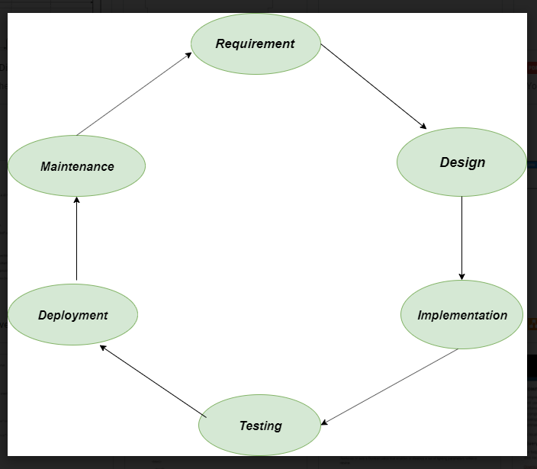
1. Requirements gathering and analysis: This phase involves gathering information about the software requirements from stakeholders, such as customers, end-users, and business analysts.
2. Design: In this phase, the software design is created, which includes the overall architecture of the software, data structures, and interfaces. It has two steps:
High-level design (HLD): It gives the architecture of software products.
Low-level design (LLD): It describes how each and every feature in the product should work and every component.
3. Implementation or coding: The design is then implemented in code, usually in several iterations, and this phase is also called as Development.
things you need to know about this phase:
This is the longest phase in SDLC model.
This phase consists of Front end + Middleware + Back-end.
In front-end: Development of coding is done even SEO settings are done.
In Middleware: They connect both the front end and back end.
In the back-end: A database is created.
4. Testing: The software is thoroughly tested to ensure that it meets the requirements and works correctly.
5. Deployment: After successful testing, The software is deployed to a production environment and made available to end-users.
6. Maintenance: This phase includes ongoing support, bug fixes, and updates to the software.
There are different methodologies that organizations can use to implement the SDLC, such as Waterfall, Agile, Scrum, V-Model and DevOps.
4) What is DFD? Create a DFD diagram on Flipkart.
Ans. A picture is worth a thousand words. A Data Flow Diagram (DFD) is a traditional way to visualize the information flows within a system. A neat and clear DFD can depict a good amount of the system requirements graphically. It can be manual, automated, or a combination of both.
It shows how information enters and leaves the system, what changes the information and where information is stored. The purpose of a DFD is to show the scope and boundaries of a system as a whole. It may be used as a communications tool between a systems analyst and any person who plays a part in the system that acts as the starting point for redesigning a system.
It is usually beginning with a context diagram as level 0 of the DFD diagram, a simple representation of the whole system. To elaborate further from that, we drill down to a level 1 diagram with lower-level functions decomposed from the major functions of the system. This could continue to evolve to become a level 2 diagram when further analysis is required. Progression to levels 3, 4 and so on is possible but anything beyond level 3 is not very common. Please bear in mind that the level of detail for decomposing a particular function depending on the complexity that function.
5) What is Flow chart? Create a flowchart to make addition of two numbers.
Ans. A flowchart is a diagram that illustrates the steps, sequences, and decisions of a process or workflow. While there are many different types of flowcharts, a basic flowchart is the simplest form of a process map. It’s a powerful tool that can be used in multiple fields for planning, visualizing, documenting, and improving processes.
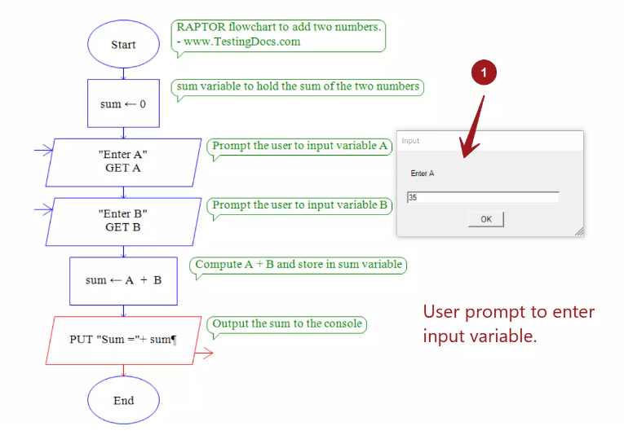
6) What is Use case Diagram? Create a use-case on bill payment on paytm.
Ans. A UML use case diagram is the primary form of system/software requirements for a new software program underdeveloped. Use cases specify the expected behavior (what), and not the exact method of making it happen (how). Use cases once specified can be denoted both textual and visual representation (i.e. use case diagram). A key concept of use case modeling is that it helps us design a system from the end user's perspective. It is an effective technique for communicating system behavior in the user's terms by specifying all externally visible system behavior.
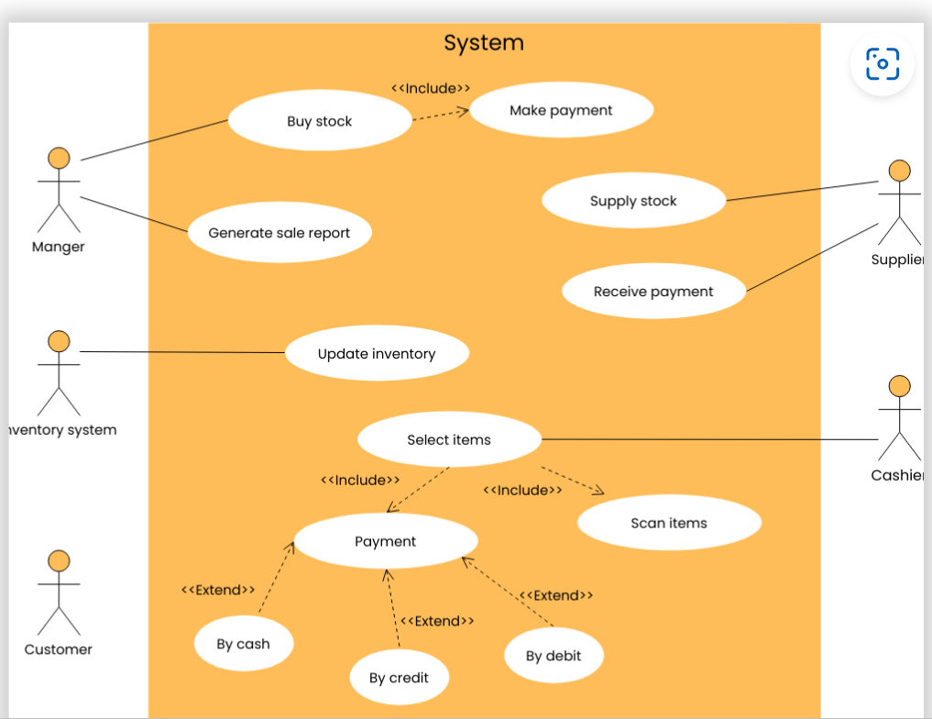

MODULE 2 : HTML
1) Define the terms: Website, Webpage, Web browser, Web server, HTML, CSS.
Ans. Website : A group of World Wide Web pages usually containing hyperlinks to each other and made available online by an individual, company, educational institution, government, or organization.
Webpage : A web page or webpage is a document, commonly written in HTML, that is viewed in an Internet browser. A web page can be accessed by entering a URL address into a browser's address bar. A web page may contain text, graphics, and hyperlinks to other web pages and files.
Web browser : A software application used to access information on the World Wide Web is called a Web Browser.
Webserver : A web server is a computer that runs websites. It's a computer program that distributes web pages as they are requisitioned. The basic objective of the web server is to store, process and deliver web pages to the users. This intercommunication is done using Hypertext Transfer Protocol (HTTP). These web pages are mostly static content that includes HTML documents, images, style sheets, test etc. Apart from HTTP, a web server also supports SMTP (Simple Mail transfer Protocol) and FTP (File Transfer Protocol) protocol for emailing and for file transfer and storage.
HTML : HTML, or Hypertext Markup Language, is a markup language for the web that defines the structure of web pages.
CSS : CSS pseudo-class represents any element that has been defined. This includes any standard element built in to the browser, and custom elements that have been successfully defined.

2) Create a webpage to show “This is my first HTML page”.
Ans. 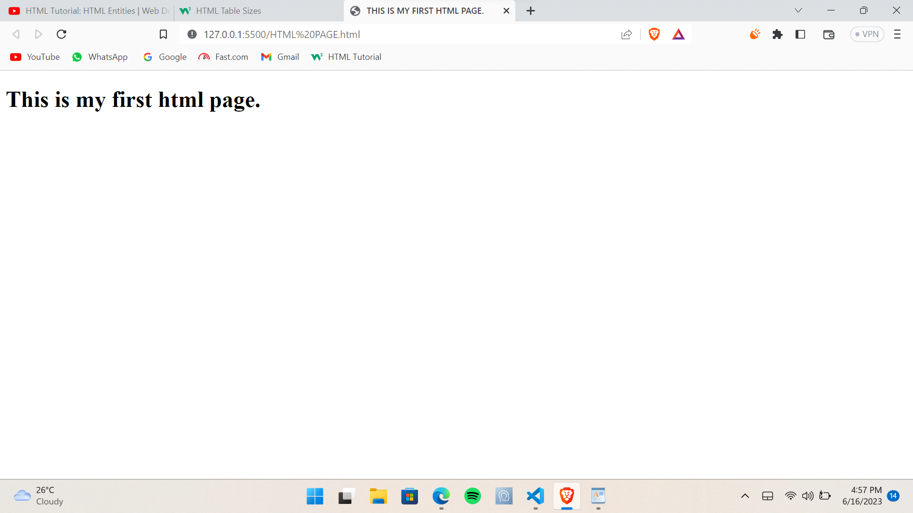
3) Display top 10 IT companies list in html webpage.
Ans.
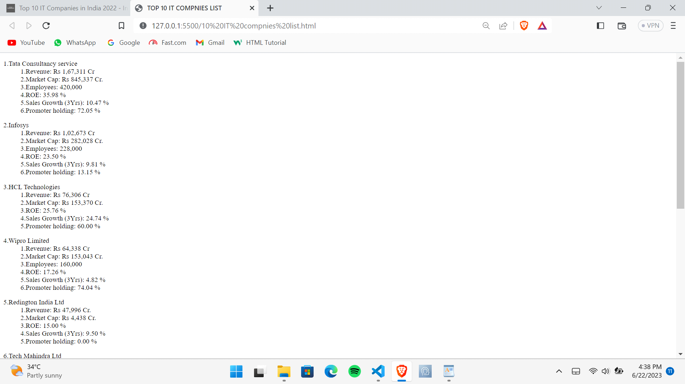
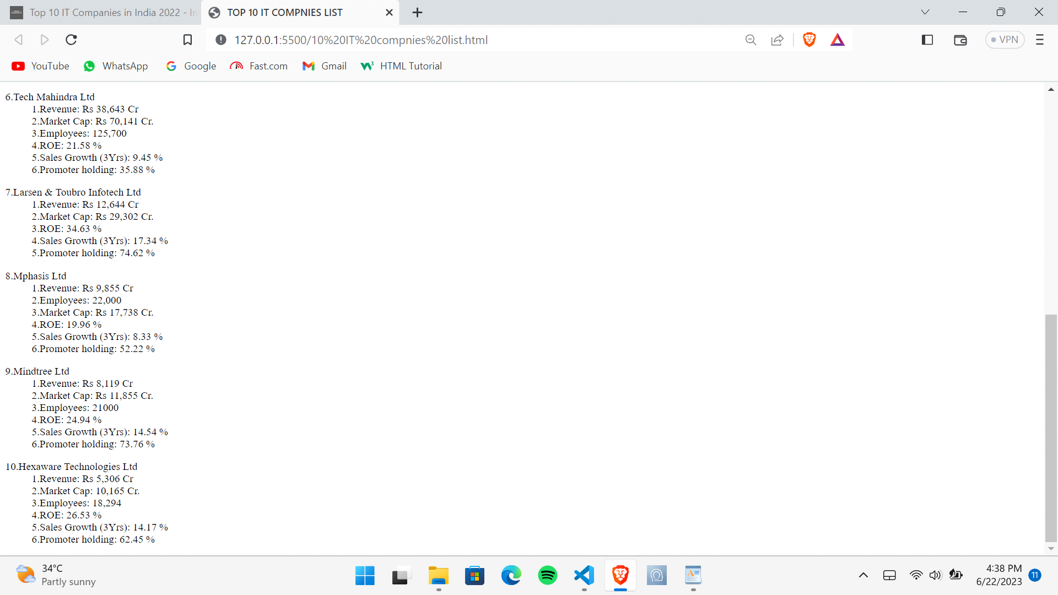
4) Create a dropdown list .
Ans.
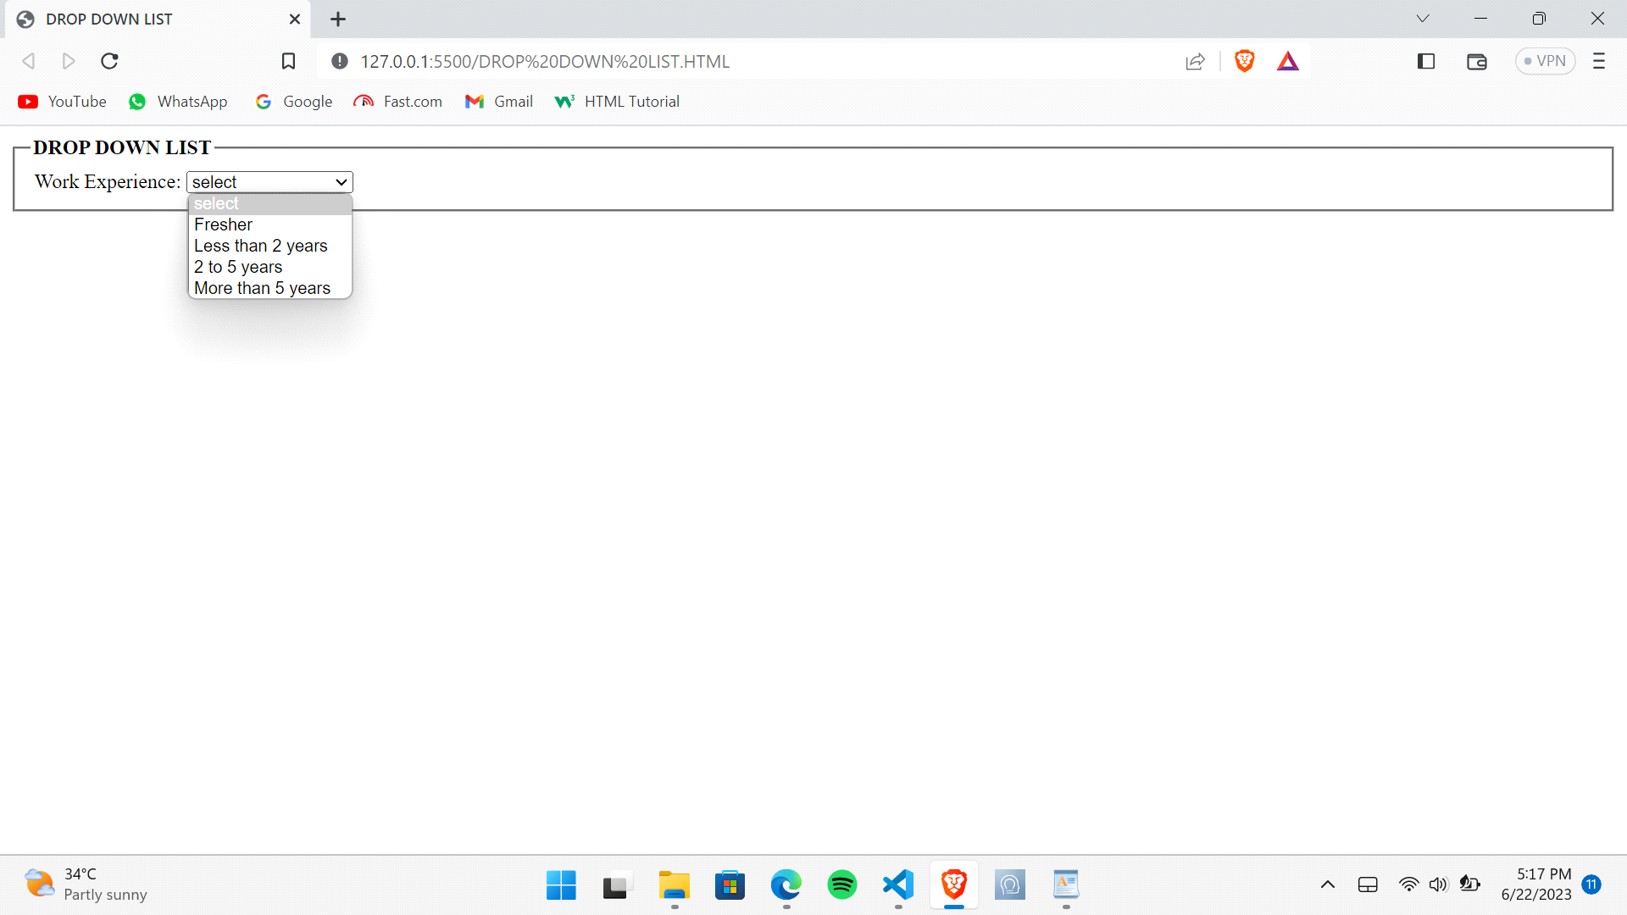
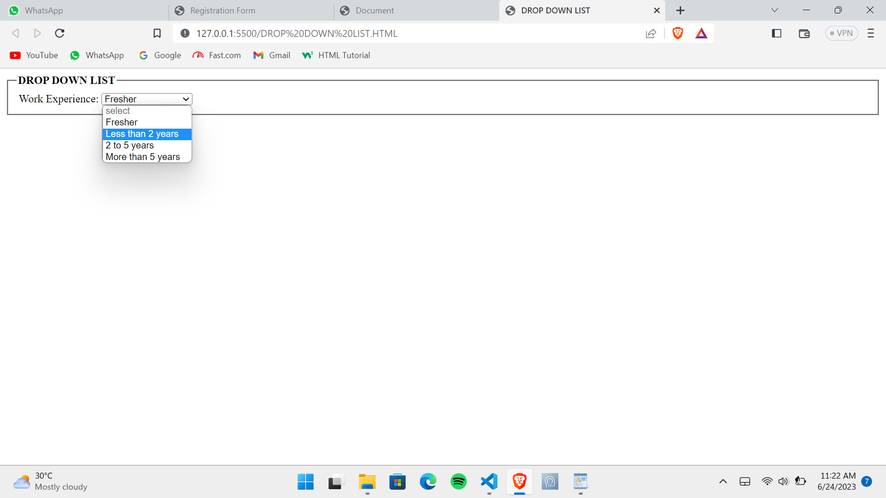
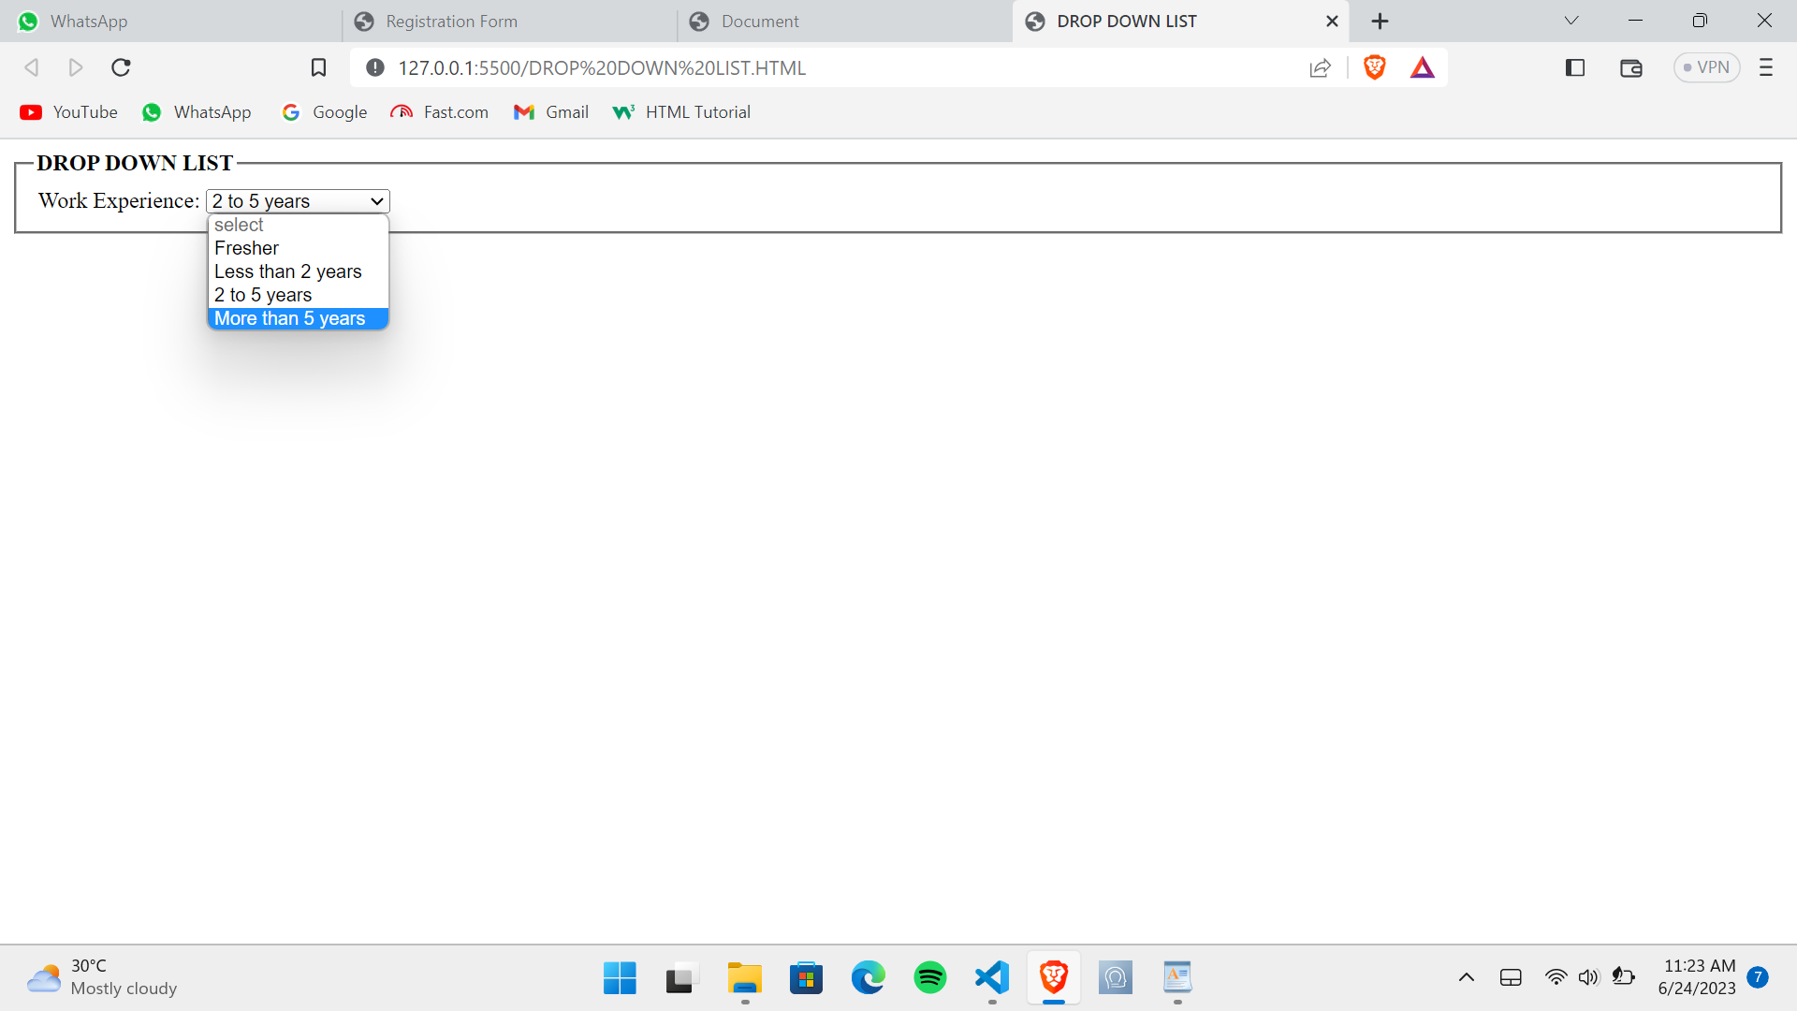

5) Create a Table Of college Management system using row span & col span.
Ans.
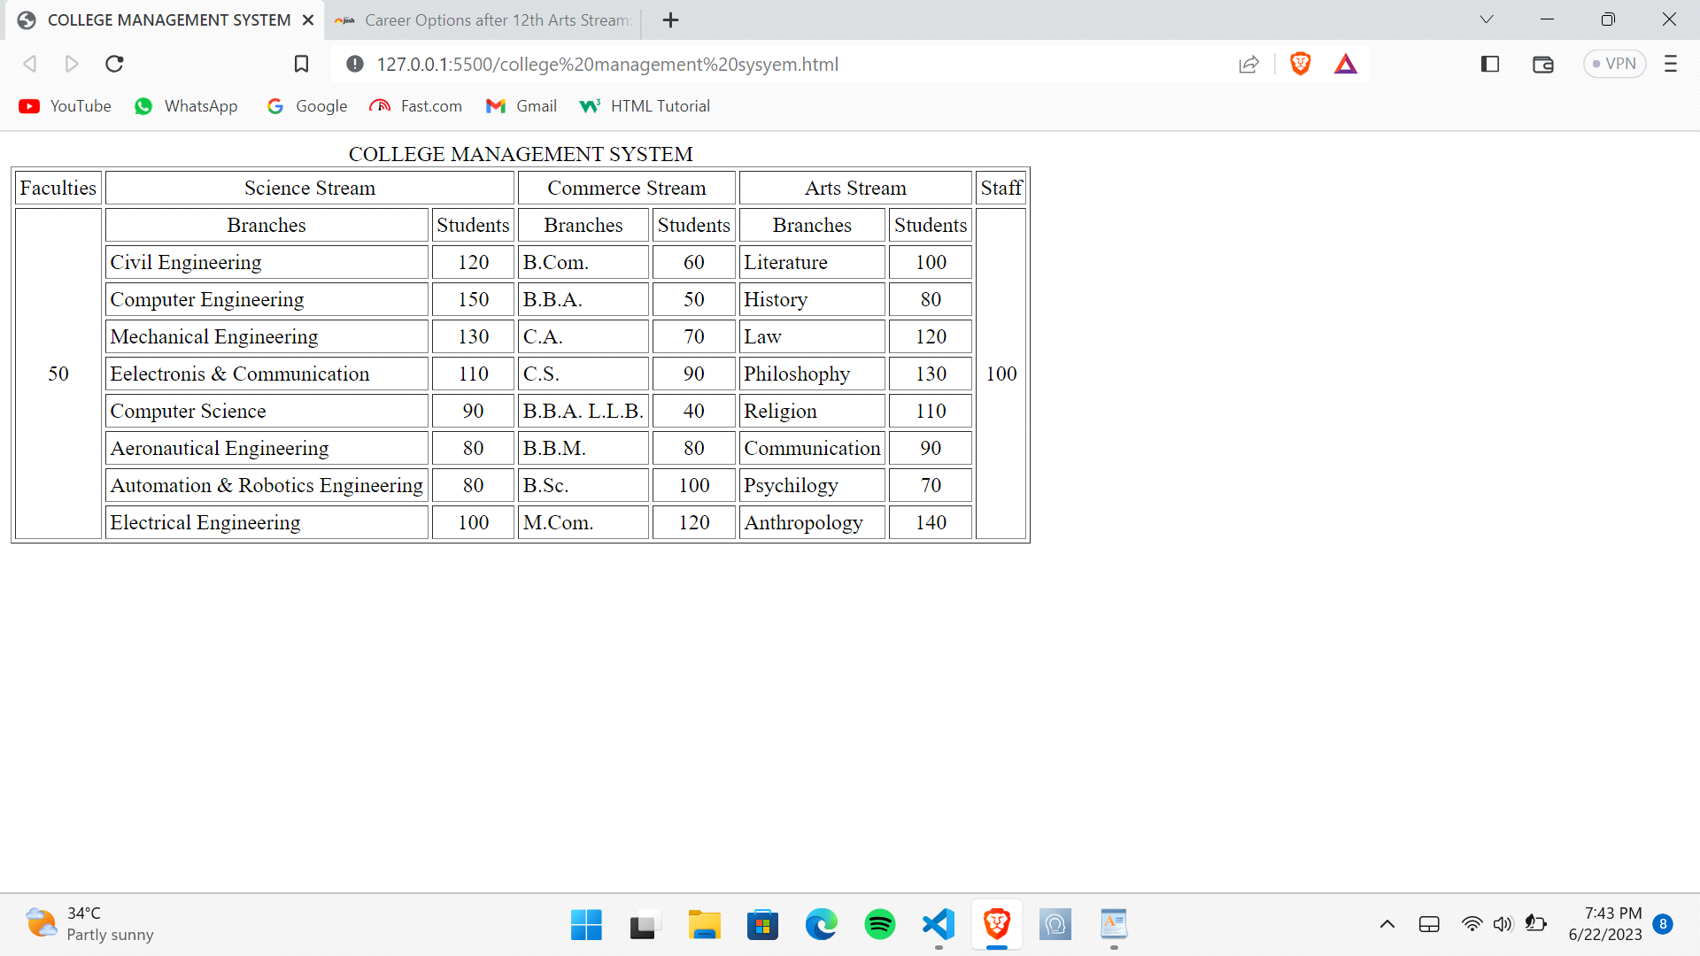
6) Create below table using HTML table tags.
Ans.
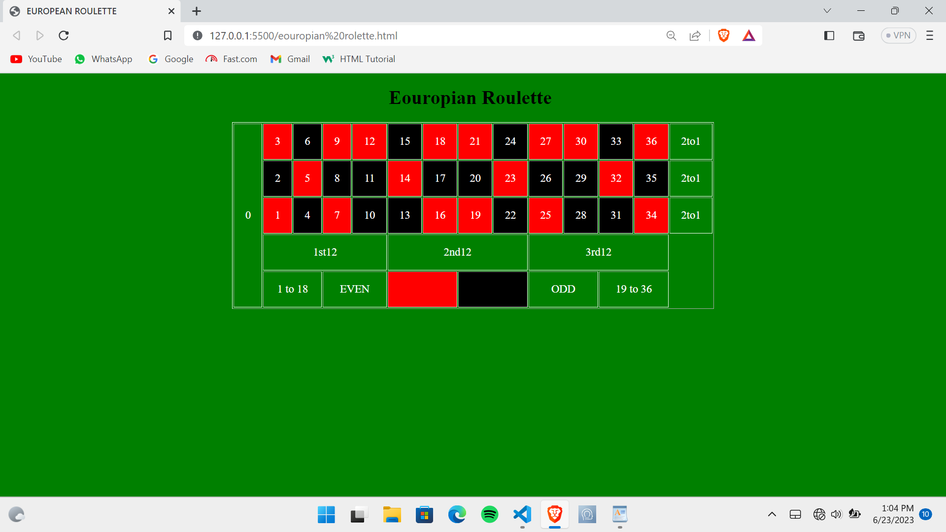

7) Create Registration form using HTML, CSS .
Ans.
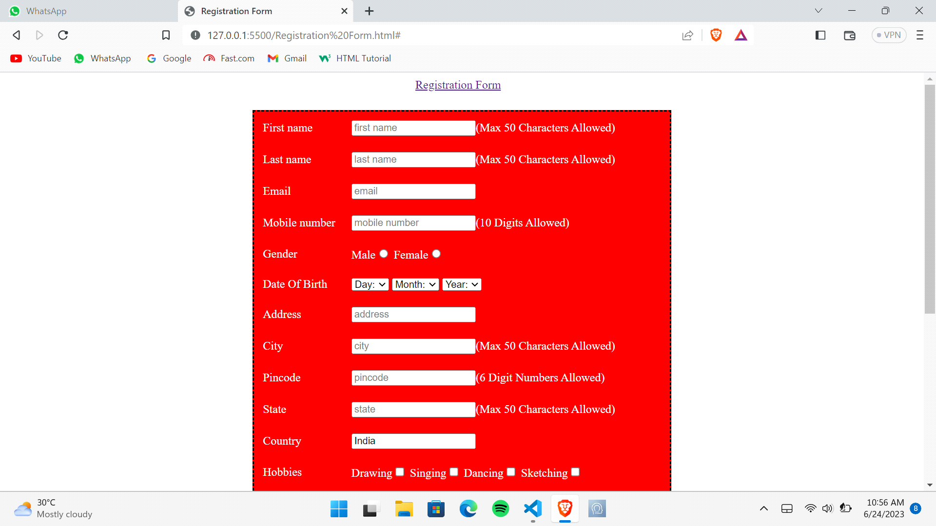
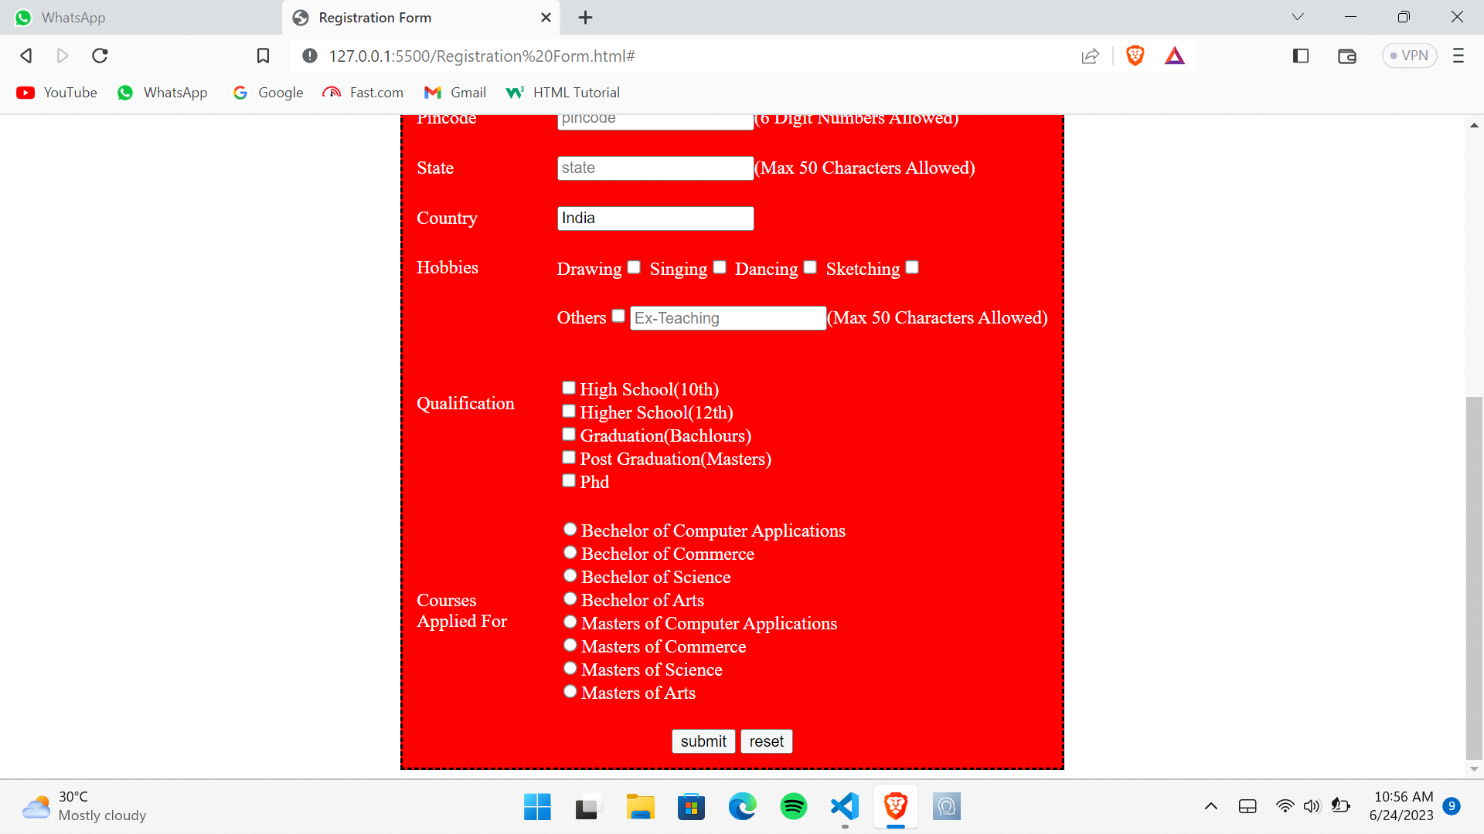
8) In how many ways can a CSS be integrated as a web page?
Ans. CSS can be integrated in three ways from as a web page.
9) Create simple three pages using External CSS, Internal CSS, and Inline CSS.
Ans. Inline CSS :
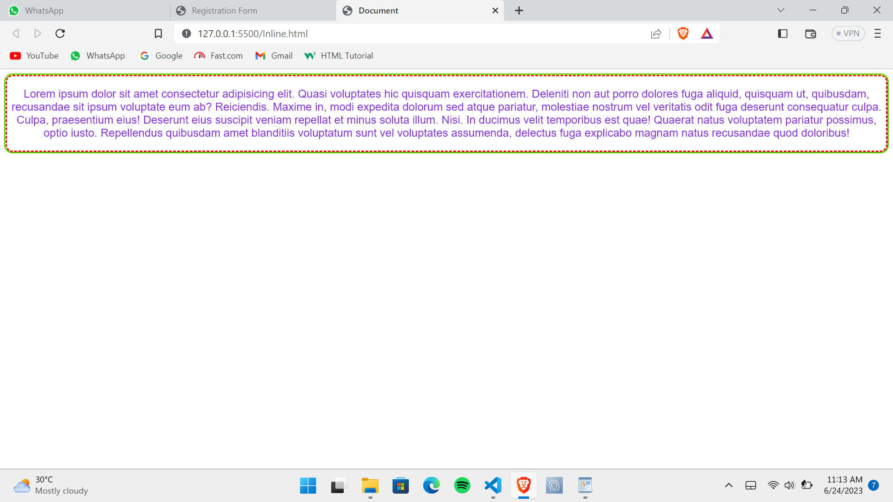

Internal CSS:
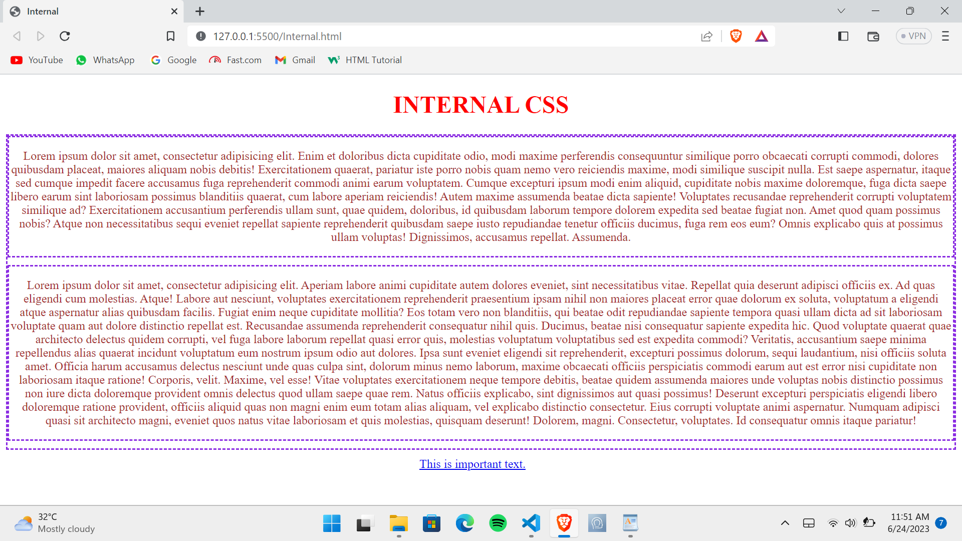
External CSS :
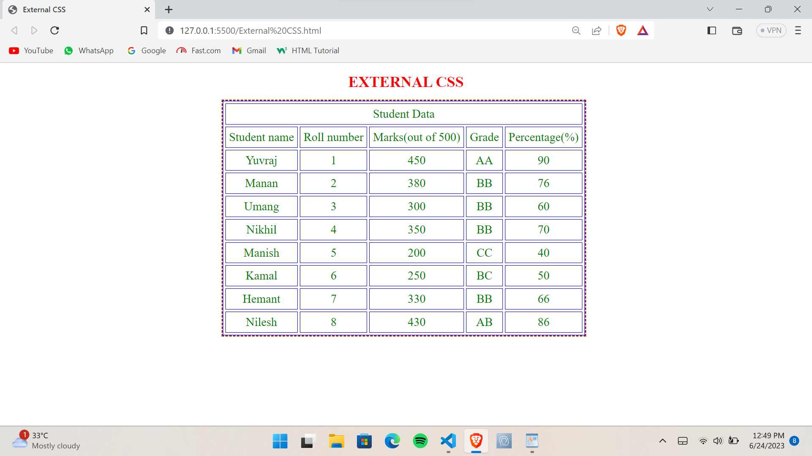
10) Create below page using HTML CSS.
Ans.
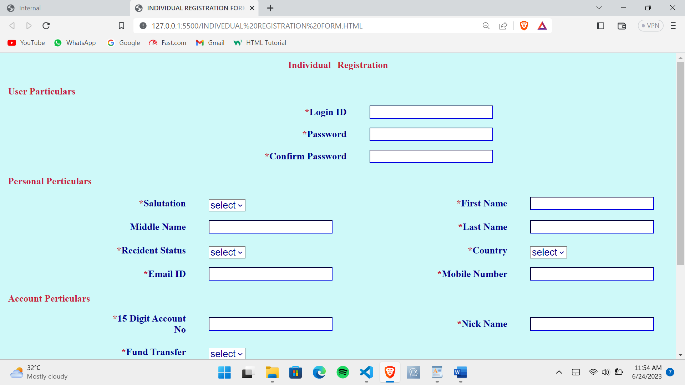
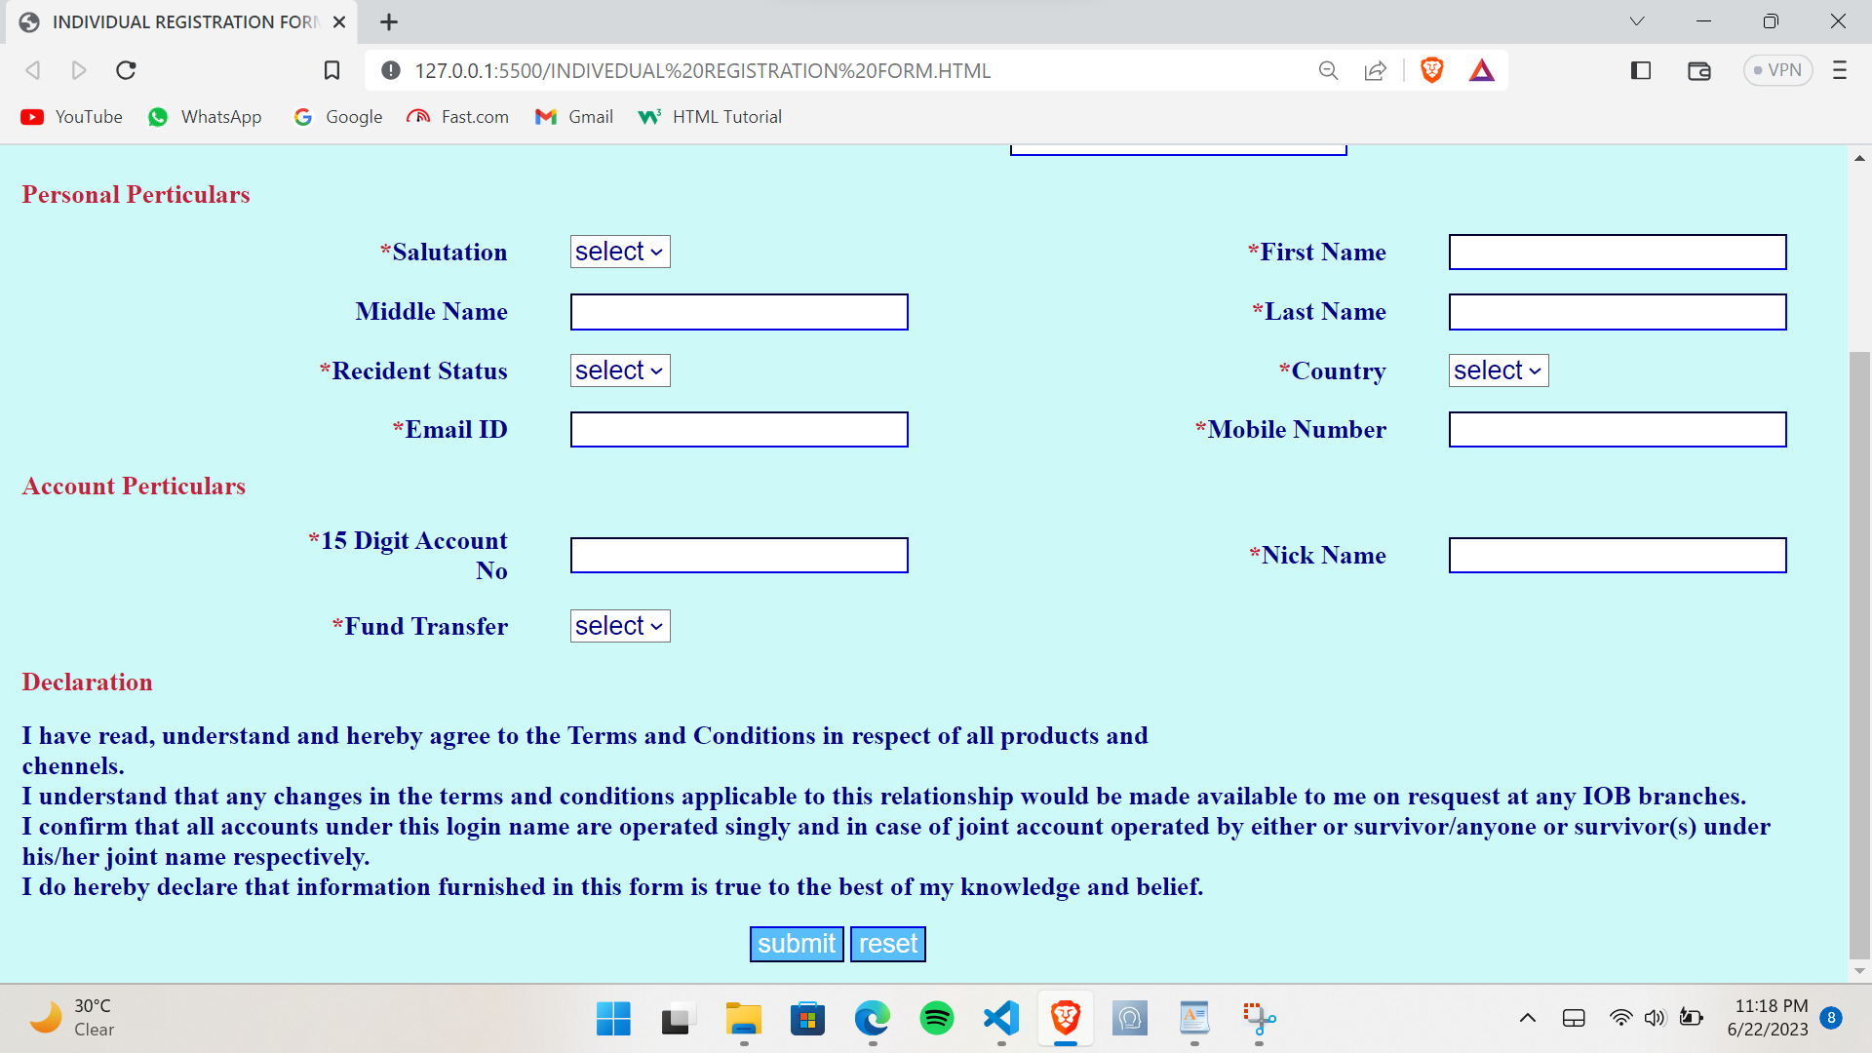
11) Create link-pseudo classes using external css, to format links on the pages.
Ans.
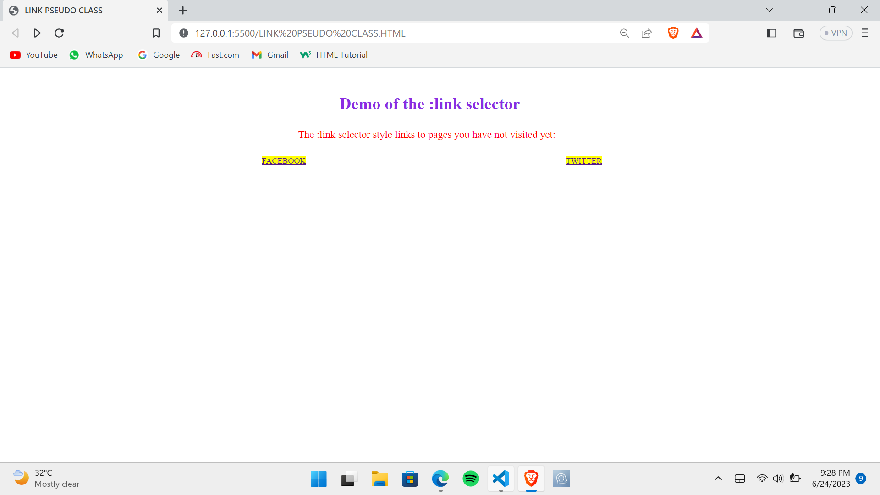

12) Create a dynamic pseudo class using HTML, CSS.
Ans.
