1、导航栏
在产品后面加Quality Assurance。将NEWS改为Industry Insights。
导航栏加大，上面的字体加粗。

2、About Us里面分三个板块

①Company Introduction公司介绍
介绍 DawnRiseCamp 是什么品牌，主营哪些户外产品，有海外供货经验。写：

DawnRiseCamp is a professional outdoor products brand dedicated to reliable camping, hiking, and adventure gear for global customers.
With years of overseas supply experience, strict quality control, and secondary inspection before shipment, we provide dependable outdoor products and flexible OEM/ODM solutions for wholesalers, distributors, retailers, and e-commerce sellers worldwide.

②Brand Mission & Service Philosophy品牌目标和服务理念
介绍品牌理念、服务态度和长期合作目标。写：
Our mission is to provide practical, durable, and reliable outdoor products for global customers. We focus on real outdoor use, stable quality, responsive service, and long-term cooperation with our business partners.

③OEM / ODM Service定制服务介绍支持 logo、包装、颜色、尺寸、材料、产品组合等定制。写：

We support OEM and ODM services, including logo customization, packaging design, color options, material selection, size adjustment, and product combination solutions. Whether you are a wholesaler, distributor, retailer, or e-commerce seller, we can help you build customized outdoor product solutions for your market.

3、Quality Assurance板块

开头口号：
Strictly Checked. Ready for Adventure.
副标题：
Every product is inspected again after production and approved for shipment only when it meets DawnRiseCamp brand standards.

下面分三个模块：

Quality Control Process流程图做成图标式，下面5个步骤
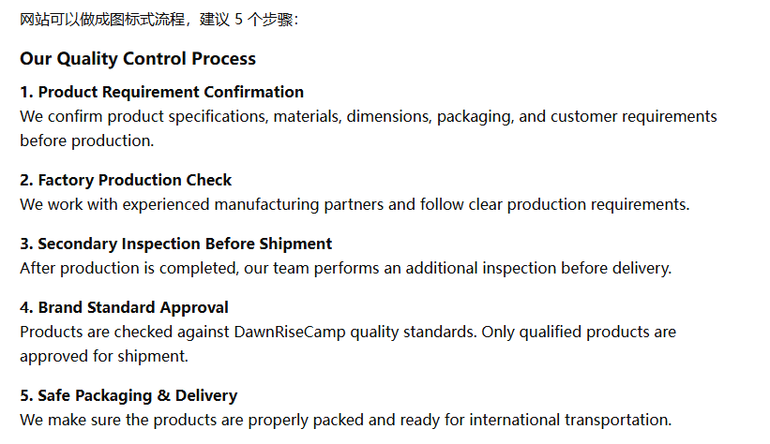
Secondary Inspection Reports
放检测报告
Company Qualifications
放公司资质证书

4、点开这个以后显示全部的产品，要不然现在显示的产品数量有点少，二级类目作为一个精确筛选项，点开一级类目是全部的产品，点开二级类目作为筛选，不要点开一级类目，自动就是进入第一个二级类目

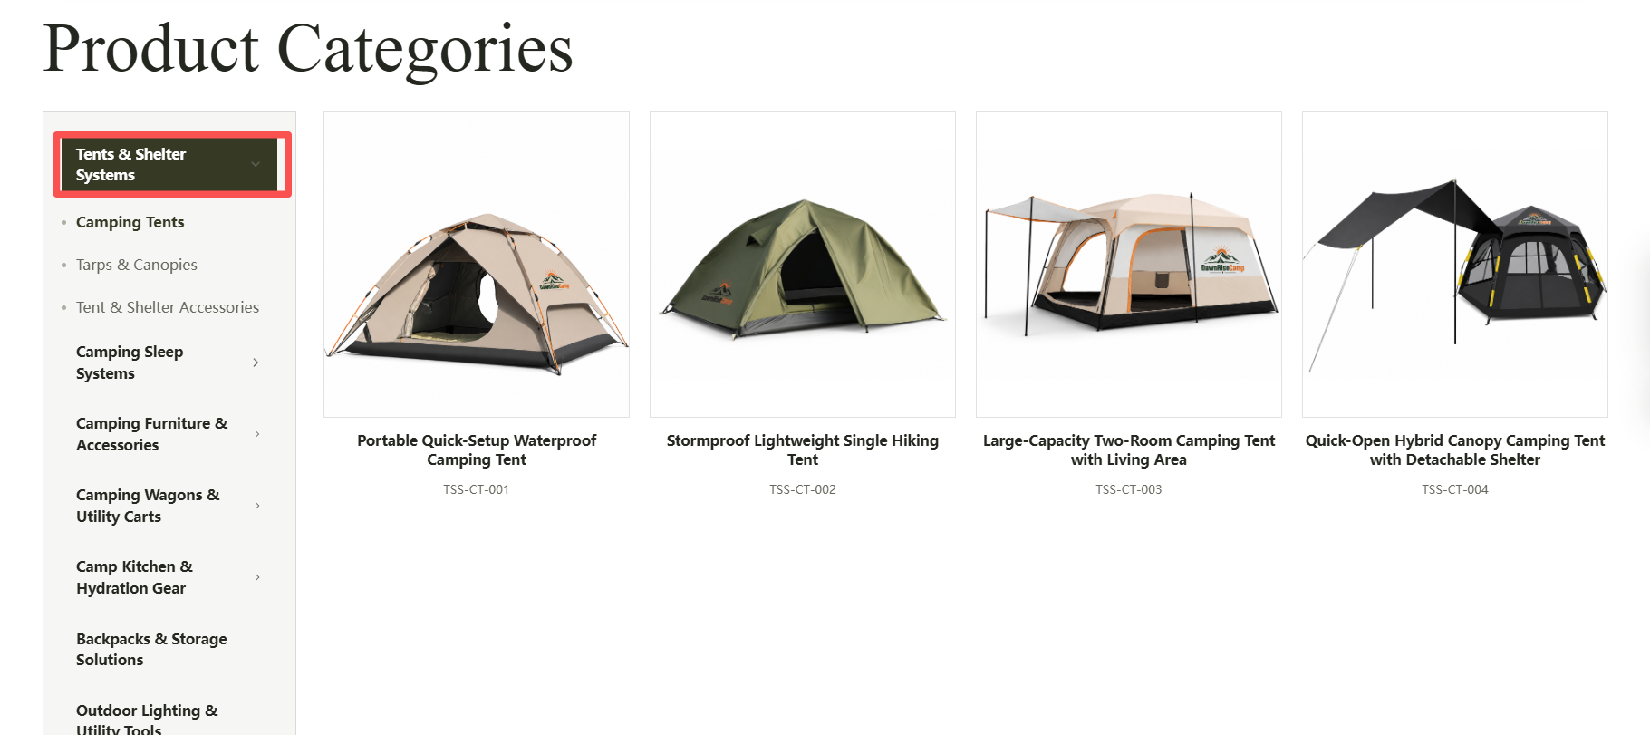

- home首页介绍
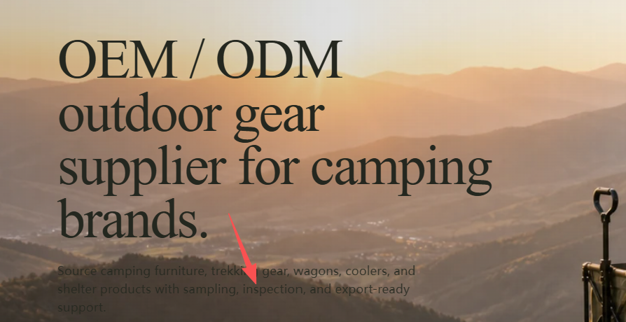
颜色加深，并改为
We provide quality-checked camping and outdoor gear with flexible OEM/ODM solutions, strict quality control, and reliable supply support for global camping brands, wholesalers, and retailers.

- Industry Insights。
这个板块里面放几篇户外产品的文章，最好把文章日期不管是图片也好，还是别的从2022年开始，每年两篇

7、产品页打开图片太大了，弄两张缩小的图片，
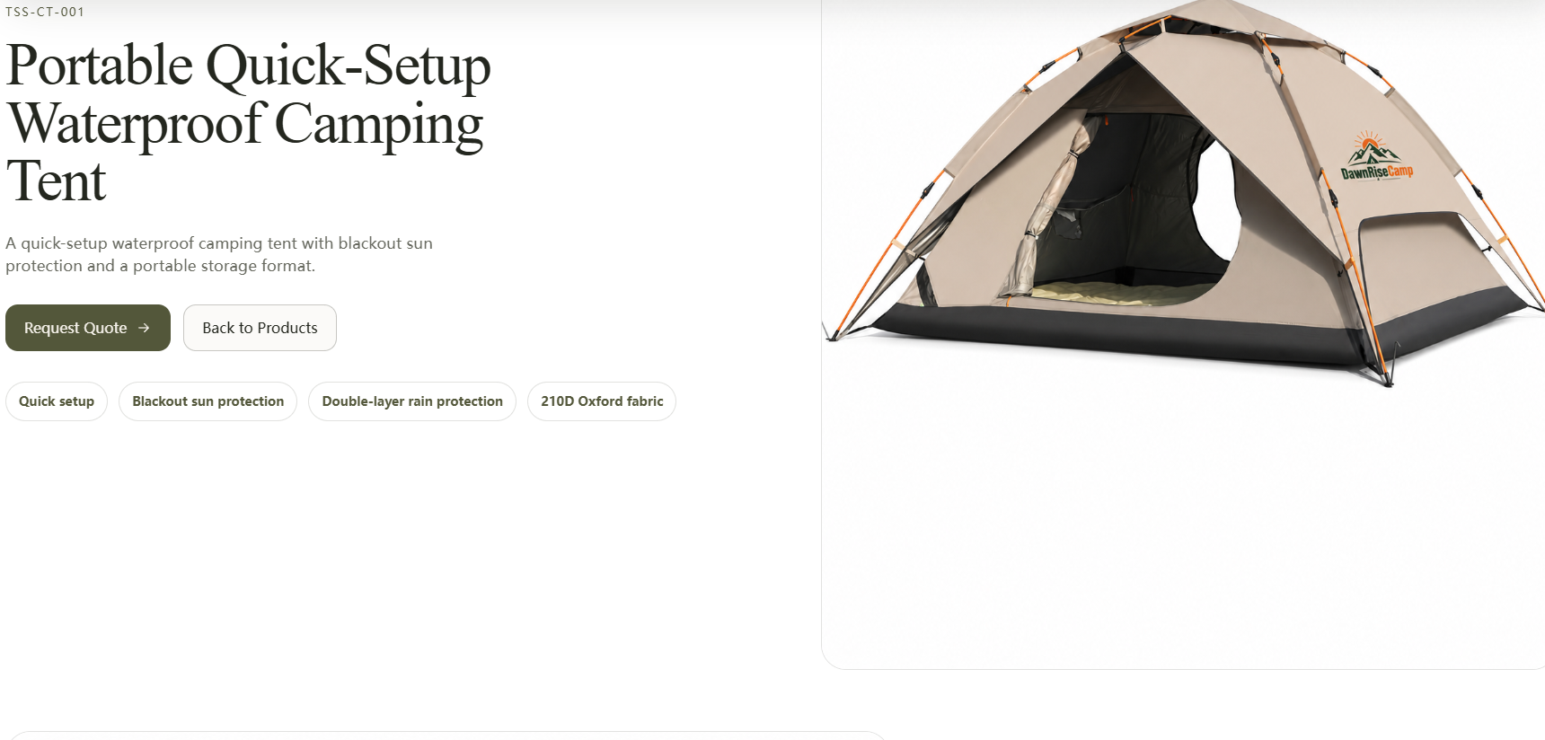

可以点开后上面是二级类目名称，然后点哪个图片，哪个图片在左侧放大，右侧这种缩小的框根据我们的白图有几张放几个。下面是示意


