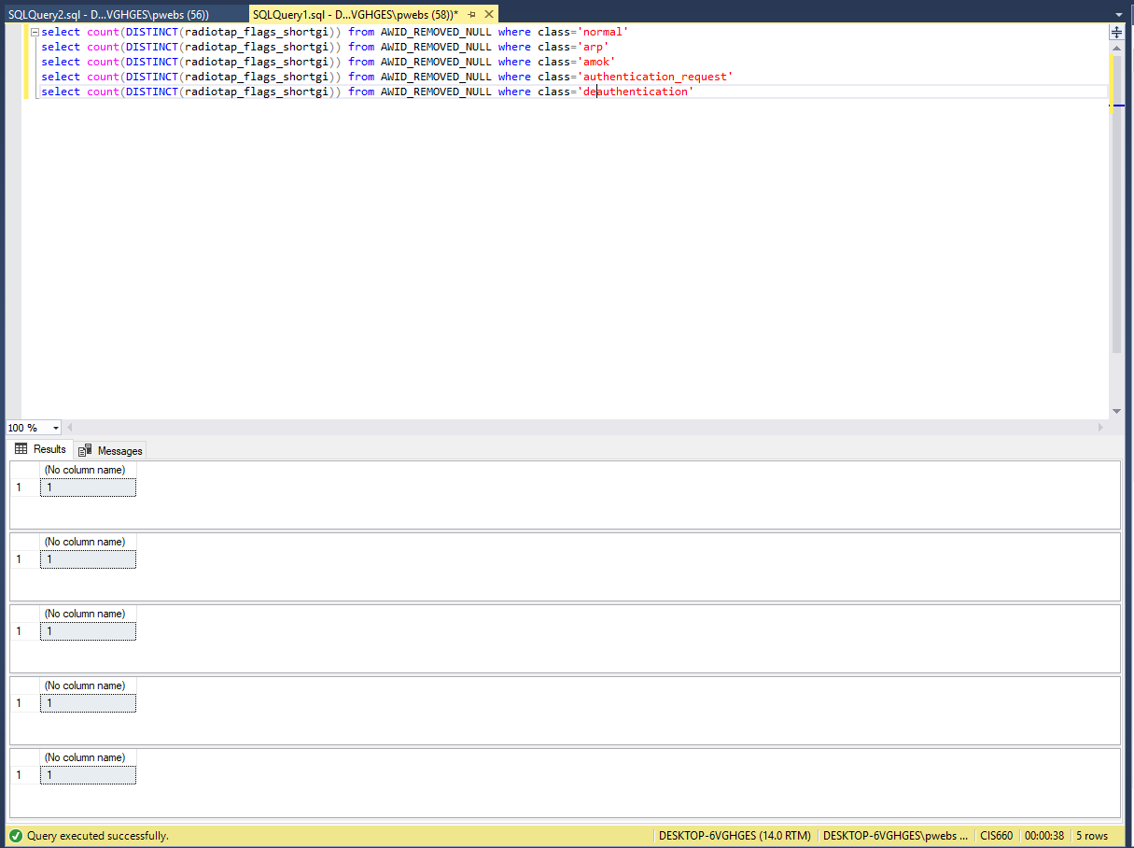

We didn’t chose this column because it had no variation

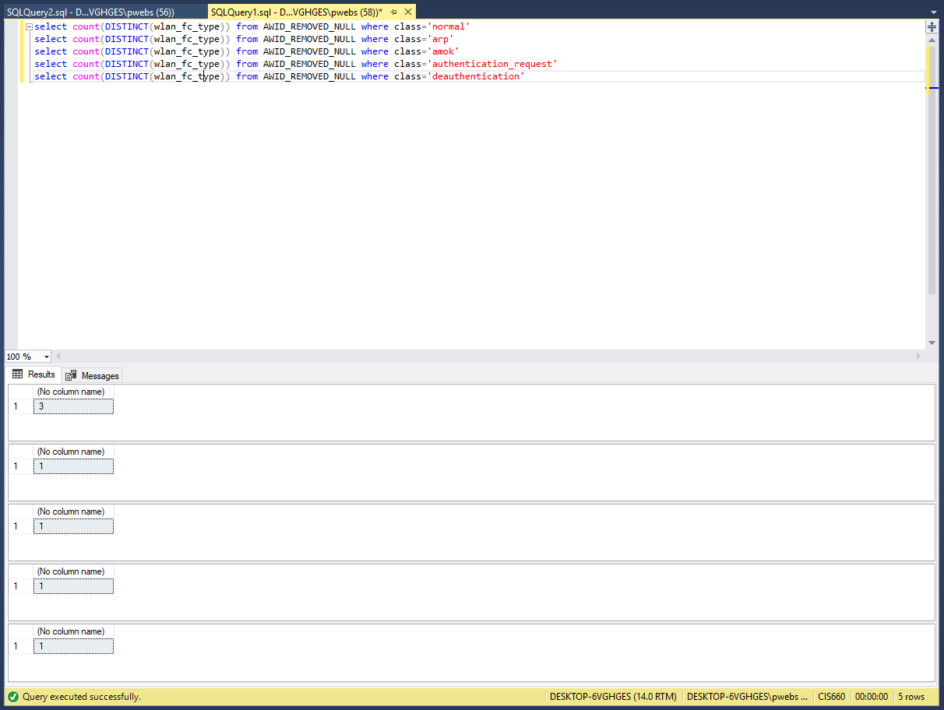

We chose this column because after looking at it further it showed that the normal class type varied highly among 3 values while the attack types all had the same values.

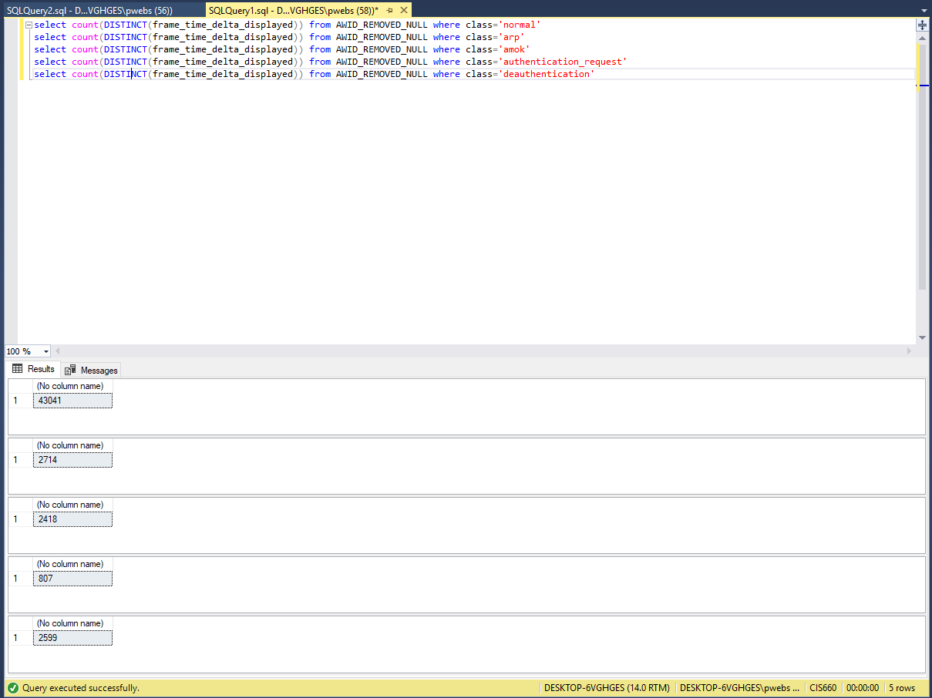

We chose this variable because upon looking further into it we saw that for the attack types all the tuples had very close values while normal was spread out.

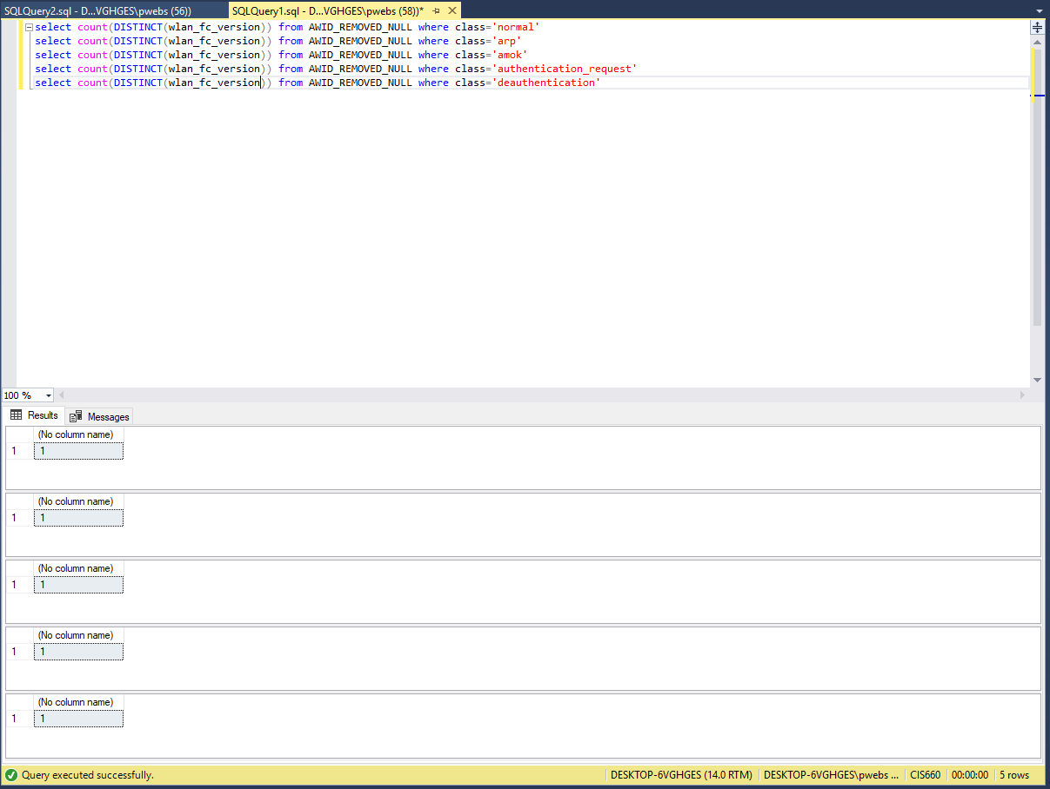

We didn’t choose this variable because of lack of variation

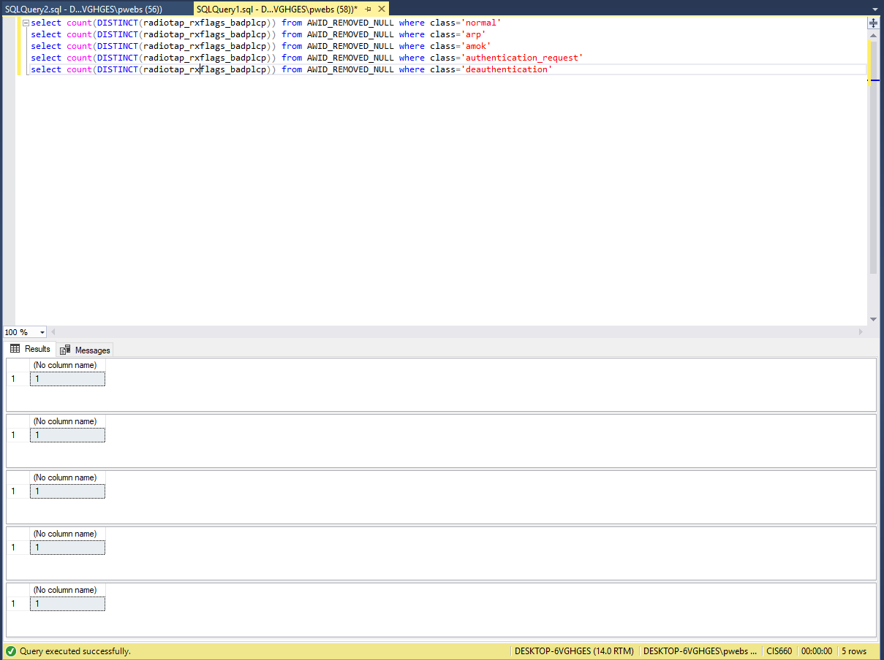

We didn’t chose this variable because of lack of variation

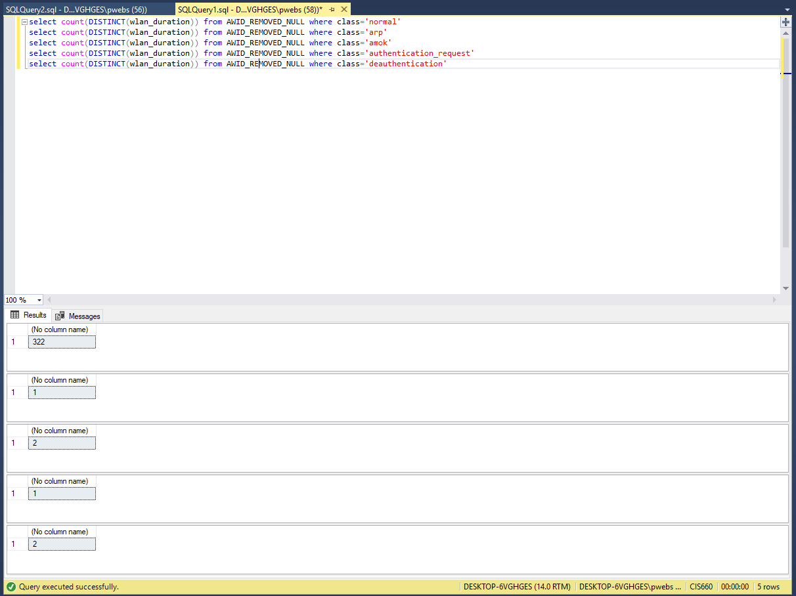

We chose this variable because there is lots of variation for normal and hardly any for attacks.

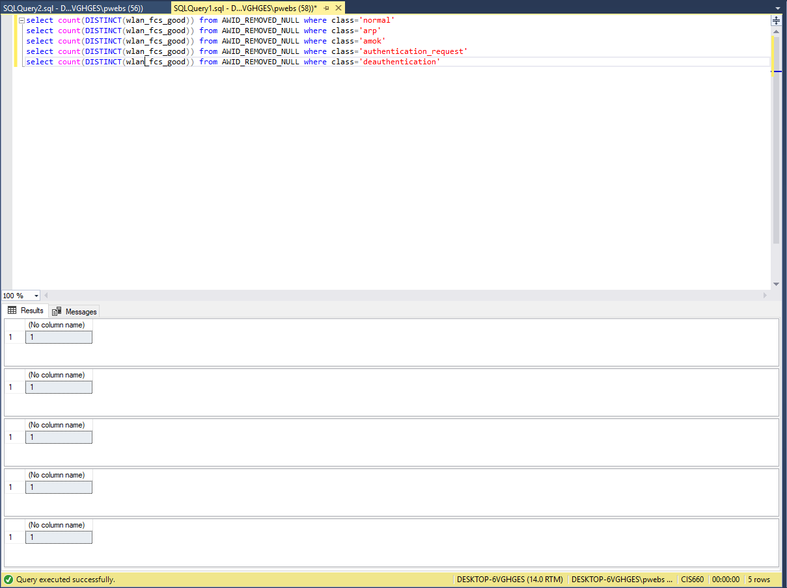

We chose not to use this variable because of lack of variation

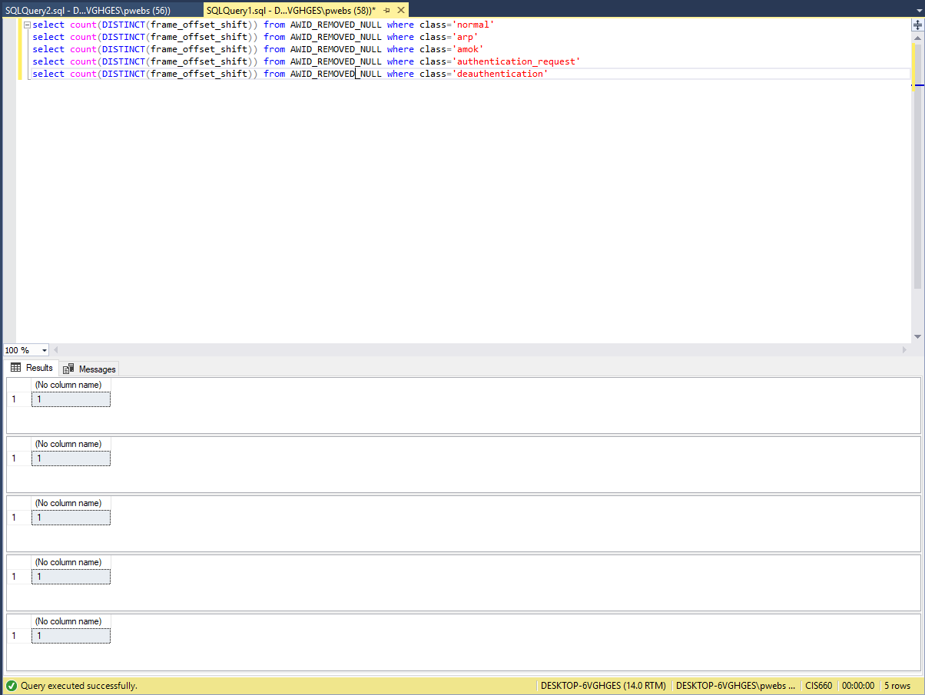

We chose to not use this variable because of lack of variation

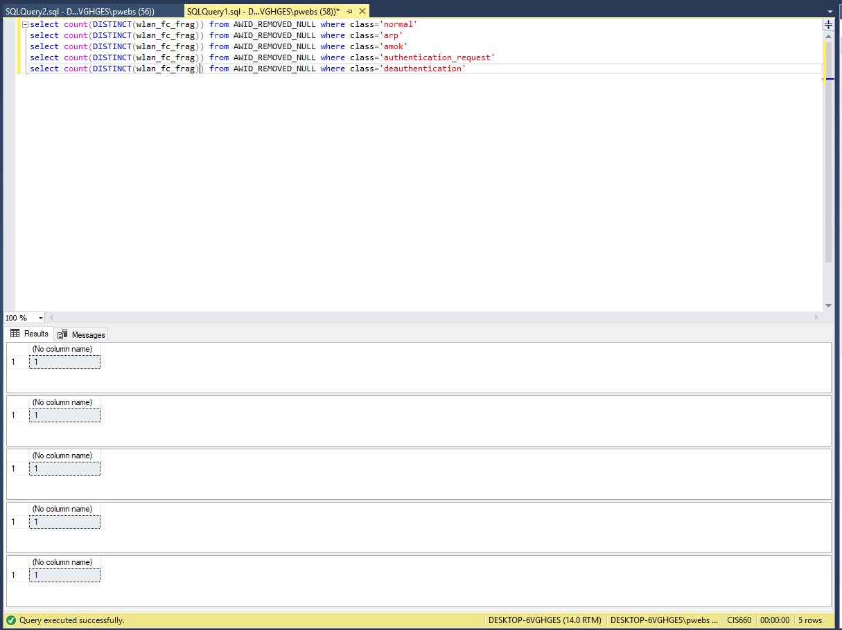

We chose to not use this variable because of lack of variation

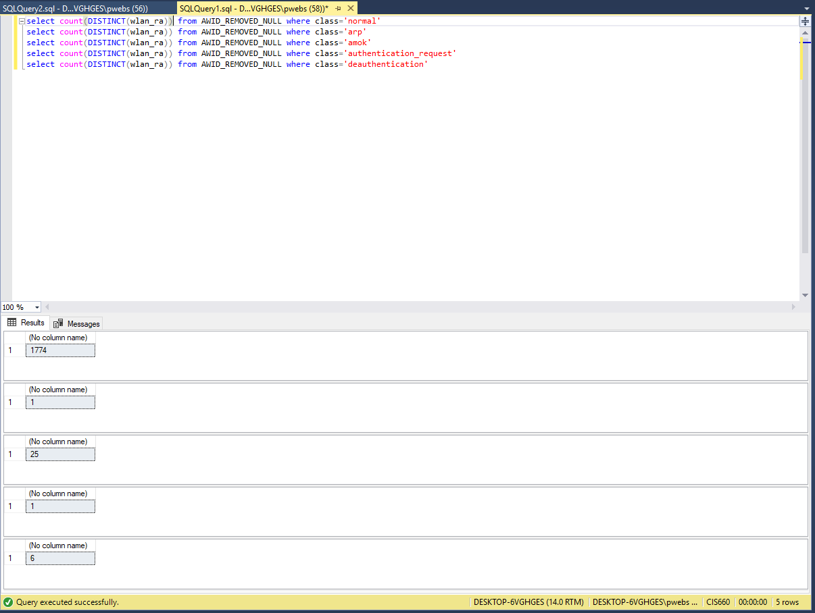

After much debate we decided to not use this variable even though it has the variation we are looking for because it is nominal and not ordinal and the rest of our variables are continuous.

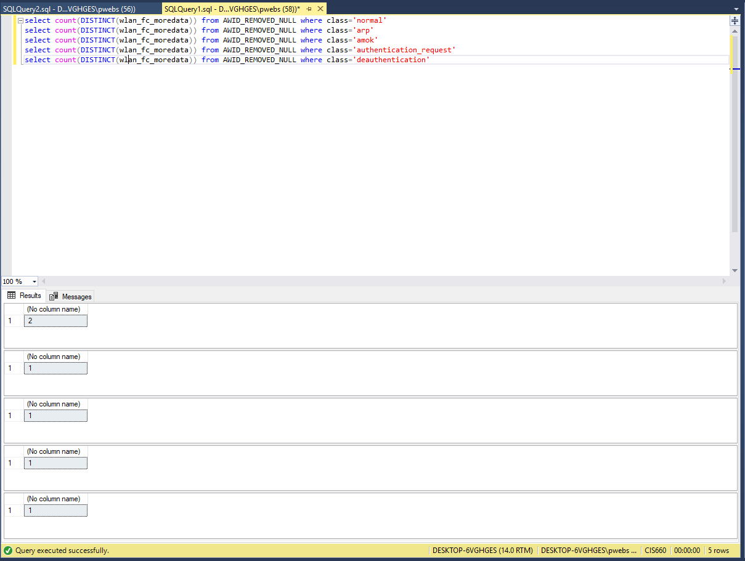

We didn’t choose this attribute because even though it has the variation we are looking for 99.9% of the normal tuples have the same value as the attack types making it basically useless.