ARP RESULTS:

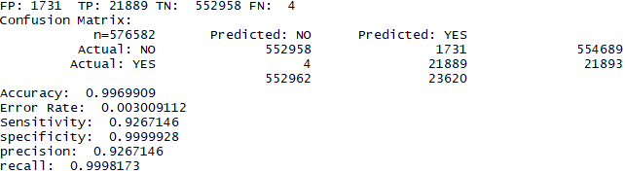

AMOK RESULTS:

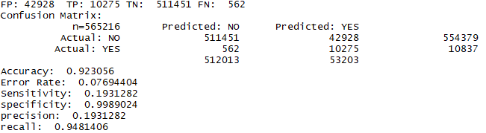

DEAUTHENTICATION RESULTS:

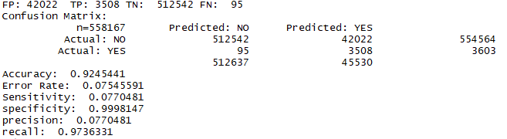

AUTHENTICATION_REQUEST RESULTS:

