ARP RESULTS:

SETTINGS: Smote.k=3 knn.k=5 smote.perc.over=150 smote.perc.under=90

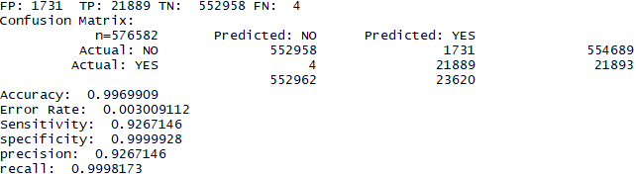

AMOK RESULTS:

SETTINGS: Smote.k=3 knn.k=5 smote.perc.over=150 smote.perc.under=90

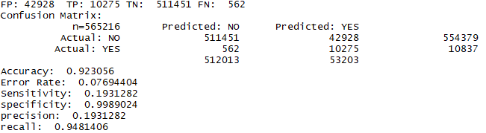

DEAUTHENTICATION RESULTS:

SETTINGS: Smote.k=3 knn.k=5 smote.perc.over=150 smote.perc.under=90

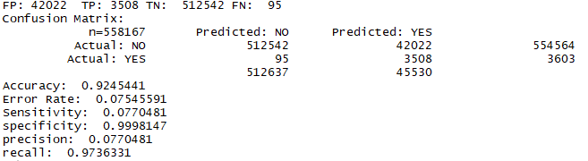

AUTHENTICATION_REQUEST RESULTS:

SETTINGS: Smote.k=3 knn.k=5 smote.perc.over=150 smote.perc.under=90

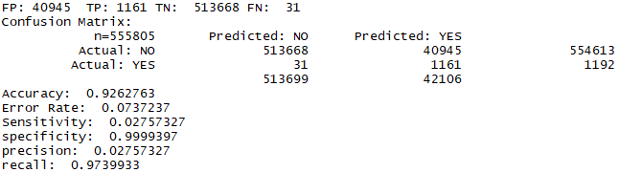

ARP RESULTS

ERRORS WITH TOO MANY TIES WITH SETTINGS: : smote.k=1 knn.k=1 smote.perc.over=100 smote.perc.under=300 don’t worry about because our results were really good with the other settings

DEAUTHENTICATION RESULTS

SETTINGS: smote.k=1 knn.k=1 smote.perc.over=90 smote.perc.under=400

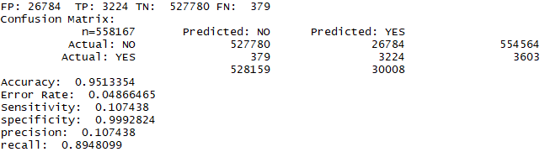

AMOK RESULTS

SETTINGS: smote.k=1 knn.k=1 smote.perc.over=120 smote.perc.under=200

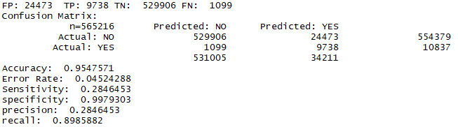

AUTHENTICATION REQUEST RESULTS

SETTINGS: smote.k=1 knn.k=1 smote.perc.over=100 smote.perc.under=300