181.超过经理收入的员工
自写代码：# Write your MySQL query statement below

select Name from Employee as a,Employee as b
where a.ManagerId=b.Id and a.Salary>b.Salary

结果：
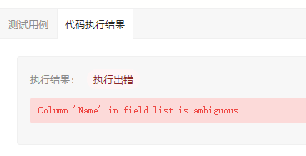
原因：
Name 没有指定是哪张表中的字段

改正代码：
# Write your MySQL query statement below

select a.Name from Employee as a,Employee as b
where a.ManagerId=b.Id and a.Salary>b.Salary

结果：
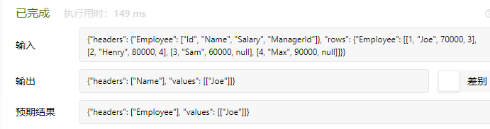

原因：没有将标头的Name变为Employee,判定程序不符合输出规则

改进代码：
# Write your MySQL query statement below

select a.Name as 'Employee' from Employee as a,Employee as b
where a.ManagerId=b.Id and a.Salary>b.Salary

结果：
