**\* Proportional thresholding [Heuvel et al., NeuroImage, 2017]**

To keep the number of connections fixed across all individuals to rule out배제시키다 the influence of network density on the computation and comparison of graph metrics across groups

아예 두 그룹을 비교해서 영향을 주는 것들을 배제시키는? 무튼 기존의 방법과는 다른!

This selection procedure is often referred to in literature as an analysis in which the “density” or “network cost” is set fixed across patient and healthy control cases, with potential between-group differences in graph metrics (e.g. clustering, path length) assumed to result from differences in the topological organization of edges and not due to differences in number of edges.

일단 binary graph로 구하는 방법은 지금은 특정 threshold 이상은 그대로 두고, 그 이하는 0으로 만들었는데, 그 이상을 그대로 두지 말고 1로 바꾸면 binary graph가 된다!!

Density나 network cost는 어떻게 구하지?

**\* Multi-threshold permutation correction (MTPC) [Drakesmith et al., NeuroImage, 2015]**

Flowchart of the MTPC pipeline, demonstrated on comparisons of clustering coefficient between the healthy and atrophied groups in experiment 2b (ξ=0.2).

Steps of the pipeline are explained in the text.

(1) Network metrics are computed for each subject and threshold, up to m = 30 streamlines.

(2) U-Statistics (Mann-Whitney U-test) were computed between groups for each threshold. The initial uncorrected unthresholded test yields a non-significant result. **=> Uncorrected t-test: t-value같은거!**

(3) Groups were permuted n=1000 times and -statistics computed for each permutation. => **Permutation test**

(4) The maximum statistic across thresholds was taken for each permutation, generating null distribution of U-statistics (note we use the term maximum with respect to the direction of the observed effect). **=> multiple comparisons을 하는 step인가?**

(5) The upper 95th percentile of this distribution is taken as the critical value for U which is Ucrit=1354.

(6) One super-critical cluster was identified with a peak of UMTPC=1267 at τ=4 with a super-critical AUC of AMTPC=2488. **=> τ=4 이게 정해진 threshold값임!**

(7) The mean super-critical AUC was Acrit=306.9.

(8) Both UMTPC and AMTPC exceed their respective critical values.

Therefore, the null hypothesis is rejected.

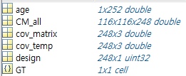<Example 분석하기>

248명의 dataset이어서 248들어간듯?

GT안에는 248*20*116 double

[GT_data,config] = MTPC_generate_metrics(CM_all)

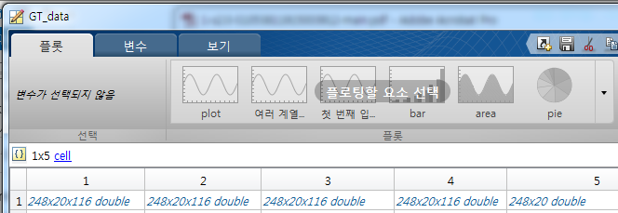

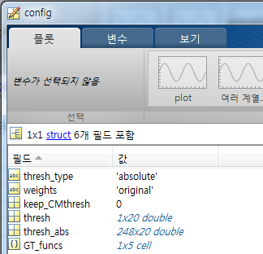GT_funcs에는 GT_data값이 뭔지 적혀있음

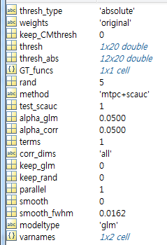

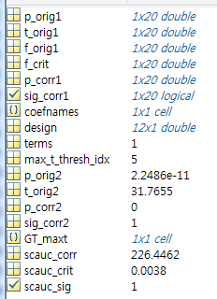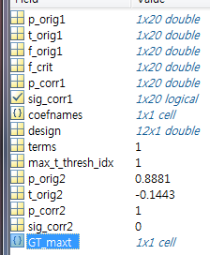

|  |  |
| --- | --- |
| p_orig1  t_orig1  f_orig1 | Original, t, F and p vlaues of the GLM fit for all thresholds |
| f_crit | the critical value of F after correction |
| p_corr1  sig_corr1 | The corrected p-values for all thresholds  Binary array indicating if the result if significant at all thresholds |
| Coefnames  Design  Terms | Cell array of coefficient names (based on varnames) |
| Max_t_thresh_idx | The index of the threshold vector corresponding to the maximum F statistic |
| scauc_corr  scauc_crit  scauc_sig | The super-critical AUC of effect  The super-critical AUC of the randomisation effect  Indicates if the effect is significant with super-critical AUC |

* Significant한 상황에서만 scauc관련 measure가 생김!!

**\* [Weisz et al., PNAS, 2014]**

Before graph theory can be applied, the all-to-all connectivity matrix needs to be thresholded to yield a so-called adjacency matrix. In the majority of studies this matrix is binary, with zeros indicating absence of a functional connection; a 1 indicates its presence. In absence of a “true” criterion, thresholds are necessarily arbitrary임의적인. We approached this issue by calculating the adjacency matrix for thresholds between 0.01 and 0.1 (note that obviously absolute values are smaller for imaginary coherence (IC) and that, furthermore, for some graph theoretical measures the graph needs to be fully connected) and then deriving small-worldedness of the entire graph.

This measure, introduced by refs. 64 and 65, can be derived from the ratio of the normalized clustering coefficient (i.e., dividing the empirically observed values by one derived from a corresponding random network) to the normalized distance (or also called path length). Although the clustering coefficient measures the density of connections of a node to its neighbors (averaged over nodes to obtain the value for the entire graph; i.e., putatively representing local integration), distance measures the amount of steps (i.e., connections or edges) it takes from one node to an arbitrary other node. Thus, the latter measure characterizes the aspect of local integration. A small-worldedness value larger than one therefore indicates that a network can be characterized by both: that is, high clustering as well as short distance.

Because small-worldedness should represent a property of naturally occurring networks such as the brain, we chose the threshold value that maximized this metric (here: IC ≥ 0.07) for the computation of all other global as well as local metrics. As indicated above, clustering coefficient and distance are measures that can be computed for the entire graph or locally for each individual node, which can then be interpolated onto a structural image. We additionally computed global and local efficiency, a measure that is in principle inversely related to distance but less sensitive to outliers. Higher efficiency values indicate globally that a network is in principle more integrated (because overall distances are low) and locally that a specific node is more highly integrated with the rest of the network. With regards to statistical analysis, we focused our analysis on 17 Hz, for which we identified an overall small-worldedness difference (Pcorrected < 0.05) between misses and hits in the prestimulus period.

**\* Group-level-permutation-statistics-approach / Single-subject-connectivity-matrices-approach [Langer et al., Plos One, 2013]**