

BÁO CÁO DEMO

Lê Thị Anh Thư

MSSV: 1312585

Email: ltathu410@gmail.com

MỤC LỤC

**I.** **App_Start:** 3

**1.1** **BundleConfig** 3

**1.2** **FilterConfig** 4

**1.3** **RouteConfig** 4

**1.4** **WebApiConfig** 4

**II.** **Global:** 5

**III.** **Models:** 5

**4.1** **Connect.cs** 5

**4.2** **DBConect.cs** 5

**4.3** **Login.cs** 5

**IV.** **View:** 5

**5.1** **Index.cshtml** 6

**5.2** **Layout.cshtml** 6

**5.3** **Error.cshtml** 6

**V.** **Controllers:** 6

1. **App_Start:**
2. **BundleConfig**

public static void RegisterBundles(BundleCollection bundles)

{

bundles.Add(new ScriptBundle("~/bundles/jquery").Include(

"~/Scripts/jquery-{version}.js"));

bundles.Add(new ScriptBundle("~/bundles/jqueryui").Include(

"~/Scripts/jquery-ui-{version}.js"));

bundles.Add(new ScriptBundle("~/bundles/jqueryval").Include(

"~/Scripts/jquery.unobtrusive*",

"~/Scripts/jquery.validate*"));

bundles.Add(new ScriptBundle("~/bundles/modernizr").Include(

"~/Scripts/modernizr-*"));

bundles.Add(new StyleBundle("~/Content/css").Include("~/Content/site.css"));

bundles.Add(new StyleBundle("~/Content/themes/base/css").Include(

"~/Content/themes/base/jquery.ui.core.css",

"~/Content/themes/base/jquery.ui.resizable.css",

"~/Content/themes/base/jquery.ui.selectable.css",

"~/Content/themes/base/jquery.ui.accordion.css",

"~/Content/themes/base/jquery.ui.autocomplete.css",

"~/Content/themes/base/jquery.ui.button.css",

"~/Content/themes/base/jquery.ui.dialog.css",

"~/Content/themes/base/jquery.ui.slider.css",

"~/Content/themes/base/jquery.ui.tabs.css",

"~/Content/themes/base/jquery.ui.datepicker.css",

"~/Content/themes/base/jquery.ui.progressbar.css",

"~/Content/themes/base/jquery.ui.theme.css"));

}

* Đăng ký các gói bundle, mỗi bundle có các file js hoặc css.
* Các files js và css sẽ được gọi trên browser khi các bundle được gọi.
* Sử dụng css bundle và javascript bundle bằng cách sử dụng @Styles.Render và @Script.Render (file _Layout.cshtml)

1. **FilterConfig**

public static void RegisterGlobalFilters(GlobalFilterCollection filters)

{

filters.Add(new HandleErrorAttribute());

}

* HandleErrorAttribute là 1 filter có sẵn của hệ thống, cho phép ta xử lý lỗi từ Actions
* Khi sử dụng filter này, 1 exception được ném ra từ hệ thống sẽ tự động gọi 1 view tên Error trong “Error.cshtml”

1. **RouteConfig**

public static void RegisterRoutes(RouteCollection routes)

{

routes.IgnoreRoute("{resource}.axd/{*pathInfo}");

routes.MapRoute(

name: "Default",

url: "{controller}/{action}/{id}",

defaults: new { controller = "Home", action = "Index", id = UrlParameter.Optional }

);

}

* Route được cấu hình bằng cách sử dụng phương thức mở rộng MapRoute() của RouteCollection với name, url và các tham số mặc định như trên, trong đó id sẽ mang giá trị mặc định của một thuộc tính Optional tĩnh của System.Web.Http.UrlParameter
* Sau khi cấu hình sẽ đăng ký trong Application_Start() trong Global.asax.cs

1. **WebApiConfig**

public static void Register(HttpConfiguration config)

{

config.Routes.MapHttpRoute(

name: "DefaultApi",

routeTemplate: "api/{controller}/{id}",

defaults: new { id = RouteParameter.Optional }

);

}

* Route được đăng ký thông qua phương thức mở rộng MapHttpRoute của thuộc tính static Routes.
* Để route nối đến đúng request phải cung cấp đủ các giá trị tham số cần thiết với name, routeTemplate và id được default như trên, trong đó id sẽ mang giá trị mặc định của một thuộc tính Optional tĩnh của System.Web.Http.RouteParameter

1. **Global:**

**Global.asax**

protected void Application_Start()

{

AreaRegistration.RegisterAllAreas();

WebApiConfig.Register(GlobalConfiguration.Configuration);

FilterConfig.RegisterGlobalFilters(GlobalFilters.Filters);

RouteConfig.RegisterRoutes(RouteTable.Routes);

BundleConfig.RegisterBundles(BundleTable.Bundles);

}

* Khi website khởi động, hàm Application_Start trong “Global.asax” sẽ chạy đầu tiên. Phương thức này sẽ gọi các phương thức Register, RegisterGlobalFilters, RegisterRoutes và RegisterBundles.
* Đây là nơi cài đặt những gì cần thiết cho hệ thống
* Mỗi project có 1 file “Global.asax” duy nhất

1. **Models:**
2. **Connect.cs**

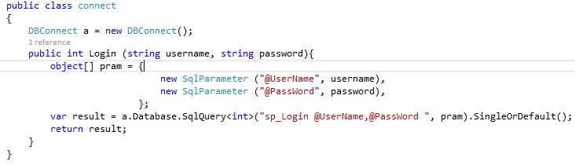

* Gọi class kết nối với SQL là DBConnect
* Truyền tham số vào Store Procedure.
* Thực thi Store Procedure

1. **DBConect.cs**

* Là lớp kết nối với database SQL.
* Lấy table Login dưới SQL server.

1. **Login.cs**

* Login là table dữ liệu.
* Lấy ra id, UserName và PassWord trong table này.

1. **View:**
2. **Index.cshtml**

* Là giao diện mặc định khi thực thi chương trình.

public ActionResult Index()

{

return View();

}

1. **Layout.cshtml**

* Định dạng trang web.

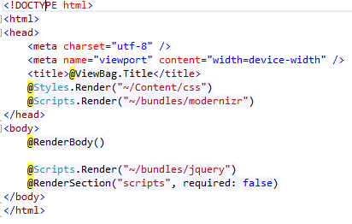

1. **Error.cshtml**

* Giao diện lỗi.

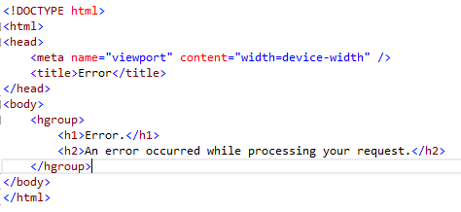

1. **Controllers:**

**HomeController**

ActionResult Index()

{

return View();

}

* Tạo view là index của HomePage.
* Là lớp cơ sở cho các kết quả trả về của các action.
* Hiển thị thông tin HomePage. (index.cshtml)

void process(FormCollection collection)

{

if (collection["sourcefile"] != null || collection["desfile"] != null)

{

string[] name = new string[3];

var desfile = collection["desfile"].ToString();

var filename = System.IO.Path.GetFileName(collection["sourcefile"]);

var date = DateTime.Now.ToString("yyyyMMdd");

int pos = filename.LastIndexOf(".");

int len = filename.Length - pos - 1;

name[0] = filename.Substring(pos);

name[1] = filename.Substring(0, len);

filename = name[1].Trim() + date.Trim() + name[0];

desfile = desfile + '\\' + filename.Trim();

System.IO.File.Move(collection["sourcefile"], desfile);

}

}

* Thực thi chương trình: nếu người dùng nhập địa chỉ nguồn và đích hợp lệ thì chương trình sẽ tiến hành di chuyển file từ địa chỉ nguồn sang địa chỉ đích và đặt lại tên file kèm theo ngày hiện tại của hệ thống.

Hết!