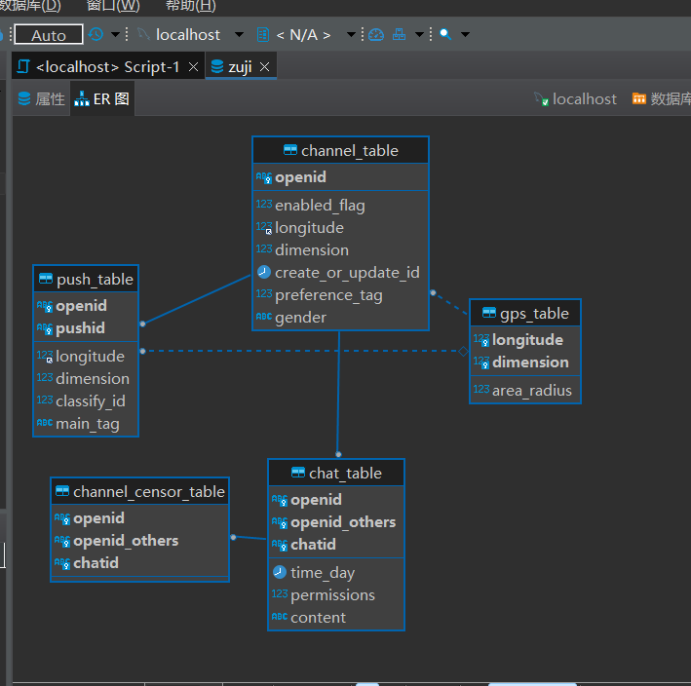

use zuji;

create table gps_table(

longitude float,

dimension float,

area_radius float,

primary key(longitude,demension)

);

create table channel_table(

openid varchar(100) primary key,

enabled_flag int,

longitude float,

dimension float,

create_or_update_id date,

preference_tag int,

gender varchar(10),

foreign key (longitude, dimension) deferences gps_table(longitude, dimension)

);

create table push_table(

openid varchar(100),

pushid varchar(100),

longitude float,

dimension float,

classify_id int default 1,

main_tag varchar(100),

primary key(openid,pushid),

foreign key (openid) deferences channel_table(openid),

foreign key (longitude, dimension) deferences channel_table(longitude, dimension)

);

create table chat_table(

openid varchar(100),

openid_others varchar(100),

chatid varchar(100),

time_day date,

premissions int,

content varchar(10000),

primary key(openid, openid_others, chatid),

foreign key (openid) deferences channel_table(openid)

);

create table channel_censor_table(

openid varchar(100),

openid_others varchar(100),

chatid varchar(100),

primary key(openid,openid_others,chatid),

foreign key(openid,openid_others,chatid)

references chat_table(openid,openid_others,chatid)

);