1. pjsip总统架构

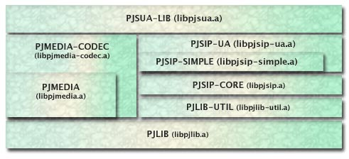

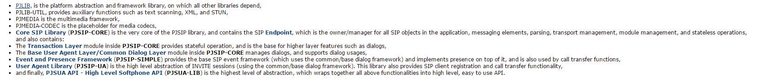

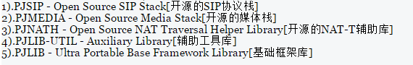

2.对应语言接口产生

Pjsua-LIB是一个C语言的库。Pjsip做的最后一次封装Pjsua2-LIB(C++的库)。

产生不同平台

…接口

python接口

java接口

S

W

I

G

工具

PJsua-LIB接口

3.对应平台和一些选项设置编译

在config_site.h文件中进行相应的配置。

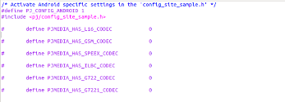

4.pjmedia流程

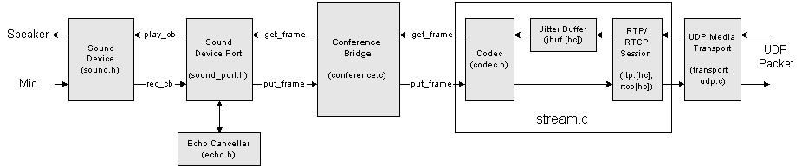



5.从pjsua-lib接口看media的启动流程

Pjsua_vid.c

Pjsua_aud.c

Pjsua_media.c

pjsua_media_subsys_init() pjsua_aud_subsys_init()

pjsua_vid_subsys_init()

pjsua_media_channel_update() …

6.sip驱动media

SDP negotiation has been completed pjsua_call.c

pjsua_media_channel_update pjsua_media.c

pjsua_aud_channel_update() pjsua_vid_channel_update()

pjsua_aud.c pjsua_vid.c

7.pjsip的数据结构

全局数据结构

struct pjsua_data

{

/* Control: */

/* Logging: */

/* SIP: */

pjsip_endpoint *endpt; /**< Global endpoint. */

pjsip_module mod; /**< pjsua's PJSIP module. */

pjsua_transport_data tpdata[8]; /**< Array of transports. */

pjsip_tp_state_callback old_tp_cb; /**< Old transport callback. */

/* Calls: */

pjsua_config ua_cfg; /**< UA config. */

unsigned call_cnt; /**< Call counter. */

pjsua_call calls[PJSUA_MAX_CALLS];/**< Calls array. */

pjsua_call_id next_call_id; /**< Next call id to use*/

};

Media stream数据结构

struct pjsua_call_media

{

pjsua_call *call; /**< Parent call. */

pjmedia_type type; /**< Media type. */

unsigned idx; /**< This media index in parent call. */

pjsua_call_media_status state; /**< Media state. */

pjsua_call_media_status prev_state;/**< Previous media state. */

pjmedia_dir dir; /**< Media direction. */

//added by chenli

/*The WebRTC Channel*/

struct {

/*Audio Channel*/

struct {

int channel_id;/**<webrtc channel of audio>*/

} audio_channel;

/*Video Channel*/

struct {

int channel_id;/**<webrtc channel of video>*/

int capture_id;/**<webrtc capture id of video>*/

} video_channel;

} webrtc_channel;

/** The stream */

struct {

/** Audio stream */

struct {

pjmedia_stream *stream; /**< The audio stream. */

int conf_slot; /**< Slot # in conference bridge. */

} a;

/** Video stream */

struct {

pjmedia_vid_stream *stream; /**< The video stream. */

pjsua_vid_win_id cap_win_id;/**< The video capture window */

pjsua_vid_win_id rdr_win_id;/**< The video render window */

pjmedia_vid_dev_index cap_dev; /**< The video capture device */

pjmedia_vid_dev_index rdr_dev; /**< The video-in render device */

} v;

} strm;

}