Lab6 答案

資訊107 戴宇 F74031043

1

1. true
2. false

Because the is-a relationship represents the inheritance. The has-a relationship represents the composition.

(3) true

(4) true

(5) false

Because a base class’s protected members can’t be accessed in

friends of the base class or in friends of the base class’s derived

classes.

2

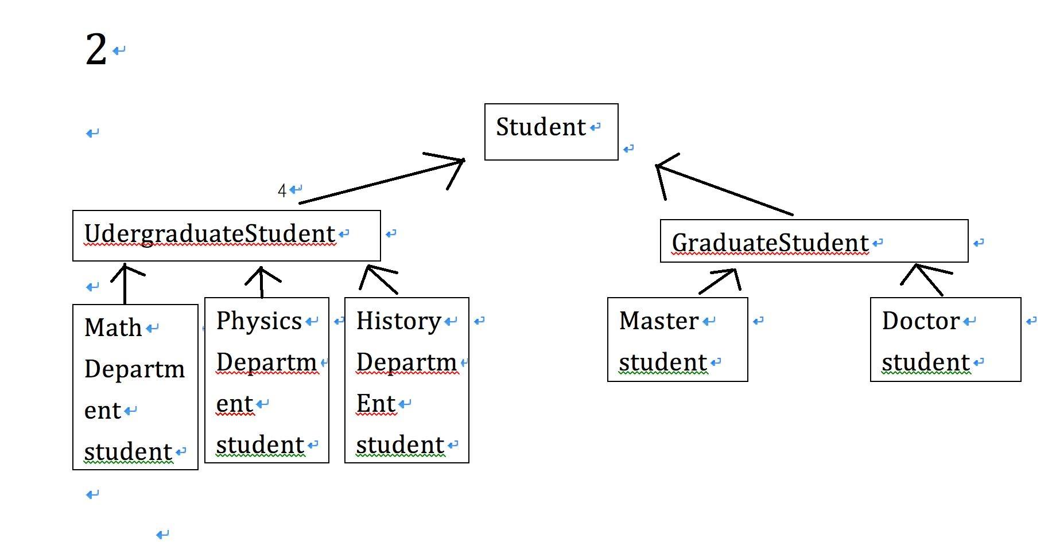

從可看出student 是base class 而UndergraduateStudent和Graduatestudent 是繼承student，而math department student,physics department student 和history department student

是繼承undergraduatestudent，間接繼承student，至於master student和doctor student是繼承graduatestudent，間接繼承student。