VLC、POTPLAYER

Version（V1.0.0）
Version | Update Date | Content
V1.0.0 | 2024.06.01 | initial version

Date：2024

Thank you for using Topotek gimbal camera products.
Topotek currently has more than 120 kinds of gimbal products to ensure product diversity and multiple interfaces for different application scenarios. Our gimbals can be compatible with different third-party links.
The purpose of this document is to provide you with a good experience for more convenient and quickly understand the using of our gimbal cameras. This file can solve most of your questions, however, you can also visit the official website www.topotek.com to learn more about them, or call the official tell at 010-57147023 to consult the after-sales engineers directly.

Operating Instructions:
Topotek supports most of the common pull streaming software and ground stations in the market.The pulling mode is the same regardless of any model of our products . This document describes the pull steaming mode, including QGC, Vlc, Potplayer and other tools.

QGC、VLC、POTPLAYER Video Player
VLC Connecting Process:
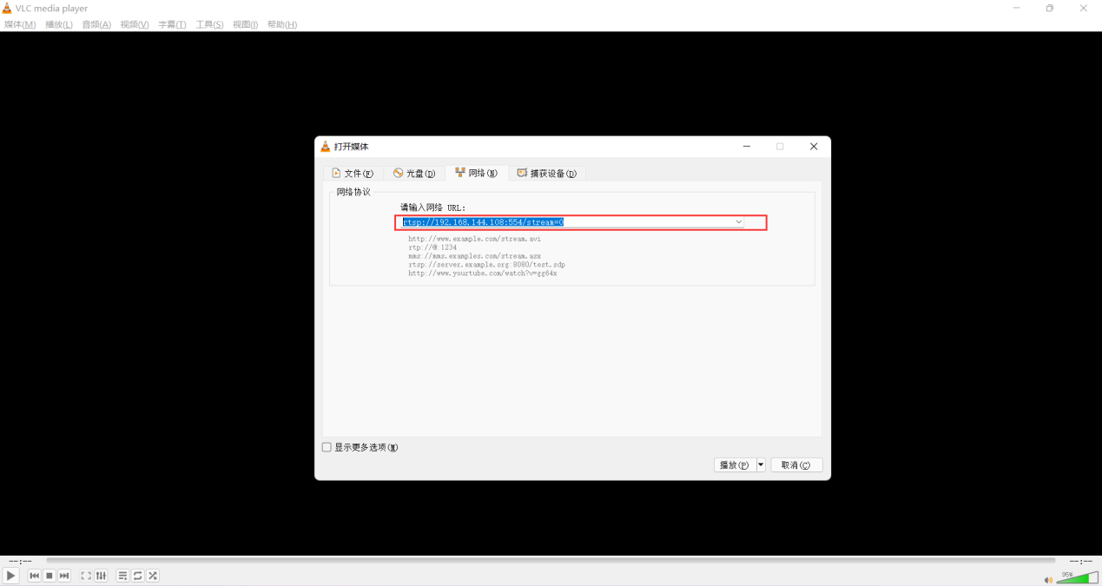

POTPLAYER Connecting Process:
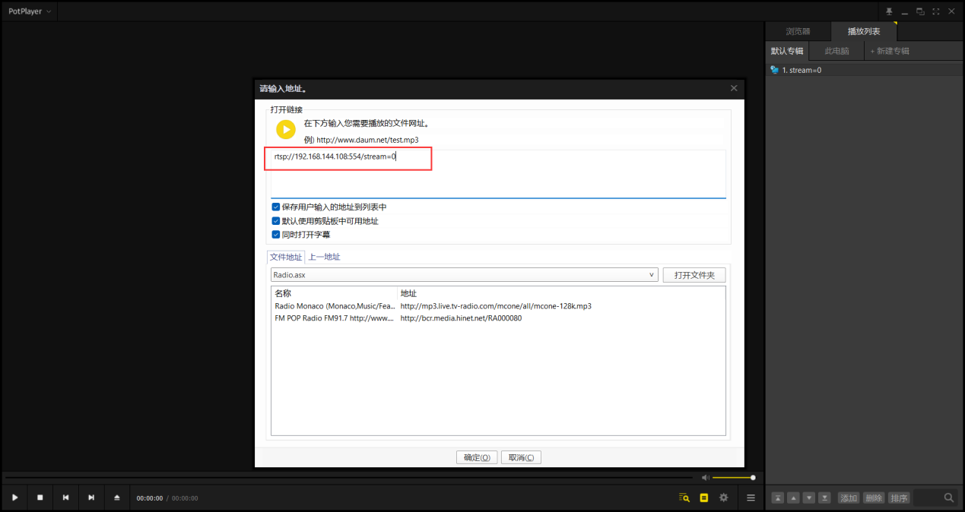

At present, the IP address is the default. If you have changed the IP address before, just sue the IP address here. The rest operations remain same.

Note: Topotek software can be downloaded from http://www.topotek.com

QGC Connecting Process:
- Open the Home Screen
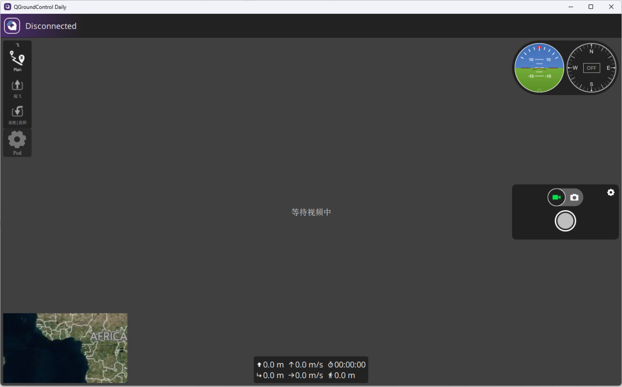

2. Click the “Disconnected” on the home screen and click the “Application Settings” in the dialog box.
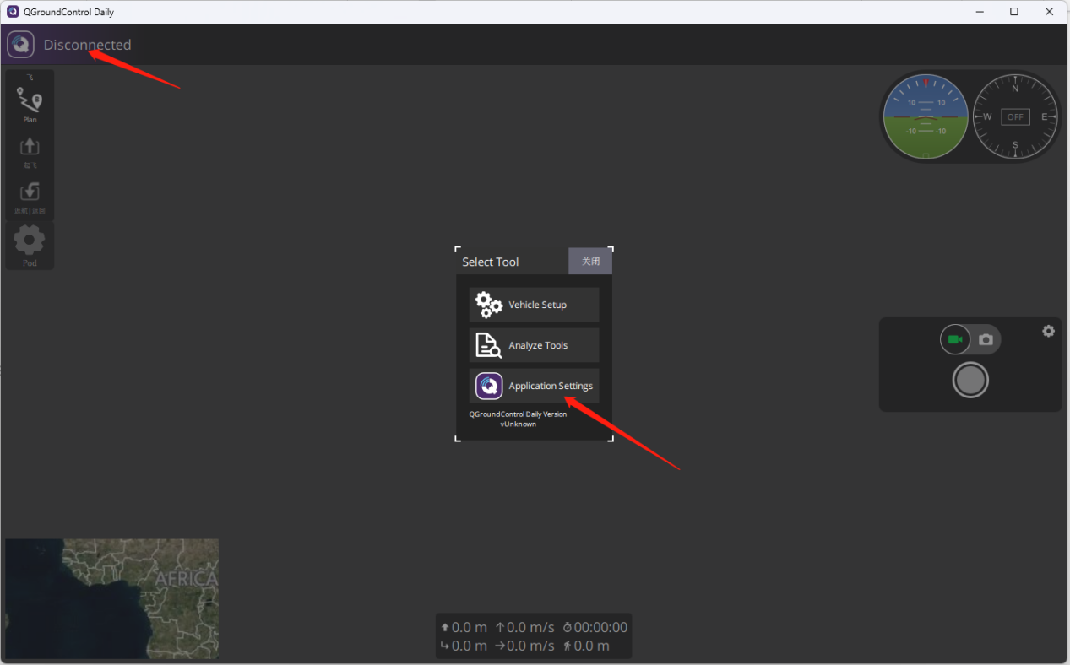

3, Click “ General”, and choose the “RTSP Video Stream” in the drop-down list of “source”.
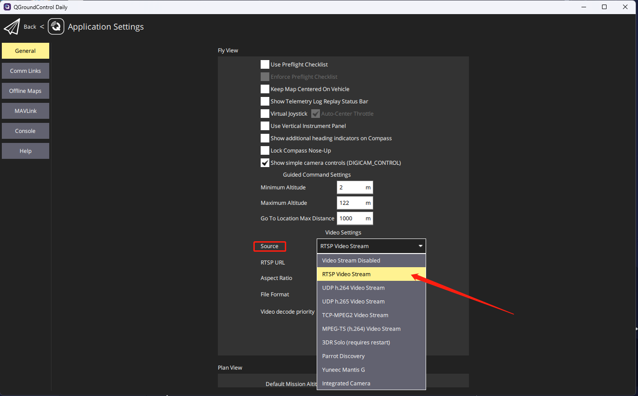

- Pls type the address “ rtsp://192.168.144.108:554/stream=0” in the RTSP URL.
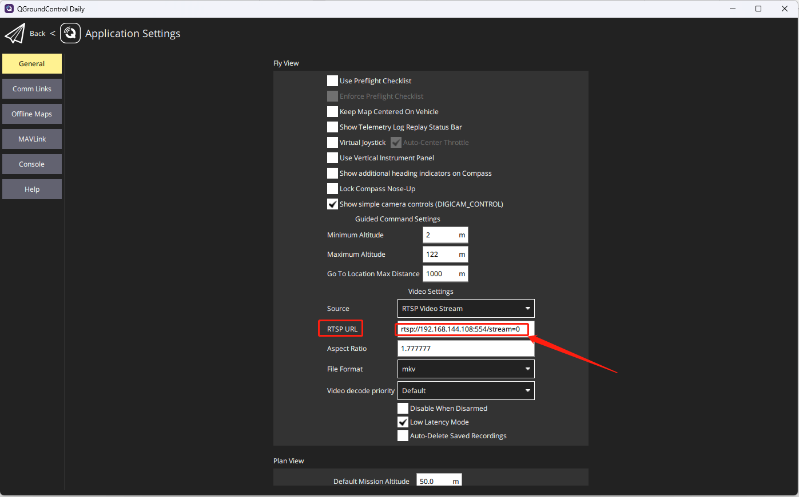
- All are finished after restarting the software.

