Wiring Usage Instructions
（MINI 10P）

Document version number（V1.0.0）
Version number | Update date | Update content
V1.0.0 | 2024.06.01 | Initial version

Date：2024

Thank you for using the gimbal camera of Topotek.
Our company currently has more than 120 types of gimbal cameras. To ensure product diversity, a variety of interfaces have been derived for different application scenarios. The rich gimbal interfaces can be compatible with different third-party links.
This document aims to provide you with a good product usage experience and help you understand the usage method of our gimbal more conveniently and quickly. The technical document can solve most of your questions. You can also visit the official website of Topotek (www.topotek.com) to learn about the relevant content of the product, or call the official after-sales hotline 010-57147023 of Topotek to directly consult the after-sales engineer of Topotek.
Document instructions
Topotek has developed many types of gimbals. For different gimbal interfaces, different wiring methods are required. When you use the gimbal of this interface type (MINI 10P), you can realize the connection between the gimbal and the PC and Android terminals through the wiring and operation methods introduced in this document.

The instructions for using TOPOTEK wiring（MINI 10P）
Interface definition:

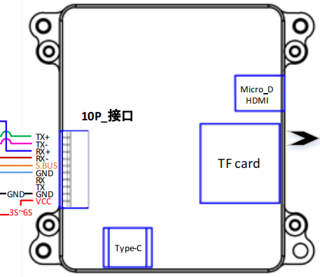

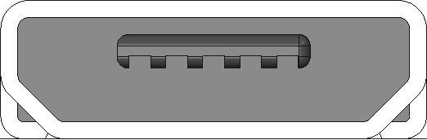
PIN | NAME | DESCRIPTION
1 | Micro-D HDMI | HDMI interface

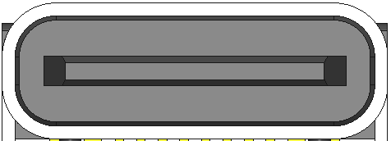

PIN | NAME | DESCRIPTION
1 | TYPE_C | Gimbal camera parameter adjustment interface

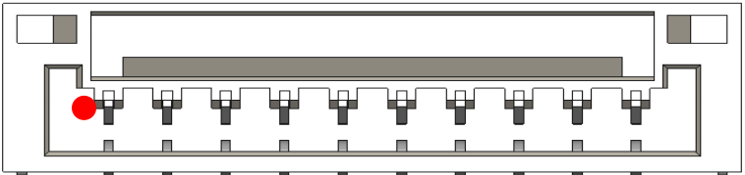

PIN | NAME | DESCRIPTION
1 | VCC | POWER INPUT（3S-6S）
2 | GND | Grounding
3 | TX | Serial port sending
4 | RX | Serial port receiving
5 | GND | Grounding
6 | SBUS | SBUS control
7 | RX- | Network Interface
8 | RX+ | Network Interface
9 | TX- | Network Interface
10 | TX+ | Network Interface

Wiring method of PC ：
Real object diagram of PC wiring 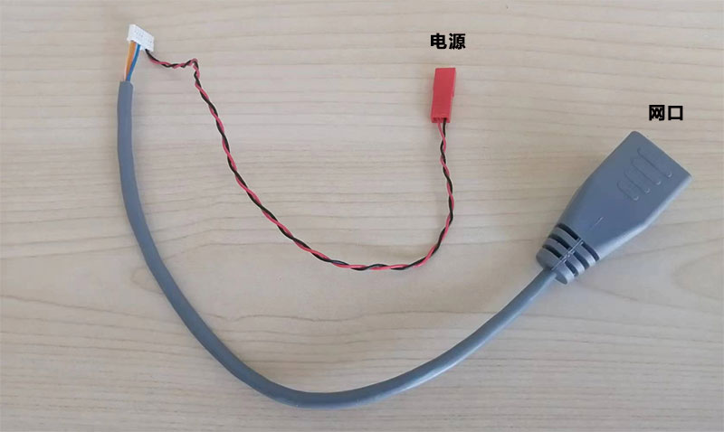
The computer configuration part: After successful connection, for the computer configuration, we need to enter the Control Panel - Network and Internet - Network and Sharing Center - Change Adapter Settings - Ethernet Properties interface, and enter the TCP/IP4 Properties:

Select 【Use the following IP address】
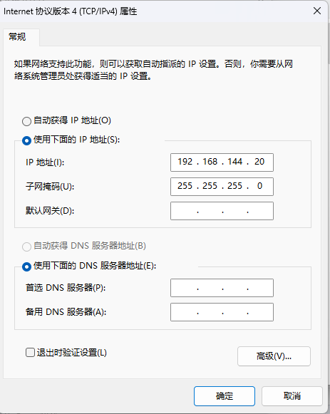
Fill in the IP address as 192.168.144.20, and the value of 20 can be within the range of 2 to 254. Note that the default IP address of the PTZ camera is 192.168.144.108, and the address of the PC should avoid being the same as the IP of the PTZ camera. Fill in the other fields as shown in the figure, then click OK to complete the settings.

Enter the TOPOTEK official ground station. You can download the latest version from the TOPOTEK official website (http://www.topotek.com).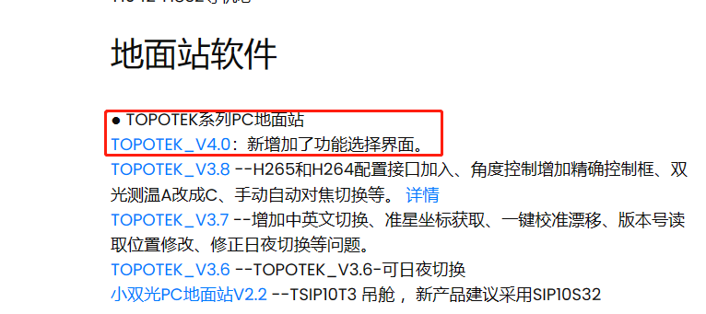

Open the software after downloading：
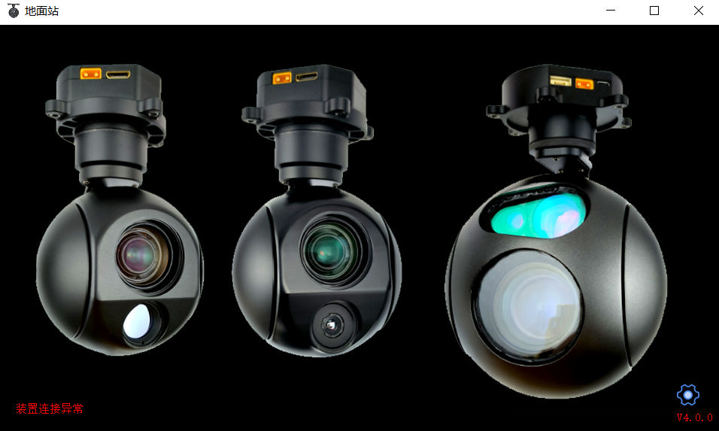

Please pay attention to the lower left corner. If the PC settings in the front are correct and the line connection is correct, the words "Device connection abnormal" will not appear in the lower left corner. After the connection is normal, click the icon in the lower right corner, and a dialog box will pop up.

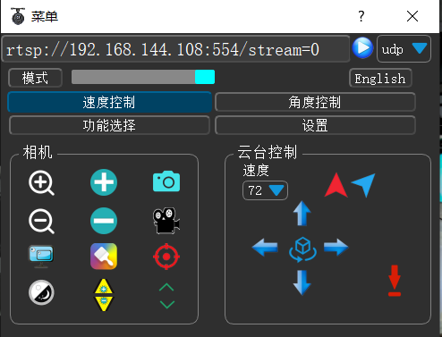

If the IP address of the gimbal camera is not changed, it remains the default, and you can directly click the blue circular button to connect successfully. For software introduction, please refer to the "Topotek Ground Station Operation Instructions".

Connection method for the Android terminal:
Physical diagram of the connection for the Android terminal:

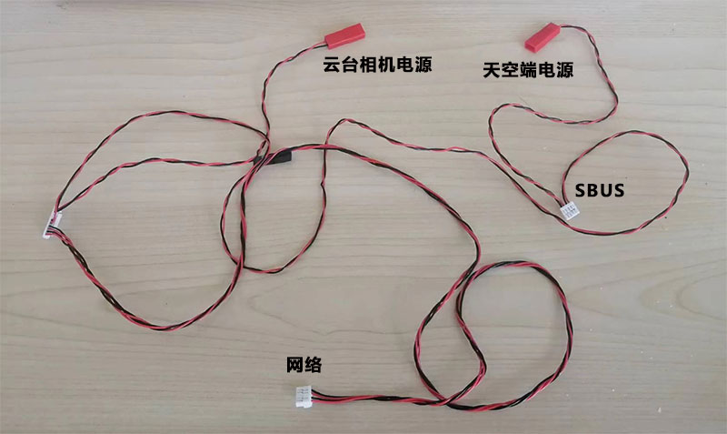

TOPOTEK mobile software
Enter the official APP of TOPOTOK. The latest version can be downloaded on the official website of TOPOTEK (http://www.topotek.com).
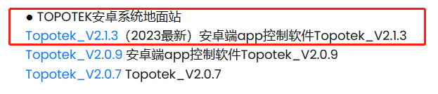

The software can be opened after normal installation.
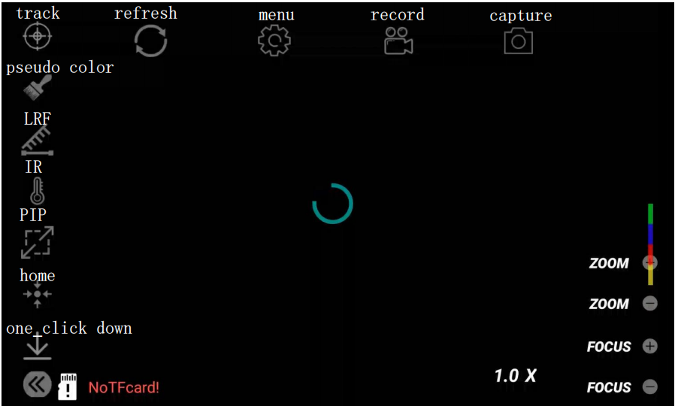
Interface Annotation Diagram
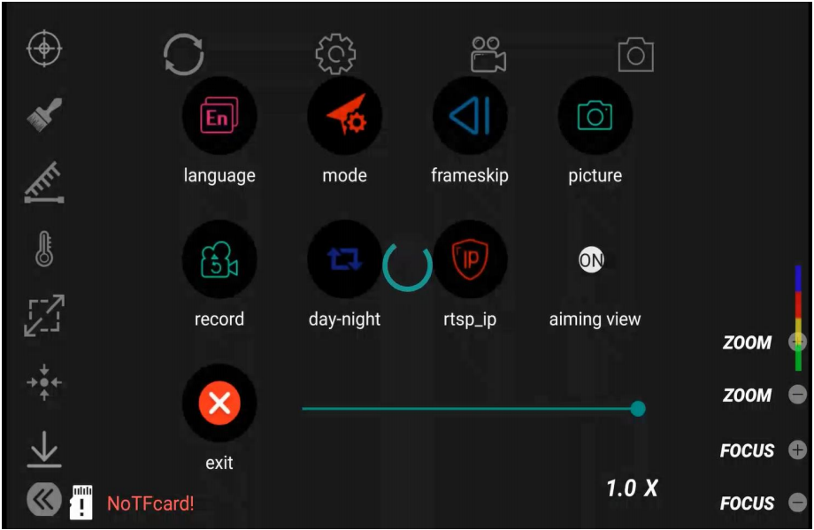
Menu Annotation Diagram

Click the Settings button, click IP Settings, set the IP to 192.168.144.108. After successful setup, click OK and you can connect successfully. If the Gimbal IP address has been changed, just enter the correct address in the IP Settings area and you can connect successfully.

