Wiring Instruction
（8P+6P+XT30）

Document version number（V1.0.0）
Version number | Update data | Update
V1.0.0 | 2024.06.01 | Initial version

Data：2024

Thank you for choosing Topotek gimbal cameras.

Recently we have more than 120 types of gimbal camera.To ensure product diversity, multiple interfaces are derived for different application. Rich PTZ interfaces are compatible with different third-party links.
This document is designed to provide you with a good experience and help you know better about how to use our gimbal in conveniently and quickly. This documents can answer most of your questions. You also can visit the official website of Topotek (www.topotek.cn) to learn more details, or call the official after-sales hotline at 010-57147023 ,our after-sales engineer will help you out.

Document description
We Topotek have developed many models, for different gimbal camera interfaces require different wiring methods. When you use a pod with this interface type (8P+6P+XT30), you can connect the gimbal to PC and Android through the wiring and operation methods introduced in this document.

TOPOTEK wiring instruction（8P+6P+XT30）
Interface definition:
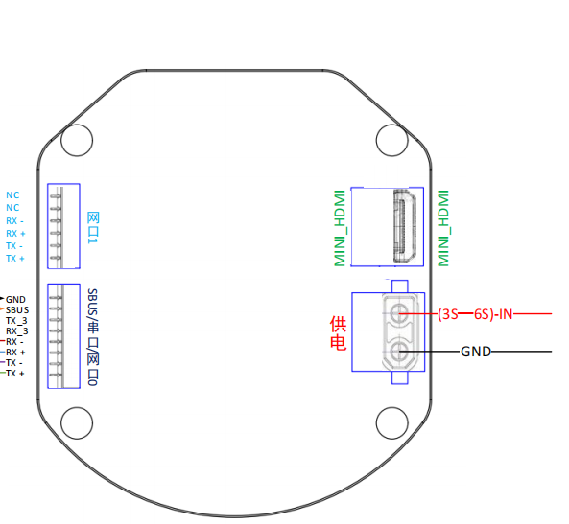

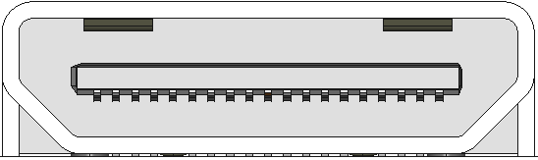

PIN | Item | Description
1 | MINI_HDMII | HDMI port

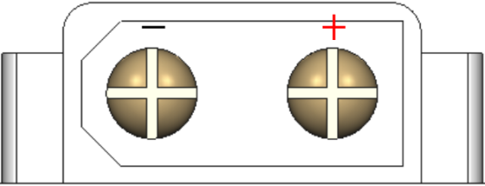

PIN | Item | Description
1 | XT30 | Power port（3S-6S）

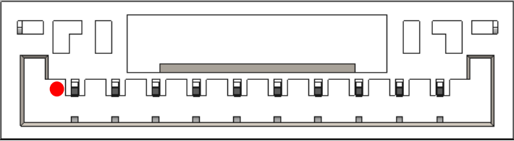
PIN | Item | Description
1 | GND | Ground
2 | SBUS | Sbus control
3 | TX_3 | UART send
4 | RX_3 | UART Receiver
5 | RN | Network interface
6 | RP | Network interface
7 | TN | Network interface
8 | TP | Network interface

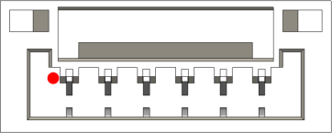

PIN | Item | Description
1 | NC | Empty
2 | NC | Empty
3 | RX- | Reserve network port
4 | RX+ | Reserve network port
5 | TX- | Reserve network port
6 | TX+ | Reserve network port

PC Terminal wiring method ：
PC terminal wiring diagram

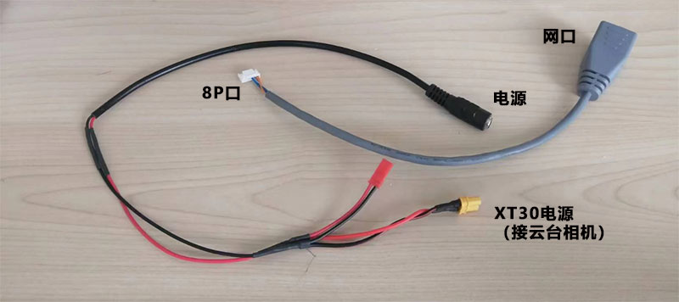

Computer configuration part:
After connecting successfully, we need to configure the computer. Enter the Control Panel--Network and Internet--Network and Sharing Center--Change Adapter Settings--Ethernet Properties interface and enter the TCP/IP4 properties:

Select【Using below IP address】
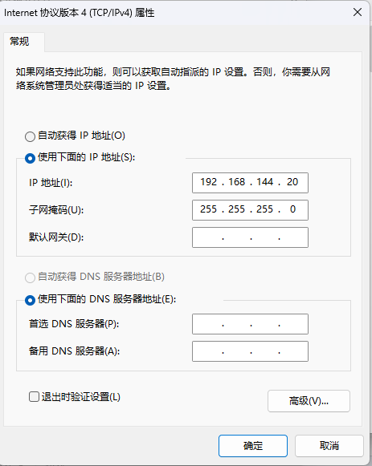
Fill in the IP address as 192.168.144.20, and the value of 20 can be in the range of 2--254. Note that the default IP address of the PTZ is 192.168.144.108. The address of the PC should not be the same as the PTZ IP. Just fill in the rest as shown in the icon, click OK after completion, and the setting is complete.

Please download the latest windows PC ground station from （http://www.topotek.com）
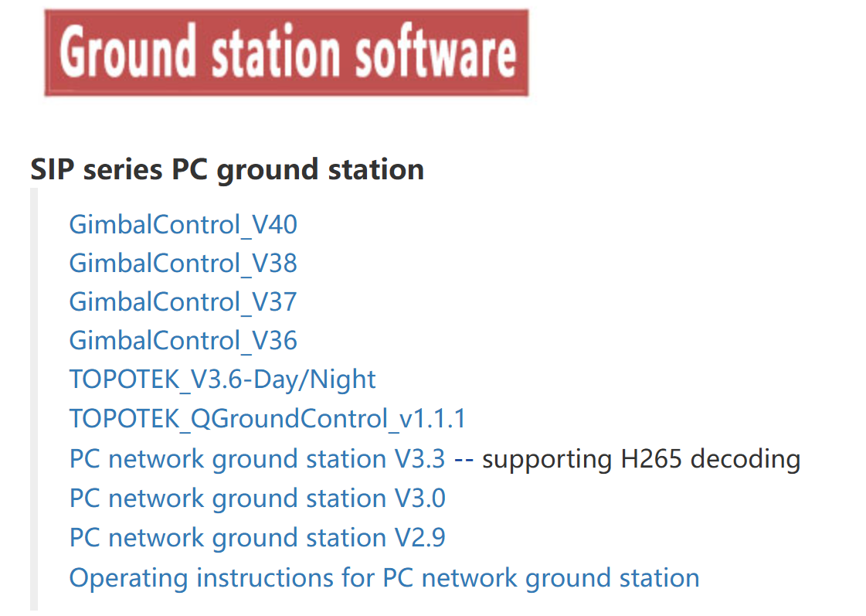

After downloading,please open the app:
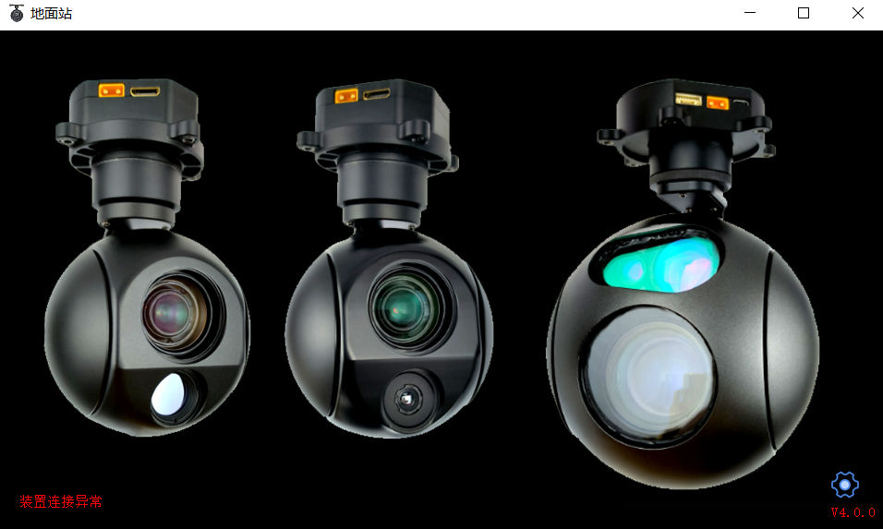

Please pay attention to the lower left corner. If the previous PC settings are correct and the line connection is correct, the words "Device Connection Abnormal" will not appear in the lower left corner. After the connection is normal, click the icon in the lower right corner and a dialog box will pop up:

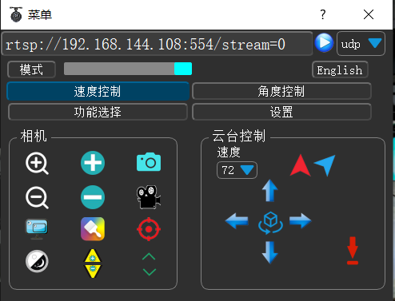

If the IP address of the gimbal camera has not been changed, the default remains unchanged. Simply click the blue round button to connect successfully. For software introduction, please refer to "TOPOTEK Ground Station Operation Instructions".

Android terminal wiring method:
Android terminal wiring diagram:
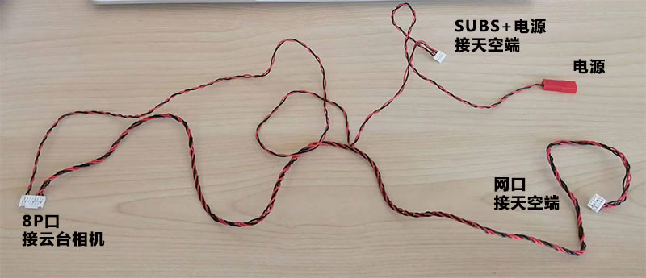

The skydroid h16 as a example H16,The wiring diagram is as follows：

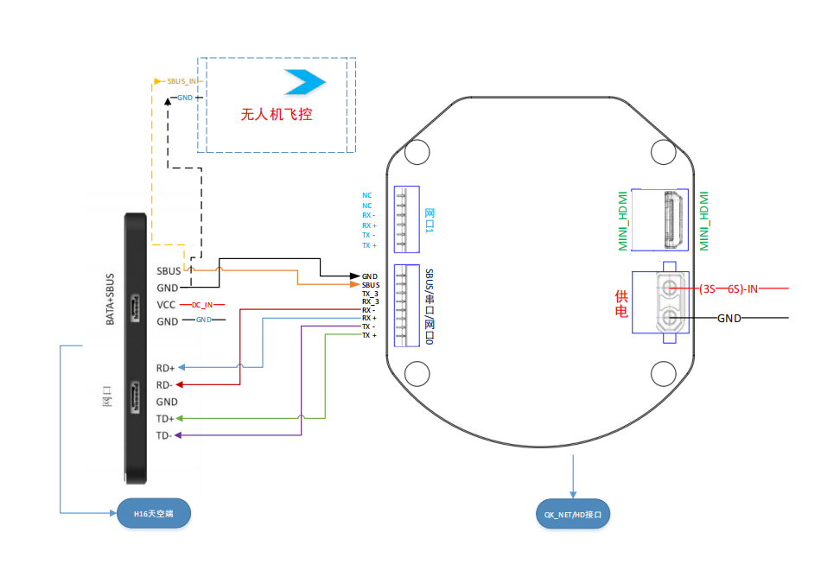

TOPOTEK Mobile terminal software.
Please download the latest android app from（http://www.topotek.com）
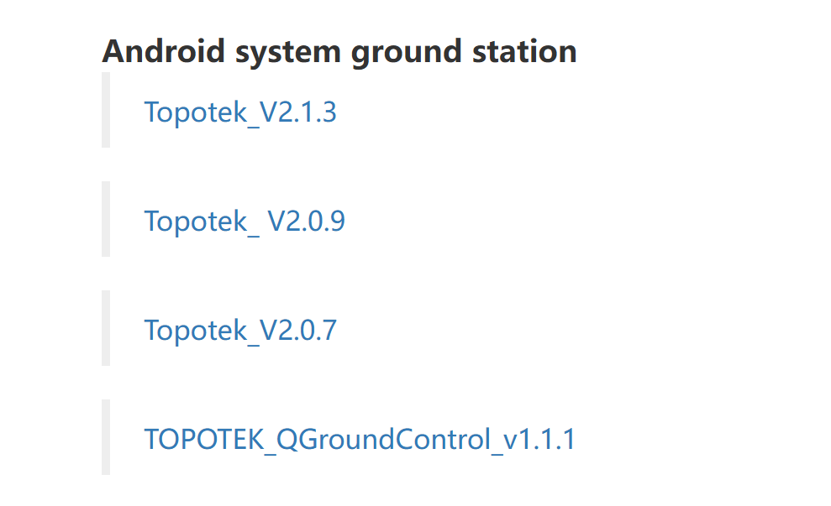

After installing,open the app:

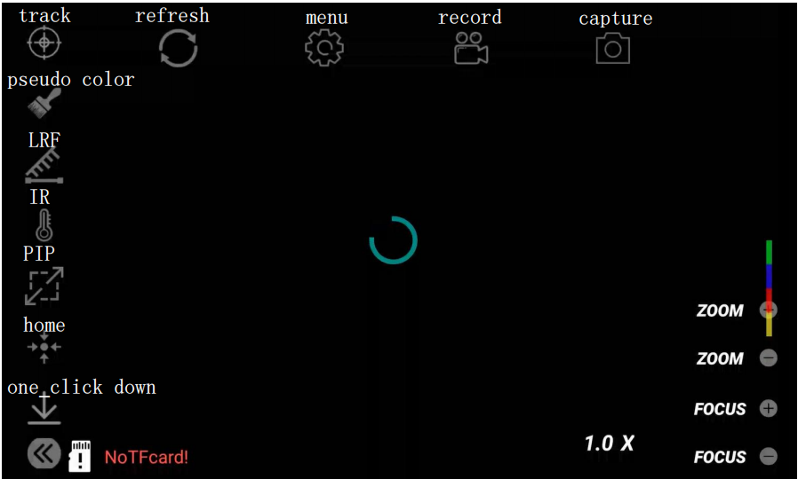
Interface annotation diagram
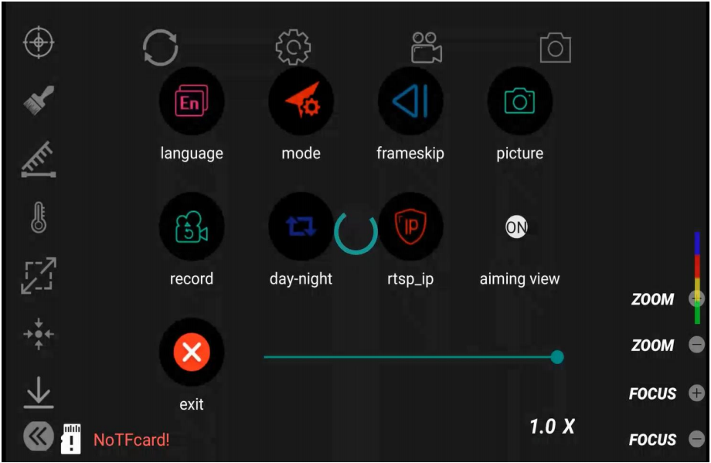
manual annotation diagram
Click the Settings button, click IP Settings, set the IP to 192.168.144.108, and click confirm after success ,then connect successfully. If you have changed the IP address of the PTZ, just enter the correct address in the IP setting area and the connection will be successful.

