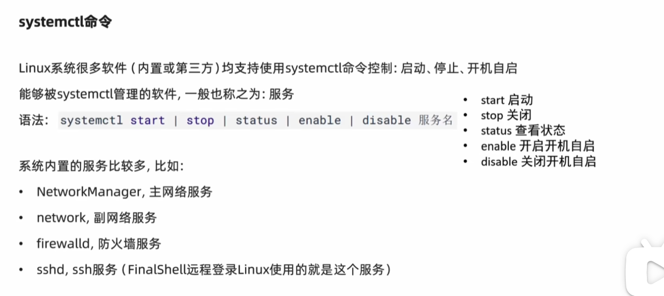



systemctl stop firewalld

Systemctl start firewalld

systemctl enable firewalld

systemctl disable firewalld