

Women in qauntum physics

From the 19th century to the present



Stephen Brown

**Table of Contents**

I. INTRODUCTION 4

1. Before… 4

2. Summary 4

II. BODY 4

1. Marie Curie(Marie Skłodowska Curie, 1867~1934) 4

(1) Nobel Prize in Physics 4

2. Mileva Marić(1875~1948) and Margrethe Nørlund(1890~1984) 4

(1) About the life of them 4

3. Emmy Noether(1882~1935) 4

(1) Noether's theorem(1915) 4

4. Elise Lise Meitner(1878~1968) 4

(1) Nuclear fission(1939) 4

5. Cecilia Helena Payne-Gaposchkin(1900~1979) 4

(1) More than 3000000 observations of variable stars: Stars of Hight Luminosity(1930) 4

6. Maria Goeppert Maye(1906~1972) 5

(1) Elementary Theory of Nuclear Shell Structure(1950) 5

7. Chien-Shiung Wu(1912~1997) 5

(1) Manhattan Project(1939~1946) 5

(2) Wu experiment(1956) 5

8. joan feynman(1927~) 5

(1) discover CME(solar coronal mass ejection) (1971) 5

9. Vera Rubin(1928~2016) 5

(1) Rubin-Ford effect(1976) 5

10. Mildred Dresselhaus(1930~2017) 5

(1) Queen of carbon science: Smallest Freestanding Single-Walled Carbon Nanotube(2003) 5

11. Valentina Vladimirovna Tereshkova (Валенти́на Влади́мировна Терешко́ва) (1937~1999) 5

(1) First woman in space(1963) 5

12. Mary K. Gaillard(1939~) 6

(1) Prediction of the mass of the charm quark prior to its discovery(1975) 6

13. Shirley Ann Jackson(1946~) 6

(1) First African-American woman to have earned a doctorate at the Massachusetts Institute of Technology (MIT) 6

(2) As a Feminist… 6

14. Fabiola Gianotti(1960~) 6

(1) First woman to hold CERN Director-General(2016~2021) 6

(2) ATLAS experiment at CERN 6

15. Lisa Randall(1962~) 6

(1) Randall-Sundrum model(1999) 6

16. Kim Young-Kee(1962~) 6

(1) The Collider Queen: CDF(Collider Detetor at Fermilab) 6

17. Deborah S. Jin(1968~2003) 6

(1) Pioneer of ultracold quantum physcis: Made first fermionic condensate(2003) 6

18. Kim Jung-Sook 7

(1) Observe the Black hole energy spurt moment(2013) 7

III. CONCLUSION 7

# INTRODUCTION

## Before…

## Summary

# BODY

## Marie Curie(Marie Skłodowska Curie, 1867~1934)

### Polonium and Radium

#### Radioactive

: radiation🡪radioactive (high energy elements)

: active elements

#### Discovery of Polonium(1898)

: Polonium is the element that gives off about 300 times more energy than uranium. She named after the name polonium from her native country, Poland.

#### Discovery of Radium(1903)

:

#### Related thesis

: *Research on Radioactive Substances(1903):* doctoral thesis of Marie Curie

(pdf) Radio-active_substances

(pdf) Marie Curie and the radioactivity, The 1903 Nobel Prize in Physics

<https://www.nobelprize.org/educational/nobelprize_info/curie-edu.html>

### Dedication to women education

: part time as a teacher at a girl’s school.

(pdf) The contribution of women to radiobiology- Marie Curie and beond

<http://www.sciencedirect.com.proxy.konkuk.ac.kr:8080/science/article/pii/S1507136715001625?via%3Dihub>

(pdf) (zip) ScienceDirect_articles_23Jan2018_03-40-45.128

## Mileva Marić(1875~1948) and Margrethe Nørlund(1890~1984)

### About the life of them

## Emmy Noether(1882~1935)

### Noether's (first) theorem(1915)

🡪 Noether E (1918). "Invariante Variationsprobleme". *Nachr. D. König. Gesellsch. D. Wiss. Zu Göttingen, Math-phys. Klasse*. **1918**: 235–257.

:relationship of symmetry and conservation law

🡪(수학)derivatoin & 물리적 설명& application 첨부

#### Derivation

#### Physical meaning

#### Physical applications (maybe same?)

### Noether’s second theorem

symmetries of an [action](https://en.wikipedia.org/wiki/Action_(physics)) [functional](https://en.wikipedia.org/wiki/Functional_(mathematics)) with a system of [differential equations](https://en.wikipedia.org/wiki/Differential_equation)

🡪 Translated in Noether, Emmy (1971). "Invariant variation problems". [*Transport Theory and Statistical Physics*](https://en.wikipedia.org/w/index.php?title=Transport_Theory_and_Statistical_Physics&action=edit&redlink=1). **1** (3): 186. *[arXiv](https://en.wikipedia.org/wiki/ArXiv" \o "ArXiv)*:[*physics/0503066*](https://arxiv.org/abs/physics/0503066)*Freely accessible*. [*Bibcode*](https://en.wikipedia.org/wiki/Bibcode):[*1971TTSP....1..186N*](http://adsabs.harvard.edu/abs/1971TTSP....1..186N). [*doi*](https://en.wikipedia.org/wiki/Digital_object_identifier):[*10.1080/00411457108231446*](https://doi.org/10.1080%2F00411457108231446).

## Elise Lise Meitner(1878~1968)

### Nuclear fission(1939)

Meitner, L.; [Frisch, O. R.](https://en.wikipedia.org/wiki/Otto_Robert_Frisch) (1939). "Disintegration of Uranium by Neutrons: A New Type of Nuclear Reaction". *Nature*. **143** (3615): 239. [Bibcode](https://en.wikipedia.org/wiki/Bibcode):[1939Natur.143..239M](http://adsabs.harvard.edu/abs/1939Natur.143..239M). [doi](https://en.wikipedia.org/wiki/Digital_object_identifier):[10.1038/143239a0](https://doi.org/10.1038%2F143239a0)

: first discovered [nuclear fission](https://en.wikipedia.org/wiki/Nuclear_fission) of uranium when it absorbed an extra [neutron](https://en.wikipedia.org/wiki/Neutron); the results were published in early 1939 //by Wik

i

## Cecilia Helena Payne-Gaposchkin(1900~1979)

### More than 3000000 observations of variable stars: Stars of High Luminosity(1930)

🡪요약🡪어디에 사용?

🡪여성으로써의 어려움…

## Maria Goeppert Maye(1906~1972)

### Elementary Theory of Nuclear Shell Structure(1950): book

🡪 Summary

🡪Nobel Prize

## Chien-Shiung Wu(1912~1997)

### Summary about her life: Queen of Nuclear Research

<https://www.atomicheritage.org/profile/chien-shiung-wu>

1940 completed Ph.D

1944 joined the Manhattan Project – SAM(Substitute Alloy Materials) Lab

Radiation detectors

Identif poisoning by xenon-135

After war investigate beta decay – first confirmation of Enrico Fermi’s theory of beta decay

1956 Wu exp.

1958 contribute to (biology) blood and sickle cell anemia

### Manhattan Project(1939~1946)

🡪article: The Manhattan Project Physicist Who Fought for Equal Rights for Women

<http://time.com/4366137/chien-shiung-wu-history/>

🡪

### Wu experiment(1956): (Book)Beta Decay(1965)

🡪summary

### Fought for women rights

🡪 National women’s hall of fame

<https://www.womenofthehall.org/inductee/chienshiung-wu/>

## joan feynman(1927~)

### About her life as a woman

 Hirshberg, Charles (2002-04-18). [*"My Mother, the Scientist"*](http://www.aas.org/cswa/status/2003/JANUARY2003/MyMotherTheScientist.html). [*Popular Science*](https://en.wikipedia.org/wiki/Popular_Science). [*Bonnier Corporation*](https://en.wikipedia.org/wiki/Bonnier_Corporation).

* <https://www.popsci.com/scitech/article/2002-04/my-mother-scientist>

AAS Committee on the Status of women

🡪<https://cswa.aas.org/>

### discover CME(solar coronal mass ejection) (1971)

🡪(wiki) known for : Work on [auroras](https://en.wikipedia.org/wiki/Aurora_(astronomy)), [solar wind](https://en.wikipedia.org/wiki/Solar_wind)

 discovered that the periodic spouting of solar material known as a solar [coronal mass ejection](https://en.wikipedia.org/wiki/Coronal_mass_ejection) (CME) could be identified by the presence of [helium](https://en.wikipedia.org/wiki/Helium) in the solar wind.[[2]](https://en.wikipedia.org/wiki/Joan_Feynman#cite_note-Hirshberg1-2)

 Crooker, N. U.; Feynman, J.; Gosling, J. T. (1977-05-01). [*"On the high correlation between long-term averages of solar wind speed and geomagnetic activity"*](https://ntrs.nasa.gov/search.jsp?R=238288&id=9&qs=Ne%3D20%26N%3D4294924156%26Ns%3DPublicationYear%257C0). [*NASA*](https://en.wikipedia.org/wiki/NASA).

: (wiki) occurrence of auroras is a product of the interaction between the Earth's magnetosphere and the magnetic field of the solar wind

pdf 유료?

🡪(pdf) A High-Speed Erupting-Prominence CME: A Bridge Between Typescause of auroras

### climate change – (ancient) Nile River levels

🡪(wiki) discovered a link between solar variability and climate change in ancient water levels of the [Nile River](https://en.wikipedia.org/wiki/Nile_River).

Is solar variability reflected in the Nile River?

Alexander Ruzmaikin,

1

Joan Feynman,

1

and Yuk L. Yung

Is solar variability reflected in the Nile River?

Alexander Ruzmaikin,

1

Joan Feynman,

1

and Yuk L. Yung

(pdf)Is solar variability reflected in the Nile River? (below link same)

<http://onlinelibrary.wiley.com.proxy.konkuk.ac.kr:8080/doi/10.1029/2006JD007462/epdf>

## Vera Florence Cooper Rubin (1928~2016)

(wiki) known for: G[alaxy rotation problem](https://en.wikipedia.org/wiki/Galaxy_rotation_problem), [dark matter](https://en.wikipedia.org/wiki/Dark_matter), [Rubin–Ford effect](https://en.wikipedia.org/wiki/Rubin%E2%80%93Ford_effect)

### Evidence of Dark matter: galaxy rotation problem

* 참고 기사 (NYT)

<https://www.nytimes.com/2016/12/27/science/vera-rubin-astronomist-who-made-the-case-for-dark-matter-dies-at-88.html>

Vera Rubin, 88, Dies; Opened Doors in Astronomy, and for Women

* 본인 논문(pdf): Rotation curves of spiral galaxies
* 신문 기사

<https://www.npr.org/sections/thetwo-way/2016/12/26/507022497/vera-rubin-who-confirmed-existence-of-dark-matter-dies-at-88>

### Rubin-Ford effect(1976)

"[anisotropy](https://en.wikipedia.org/wiki/Anisotropy) in the [expansion of the Universe](https://en.wikipedia.org/wiki/Expansion_of_the_Universe) on a scale of around 100 million [light years] as revealed by a study of the motions of a sample of spiral galaxies,"

(book) A Dictionary of Astronomy (406 page)

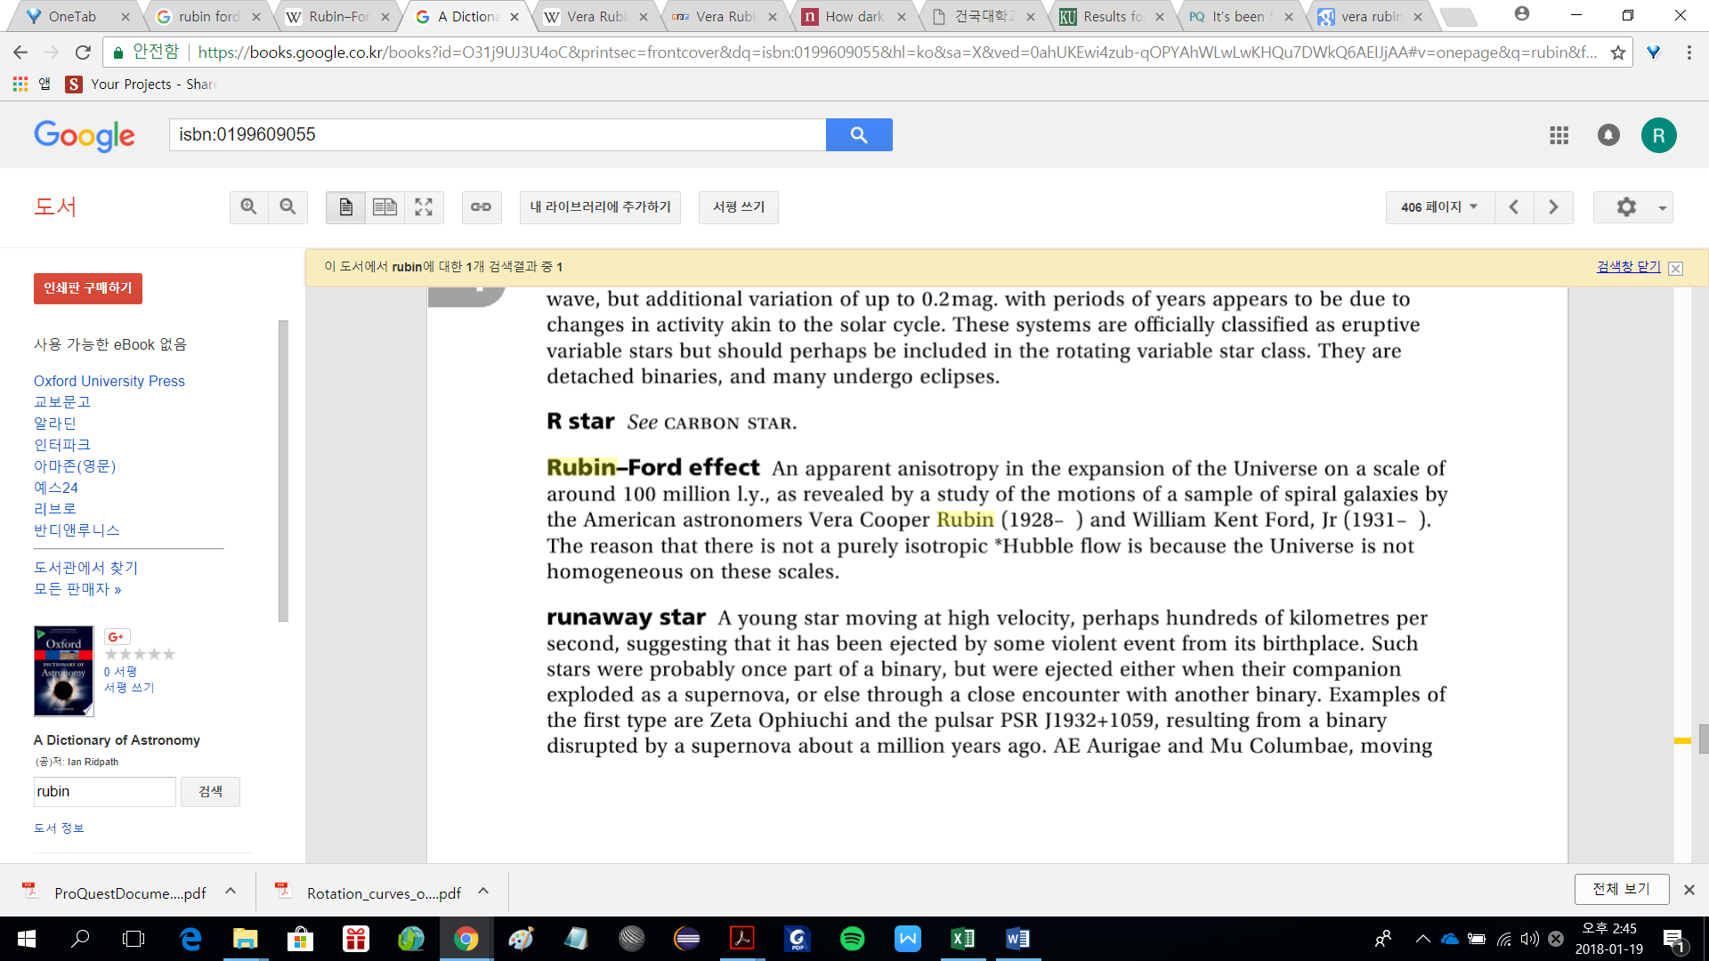

### Life as a woman: Nobel Prize forgot?

<https://www.popsci.com/in-memory-vera-rubin-woman-nobel-prize-forgot>

<https://www.nytimes.com/2017/01/04/opinion/why-vera-rubin-deserved-a-nobel.html>

<https://airandspace.si.edu/explore-and-learn/topics/women-in-aviation/rubin.cfm>

(pdf) It's been 53 years since a woman won the Nobel Prize in physics. What's the holdup?: It's time to give Vera Rubin a Nobel for dark matter.

## Mildred Dresselhaus(1930~2017)

### Queen of carbon science: Smallest Freestanding Single-Walled Carbon Nanotube(2003)

## Valentina Vladimirovna Tereshkova (Валенти́на Влади́мировна Терешко́ва) (1937~1999)

### First woman in space(1963)

## Mary K. Gaillard(1939~)

### Prediction of the mass of the charm quark prior to its discovery(1975)

## Shirley Ann Jackson(1946~)

### First African-American woman to have earned a doctorate at the Massachusetts Institute of Technology (MIT)

### As a Feminist…

## Fabiola Gianotti(1960~)

### First woman to hold CERN Director-General(2016~2021)

### ATLAS experiment at CERN

## Lisa Randall(1962~)

### Randall-Sundrum model(1999)

## Kim Young-Kee(1962~)

### The Collider Queen: CDF(Collider Detetor at Fermilab)

## Deborah S. Jin(1968~2003)

### Pioneer of ultracold quantum physcis: Made first fermionic condensate(2003)

## Kim Jung-Sook

### Observe the Black hole energy spurt moment(2013)

🡪 <http://m.biz.khan.co.kr/view.html?artid=201307201611491&code=930401&med>=

블랙홀의 ‘에너지 분출 순간’ 최초 포착

🡪이론을 관측, 혹은 실험으로 증명: 물리학에서 남은 과제?

🡪관련 논문

(pdf) EVOLUTION OF THE WATER MASER EXPANDING SHELL IN W75N VLA 2

김정숙;김순욱;Kurayama;Honma;Sasao;Surcis;Canto;Torrelles;김상준 2013-04-10 THE ASTROPHYSICAL JOURNAL 767 : 86~94

# CONCLUSION

Reference