|  |  |
| --- | --- |
| **Table 2-1: Autonomous Point Values** (15-seconds) | |
| **Action** | **Value** |
| Cross the Auto Line (a.k.a Auto-Run) | 5 points |
| Switch Ownership | 2, + 2 points per second |
| Scale Ownership | 2, + 2 points per second |

|  |  |
| --- | --- |
| **Table 2-2: Teleoperated Point Values** (2:15 minutes, end game: last 30 seconds) | |
| **Action** | **Value** |
| Switch Ownership | 1, + 1 points per second |
| Scale Ownership | 1, + 1 points per second |
| Power Cube in Vault | 5 points |
| Boost Power Up Bonus | 2 points per second |
| Parked on Platform (did not successfully climb) | 5 points |
| Successful Climb | 30 points |

|  |  |
| --- | --- |
| **Table 2-3: Ranking Point Values** | |
| **Action** | **Value** |
| Match Win | 2 points |
| Match Tie | 1 point |
| Auto-Quest (Autonomous; 3-Bots Auto-Run and team gains ownership of their Switch) | 1 point |
| Face the Boss (Successful Triple Climb) | 1 point |

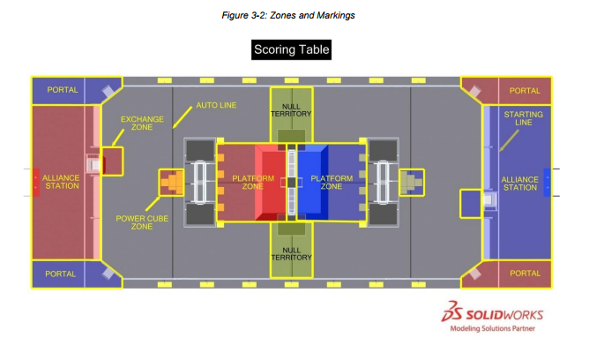

|  |  |  |  |  |
| --- | --- | --- | --- | --- |
| **Table 3-1: PLATE Lighting** | | | | |
| **Color** | **Pre-MATCH** | **AUTO** | **TELEOP** | **Post-MATCH** |
| Blue at 100% brightness | N/A | ALLIANCE color | ALLIANCE color | N/A |
| Blue (pulsing) | N/A | Blue OWNERSHIP | Blue OWNERSHIP | N/A |
| Blue (pulsing) with solid red corners | N/A | Blue FORCE POWER UP is active | Blue FORCE POWER UP is active | N/A |
| Blue at 25% brightness | N/A | Red OWNERSHIP | Red OWNERSHIP | N/A |
| Blue (chase pattern) | N/A | N/A | Blue BOOST POWER UP is active | N/A |
| Red at 100% brightness | N/A | ALLIANCE color | ALLIANCE color | N/A |
| Red (pulsing) | N/A | Red OWNERSHIP or FORCE POWER UP is active | Red OWNERSHIP or FORCE POWER UP is active | N/A |
| Red (pulsing) with solid blue corners | N/A | Red FORCE POWER UP is active | Red FORCE POWER UP is active | N/A |
| Red at 25% brightness | N/A | Blue OWNERSHIP | Blue OWNERSHIP | N/A |
| Red (chase pattern) | N/A | N/A | Red BOOST POWER UP is active | N/A |
| Purple (pulsing) | N/A | N/A | N/A | FIELD is safe for FIELD STAFF |
| Green | N/A | N/A | N/A | FIELD is safe for all |
| Off | MATCH  ready to start | N/A | N/A | N/A |

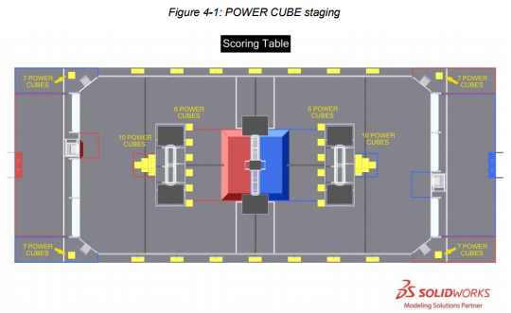

|  |  |  |
| --- | --- | --- |
| **Table 3-3: Open FMS Ports** (FMS: Field Management System) | | |
| **Port** | **Designation** | **Bi-directional?** |
| UDP/TCP 1180-1190 | Camera data from the roboRIO to the Driver Station (DS) when the camera is connected to the roboRIO via USB | Yes |
| TCP 1735 | SmartDashboard | Yes |
| UDP 1130 | Dashboard-to-ROBOT control data | Yes |
| UDP 1140 | ROBOT-to-Dashboard status data | Yes |
| HTTP 80 | Camera connected via switch on the ROBOT | Yes |
| HTTP 443 | Camera connected via switch on the ROBOT | Yes |
| UDP/TCP 554 | Real-Time Streaming Protocol for h.264 camera streaming | Yes |
| UDP/TCP 5800-5810 | Team Use | Yes |

|  |  |  |  |  |
| --- | --- | --- | --- | --- |
| Table 4-1: FIRST® POWER UP Rewards | | | | |
| **Action** | **Criteria** | **MATCH Points** | | **Ranking** |
|  |  | **AUTO** | **TELEOP** | **Points** |
| AUTO-RUN | For each ROBOT that breaks the vertical plane of the AUTO LINE with its BUMPER at any point in the AUTO stage | 5 | ̶ | ̶ |
| OWNERSHIP | SCALE | 2 + 2/sec | 1 + 1/sec | ̶ |
| ALLIANCE’S SWITCH | 2 + 2/sec | 1 + 1/sec | ̶ |
| VAULT | For each POWER CUBE placed in the VAULT | ̶ | 5 | ̶ |
| PARKING | For each ROBOT fully supported by the SCALE (either directly or transitively), not at all in the opponent’s PLATFORM ZONE, and has not CLIMBED | ̶ | 5 | ̶ |
| CLIMBING | For each ROBOT fully supported by the SCALE (either directly or transitively) with BUMPERS fully above the BRICKS at T=0, and not at all in the opponent’s PLATFORM ZONE | ̶ | 30 | ̶ |
| AUTO QUEST | ALLIANCE completes three (3) AUTO-RUNS and has OWNERSHIP of their SWITCH at T=0 of the AUTO stage | ̶ | ̶ | 1 |
| FACE THE BOSS | All three (3) ALLIANCE ROBOTS have CLIMBED or two (2) ROBOTS have CLIMBED and the ALLIANCE has played the LEVITATE POWER UP | ̶ | ̶ | 1 |
| Win Match | ALLIANCE’s final MATCH score exceeds their opponents’ | ̶ | ̶ | 2 |
| Tie Match | ALLIANCE’s final MATCH score equals their opponents’ | ̶ | ̶ | 1 |

Points are earned for establishing OWNERSHIP, with additional points earned for each additional second of OWNERSHIP. For example, a team that establishes OWNERSHIP of their SWITCH three (3) seconds after the start of AUTO and maintains OWNERSHIP for five (5) seconds earns two (2) points + ten (10) points, for a total of twelve (12) points. The MATCH points listed in Table 4-1 for OWNERSHIP during the TELEOP stage are increased if the BOOST POWER UP is played.

|  |  |  |  |
| --- | --- | --- | --- |
| Table 4-2: FIRST® POWER UP Rewards | | | |
| **Name** | # of POWER CUBES | Effect | Duration (seconds) |
| **LEVITATE** | 3 | An additional CLIMBING ROBOT, up to a maximum of three (3) ROBOTS, is credited to the ALLIANCE at the end of the MATCH | N/A |
| **FORCE** | 1 | ALLIANCE earns OWNERSHIP points from their SWITCH regardless of PLATE position | 10 |
| 2 | ALLIANCE earns OWNERSHIP points from the SCALE regardless of PLATE position | 10 |
| 3 | ALLIANCE earns OWNERSHIP points from the SWITCH and the SCALE regardless of PLATE position | 10 |
| **BOOST** | 1 | Increases the points for OWNERSHIP of the ALLIANCE’S SWITCH from one (1) point per second to two (2) points per second | 10 |
| 2 | Increases the points for OWNERSHIP of the SCALE from one (1) point per second to two (2) points per second | 10 |
| 3 | Increases the points for OWNERSHIP of both the ALLIANCE’S SWITCH and the SCALE from one (1) point per second to two (2) points per second | 10 |

