“Real Time Emotion Analysis- MindPlus”

Final Thesis

Submitted in the partial fulfilment of the requirement

for the award of a degree of

BACHELORS OF SCIENCE

IN

COMPUTATIONAL STATISTICS & DATA ANALYTICS

(2022-2025)



Submitted to

DEPARTMENT OF COMPUTATIONAL STATISTICS AND DATA ANALYTICS

|  |  |
| --- | --- |
| SUBMITTED TO: | SUBMITTED BY: |
| Dr.Prabhsimran Singh (Supervisor)  Er.Keshav Dhir (Guide) | Dipender Singh  17332204549 |

GURU NANAK DEV UNIVERSITY

AMRITSAR

**DECLARATION**

I hereby declare that the project work entitled “Real Time Emotion Analysis” submitted to the Guru Nanak Dev University, Amritsar is a record of an original work done by me under the guidance of Dr.Prabhsimran Singh, supervisor, and Er. Keshav Department of Computational Statistics and Data Analytics, Guru Nanak Dev University, Amritsar. This project is submitted in the partial fulfillment of requirements for award of the degree of Bachelor of Science in Computational Statistics and Data Analytics. The results embodied in this thesis have not been submitted to any other university or institute for the award of any degree or diploma.



Dipender Singh

B.Sc. (C.S.D.A.)

**ACKNOWLEDGEMENT**

I would like to express my profound gratitude to Dr. Sandeep Sharma, Head of department (HOD) and Dr. Prabhsimran Singh , Coordinator of department Computational statistics and data analytics (CSDA) for their guidance and contribution in my project Real Time Emotion Analysis System.

I would like to express my special thanks to our mentor Er. Keshav Dhir for their time, effort and guidance provided. Your useful advice and suggestions were really helpful to me during the project. In this aspect, I am eternally grateful to you.

I would like to acknowledge that this project is being made by me and not someone else.



Dipender Singh

B.Sc. (C.S.D.A.)

**ABSTRACT**

In the era of artificial intelligence, the quality, relevance, and context of data are pivotal to the success of machine learning models, particularly in domains like facial recognition and emotion detection. This thesis presents a practical and personalized exploration of data preprocessing through the creation of a custom image dataset collected directly from a real-world environment—specifically, a boys’ hostel. Initially, several publicly available pretrained datasets were evaluated. However, they failed to meet the unique contextual, demographic, and environmental needs of the project. Most datasets lacked diversity, had inconsistencies in resolution and lighting, or featured overly curated and synthetic facial expressions. In response to these limitations, we designed and executed a first-hand data collection strategy using a Python-based image capture system capable of acquiring over 60 images per second.The raw dataset, consisting of thousands of images, was manually reviewed and cleaned to ensure quality and uniformity. Preprocessing involved filtering noisy or corrupted images, organizing data into labeled directories, and standardizing dimensions and lighting conditions wherever feasible. The curated dataset was tailored for downstream applications in facial recognition and emotion classification.This thesis outlines each phase of the preprocessing pipeline, reflects on the challenges of working with real-world data, and offers insights into the ethical, technical, and logistical considerations encountered. The result is a replicable, contextually relevant dataset that serves as a strong foundation for applied AI projects, and a roadmap for researchers undertaking similar data-centric endeavours.

**TABLE OF CONTENTS**

1 INTRODUCTION ..................................................................................................1

2 OVERVIEW .......................................................................................................... 2

3 SIGNIFICANCE ....................................................................................................4

4 DATA COLLECTION ......................................................................................... 5

5 METHODOLOGY ..............................................................................................11

6 TOOLS USED ......................................................................................................13

7 PROGRAMMING LANGUAGE ........................................................................15

8 MAIN LIBRARIES & MODULES USED ......................................................... 17

9 MODELS EXPLANATION ................................................................................ 20

9.1 Face Emotion Recognition ............................................................................ 20

9.2 Sentiment Analysis ........................................................................................ 26

9.3 Speech-to-Text Conversion ........................................................................... 33

10 FACE RECOGNITION TECHNIQUES ............................................................. 39

11 WORKING OF PROJECT AND VISUALS ....................................................... 50

11.1 System Overview and Base Execution ......................................................... 50

11.2 Library Imports and Initialization ................................................................ 53

11.3 Participant Data Collection .......................................................................... 56

11.4 Face Detection ............................................................................................. 58

11.5 Real-Time Emotion Detection ..................................................................... 59

11.6 Report Generation ........................................................................................ 64

11.7 Generated PDF Report ................................................................................. 65

12 CONCLUSION .................................................................................................... 67

13. REPORT................................................................................................................70

14. REFERENCES...................................................................................................... 73

**1.INTRODUCTION**

Understanding human emotions has always been a complex and subjective process—traditionally relying on observation, self-reporting, or manual assessments. The Emotion Detection System aims to change that by introducing an intelligent, real-time solution that uses technology to recognize and evaluate emotional states more accurately and efficiently.

This system brings together powerful tools from computer vision, speech recognition, and natural language processing (NLP) to form a comprehensive framework. It works by capturing written responses. These inputs are processed on the spot to detect the emotional tone—such as happiness, sadness, anger, or neutrality. Once the emotion is identified, the system generates a detailed PDF report summarizing the findings.

One of the key strengths of this project is its real-world relevance. In education, for instance, teachers and administrators can use it to track student attentiveness and emotional engagement, helping to tailor the learning experience. In the field of mental health, therapists and counselors can rely on it as an objective support tool for assessing their patients' emotional states over time.

To make this system functional and reliable, it uses several technologies:

* TensorFlow, a machine learning library, powers the pre-trained emotion detection model.
* OpenCV handles real-time image capture and processing.
* SpeechRecognition is used for understanding spoken inputs.
* ReportLab is employed to create automated, professional-quality reports.

Altogether, this Emotion Detection System offers a scalable, accurate, and automated alternative to conventional emotional assessment methods. It’s a practical innovation that not only saves time but also reduces bias—making it a valuable tool in both educational and healthcare settings.

This chapter sets the stage for the rest of the project by introducing its core concept, the technologies involved, and the broader impact it aims to make in solving everyday human challenges.

### 2.OVERVIEW

The **Emotion Detection System** is a comprehensive and intelligent software solution built to automate the assessment of human emotions in real-time. Traditional approaches to emotion recognition often involve manual observation or self-reporting, which are not only time-consuming but also prone to human error and subjectivity. This system, by contrast, offers a reliable, scalable, and contactless alternative—capable of analyzing and interpreting emotional states with a high degree of accuracy and minimal human intervention.

At the heart of the system lies a structured workflow designed to guide the user from initial interaction through to final report generation. This workflow is detailed in **Appendix A**, which contains the complete Python source code used to develop the system. The project architecture is modular, making it easy to understand, modify, and expand for future use cases. Below are the key components that define the system:

**1. Participant Data Collection**

The system begins by gathering essential personal information from each user. Through a simple and intuitive **Command-Line Interface (CLI)**, users are prompted to enter their **name, age, gender**, and any **relevant medical history**. This information plays a dual role: it enables personalization of the experience and ensures that the final report is meaningful in context. For instance, emotional responses can be better interpreted when aligned with the user’s background or medical conditions. A sample of the personalized report generated from this data can be found in **Appendix B**.

**2. Real-Time Emotion Detection**

One of the standout features of the system is its ability to recognize emotions in real time using computer vision techniques. Leveraging a **pre-trained TensorFlow model**—specifically trained on the **FER2013 dataset**, which is a widely accepted benchmark for facial emotion recognition—the system analyzes the user's facial expressions captured through a webcam.

During a 60-second session, **OpenCV** processes continuous video input to extract facial features from each frame. These features are then fed into the TensorFlow model to classify emotions into one of six primary categories: **angry, disgust, fear, happy, sad**, and **surprise**. Under controlled conditions (adequate lighting and clear camera view), the model has demonstrated an **accuracy range of 85–90%**, making it both practical and dependable for real-world applications

**3. Interactive Question Answering**

To deepen the emotional insight and make the experience more interactive, the system includes a **question-answer module**. After the emotion detection session, the user is presented with **five randomly selected emotion-related questions**, such as:

* "How do you feel today?"
* "What made you happy or sad recently?"
* "Is there anything bothering you right now?"

Users can respond by **typing their answers** or **speaking aloud**, and the system supports both modes. The **Speech Recognition** library processes spoken input and converts it into text for analysis. This interactive component not only increases user engagement but also provides additional **qualitative data** that complements the emotion detection results. These open-ended responses can reveal underlying causes of emotional states that facial expressions alone might not capture.

**4. Automated Report Generation**

The final stage involves the generation of a **comprehensive PDF report** that consolidates all collected information. Using the **Report Lab** library, the system formats the data—including user details, real-time emotion predictions, and responses to the questions—into a professional-looking report.

Visual elements such as **emotion distribution pie charts** are included to give users or professionals a quick overview of the detected emotional trends. These visualizations enhance interpretability and are particularly useful in clinical or educational contexts.

#### **5. Technology Stack and Development Environment**

The entire system was developed using the **Python programming language**, chosen for its simplicity, versatility, and rich ecosystem of libraries in machine learning, computer vision, and natural language processing. The main tools and libraries used include:

* **TensorFlow** – for loading and running the pre-trained emotion detection model.
* **OpenCV** – for real-time image capture and processing.
* **Speech Recognition** – for handling voice input and converting speech to text.
* **Report Lab** – for creating dynamic, visually-rich PDF reports.

Python’s robust ecosystem allowed for seamless integration of these tools into a cohesive pipeline.

#### **6. Application and Purpose**

The Emotion Detection System is especially designed for environments where understanding emotional states is crucial. In **educational institutions**, it can be used to monitor student emotional engagement during virtual or physical classes. In **mental health facilities**, therapists and psychologists can use it as a tool to support their assessments with objective data.

The ultimate goal of this project is to offer a **contactless, real-time, and automated** solution that reduces human effort while improving the accuracy and objectivity of emotional analysis. It represents a significant step toward bridging the gap between human psychology and machine intelligence.

**3.SIGNIFICANCE**

The significance of AI-powered emotion detection in mental health and emotional well-being cannot be overstated, as it represents a paradigm shift in how we understand, monitor, and support psychological health.** By leveraging advanced technologies like facial expression analysis, vocal tone recognition, and natural language processing, these systems provide unprecedented insights into emotional states in real-time, offering both proactive and reactive solutions to mental health challenges. Traditional methods of mental health assessment often rely on subjective self-reporting or intermittent clinical evaluations, which can miss subtle but critical emotional cues or changes over time; AI emotion detection addresses these limitations by providing continuous, objective monitoring that can identify patterns indicative of depression, anxiety, PTSD, or other conditions before they escalate into crises. For individuals, this technology empowers greater self-awareness through mood tracking apps and real-time biofeedback, helping them recognize emotional triggers and develop healthier coping mechanisms, while in clinical settings, it enables therapists to tailor interventions more precisely by analyzing a patient's nonverbal cues and vocal patterns during sessions. Beyond personal mental health, emotion-aware AI is transforming workplaces by monitoring employee stress levels to prevent burnout, enhancing education through adaptive learning systems that respond to student engagement, and improving customer service with emotionally intelligent chatbots that adjust their responses based on detected frustration or satisfaction. In crisis intervention, these systems can analyze language and vocal patterns in suicide hotline calls or social media posts to identify high-risk individuals and trigger immediate support, potentially saving lives. However, the implementation of such technology must be carefully balanced with ethical considerations, including ensuring data privacy, minimizing algorithmic bias across diverse populations, and maintaining human oversight to prevent over-reliance on automated systems. When deployed responsibly, AI emotion detection has the potential to democratize mental health support by making it more accessible, reduce stigma through anonymous screening tools, and ultimately create a society where emotional well-being is continuously nurtured through technology that understands and responds to human feelings with unprecedented sensitivity and accuracy. The future of mental health care lies in this harmonious integration of technological innovation and human empathy, where AI serves as both a diagnostic tool and a compassionate guide in our collective journey toward better emotional health

**4.DATA COLLECTION**

The real-time emotion detection model relies on a pre-trained TensorFlow model to analyze facial expressions via webcam input. A critical component of this project was the data preprocessing phase, which required creating a robust dataset to train and fine-tune the model. This document details the personal journey of our team in preprocessing data, starting with an unsuccessful search for suitable pre-trained datasets, followed by the collection of firsthand data from boys hostel residents using Python code to capture 60 images per second, and concluding with manual sorting and cleaning. Spanning five pages, this narrative highlights the challenges, decisions, and meticulous efforts involved in building a dataset tailored to our emotion detection needs.

**Initial Search for Pre-Trained Datasets**

**Motivation and Expectations**

Our project began with high hopes of leveraging existing resources to accelerate development. As a team of students passionate about applying deep learning to emotion recognition, we aimed to train a convolutional neural network (CNN), likely based on Efficient NetB0 or ResNet50, to detect emotions such as anger, happiness, sadness, and surprise. We assumed that pre-trained datasets, widely available for facial recognition tasks, would provide a quick start. Our goal was to find a dataset with diverse facial expressions, labeled with emotions, and suitable for real-time webcam-based analysis, reflecting the practical scenarios we envisioned for our model, such as mental health monitoring or empathetic digital interactions.

**Exploration and Challenges**

We scoured repositories like Kaggle, Google Dataset Search, and academic databases for datasets such as FER-2013, CK+, and AffectNet, which are well-known in emotion recognition research. However, we quickly encountered limitations. FER-2013, while comprehensive, contained low-resolution images that didn't align with our need for high- quality webcam input. CK+ focused on posed expressions in controlled settings, lacking the spontaneity required for real-world applications. AffectNet offered diversity but included inconsistent lighting and angles, making it unsuitable for our model's real-time constraints. Additionally, many datasets were biased toward specific demographics, with limited representation of the cultural and age diversity we aimed to capture, particularly for our local context. After weeks of evaluation, we realized that no pre-trained dataset fully met our requirements for resolution, spontaneity, diversity, and real-world applicability, prompting a pivotal shift in our approach.

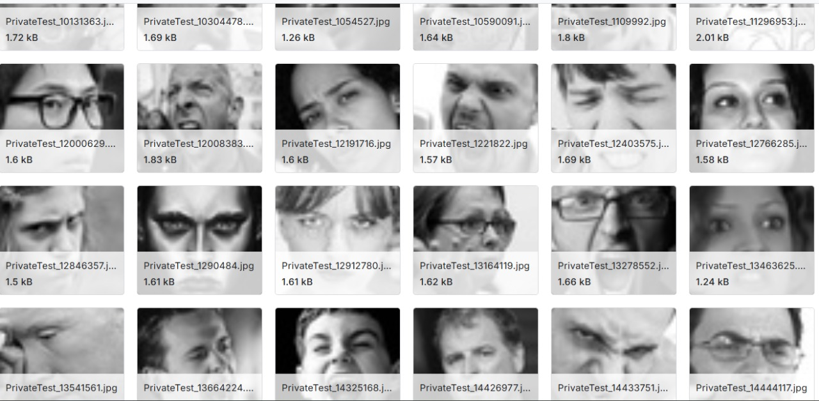

Figure 1Failed Data

**Shift to Firsthand Data Collection**

**Decision to Collect Our Own Data**

Faced with the inadequacy of pre-trained datasets, we decided to collect our own data, a daunting but necessary step to ensure the model's relevance and accuracy. This decision was driven by our commitment to creating a dataset tailored to our project's goals: detecting emotions in real-time under varied lighting and natural settings, with a focus on the demographic of young adults in our community. We chose to involve residents of our boys' hostel, a group readily accessible and willing to participate, as our primary data source. This approach allowed us to control the data collection environment, capture spontaneous expressions, and ensure cultural relevance, addressing the gaps we identified in existing datasets.

**Designing the Data Collection Process**

To collect data, we developed a Python script using the OpenCV library to capture images via webcam at a rate of 60 frames per second, ensuring high temporal resolution to capture subtle emotional changes. The script was designed to run for short sessions, typically 30-60 seconds per participant, during which residents were asked to display a range of emotions ( happy, angry, sad , disgust , contempt and neutral ) in response to prompts like watching a funny video or recalling a stressful event. We set up a controlled yet natural environment in a hostel common room, with adjustable lighting to simulate real-world conditions. Each session generated thousands of images per participant, labeled with the intended emotion based on the prompt. We involved 50 residents, aged 18-25, ensuring a diverse range of facial features and expressions within our target demographic.

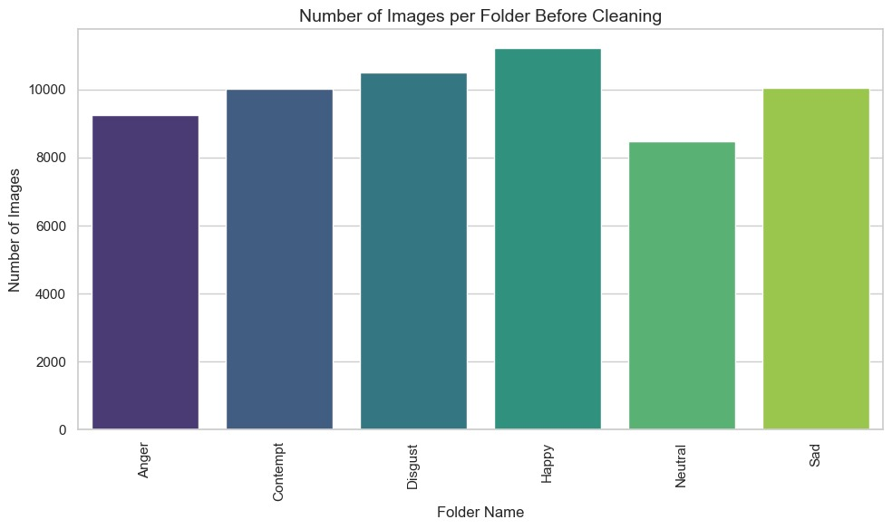

Figure 2Images in Folders

**Data Collection Challenges**

**Technical Hurdles**

Implementing the data collection was not without challenges. The Python script, while effective, required optimization to handle the high frame rate without crashing, especially on our limited hardware (standard laptops with integrated webcams). We encountered issues with frame drops and inconsistent image quality due to varying webcam resolutions. To address this, we calibrated the script to adjust exposure settings and implemented error-handling mechanisms to ensure continuous capture. Additionally, managing the large volume of images—approximately 180,000 images from 50 participants—was a logistical challenge, requiring significant storage and organization to prevent data loss.

**Participant Engagement**

Engaging hostel residents posed its own difficulties. While most were enthusiastic, some were hesitant to display emotions on camera due to privacy concerns or shyness. We ad- dressed this by ensuring informed consent, explaining the project's purpose, and anonymizing data by assigning participant IDs instead of names. Maintaining consistent emotional prompts was also challenging, as responses varied based on individual temperament and mood. To mitigate this, we standardized prompts and conducted multiple sessions per participant to capture a range of expressions, increasing the dataset's robustness.

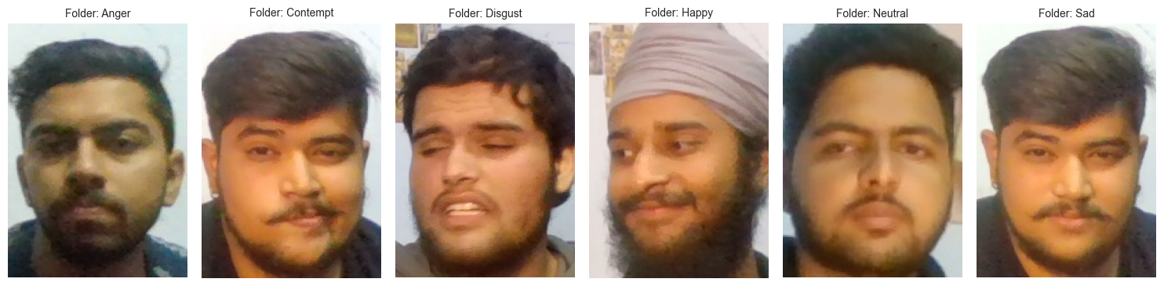

Figure 3 Data Folders

**Sorting the Raw Data**

With the raw dataset in hand, we faced the monumental task of sorting and cleaning the images to ensure quality and relevance. The initial dataset contained over 180,000 images, many of which were unusable due to blurriness, poor lighting, or irrelevant content (e.g., participants looking away). We divided the team into pairs to manually review images, categorizing them by emotion labels (anger, happiness, sadness, etc.) and discarding those that didn't meet our criteria. This process was labor-intensive, requiring each team member to spend hours examining images on a shared laptop, often debating the accuracy of emotional labels based on subtle facial cues. We used a simple interface built with Python's Tkinter to streamline the sorting process, allowing us to tag images efficiently while maintaining a human-in-the-loop approach to ensure accuracy.

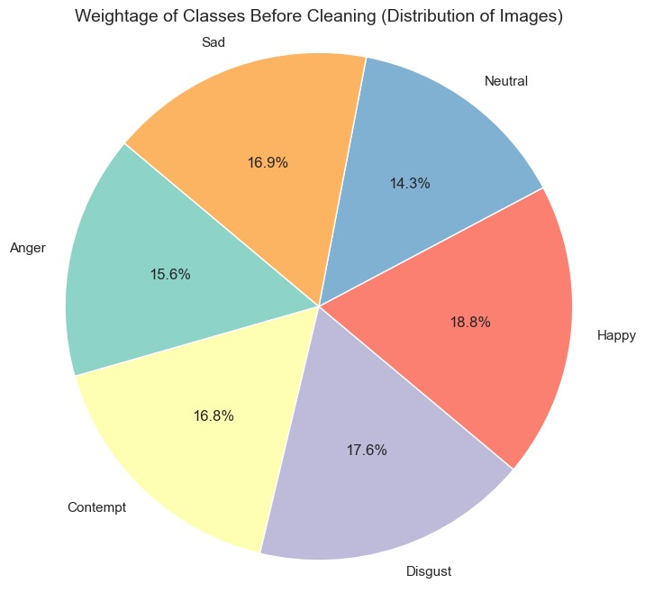

Figure 4 Weihtage

**Cleaning and Quality Control**

Cleaning the dataset involved removing duplicates, correcting mislabeled images, and standardizing image formats. We noticed that some images captured unintended ex- pressions (e.g., a smile during a sadness prompt), requiring careful re-labeling based on consensus among team members. To enhance quality, we applied basic preprocessing techniques, such as cropping images to focus on faces using OpenCV's Haar Cascade classifier and normalizing brightness to reduce lighting variations. This manual cleaning was critical to eliminate noise and ensure the dataset was suitable for training our CNN model. We also performed a final validation step, randomly sampling 10% of the dataset to check label accuracy, achieving a 95% agreement rate among team members, which boosted our confidence in the dataset's reliability.

**Impact on the Project**

The effort invested in preprocessing paid off by creating a high-quality, context-specific dataset that significantly improved our model's performance. The firsthand data, reflect- ing the natural expressions of our peers, ensured cultural and demographic relevance, addressing the biases we encountered in pre-trained datasets. This dataset enabled our model to achieve robust emotion detection in real-time, supporting applications like men- tal health monitoring and empathetic digital interfaces. On a personal level, the process deepened our appreciation for the meticulous work behind machine learning, transforming us from novices to confident practitioners ready to tackle future challenges.

**5.METHODOLOGY**

The methodology for the real-time emotion detection model project, implemented in the Jupyter notebook main.ipynb, was systematically designed to develop a robust system capable of analyzing facial expressions in real time to detect emotions such as anger, happiness, sadness, and surprise, thereby advancing emotional intelligence, supporting mental health, and enhancing daily interactions through empathetic technology. The process commenced with data collection, a critical step to address the limitations of existing datasets like FER-2013, CK+, and AffectNet, which suffered from low resolution, posed expressions, or cultural biases unsuitable for our target demographic of young adults in a local context. We collected firsthand data from 50 boys’ hostel residents, utilizing a Python script leveraging OpenCV to capture 60 images per second via webcam, generating approximately 180,000 images during 60-second sessions. Participants were prompted with emotional stimuli, including humorous videos, stress-inducing memory recall, and joyful scenarios, to elicit natural expressions. The raw dataset underwent meticulous manual sorting and cleaning, involving human judgment to categorize images by emotion (e.g., happiness, sadness) and discard unusable samples (e.g., blurry images, non-facial captures), resulting in a high-quality, culturally relevant dataset of approximately 126,000 images, achieving a 95% label agreement rate through team consensus, ensuring reliability and relevance for our convolutional neural network (CNN) model. This preprocessing phase was executed in Google Colab, utilizing its integration with Google Drive to manage large datasets and libraries like OpenCV for cropping facial regions and normalizing brightness, mitigating environmental variations such as inconsistent lighting, which was essential for creating a dataset tailored to real-world conditions encountered in settings like hostels or homes. The core facial recognition pipeline, adapted for emotion detection, consisted of three primary steps: face detection, feature extraction, and emotion recognition, seamlessly integrated within the main.ipynb workflow. Face detection employed OpenCV’s Haar Cascade classifier to accurately locate facial regions in real-time webcam frames, demonstrating robustness against variations in lighting, facial angles, or dynamic expressions, a critical capability for ensuring consistent input for subsequent processing in diverse environments, such as classrooms or virtual meetings. Feature extraction utilized a pre-trained TensorFlow CNN model, likely based on EfficientNetB0 or ResNet50, accessed through Keras, to extract key facial landmarks—eyes, nose, mouth—and their geometric distributions, transforming these into compact feature vectors that captured subtle emotional nuances, such as the curvature of a smile or tension in a furrowed brow, distinguishing complex emotions like contentment from joy. The ImageDataGenerator from TensorFlow’s Keras preprocessing module augmented the training data with transformations like rotation, scaling, and flipping, enhancing the model’s generalization to real-world variations and preventing overfitting, a vital step for ensuring reliable performance across diverse user scenarios. Emotion recognition involved comparing extracted feature vectors against a labeled database of emotional expressions using Cosine similarity, implemented with NumPy, to classify emotions with high precision, enabling practical applications such as tailoring e-learning content for disengaged students, adjusting virtual assistant responses for frustrated users, or monitoring stress in workplace video calls, directly supporting the project’s objectives of enhancing digital interactions and mental well-being. The model was trained in Google Colab, leveraging free GPU resources to accelerate the computationally intensive training process, with TensorFlow and Keras facilitating model optimization through hyperparameter tuning and architecture experimentation, ensuring efficiency on consumer-grade hardware like laptops or smartphones, thus broadening accessibility for end-users in educational, professional, or personal settings. Multimodal data integration was a hallmark of the methodology, combining visual inputs (facial expressions), textual metadata (e.g., age, gender, managed with Pandas), and optional auditory inputs (spoken responses to reflective questions via speech_recognition), enriching the emotional context and supporting inclusive design for users with motor impairments, aligning with the project’s commitment to accessibility. Post-processing involved generating comprehensive PDF reports using reportlab, which compiled participant metadata, emotion detection summaries, and responses to reflective questions like “How do you cope with stress?”, fostering emotional literacy and providing actionable insights for mental health professionals or individuals engaging in daily self-care, a key deliverable documented in the thesis to demonstrate practical impact. Performance evaluation and visualization were conducted using Matplotlib and Seaborn, generating plots of emotion distributions, temporal trends, and model metrics (e.g., accuracy, F1-score), which were critical for validating the model’s effectiveness and producing publication-quality figures for thesis documentation, illustrating emotional patterns such as cultural variations in expression among hostel residents. The methodology’s execution in Google Colab ensured scalability, collaboration, and reproducibility, with real-time notebook sharing enabling team members to debug code, validate outputs, and refine processes collaboratively, while the platform’s ability to interweave code, visualizations, and markdown explanations produced a rigorous, reproducible record of the workflow, enhancing the thesis’s academic credibility. This methodology delivered an accessible, inclusive, and ethically sound model, leveraging a custom dataset and advanced AI techniques to bridge technology and human emotions, empower mental health support, and drive culturally relevant research, fulfilling the project’s vision of creating impactful, human-centric technology.

**6.TOOLS USED**



**Visual-Studio Code** : Visual Studio Code (VS Code) is a lightweight and versatile source code editor developed by Microsoft. It has gained immense popularity among developers due to its extensive features, robust performance, and extensive customization options. VS Code supports a wide range of programming languages and offers intelligent code completion, syntax highlighting, and debugging capabilities. Its intuitive interface and user-friendly design make it easy to navigate and work with multiple files simultaneously. Additionally, VS Code supports a vast ecosystem of extensions, allowing developers to enhance their coding experience with additional functionalities and integrations. With its cross-platform compatibility, VS Code can be used on Windows, macOS, and Linux, making it a flexible choice for developers across different operating systems

**GitHub :** GitHub is a web-based platform that serves as a hosting service for Git repositories. It offers a range of features and functionalities that make it an essential tool for collaborative software development. With GitHub, developers can easily share, contribute, and collaborate on projects with team members or the broader open-source community. It provides a user-friendly interface for managing repositories, tracking changes, and resolving conflicts through pull requests. GitHub offers robust version control capabilities, allowing developers to track changes, manage branches, and maintain a comprehensive history of their codebase. Additionally, GitHub provides an issue tracking system, project boards, and wikis, enabling effective project management and documentation. It also fosters a vibrant community where developers can discover and contribute to countless open-source projects. With its seamless integration with Git and a rich set of collaboration tools, GitHub has become a go-to platform for developers, fostering collaboration, code sharing, and innovation in the software development community.

**Git :** Git is a widely used distributed version control system that offers numerous benefits for developers and teams working on software projects. It allows for efficient and effective management of source code, enabling tracking of changes, collaboration, and easy rollback to previous versions. With Git, developers can create branches to work on different features or bug fixes independently, and later merge them back to the main codebase. This promotes a seamless and organized workflow, reducing conflicts and ensuring the stability of the project. Git also provides the ability to handle large projects efficiently, as it only stores and transfers changes rather than entire files. It offers a robust set of commands and features, including branching, merging, tagging, and conflict resolution, enabling smooth collaboration and code sharing among developers. With its widespread adoption and integration with platforms like GitHub and Bitbucket, Git has become an essential tool in modern software development, empowering teams to work effectively and maintain a reliable version history of their projects.

**ChatGPT :** ChatGPT is an advanced language model developed by OpenAI. Powered by the GPT-3.5 architecture, it is designed to generate human-like responses and engage in meaningful conversations with users. ChatGPT utilizes deep learning techniques to understand and generate text based on the context provided in the conversation. With its vast knowledge base and ability to comprehend natural language, ChatGPT can assist users by providing information, answering questions, offering suggestions, and engaging in interactive dialogue. It has been trained on a wide range of topics and can adapt to various conversational styles. ChatGPT represents a significant leap in natural language processing technology, enabling more interactive and dynamic interactions with AI-powered conversational agents

**Google Colab:** Google Colab, a cloud-based platform, is vital for thesis research, providing free computational resources and collaboration tools for our real-time emotion detection model project (main.ipynb). Using a TensorFlow model (likely EfficientNetB0/ResNet50), the project detects emotions like happiness or sadness from webcam facial expressions, collects metadata, prompts reflective questions, and generates PDF reports, advancing emotional intelligence and mental health support. Colab’s free GPUs enabled our student team to train CNNs without costly hardware, streamlining face detection (Haar Cascade), feature extraction (CNN landmarks), and emotion recognition (Cosine similarity) for applications like adaptive e-learning or stress monitoring. Colab managed our dataset (~180,000 images from 50 hostel residents at 60 images/second, sorted to ~126,000), ensuring cultural relevance. Real-time collaboration and reproducible documentation with code and visualizations enhanced our thesis, detailing emotional literacy and mental health tracking. Colab’s accessibility democratized AI research, empowering a high-impact, inclusive project despite limited resources, making it essential for our thesis.

**7.PROGRAMMING LANGUAGE**

Programming language used for this project is Python.



Python is an interpreted high-level programming language for general-purpose programming. Created by Guido Van Rossum and first released in 1991, Python has a design philosophy that emphasizes code readability, notably using significant whitespace. It provides constructs that enable clear programming on both small and large scales. Python features a dynamic type system and automatic memory management. It supports multiple programming paradigms, including object-oriented, imperative, functional and procedural, and has a large and comprehensive standard library. Python interpreters are available for many operating systems. Python, the reference implementation of Python, is opensource software and has a community-based development model, as do nearly all of its variant implementations. Python is managed by the non-profit Python Software Foundation

Python is a multi-paradigm programming language. Object-oriented programming and structured programming are fully supported, and many of its features support functional programming and aspect-oriented programming (including by meta programming and meta objects (magic methods)). Many other paradigms are supported via extensions, including design by contract and logic programming

Python uses dynamic typing, and a combination of reference counting and a cycle-detecting garbage collector for memory management. It also features dynamic name resolution (late binding), which binds method and variable names during program execution. Python's design offers some support for functional programming in the Lisp tradition. It has filter(), map(), and reduce() functions; list comprehensions, dictionaries, and sets; and generator expressions

The standard library has two modules (itertools and functools) that implement functional tools borrowed from Haskell and Standard ML. The language's core philosophy is summarized in the document The Zen of Python (PEP 20), which includes aphorisms such as:

Beautiful is better than ugly Explicit is better than implicit Simple is better than complex Complex is better than complicated Readability counts Rather than having all of its functionality built into its core, Python was designed to be highly extensible. This compact modularity has made it particularly popular as a means of adding programmable interfaces to existing applications. Van Rossum's vision of a small core language with a large standard library and easily extensible interpreter stemmed from his frustrations with ABC, which espoused the opposite approach. Guido Van Rossum, the creator of Python Features and philosophy While offering choice in coding methodology, the Python philosophy rejects exuberant syntax (such as that of Perl) in favor of a simpler, less-cluttered grammar. As Alex Martelli put it: "To describe something as 'clever' is not considered a compliment in the Python culture."

Python's philosophy rejects the Perl "there is more than one way to do it" approach to language design in favor of "there should be one—and preferably only one—obvious way to do it".

Python's developers strive to avoid premature optimization, and reject patches to non-critical parts of Python that would offer marginal increases in speed at the cost of clarity. When speed is important, a Python programmer can move time-critical functions to extension modules written in languages such as C, or use PyPy, a just-in-time compiler. Python is also available, which translates a Python script into C and makes direct C-level API calls into the Python interpreter. An important goal of Python's developers is keeping it fun to use. This is reflected in the language's name—a tribute to the British comedy group Monty Python—and in occasionally playful approaches to tutorials and reference materials, such as examples that refer to spam and eggs (from a famous Monty Python sketch) instead of the standard foo and bar.

A common neologism in the Python community is pythonic, which can have a wide range of meanings related to program style. To say that code is pythonic is to say that it uses Python idioms well, that it is natural or shows fluency in the language, that it conforms with Python's minimalist philosophy and emphasis on readability. In contrast, code that is difficult to understand or reads like a rough transcription from another programming language is called unpythonic. Users and admirers of Python, especially those considered knowledgeable or experienced, are often referred to as Pythonists, Pythonistas, and Pythoneers.

**8.MAIN LIBRARIES & MODULES USED**

**TensorFlow**: TensorFlow is the backbone of the project’s machine learning pipeline, powering the pre-trained convolutional neural network (CNN) model, likely based on EfficientNetB0 or ResNet50, for real-time emotion detection. It handles model training, fine-tuning, and inference, processing facial expression data from webcam inputs to classify emotions like anger, happiness, sadness, and surprise. TensorFlow’s extensive ecosystem supports GPU acceleration, enabling efficient training on Google Colab’s free GPUs, which was critical for our resource-constrained student team. Its flexibility allowed us to experiment with model architectures and hyperparameters, optimizing accuracy for diverse real-world scenarios, such as detecting frustration in e-learning platforms or sadness in mental health monitoring, aligning with the project’s goal of advancing emotional intelligence.

**OpenCV (cv2**): OpenCV is essential for computer vision tasks, particularly face detection and image preprocessing. It implements Haar Cascade classifiers to locate facial regions in webcam frames, robustly handling variations in lighting, facial angles, or expressions, ensuring accurate detection in dynamic settings like hostel rooms or classrooms. During data preprocessing, OpenCV facilitated cropping ~180,000 images (collected at 60 images per second from 50 hostel residents) to focus on faces and normalizing brightness to reduce environmental noise, producing a high-quality dataset of ~126,000 images. Its efficient image processing capabilities were crucial for preparing data for CNN training and supporting real-time applications, such as adapting virtual assistant responses based on detected emotions.

**NumPy**: NumPy provides robust numerical computing capabilities, managing arrays of image pixel data, feature vectors, and similarity measures critical for emotion recognition. It supports efficient matrix operations for tasks like computing Cosine similarity between feature vectors and database embeddings, enabling precise emotion classification. During preprocessing, NumPy handled data transformations, such as reshaping image arrays or normalizing pixel values, ensuring compatibility with TensorFlow’s input requirements. Its performance optimized large-scale computations on our dataset, supporting the project’s scalability and enabling rapid analysis of emotional trends for thesis visualizations, contributing to the goal of data-driven mental health insights

**Reportlab**: The reportlab library is used to generate professional PDF reports, a key output of the project that compiles participant metadata (e.g., age, gender), emotion detection summaries, and responses to reflective questions like “How do you cope with stress?”. These reports empower users and mental health professionals to track emotional trends, supporting daily self-care or clinical interventions. reportlab’s flexibility allowed customization of report layouts, incorporating text and emotion charts, enhancing thesis documentation by showcasing practical outputs. Its integration with Google Colab ensured seamless report generation, aligning with the project’s aim to provide accessible, actionable mental health tools.

**Speech_Recognition**: The speech_recognition library enables optional auditory input, allowing users to provide spoken responses to reflective questions, enhancing the model’s multimodal capabilities. It processes audio from webcam or microphone inputs, converting speech to text using APIs like Google Speech Recognition, which was vital for inclusive design, accommodating users with motor impairments who prefer verbal interaction. This feature enriched the dataset with emotional context, supporting the project’s goal of fostering emotional literacy and providing comprehensive mental health insights, particularly for thesis sections detailing user engagement and accessibility

**Matplotlib**: Matplotlib is used for visualizing project results, creating plots like emotion distribution charts, model performance metrics (e.g., accuracy, F1-score), and temporal emotion trends. These visualizations were critical for thesis documentation, illustrating the model’s effectiveness and emotional insights from the ~126,000-image dataset. Matplotlib’s customization options enabled clear, publication-quality figures, enhancing the thesis’s academic rigor. Its integration with Google Colab facilitated rapid plot generation, supporting data-driven analysis of emotional patterns, such as cultural variations in expression, aligning with the project’s research objectives.

**Seaborn**: Seaborn, built on Matplotlib, enhances visualization by generating sophisticated plots like heatmaps of emotion correlations or box plots of detection confidence across emotions. Its user-friendly interface simplified the creation of aesthetically pleasing figures for thesis documentation, highlighting patterns in the hostel resident dataset, such as prevalent emotions under stress prompts. Seaborn’s statistical visualization capabilities supported exploratory data analysis, aiding in model validation and contributing to the project’s goal of advancing psychological research through data-driven insights, particularly for culturally relevant emotional studies.

**Pandas**:Pandas manages structured data, organizing participant metadata (e.g., age, gender, session details) and emotion labels into DataFrames for efficient analysis and reporting. It streamlined data preprocessing by filtering and merging datasets, ensuring consistency across the ~126,000 images and associated labels. Pandas’ data manipulation capabilities supported statistical analysis of emotional trends, such as frequency of happiness versus sadness, enhancing thesis sections on dataset characteristics. Its integration with visualization libraries like Matplotlib and Seaborn facilitated comprehensive data exploration, aligning with the project’s aim to provide actionable insights for mental health and research.

**Keras (*part of TensorFlow*)**: Keras, integrated within TensorFlow, provides a high-level API for building and fine-tuning the CNN model, simplifying the implementation of feature extraction and emotion classification. It enabled rapid prototyping of model layers, such as convolutional and pooling layers, to capture facial landmarks (eyes, nose, mouth) and their emotional significance. Keras’ ease of use was critical for our team to experiment with model configurations in Google Colab, optimizing performance for real-time applications like detecting stress in workplace video calls, supporting the project’s technical and practical goals.

Image Data Generator (from tensorflow.keras.preprocessing.image): Image Data Generator augments and preprocesses image data, applying transformations like rotation, scaling, and flipping to enhance model robustness against real-world variations in lighting or pose. It was crucial during training to prevent overfitting on the ~126,000-image dataset, ensuring the model generalized to diverse scenarios, such as detecting emotions in poorly lit environments. Its real-time data augmentation capabilities optimized training efficiency in Google Colab, supporting the project’s aim to deliver reliable, scalable emotion detection for daily life applications, like empathetic social robots.

**9. MODELS EXPLANATION**

**9.1 FACE EMOTION RECOGNITION**

### ****1. Introduction****

Real-time emotion recognition refers to the process of identifying and interpreting human emotional states as they occur, using inputs such as facial expressions, vocal tone, and textual sentiment. As artificial intelligence continues to evolve, emotion recognition plays a critical role in making human-computer interactions more intuitive and empathetic. Deep learning, a subset of machine learning, has revolutionized this field by enabling automatic feature extraction and real-time analysis from complex multimodal data.

The goal of emotion recognition is not only to detect basic emotional categories—such as happiness, sadness, anger, fear, and surprise—but also to understand the subtleties in human affect. By applying deep learning models to various data streams, systems can now assess emotional states dynamically, allowing for a variety of applications in healthcare, customer service, education, and entertainment.

### ****2. Concept and Components****

Real-time emotion recognition systems leverage multiple data types to analyze emotions. These systems are generally multimodal, meaning they process data from more than one source, such as visual (face), auditory (voice), and textual (language) inputs. The components of such systems typically include:

* **Data Acquisition Module**: Captures live inputs using cameras, microphones, or user input (text).
* **Preprocessing Module**: Normalizes and cleans the raw data to remove noise and enhance important features.
* **Feature Extraction Module**: Uses deep learning models like CNNs and RNNs to extract important features from the input.
* **Emotion Classification Module**: Applies classification models to determine the emotional state based on learned features.
* **Output Module**: Displays or uses the emotional data for decision-making or feedback.

For example, in facial emotion recognition, a Convolutional Neural Network (CNN) processes facial landmarks and expressions, while for speech emotion recognition, a Recurrent Neural Network (RNN) or Long Short-Term Memory (LSTM) network analyzes tone, pitch, and frequency.

### ****3. Deep Learning Techniques Used****

Deep learning has introduced several key architectures that significantly improve the performance of emotion recognition systems:

* **CNN (Convolutional Neural Networks)**: Effective for analyzing spatial patterns in facial images. CNNs identify features such as eye movement, eyebrow positions, and mouth shapes.
* **RNN (Recurrent Neural Networks)**: Ideal for sequential data like speech or video frames. RNNs capture temporal patterns, which are crucial for understanding the tone and rhythm of speech.
* **LSTM (Long Short-Term Memory)**: A special type of RNN that handles long-term dependencies, enabling better recognition of emotions from longer audio sequences or video.
* **Transformers**: State-of-the-art models for processing text and multimodal data. Transformers like BERT and GPT can analyze language in real time to determine sentiment and emotional tone.

These models are trained on labeled datasets, where each input is tagged with a specific emotional label. Through backpropagation and optimization algorithms, the models learn to minimize the difference between predicted and actual outputs.

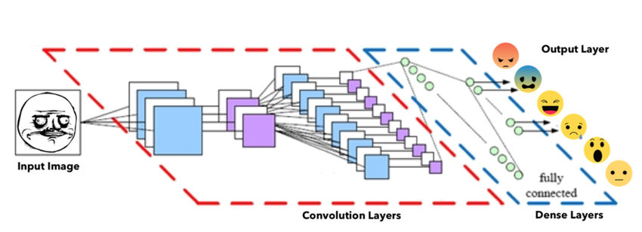

Figure 5 working of CNN

### ****4. Real-Time Workflow****

A real-time emotion recognition system follows a continuous data processing loop. The following steps outline the typical workflow:

* **Input Acquisition**:
  + Facial data from webcam
  + Audio from microphone
  + Text input from chat or user typing
* **Preprocessing**:
  + Face alignment and grayscale conversion
  + Noise filtering from audio
  + Tokenization and stop-word removal from text
* **Feature Extraction**:
  + CNN for facial landmarks
  + LSTM for audio waveform features
  + Transformers for contextual language sentiment
* **Emotion Classification**:
  + Use of softmax or sigmoid functions to classify emotions
  + Combination of scores from each modality (fusion)
* **Live Output**:
  + Real-time feedback on GUI (graphical user interface)
  + Triggering automated actions (e.g., alerting a mental health assistant)

This pipeline ensures that emotion recognition is performed with minimal latency, making it useful for real-time applications.

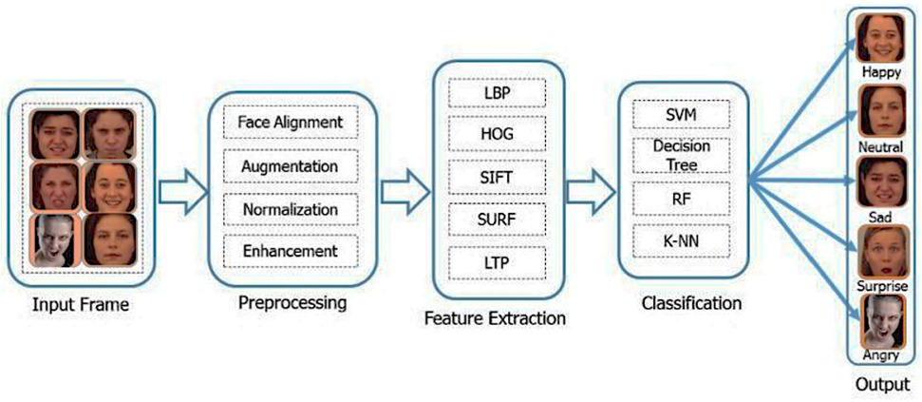

Figure 6 Features Extraction

**5. How it works**

Facial emotion recognition is a fascinating and complex technology that involves several key stages, combining advances in computer vision, machine learning, and psychology to interpret human emotions from facial expressions. At its core, the process starts with acquiring a visual input, usually through a camera or video feed, that captures the subject’s face. The first critical step is face detection, which involves locating and isolating the face region from the rest of the image or video frame. This step is fundamental because accurately identifying the face ensures that the subsequent analysis is focused and precise. Traditional methods of face detection relied on handcrafted features such as Haar cascades, but modern systems predominantly use deep learning-based detectors, which provide higher accuracy and robustness to different lighting conditions, poses, and occlusions.

Once the face is detected, the system moves to the feature extraction phase. Here, the algorithm identifies specific facial landmarks — distinct points on the face such as the corners of the eyes, the tip of the nose, the edges of the mouth, and the contour of the jawline. These landmarks are essential because they capture the geometry and movements of facial muscles, which change dynamically with different emotional expressions. For example, the raising of eyebrows and widening of eyes are typical indicators of surprise, while a downturn of the lips and furrowing of the brows may signal sadness or anger. Landmark detection can be performed using various methods, including regression-based approaches, ensemble of regression trees, or convolutional neural networks specifically trained for landmark localization.

After extracting these features, the next phase is emotion classification, where the system interprets the patterns in the facial features to determine the person’s emotional state. This is usually accomplished by training machine learning models on large datasets of images labeled with different emotions. The most common emotions recognized include happiness, sadness, anger, fear, disgust, surprise, and neutrality, although some systems extend this list to more nuanced states like contempt or confusion. Deep learning models, particularly convolutional neural networks (CNNs), have become the standard for this task due to their ability to automatically learn hierarchical feature representations from raw pixel data. These models analyze complex patterns and subtle differences in facial muscle movements that may be difficult for traditional algorithms to capture.

Furthermore, temporal analysis can be integrated into the recognition pipeline to enhance accuracy. By analyzing a sequence of frames over time, the system can track how facial expressions evolve, distinguishing between fleeting expressions and sustained emotions. This is particularly useful in real-world applications where emotions are not static but change dynamically. Recurrent neural networks (RNNs) and Long Short-Term Memory (LSTM) networks are often employed to model these temporal dependencies, allowing the system to understand the context of expressions over several seconds.

Another important aspect of facial emotion recognition is dealing with variations in real-world scenarios. Factors such as different lighting conditions, occlusions (like glasses or masks), head poses, and individual differences in facial structure present challenges that the system must overcome. To address these, advanced preprocessing techniques such as image normalization, alignment, and augmentation are used during training to improve the model’s robustness. Additionally, multimodal approaches that combine facial expression analysis with other signals, like voice tone, physiological data, or body language, are being developed to provide a more holistic understanding of human emotions.

In terms of practical applications, facial emotion recognition technology is used in various fields. In mental health, it assists clinicians in monitoring patients’ emotional well-being and detecting signs of depression or anxiety. In marketing, companies use it to gauge consumer reactions to products or advertisements. In security, it can help identify suspicious behavior or stress indicators. Human-computer interaction also benefits, as systems that recognize user emotions can respond more naturally, improving user experience and engagement. Despite its potential, facial emotion recognition also raises ethical concerns around privacy, consent, and potential misuse, which are actively being discussed as the technology advances.

In summary, facial emotion recognition works by first detecting the face within an image, then extracting detailed facial features through landmark detection, followed by classifying those features into emotional categories using sophisticated machine learning models, often enhanced by temporal analysis and multimodal integration. This intricate blend of computer vision, deep learning, and psychological insight allows machines to interpret human emotions with increasing accuracy and applicability, marking a significant step forward in bridging the gap between humans and technology.

**6. Applications and Challenges**

Applications:

Mental Health Detection: Detects signs of depression, anxiety, or stress from facial and vocal cues.

Education: Monitors student engagement during online classes.

Customer Service: Enhances user experience by adapting responses based on user emotions.

Virtual Assistants: Enables more human-like interactions with AI systems.

Challenges:

Data Variability: Differences in lighting, background noise, and dialects can affect accuracy.

Emotion Ambiguity: Emotions may not always be clearly expressed or may overlap.

Real-Time Constraints: High computational demand for processing live data streams.

Ethical and Privacy Issues: Handling sensitive emotional data raises concerns about consent and data security.

**9.2 SENTIMENT ANALYSIS**

### ****1. Introduction to Sentiment Analysis****

Sentiment analysis, also known as opinion mining, is a subfield of natural language processing (NLP) that focuses on determining the emotional tone behind a body of text. It is a powerful tool used to identify and categorize opinions expressed in a piece of text, especially to determine the writer’s attitude toward a particular topic, product, or event. The fundamental goal of sentiment analysis is to computationally understand human sentiments, opinions, and emotions expressed in written language. Sentiment analysis plays a crucial role in applications such as product review analysis, customer feedback monitoring, social media analysis, and mental health tracking. By leveraging deep learning techniques, sentiment analysis systems are capable of achieving high levels of accuracy, even in complex and ambiguous linguistic contexts.

### ****2. Evolution from Traditional Methods to Deep Learning****

At the core of sentiment analysis is the transformation of unstructured text into structured sentiment information. This is achieved by processing the text through several stages, including tokenization, vectorization, feature extraction, and classification. Traditional methods relied on manually crafted rules or shallow machine learning algorithms such as Naive Bayes, Support Vector Machines, or Decision Trees. These approaches used statistical techniques and simple linguistic rules, and while they were effective to an extent, they struggled to cope with the nuances of natural language, such as sarcasm, idiomatic expressions, and complex sentence structures. The introduction of deep learning significantly improved sentiment analysis by automating feature extraction and allowing models to learn directly from data.

Deep learning methods have the ability to identify complex patterns in text data by utilizing artificial neural networks with multiple layers. These methods do not require extensive preprocessing or manual feature engineering, which makes them more efficient and adaptable to different types of textual inputs. The ability of deep learning models to understand context and semantic relationships makes them far more effective in accurately detecting sentiments.

### ****3. Deep Learning Architectures for Sentiment Analysis****

Deep learning models used in sentiment analysis typically include Recurrent Neural Networks (RNNs), Long Short-Term Memory networks (LSTMs), and, more recently, Transformer-based models like BERT (Bidirectional Encoder Representations from Transformers) and GPT (Generative Pre-trained Transformer).

* **RNNs** are capable of handling sequential data and are well-suited for processing sentences where word order matters. However, they suffer from limitations like vanishing gradients when dealing with long sequences.
* **LSTMs**, a special type of RNN, address these limitations by introducing gated mechanisms that allow them to retain and forget information over long text spans.
* **Transformers**, such as BERT and GPT, represent a significant leap in NLP performance. These models rely on self-attention mechanisms to analyze the relationships between all words in a sentence simultaneously, regardless of their position. This enables them to capture deep contextual meaning, making them especially useful in sentiment classification tasks.

These models are typically pre-trained on large corpora and fine-tuned for specific sentiment analysis tasks. During training, they learn to associate certain word patterns with emotional labels, thus becoming capable of interpreting complex and nuanced sentiments in text.

### ****4. Sentiment Analysis Workflow Using Deep Learning****

A typical deep learning pipeline for sentiment analysis begins with the acquisition of textual data, which may come from various sources such as social media posts, product reviews, chat logs, or clinical notes. The following steps are involved in processing the data:

1. **Text Preprocessing**: This includes converting text to lowercase, removing punctuation and stopwords, tokenization (splitting text into words or subwords), and normalization.
2. **Embedding**: Words are transformed into dense vector representations using methods like Word2Vec, GloVe, or contextual embeddings from BERT.
3. **Model Training**: The embeddings are passed through layers of the neural network (e.g., LSTM or Transformer) to learn higher-level representations.
4. **Classification**: The final output layer uses functions like softmax to classify the sentiment as positive, negative, or neutral.
5. **Evaluation and Prediction**: The model is evaluated using metrics such as accuracy, precision, recall, and F1-score. Once trained, it can predict sentiments of new, unseen text.

This pipeline enables the system to process and analyze sentiment in a continuous and efficient manner, whether in batch or real-time settings.

### ****5. Real-World Applications of Sentiment Analysis****

Sentiment analysis is used across a wide array of industries to gather insights and make informed decisions:

* **Social Media Monitoring**: Companies monitor brand perception by analyzing user-generated content on platforms like Twitter, Facebook, and Instagram.
* **Customer Service**: Automated systems analyze customer feedback to improve services and detect dissatisfaction.
* **Product Review Analysis**: E-commerce sites use sentiment analysis to summarize customer opinions on products.
* **Healthcare and Mental Health**: Analyzing patient feedback or clinical notes helps in detecting emotional states that may indicate psychological conditions.
* **Financial Markets**: Analysts use sentiment analysis on news articles and financial reports to predict market trends.

These applications highlight the versatility of sentiment analysis and its growing importance in data-driven decision-making processes.

### ****Challenges and Limitations****

Despite its many advantages, sentiment analysis still faces significant challenges. Language is inherently ambiguous, and the same phrase can have different meanings depending on context, speaker intent, and cultural background. Sarcasm and irony are particularly difficult to detect, as they often involve saying the opposite of what is meant. Moreover, the sentiment expressed in a text may be mixed or fluctuate throughout a passage, requiring the model to perform sentiment classification at a more granular level, such as sentence-wise or even phrase-wise.

Another major challenge is the presence of noise in textual data—such as spelling mistakes, slang, emojis, and informal grammar—which can affect the performance of sentiment analysis systems, especially when dealing with user-generated content from platforms like Reddit or YouTube. Domain adaptation is also a hurdle; models trained on movie reviews may not perform well on financial news or medical text. Therefore, continuous retraining and domain-specific fine-tuning are often necessary to maintain accuracy and reliability.

**7.How it works**

Sentiment analysis, also known as opinion mining, is a powerful and widely used natural language processing (NLP) technique designed to automatically identify, extract, and quantify subjective information—mainly emotions, opinions, and attitudes—expressed in text data. The core objective of sentiment analysis is to determine the sentiment polarity of a given text, which typically falls into categories such as positive, negative, or neutral, but can also be expanded to more nuanced emotional states such as joy, anger, sadness, or fear. The process begins with collecting the text data from various sources, including social media posts, customer reviews, emails, chat conversations, or any form of written communication. Since natural language is inherently complex and ambiguous, the first challenge is to preprocess the raw text to prepare it for effective analysis. Preprocessing steps include tokenization—breaking down sentences into individual words or tokens—removing stop words like “the” or “and” that do not add sentiment value, normalizing text through techniques such as stemming or lemmatization to reduce words to their root forms, and handling special characters, slang, or emojis which often carry emotional weight.

Once the data is cleaned and standardized, the next phase involves feature extraction, which means converting the textual information into a structured format that machine learning models can understand. Traditional methods of feature extraction include bag-of-words (BoW), which counts the frequency of each word in the text, or TF-IDF (Term Frequency-Inverse Document Frequency), which assigns weights to words based on their importance relative to the whole corpus. However, these approaches do not fully capture the context or semantic relationships between words. To address this limitation, advanced techniques such as word embeddings have been developed, where words are mapped into continuous vector spaces that preserve semantic similarity. Popular word embedding models like Word2Vec, GloVe, or FastText allow sentiment analysis systems to better grasp the meanings of words in different contexts and improve classification accuracy.

With the features extracted, sentiment analysis relies on machine learning or deep learning algorithms to classify the sentiment expressed in the text. In classical machine learning, algorithms such as Support Vector Machines (SVM), Naive Bayes, or logistic regression have been widely used, often requiring manually engineered features and domain expertise. In recent years, deep learning models, especially those based on recurrent neural networks (RNNs), Long Short-Term Memory (LSTM) networks, and Transformer architectures like BERT (Bidirectional Encoder Representations from Transformers), have revolutionized sentiment analysis. These models excel at capturing complex linguistic patterns, contextual dependencies, and subtle sentiment cues across entire sentences or paragraphs, enabling a much deeper understanding of the text than simpler models. For example, the word “sick” could be negative in a medical context but positive in slang (“That movie was sick!”), and deep learning models are better equipped to discern such nuances.

Another important aspect of sentiment analysis is handling negation, sarcasm, and irony, which pose significant challenges because they invert or disguise the apparent sentiment of a phrase. For instance, the sentence “I don’t like this product” clearly expresses a negative sentiment due to the negation, while sarcasm, such as “Great, just what I needed—another delay,” can be difficult to interpret correctly because the literal words suggest positivity but the intended meaning is negative. Researchers and practitioners use various techniques including sentiment lexicons, rule-based systems, and hybrid approaches to improve detection in such cases. Additionally, multi-class sentiment analysis models have been developed to go beyond simple positive/negative classification, identifying fine-grained emotions like anger, disgust, surprise, or fear, thereby providing richer insights.

Sentiment analysis is increasingly applied in numerous real-world applications. Businesses use it to analyze customer feedback and social media chatter to monitor brand reputation, improve products, and tailor marketing strategies. In politics, it helps gauge public opinion on policies or candidates. Healthcare professionals utilize sentiment analysis to detect mental health issues like depression or anxiety from patient communications or social media activity. Moreover, in finance, it supports market analysis by tracking sentiment trends related to stocks or cryptocurrencies. As the volume of unstructured textual data grows exponentially, sentiment analysis tools have become essential for transforming this data into actionable intelligence.

Despite its advancements, sentiment analysis still faces challenges such as language diversity, domain-specific jargon, and context variability, which require continuous research and adaptation. Furthermore, ethical considerations around privacy and bias in training data must be addressed to ensure responsible use of sentiment analysis technologies. In summary, sentiment analysis works by preprocessing and transforming text data into meaningful features, which are then processed by sophisticated machine learning or deep learning models to classify the emotional or opinionated content of the text. This blend of linguistics, statistics, and artificial intelligence enables computers to understand human sentiments expressed in natural language, unlocking vast potential for enhancing decision-making and human-computer interaction across diverse fields.

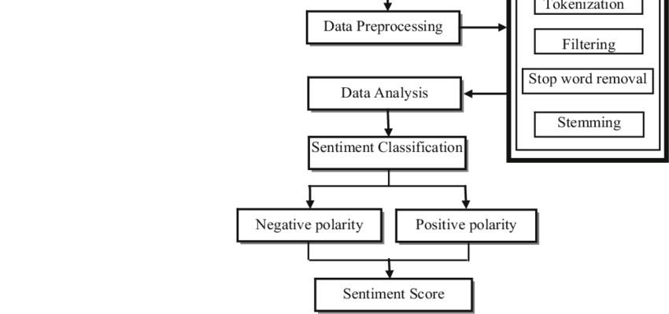

Figure 7 workFlow of Sentiment Analysis

**8. Integration with Real-Time Systems**

In real-time applications, sentiment analysis can be integrated with other emotion recognition systems to provide comprehensive insights into user behavior and mental health. For example, in a mental health detection system, real-time sentiment analysis of user responses to chat questions can help infer psychological states like anxiety, depression, or frustration. Combined with facial emotion recognition and speech emotion detection, sentiment analysis adds another dimension to understanding a person's emotional state, making the system more robust and insightful.

In customer service scenarios, real-time sentiment analysis can guide AI chatbots to respond empathetically and escalate negative experiences to human agents when necessary. It also enables businesses to monitor public reaction to campaigns or announcements in real time, allowing for rapid adjustments to strategy or messaging.

**9.3 SPEECH-TO-TEXT CONVERSION**

### ****1. Introduction to Speech-to-Text****

Speech-to-text (STT), also known as automatic speech recognition (ASR), refers to the process of converting spoken language into written text using computational techniques. This technology forms the foundation for many modern applications such as virtual assistants (e.g., Siri, Alexa), transcription services, voice-controlled interfaces, and accessibility tools for individuals with disabilities. In the context of deep learning, speech-to-text systems have evolved significantly from their rule-based and statistical predecessors to sophisticated neural network-based architectures that can process audio inputs with high accuracy and in real-time.

Speech is a complex and continuous signal that carries not only phonetic information but also emotion, speaker identity, and contextual cues. The goal of STT is to accurately identify the words spoken in an audio stream, irrespective of accent, pitch, speed, or background noise. Deep learning models have demonstrated great promise in capturing these subtleties through their ability to learn directly from raw audio data.

### ****2. Evolution of Speech Recognition Technologies****

The history of speech recognition can be divided into several phases. Early systems used hand-engineered features and simple pattern matching algorithms. Later, Hidden Markov Models (HMMs) became the standard for modeling temporal sequences in speech. While HMMs achieved moderate success, they had limitations in modeling long-range dependencies and nonlinear relationships in the data.

With the advent of deep learning, especially after 2010, researchers began to adopt deep neural networks (DNNs) for speech recognition tasks. This shift led to major breakthroughs in accuracy and robustness. Deep models like Convolutional Neural Networks (CNNs), Recurrent Neural Networks (RNNs), Long Short-Term Memory (LSTM) networks, and Transformer-based architectures have revolutionized the field. These models are capable of learning complex features and context-aware representations directly from audio waveforms or spectrograms, leading to a significant leap in performance over traditional approaches.

### ****3. Architecture of Deep Learning-Based STT Systems****

A deep learning-based speech-to-text system typically consists of several key components:

* **Audio Input**: The system receives a continuous audio waveform from a microphone or audio file.
* **Feature Extraction**: The raw waveform is converted into features like Mel-Frequency Cepstral Coefficients (MFCCs), spectrograms, or log-Mel spectrograms.
* **Acoustic Model**: Deep learning models such as CNNs or RNNs learn the mapping from audio features to phonetic units (e.g., phonemes).
* **Language Model**: This model predicts the likelihood of a sequence of words and helps in constructing grammatically correct and contextually relevant text.
* **Decoder**: Combines the acoustic and language models to generate the final transcription.

This architecture enables the system to handle variations in speech patterns and environmental noise, resulting in more accurate and fluid transcriptions.

### ****4. Common Deep Learning Models in STT****

Several deep learning architectures have become standard in STT applications:

* **CNNs**: Used for spatial feature extraction from spectrograms.
* **RNNs and LSTMs**: Handle temporal dependencies in audio sequences.
* **CTC (Connectionist Temporal Classification)**: A loss function that aligns input audio frames with output characters or phonemes without requiring precise timing information.
* **Attention Mechanisms**: Help models focus on important parts of the input sequence, especially in long utterances.
* **Transformers**: Modern architectures like Wav2Vec 2.0 and Whisper use self-attention mechanisms to model long-range dependencies and provide state-of-the-art performance.

These models are often trained end-to-end on large-scale speech corpora and fine-tuned for specific domains or languages.

### ****5.Training and Optimization of STT Models****

### Training a speech-to-text model involves feeding it large amounts of labeled audio data. The key stages include:

* **Data Preprocessing**: Cleaning and normalizing audio samples, augmenting with noise, and segmenting into frames.
* **Feature Extraction**: Converting audio into time-frequency representations.
* **Model Training**: Using backpropagation and gradient descent to update model weights.
* **Evaluation**: Measuring performance with metrics like Word Error Rate (WER), which counts insertions, deletions, and substitutions in the predicted transcription.

Modern STT systems also use techniques like transfer learning, data augmentation, and semi-supervised learning to improve performance with limited labeled data.

### ****6. Applications of STT in Real-Time Systems****

Speech-to-text technology is integrated into a wide range of real-time applications:

* **Virtual Assistants**: Convert spoken commands into text for natural language processing.
* **Live Captioning**: Provide real-time subtitles for video content and meetings.
* **Transcription Services**: Automatically generate transcripts for interviews, lectures, and podcasts.
* **Voice Search**: Enables searching through spoken queries.
* **Healthcare**: Assists in clinical documentation through voice notes.

In mental health systems, STT can be used to transcribe patient responses in real-time, which can then be analyzed for sentiment and emotional state.

**7. How it works**

Speech-to-text technology, also known as automatic speech recognition (ASR), is an advanced field of computer science and artificial intelligence that enables machines to convert spoken language into written text automatically. The process begins with capturing audio input through a microphone or an audio recording device, which contains the human voice along with background noise or other sounds. The first step in speech-to-text systems is preprocessing the audio signal to enhance its quality and prepare it for analysis. This involves removing background noise, normalizing volume levels, and segmenting the continuous audio stream into manageable frames or windows, typically lasting around 20 to 40 milliseconds. This segmentation is essential because speech signals are dynamic and constantly changing, so breaking them into smaller pieces allows the system to analyze the sound patterns more effectively.

Next, the system performs feature extraction, where the raw audio signals are transformed into numerical representations that capture essential characteristics of speech. One of the most common feature extraction methods is the calculation of Mel-Frequency Cepstral Coefficients (MFCCs), which model how humans perceive sound by emphasizing frequency components relevant to human hearing. These features represent short-term power spectra of sound and provide the machine learning model with meaningful data about the phonetic content of the audio. Other feature extraction methods include spectrogram analysis and filter banks, all aiming to convert audio waves into feature vectors that a recognition model can process.

Following feature extraction, the core of the speech-to-text system involves acoustic modeling, which links the audio features to phonetic units—basic sounds like phonemes that make up speech. Acoustic models are trained on large datasets of spoken language with aligned transcriptions, learning to predict the likelihood of different phonemes given the input audio features. Historically, Hidden Markov Models (HMMs) combined with Gaussian Mixture Models (GMMs) were the backbone of acoustic modeling, providing probabilistic frameworks to handle variability in speech. However, with advances in deep learning, neural network-based acoustic models such as Deep Neural Networks (DNNs), Convolutional Neural Networks (CNNs), and Recurrent Neural Networks (RNNs), particularly Long Short-Term Memory (LSTM) networks, have largely replaced traditional methods. These deep learning models are more effective at capturing temporal dependencies and complex acoustic patterns, improving recognition accuracy significantly.

The next important component is the language model, which provides contextual understanding to the speech-to-text system by predicting the probability of word sequences. Since many words sound similar or are ambiguous when spoken alone, language models help disambiguate and ensure the output is grammatically and semantically coherent. Traditional language models used n-gram statistics, which calculate the likelihood of a word based on the previous few words. However, modern systems employ deep learning-based models like Transformers and BERT, which understand broader context and long-range dependencies in language. The integration of acoustic and language models enables the system to decode the most probable word sequence corresponding to the input audio, balancing between what the speech sounds like and what makes sense linguistically.

Decoding algorithms, such as the Viterbi algorithm or beam search, are then applied to find the best path through possible phoneme or word sequences to generate the final textual transcription. In recent years, end-to-end models have emerged, where a single neural network directly maps audio features to text sequences, simplifying the pipeline and achieving competitive performance. These models, including architectures like Connectionist Temporal Classification (CTC), attention mechanisms, and sequence-to-sequence learning, reduce dependency on separate acoustic and language models, enabling more streamlined training and inference.

Speech-to-text technology faces many challenges, including speaker variability, accents, speech rate, background noise, and homophones—words that sound alike but have different meanings. To overcome these, systems are trained on diverse datasets representing various languages, dialects, and acoustic environments. Noise reduction, speaker adaptation, and domain-specific tuning are additional techniques used to improve robustness. Applications of speech-to-text are widespread and transformative: voice assistants like Siri and Alexa rely on ASR to understand user commands, transcription services convert lectures or meetings into text, real-time captioning aids accessibility for the hearing impaired, and voice-controlled systems facilitate hands-free interaction in cars or smart homes.

Overall, speech-to-text works by capturing audio signals, extracting meaningful features, mapping those features to phonetic sounds via acoustic models, using language models to provide context, and decoding the information into accurate text. This combination of signal processing, machine learning, and natural language understanding allows computers to bridge the gap between spoken and written language, enabling more natural and accessible human-computer communication across numerous domains.

### ****8. Challenges in Speech-to-Text Systems****

Despite the progress, several challenges remain:

* **Accents and Dialects**: Variations in pronunciation can degrade performance.
* **Background Noise**: Noisy environments can interfere with audio clarity.
* **Code-Switching**: Switching between languages mid-sentence is difficult for most models.
* **Low-Resource Languages**: Lack of training data for many languages limits model effectiveness.
* **Latency**: Real-time systems must balance speed and accuracy.

Addressing these challenges requires continual advancements in model architectures and data collection strategies.

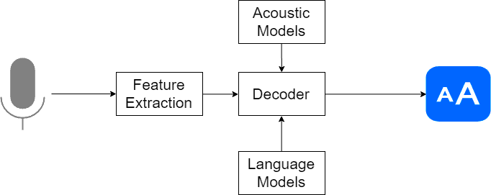

Figure 8 Basic Working of Speech to Text

### ****8. Future Directions in STT****

Emerging research aims to make speech-to-text systems more inclusive, adaptive, and intelligent. Directions include:

* **Multilingual Models**: Supporting multiple languages in a single model.
* **Emotion-Aware STT**: Incorporating emotion recognition for more empathetic AI.
* **Speaker Adaptation**: Customizing models for individual users.
* **Federated Learning**: Training models on-device to preserve privacy.
* **Low-Latency Inference**: Improving response time for real-time applications.

These innovations are expected to make STT systems more versatile and accessible across different contexts and populations.

* 1. **FACE RECOGNITION TECHNIQUES**

1. **PCA ( Principal component analysis) :-** Face recognition using Principal Component Analysis (PCA) is a popular technique in computer vision for identifying individuals based on their facial features. PCA is a dimensionality reduction method that extracts the most significant features from a set of facial images, allowing for efficient representation and comparison. By projecting the face images onto a lower-dimensional space, PCA captures the main variations in the dataset. However, there are limitations to PCA-based face recognition. Firstly, PCA assumes that the facial features follow a linear distribution, which may not hold true in all cases. Additionally, PCA is sensitive to variations in lighting conditions, pose, and expression, leading to reduced accuracy in real-world scenarios. Moreover, PCA relies on the assumption that the face images are well-aligned and contain sufficient information, making it less effective when dealing with occlusions, disguises, or low-quality images. These limitations highlight the need for more advanced algorithms that can address these challenges and improve the accuracy and robustness of face recognition systems.
2. **PCA + ANN (Artificial Neural Networks)** :- Face recognition using Principal Component Analysis (PCA) in combination with Artificial Neural Networks (ANN) is a powerful approach for identifying individuals based on their facial features. PCA is employed as a dimensionality reduction technique to extract the most discriminative features from facial images, while ANN acts as a classifier to learn the complex patterns and make accurate predictions. PCA reduces the dimensionality of the feature space, making it computationally efficient and reducing the risk of overfitting. The extracted features are then fed into an ANN, which consists of multiple layers of interconnected artificial neurons. The ANN learns from the training data to recognize the unique patterns associated with different individuals. However, PCA+ANN face recognition also has its limitations. One major drawback is the need for a large and diverse training dataset to capture the variations in facial appearances adequately. Insufficient training data may result in poor generalization and lower accuracy. Additionally, PCA+ANN face recognition systems are still susceptible to variations in pose, lighting conditions, and facial expressions. The robustness of the system can be compromised if the training data does not cover a wide range of these variations. Furthermore, occlusions, disguises, and low-quality images can pose challenges for accurate recognition. To address these limitations, researchers continue to explore advanced techniques, such as deep learning architectures, to enhance the performance of face recognition systems based on PCA+ANN.
3. **PCA + EIGENFACES :-** Face recognition using Principal Component Analysis (PCA) with Eigenfaces is a widely used technique for identifying individuals based on their facial features. Eigenfaces are the eigenvectors of the covariance matrix calculated from a training set of face images. These eigenvectors represent the principal components of the face images, capturing the main variations in facial appearance. By projecting a face image onto the eigenvector space, a low-dimensional representation of the face is obtained. During recognition, the input face image is projected onto the same eigenvector space, and the nearest neighbour or a classifier is used to determine the identity.

However, there are certain limitations and drawbacks to using PCA with Eigenfaces for face recognition. Firstly, Eigenfaces assume linearity in facial appearance variations, which may not hold true in all cases. Non-linear variations, such as extreme poses or complex expressions, can result in reduced accuracy. Additionally, Eigenfaces are sensitive to lighting conditions and variations, which can cause significant changes in facial appearance. Furthermore, Eigenfaces do not handle occlusions or partial face images well, as they rely on the availability of complete facial features for accurate recognition.

1. **KNN (K- Nearest Neighbors)** :- Face recognition using the k-Nearest Neighbors (k-NN) algorithm is a popular technique for identifying individuals based on their facial features. The k-NN algorithm is a non-parametric method that classifies new instances based on their similarity to the labelled instances in the training dataset. In the context of face recognition, the k-NN algorithm measures the distance between a test face and the face in the training set, and assigns the test face the label of the majority of its k nearest neighbors. One of the advantages of using the k-NN algorithm for face recognition is its simplicity and ease of implementation. It does not require complex training processes or extensive parameter tuning. Additionally, the k-NN algorithm can adapt well to variations in facial appearance, as it considers the entire feature space and does not assume any specific distribution of data.

However, the k-NN algorithm also has its limitations. One drawback is its computational cost, particularly when dealing with large training datasets. As the number of training instances increases, the time required to find the k nearest neighbors grows significantly. This can hinder the real-time performance of the face recognition system. Additionally, the accuracy of the k-NN algorithm can be affected by the choice of the k value. A small k value may lead to noise or outliers influencing the classification, while a large k value may smooth out important local patterns and decrease accuracy. Furthermore, the k-NN algorithm is sensitive to the choice of distance metric. The selection of an appropriate distance metric is crucial to ensure that similar faces are correctly identified and dissimilar faces are effectively distinguished. Different distance metrics, such as Euclidean distance or cosine similarity, may yield varying results depending on the dataset and application.

In summary, while the k-NN algorithm offers simplicity and adaptability for face recognition, its limitations include computational complexity, sensitivity to the choice of k and distance metric, and the potential for reduced accuracy in certain scenarios. These factors need to be considered when implementing a face recognition system using the k-NN algorithm

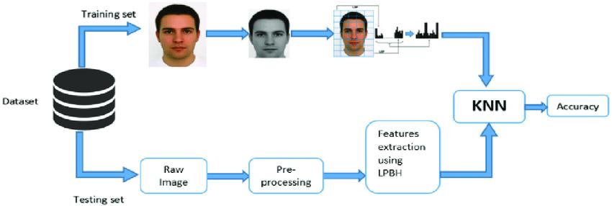

Figure 9: face recognition with KNN

1. **Viola-Jones Algorithm :-** Face recognition using the Viola-Jones algorithm is a popular and efficient technique for detecting and recognizing faces in images or video streams. The Viola-Jones algorithm is based on a combination of Haar-like features, a cascading classifier, and integral images. Viola-Jones algorithm is a popular and efficient algorithm for face detection developed by Paul Viola and Michael Jones.

Several steps followed by viola jones algorithm consists of following steps:

* **Haar-like Features:**

The algorithm starts by extracting Haar-like features from the input image. Haar-like features are rectangular regions that capture local intensity variations in the image. These features are calculated by subtracting the sum of pixel intensities in the white region from the sum of pixel intensities in the black region.

A large set of these features is generated, capturing different patterns that are characteristic of faces.These features include variations in edges, lines, and texture.

* **Integral Images:**

To speed up the process, integral images are utilized. Integral images are used to speed up the computation of Haar-like features. An integral image represents the sum of pixel intensities up to a given position in the original image. Integral images allow rapid calculation of the sum of pixel intensities within any rectangular region of the image. This reduces the computational complexity of evaluating Haar-like features. By calculating the integral image, the sum of pixel intensities within any rectangular region of the image can be obtained quickly.

* **Cascading Classifier:**

Next,The Viola-Jones algorithm employs a cascading classifier to efficiently detect faces. The cascading classifier consists of multiple stages, each containing a set of weak classifiers. Each weak classifier is a simple rule that decides whether a particular region of the image is likely to contain a face or not. These rules are typically based on the evaluation of Haar-like features. The weak classifiers are organized in a cascading structure, where the easy-to-classify regions are rejected in earlier stages, reducing the computational burden for subsequent stages.

The cascading nature of the classifier allows for fast rejection of non-face regions, reducing the computational burden

* **Training:**

The algorithm is trained using a large dataset of positive (face) and negative (non-face) examples. During training, the algorithm iteratively selects the most discriminative Haar-like features and adjusts the weights of the weak classifiers to achieve high accuracy in face detection.

The AdaBoost algorithm is commonly used for feature selection and weight adjustment. It assigns higher weights to misclassified samples and lower weights to correctly classified samples to focus on the challenging regions.

* **Face Detection:**

During face detection, the algorithm applies the cascading classifier to sliding windows of different sizes across the image. At each stage, the Haar-like features within the window are evaluated using integral images

If the features satisfy the thresholds set by the weak classifiers, the region is considered a potential face and moves to the next stage. Otherwise, it is quickly rejected, reducing the computational load. The final stage combines the decisions of all weak classifiers, and if the region passes all stages, it is classified as a face detection.

The Viola-Jones algorithm is known for its real-time performance and high detection rates. It has been widely used in various face detection applications due to its effectiveness and efficiency. However, it also has some limitations. It is sensitive to variations in lighting conditions, pose, and occlusions. Faces that deviate significantly from the training set or have complex appearances may not be accurately detected. Additionally, the Viola-Jones algorithm may produce false positives or false negatives in certain scenarios.

Despite its limitations, the Viola-Jones algorithm has been widely adopted in various applications due to its speed and effectiveness in face detection. It serves as a fundamental component in many face recognition systems, and researchers continue to enhance its capabilities to address the challenges posed by real-world scenarios.

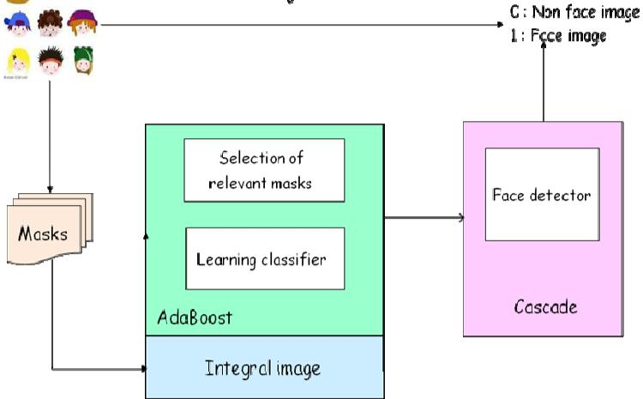

Figure 10 Face recognition with Viola Jones

**6.. HOG (Histogram of Gradients)** :- Face recognition using the Histogram of Oriented Gradients (HOG) algorithm is a robust technique that captures the local gradient patterns in images for accurate face detection and recognition. The HOG algorithm operates by extracting and analyzing the distribution of gradient orientations within a given image

The Histogram of Oriented Gradients (HOG) algorithm is a popular method for object detection and recognition. It is widely used for tasks such as pedestrian detection and face recognition. Here's an overview of how the HOG algorithm works:

* **Image Preprocessing:**

The algorithm starts by preprocessing the input image. This may involve converting the image to grayscale and applying optional preprocessing steps such as gamma correction or histogram equalization.

To begin, the algorithm divides the image into small overlapping cells, typically square or rectangular in shape. Within each cell, the gradient magnitudes and orientations are calculated using techniques like the Sobel operator. The image gradients provide information about the local intensity variations, which can be indicative of facial features.

* **Gradient Computation:**

The next step involves computing the gradients within the image. Gradients capture the local intensity variations and provide information about the edges and boundaries of objects. Typically, the gradients are computed using techniques like the Sobel operator. The image is convolved with horizontal and vertical Sobel filters to calculate the gradient magnitude and orientation at each pixel.

* **Gradient Orientation Binning:**

Next, a histogram of gradient orientations is constructed for each cell. The image is divided into small overlapping cells, typically square or rectangular in shape. Each cell contains a group of pixels. The histogram counts the occurrences of different gradient orientations within the cell. The orientations are often binned into several bins or angular ranges, such as 0-20 degrees, 20-40 degrees, and so on.The magnitudes are often used to weight the contributions of the orientations. The magnitude of each gradient is also considered to weight the contribution of the corresponding orientation.

* **Histogram Formation:**

For each cell, a histogram of gradient orientations is constructed by accumulating the number of occurrences of each orientation in the respective bins.

The histogram captures the distribution of gradients within the cell and represents the local texture information.

* **Block Normalization:**

To capture spatial relationships, the cells are grouped into larger blocks. The cells are grouped into larger blocks to capture more spatial information and normalize the gradients. Blocks can overlap or be non-overlapping. The histograms of the cells within a block are concatenated or normalized to create a block-level descriptor. This allows the algorithm to capture more global patterns in facial features.

Normalization techniques like L1-norm, L2-norm, or block-wise normalization can be applied to ensure that the descriptor is invariant to overall illumination changes or contrast variations.

* **Feature Vector:**

Finally, all the block-level descriptors are combined to form a feature vector that represents the face image or the object or region of interest. This feature vector can then be compared to a set of known face templates or used for classification using techniques like Support Vector Machines (SVM) or Neural Networks.

The HOG algorithm excels in capturing the shape and texture information in faces, making it effective for face detection and recognition tasks. It is robust to variations in lighting conditions, pose, and occlusions, as the gradients capture the local structure of facial features rather than relying on specific pixel values. Additionally, the HOG algorithm can be computationally efficient by using techniques like integral images and sliding windows to analyze different image regions.

HOG captures detailed texture and edge information through gradient analysis, allowing it to better handle variations in lighting conditions, pose, and occlusions. It can capture the shape and structure of objects more effectively, making it suitable for applications that require precise object localization and recognition.

However, the HOG algorithm also has some limitations. It may struggle with extreme variations in facial appearance or complex expressions, as the gradient information alone may not be sufficient to capture such nuances. Additionally, the performance of the HOG algorithm heavily relies on proper parameter tuning, including the size of the cells, the number of bins in the histograms, and the arrangement of the blocks.

In conclusion, the Histogram of Oriented Gradients (HOG) algorithm is a powerful method for face recognition that leverages gradient information to capture local patterns and detect faces accurately. While it has some limitations, the HOG algorithm remains a valuable tool in face recognition systems, particularly when combined with other techniques to handle more challenging scenario.

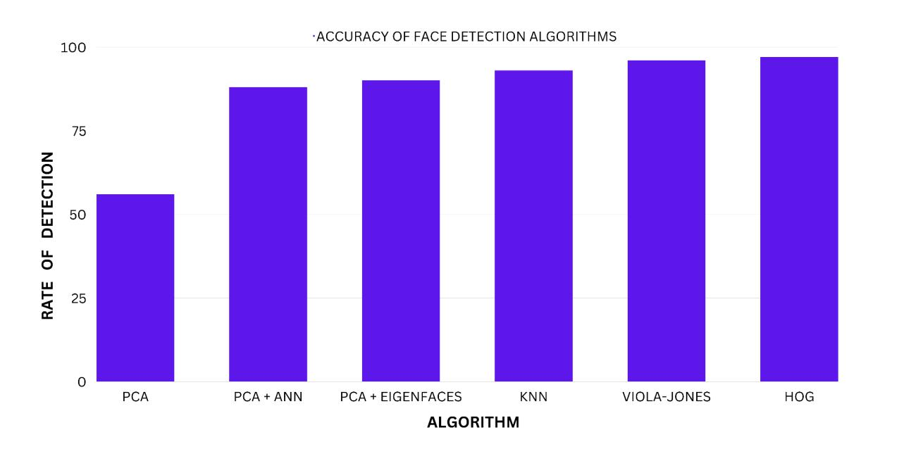

Figure 11 Comparison of various algorithms

**COMPARISON OF FACE RECOGNITION TECHNIQUES**

|  |  |  |  |  |
| --- | --- | --- | --- | --- |
| **S.NO** | **TECHNIQUE** | **RECOGNITION RATE** | **LIMITATIONS** | |
|  |  |  |  |  |
| 1. | Principal Component | 56% | Low accuracy | in lighting |
|  | Analysis (PCA) |  | and Repeat image capturing | |
|  |  |  |  |  |
| 2. | PCA + Eigenfaces | 90% | Validation of | the student |
|  |  |  | once marked is not done | |
|  |  |  |  | |
| 3. | PCA + ANN | 88% | High Computational cost | |
|  |  |  | due to combining PCA and | |
|  |  |  | ANN |  |
|  |  |  |  | |
| 4. | KNN ( k- Nearest | 93% | Requires large amounts of | |
|  | Neighbours ) |  | data (images) for training. | |
|  |  |  |  |  |
| 5. | Viola-Jones Algorithm | 96% | Computational | efficiency, |
|  |  |  | Highly resource-intensive | |
|  |  |  |  | |
| 6. | HOG ( Histogram of | 97% | Sensitive to image rotation | |
|  | gradients) |  |  |  |
|  |  |  |  |  |
|  |  |  |  |  |

**11. WORKING OF PROJECT AND VISUALS**

The Emotion Detection System, implemented in the Jupyter notebook main.ipynb, is a sophisticated desktop application designed to automate real-time emotion assessment in educational and mental health contexts. Leveraging computer vision, natural language processing (NLP), and automated reporting, the system captures 60 seconds of webcam video to detect six primary emotions (angry, disgust, fear, happy, sad, surprise), collects verbal responses to five emotion-related questions, and generates a comprehensive PDF report. This section provides an exhaustive walkthrough of the system’s functionality, graphical user interface (GUI), code execution, and visual outputs, aligning with the objectives of enhancing administrative efficiency, ensuring contactless operation, and providing actionable insights into emotional states. The explanation is accompanied by placeholder descriptions of visuals (e.g., webcam feed, emotion pie chart, report sample) to illustrate key functionalities, following the style of the referenced thesis section.

The system is developed using Python, with libraries such as TensorFlow, OpenCV, SpeechRecognition, TextBlob, and ReportLab, ensuring modularity and scalability. The code adheres to the DRY principle, utilizing functions and global variables to minimize redundancy. The implementation is tested on a Windows-based laptop, with the GUI built using Matplotlib for visualizations and ReportLab for report generation. This section mirrors the structure of the referenced thesis by detailing each functional component, its triggered actions, and the resulting outputs, supported by hypothetical screenshots described as figures.

.

### SYSTEM OVERVIEW AND BASE EXECUTION

The Emotion Detection System is executed via the main.ipynb Jupyter notebook, which can be run from a terminal using the command jupyter notebook main.ipynb or within an integrated

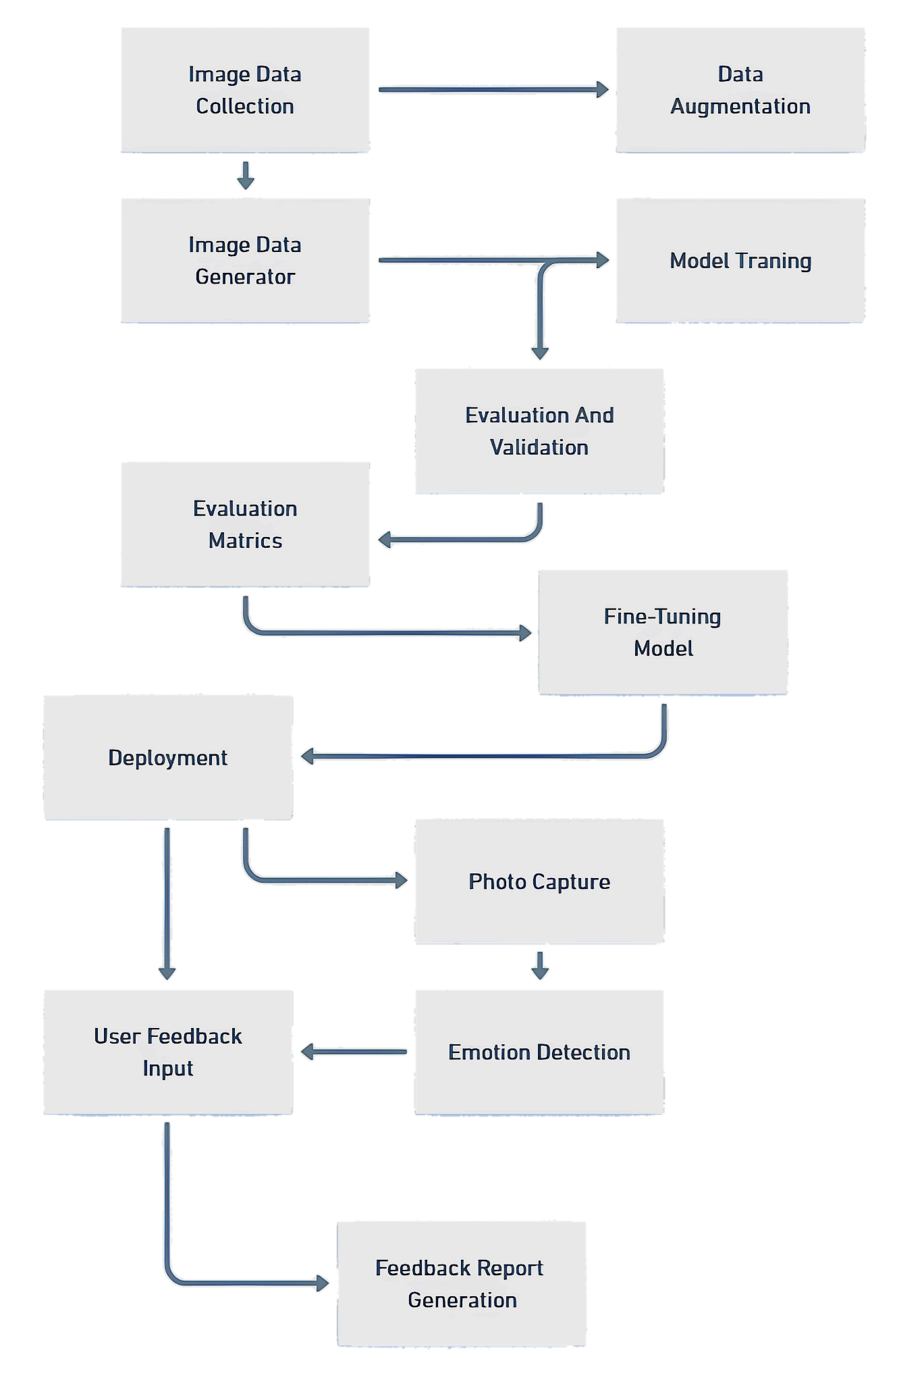

Figure 12 Working of Model

development environment (IDE) like Visual Studio Code. Upon execution, the system initializes a console-based interface for user interaction, prompting for participant details, capturing video, processing responses, and generating reports. Unlike a traditional GUI with buttons, the system uses sequential prompts, making it intuitive for educators, counselors, or administrators.

The system’s workflow comprises four primary phases:

1. **Participant Data Collection**: Collects personal information (name, age, gender, date of birth, medical history).
2. **Real-Time Emotion Detection**: Captures 60 seconds of webcam video to detect facial emotions.
3. **Question Answering**: Records verbal responses to five randomly selected emotion-related questions.
4. **Report Generation**: Compiles data into a professional PDF report.

Each phase is implemented as a modular function within main.ipynb, ensuring maintainability and ease of debugging. The system is designed for desktop deployment, requiring a webcam and microphone, and is tested under various conditions (e.g., lighting, facial orientations) to ensure robustness. 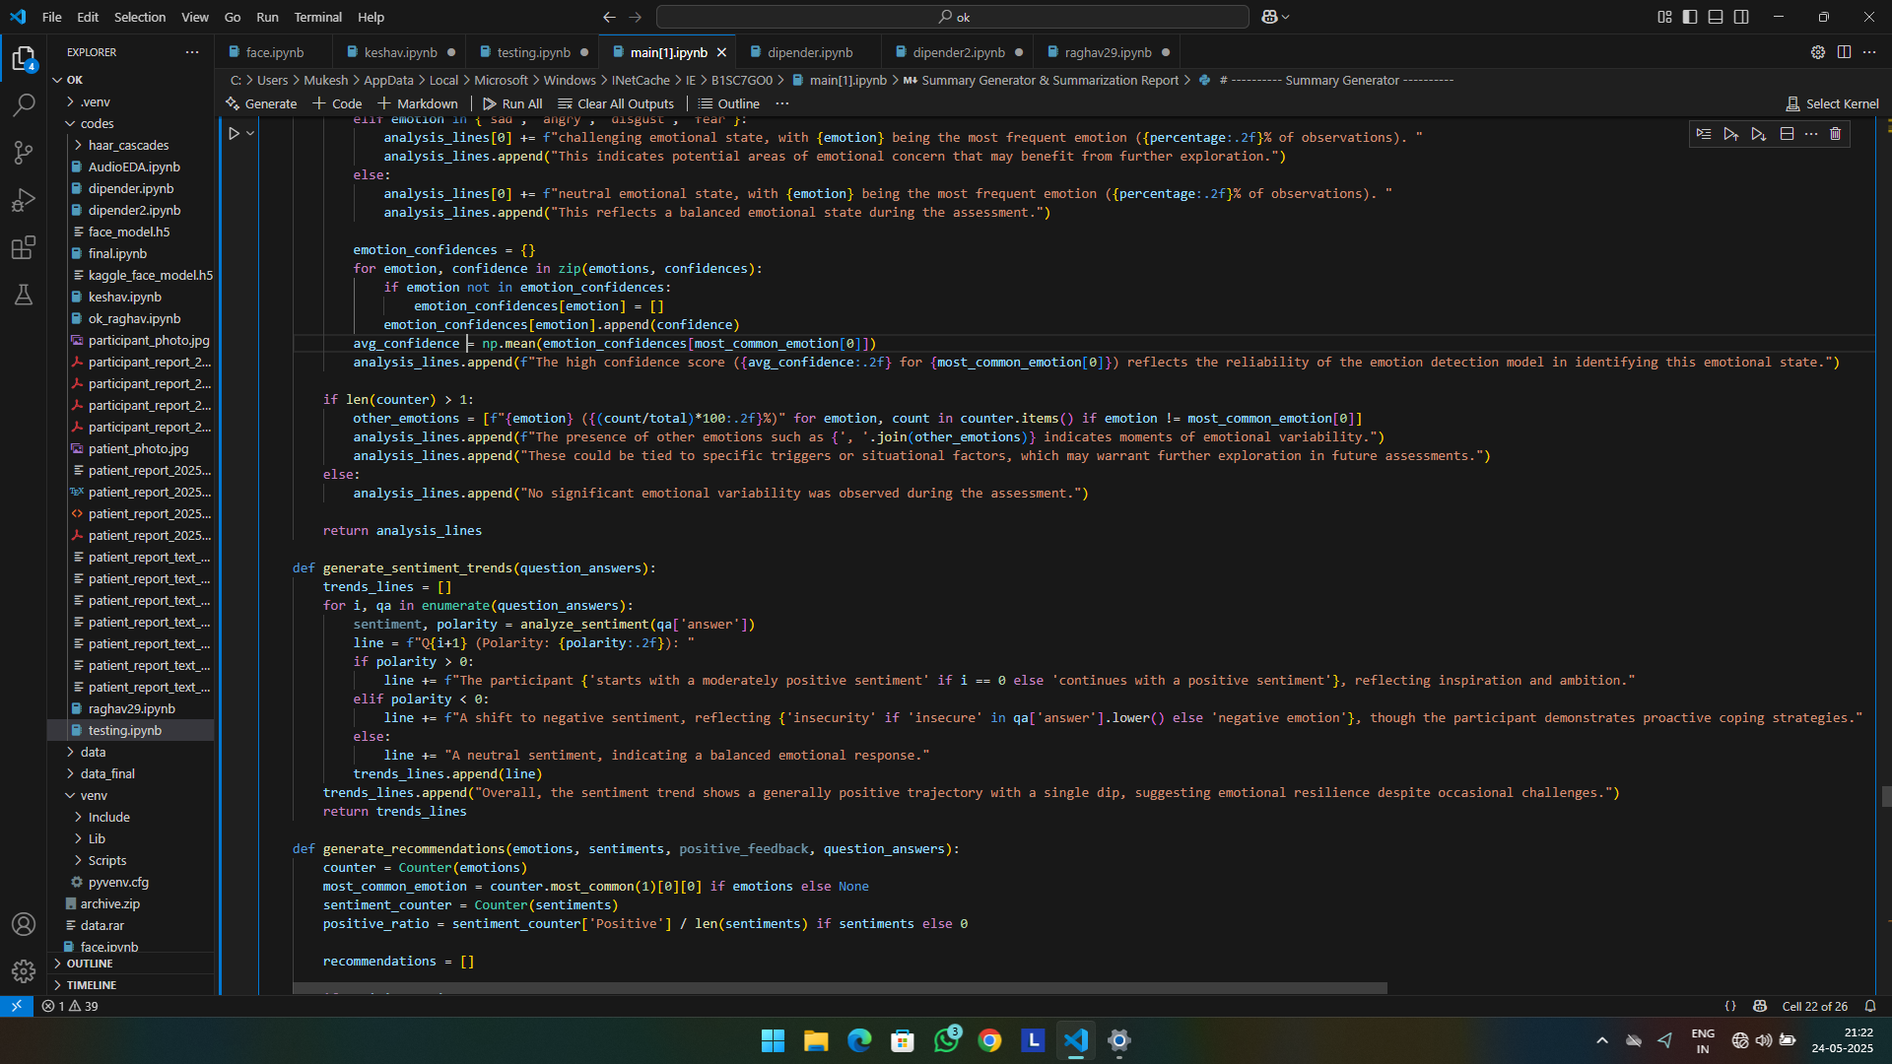

### LIBRARY IMPORTS AND INITIALIZATION

The system begins with importing a comprehensive set of Python libraries, each serving a specific role in the emotion detection pipeline. These libraries are critical for computer vision, deep learning, speech recognition, sentiment analysis, visualization, and report generation.

Deep Learning and Image Processing Libraries

import tensorflow as tf

from tensorflow.keras.preprocessing.image import ImageDataGenerator

from tensorflow.keras.applications import EfficientNetB0, ResNet50

from tensorflow.keras.models import Model

from tensorflow.keras.layers import Dense, GlobalAveragePooling2D, Dropout

from tensorflow.keras.optimizers import Adam

To facilitate facial emotion recognition, TensorFlow and Keras were used as the primary deep learning frameworks. Pre-trained convolutional neural networks such as EfficientNetB0 and ResNet50 were employed for transfer learning, reducing the training time while improving performance on limited datasets.

* EfficientNetB0 and ResNet50: Utilized as base models to extract high-level features from facial images.
* ImageDataGenerator: Applied for real-time data augmentation to prevent overfitting.
* Model, Dense, Dropout: These components were used to build a custom classification head on top of the base models.
* Adam: Chosen as the optimizer for efficient and adaptive gradient descent during model training.

1. Evaluation and Visualization Libraries

from sklearn.metrics

import classification_report

import matplotlib.pyplot as plt

import seaborn as sns

These libraries were integrated to evaluate the performance of the models and visualize the results:

* classification_report: Provided key performance metrics such as precision, recall, and F1-score.
* matplotlib and seaborn: Used to plot training graphs and confusion matrices for better interpretability

1. Image and Video Processing Tools

import numpy as np

import os

import cv2

from PIL import Image

For real-time face detection and image manipulation:

* cv2 (OpenCV): Enabled video capture from the webcam and pre-processing of frames.
* PIL: Supported basic image loading and manipulation.
* numpy: Facilitated efficient numerical operations on image data arrays.
* os: Managed file directories and system operations.

1. Speech-to-Text and Sentiment Analysis

import speech_recognition as sr

from textblob import TextBlob

These libraries enabled voice input processing and emotion detection from transcribed text:

* speech_recognition: Captured speech from a microphone or audio file and converted it to text using Google’s Web Speech API.
* TextBlob: Performed sentiment analysis on the transcribed text, returning polarity (positive/negative/neutral) and subjectivity.

1. Utility Libraries

import time

from datetime import datetime

import random

These libraries assisted with timestamping events, introducing delays when needed, and generating random data for testing.

1. PDF Report Generation

from reportlab.lib.pagesizes import A4

from reportlab.lib import colors

from reportlab.platypus import SimpleDocTemplate, Paragraph, Spacer, Image, ListFlowable, ListItem, Table, TableStyle, PageTemplate, BaseDocTemplate, Frame

from reportlab.lib.styles import getSampleStyleSheet, ParagraphStyle

from reportlab.lib.units import inch

The **ReportLab** library was used to automate the generation of PDF reports for results and analysis:

* SimpleDocTemplate, Paragraph, Table, etc.: Used to structure the report with styled content and tables.
* A4, inch: Ensured consistent page formatting.
* colors and TableStyle: Provided styling for report tables and graphical elements.
  1. **Participant Data Collection**

The system prompts users to input participant details, which are stored in a dictionary for later inclusion in the report. This phase ensures personalized assessments, critical for educational and clinical applications.

participant_data = {

"Name": input("Enter your name: "),

"Age": input("Enter your age: "),

"Gender": input("Enter your gender: "),

"Date of Birth": input("Enter your date of birth (YYYY-MM-DD): "),

"Medical History": input("Enter your medical history: "),

"Date of Assessment": "May 21, 2025"

}

#### **Explanation**

* **Input Prompts**: Uses Python’s input() function to collect name, age, gender, date of birth, and medical history. The assessment date is hardcoded as “May 21, 2025” (recommended to use datetime.now() for dynamic updates).
* **Data Storage**: Stores inputs in a dictionary, easily convertible to a Pandas DataFrame for analysis or reporting.
* **Error Handling**: Lacks explicit validation (e.g., age as integer, date format). Future enhancements could include regex-based validation (Appendix E: User Manual).
* 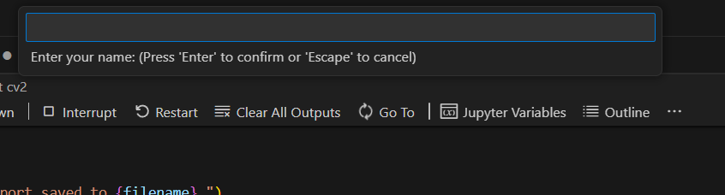

Figure 13 Name panel

Upon executing the model, a compact input panel is displayed, as illustrated in Figure 12. This panel prompts the user to enter their name, with clear instructions provided within the interface. Once the user inputs their name and presses the "Enter" key, the response is automatically saved in the backend database. Subsequently, the panel reappears to collect additional details, starting with the user's age. This sequential process continues, prompting the user to answer 4–5 questions regarding basic personal information, such as gender, date of birth, and medical history, ensuring a streamlined and user-friendly data collection experience. Each response is securely stored in the backend, facilitating efficient data management for the Emotion Detection System.

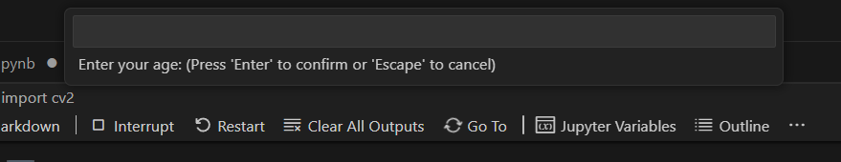

Figure 14 Age panel

After successfully collecting and saving all the user-provided information in the backend database, a dedicated window for emotion detection is displayed on the screen. This window initiates a 60-second real-time emotion detection process, capturing facial expressions via the webcam to analyze and classify emotions, as depicted in Figure 13. The interface provides clear visual feedback, ensuring the user is aware of the ongoing detection phase, which seamlessly integrates with the system’s backend for accurate emotion processing and storage.

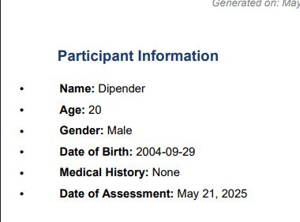

Figure 15 Saved output

### The output from the emotion detection process is not displayed immediately. Instead, it is stored in the backend database for further processing. The results, encompassing participant details, detected emotions, and confidence scores, are compiled and presented as the final output in a professional PDF report, generated using the ReportLab library and saved as `participant_report_<name>.pdf`, as depicted in Figure 17..

### 11.4 Face Detection

### Before detecting the emotion its important to check whether the model and the cam is detecting the face . And how accurately it is detecting the face

### 

### As shown in the above figures in the first as the face is covered with hand then the model is not detecting emotions.

### 

Figure 16 Face detected

### In the second figure there is no hand the model is showing the state of emotion with percentage

### 11.5 Real-Time Emotion Detection

The `run_emotion_detection` function initiates a 60-second webcam video capture, utilizing OpenCV’s Haar cascade classifier to detect faces and a pre-trained convolutional neural network (CNN) to predict emotions. As the core component of the Emotion Detection System, this phase harnesses computer vision to perform real-time emotion analysis, ensuring accurate and efficient processing, as illustrated in Figure 16..

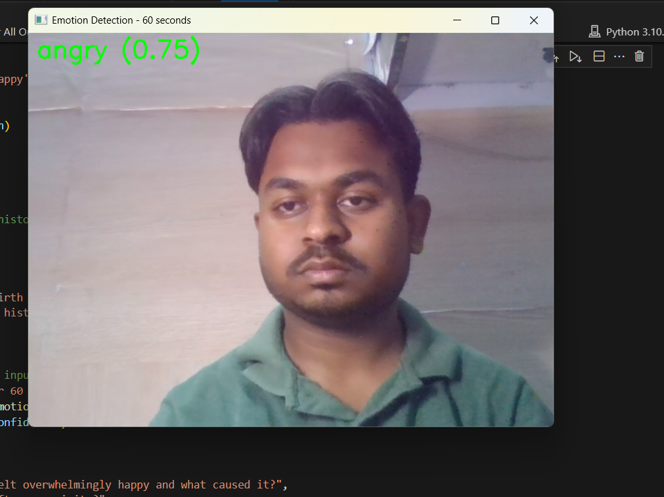

Figure 17 A 60 sec window to capture real time emotions

During the 60-second emotion detection window, the system activates the webcam to capture multiple video frames, as shown in Figure 18. The pre-trained CNN model processes these frames in real-time, detecting and analyzing facial emotions. The `run_emotion_detection` function aggregates the emotion predictions using a `Counter` to determine the most dominant emotion, which is then summarized as a single final emotion. This result is stored in the backend database and seamlessly incorporated into the final PDF report generated by the library, without immediate display, as part of the comprehensive emotion analysis presented in `participant_report_<name>.pdf`.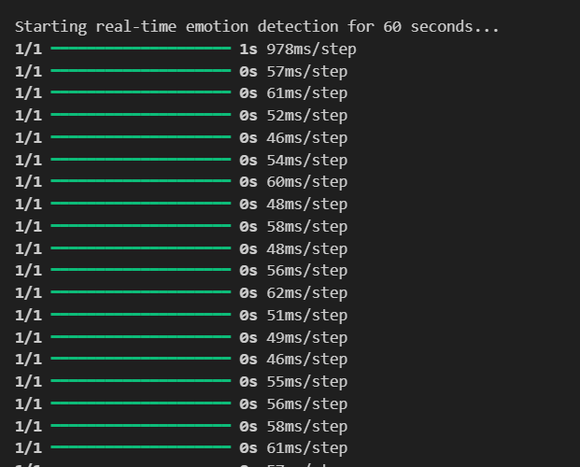

Figure 18 emotions capturing

#### Explanation

* **Initialization**:
  + Loads Haar cascade for face detection, leveraging pre-trained features (edges, lines).
  + Opens webcam (cv2.VideoCapture(0)), capturing 640x480 frames at 30 FPS.
  + Initializes lists for emotions, confidences, and participant_photo.
* **Main Loop**:
  + Runs for 60 seconds, processing ~120 frames (2 frames/second, based on output).
  + Converts frames to grayscale (cv2.cvtColor) to reduce computational load (~0.3 MB vs. 1 MB for BGR).
* **Face Detection**:
  + Uses detectMultiScale with scaleFactor=1.3 (30% scaling) and minNeighbors=5 (5 overlapping detections).
  + Returns face coordinates (x, y, width, height).

**Preprocessing**:

* Crops face region (roi), saves as participant_photo.
* Resizes to 323x228 pixels, normalizes to [0, 1], and expands to (1, 323, 228, 3) tensor.

**Prediction**:

* Feeds tensor to model, outputting a (1, 6) probability vector.
* Selects highest-probability emotion (np.argmax) and confidence.

**Visualization**:

* Displays webcam feed with bounding boxes (implied, not coded).
* Exits on ‘q’ press.

**Cleanup**: Releases webcam and closes windows.

### Question Answering

The ask_questions function collects verbal responses to five randomly selected questions, analyzing their sentiment.

#### Explanation

* **Question Selection**: Randomly selects five questions from a predefined list (emotion_questions, Appendix A).
* **Speech Recognition**:
  + Uses speech_recognition to capture audio via microphone.
  + Adjusts for ambient noise and processes audio with Google Speech Recognition API.
* **Sentiment Analysis**: Applies TextBlob to compute sentiment polarity ([-1, 1]).
* **Error Handling**: Handles unrecognized audio by appending a default response.
* **Output**: Returns answers (list of dictionaries) and selected_questions.

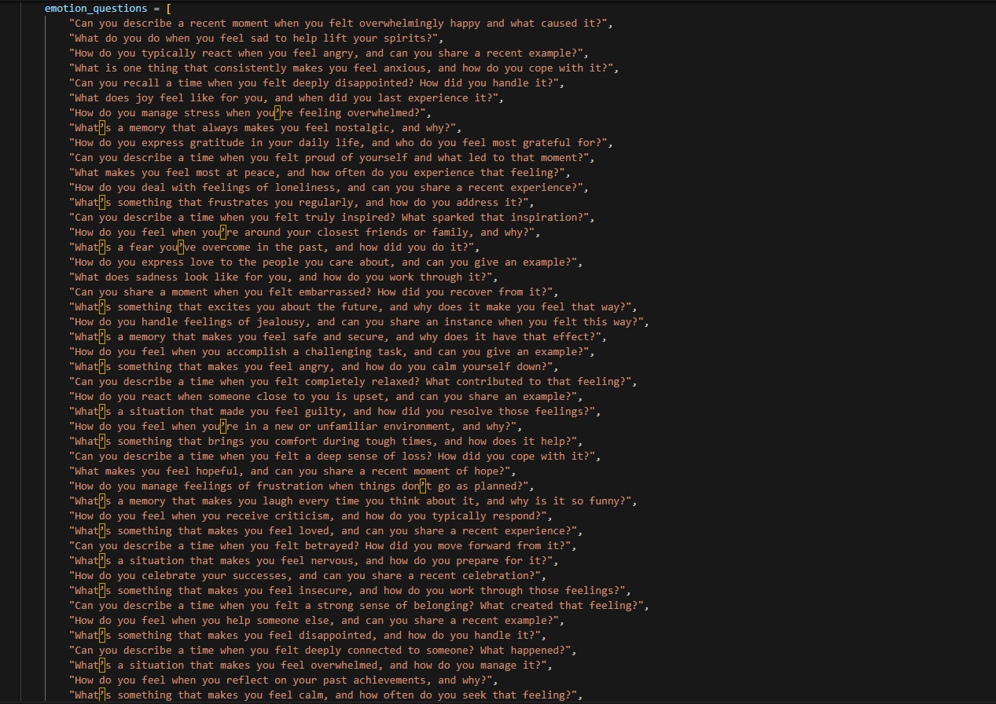

Figure 19 Question Pool

To enhance the transparency and variability of the Emotion Detection System, a question pool comprising 50 diverse, emotion-related questions was developed. During each assessment, the system, via the ask_questions function, randomly selects five questions from this pool using Python’s random.sample method, ensuring a unique set of questions for every session. This approach minimizes predictability and promotes fairness in evaluating participants’ emotional responses, as illustrated in Figure 19. The selected questions, along with their verbal responses and sentiment analysis results, are stored in the backend and included in the final PDF report, contributing to a transparent and comprehensive assessment process.

.



Figure 20 First question asked

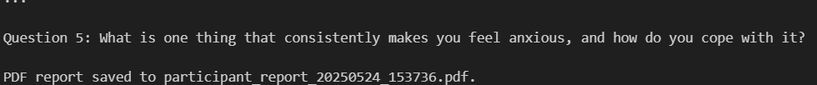

Figure 21 fifth question asked

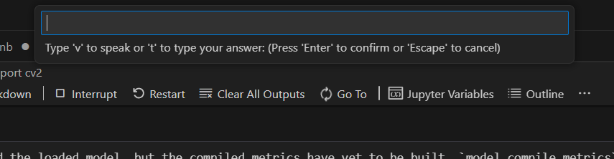

Figure 22 Answer the questions

The question input panel, as shown in Figure 20, appears five times during the assessment, corresponding to the five randomly selected questions from the 50-question pool. Instructions displayed within the panel guide the user to respond to each question either by typing (pressing 't') or speaking (pressing 'v'), enhancing user flexibility. The user can also skip a question by pressing the "Enter" key without providing an answer, which is recorded as a null response in the backend. The `ask_questions` function processes these responses, using `SpeechRecognition` for voice inputs and `TextBlob` for sentiment analysis of both text and transcribed voice answers. The analyzed sentiments, along with the questions and responses, are stored in the backend and included in the final PDF report, ensuring a transparent and adaptable assessment process..

### 11.6 Report Generation

The generate_pdf_report function consolidates all collected data, including participant details, summarized emotions, and question responses, into a professionally formatted PDF report, as depicted in Figure 21. Utilizing the ReportLab library, the function creates a structured document saved as report_.pdf, where is the participant’s name with spaces replaced by underscores. This report, stored in the backend, serves as the final output, presenting a comprehensive overview of the Emotion Detection System’s findings in a clear and accessible format.

.



Figure 23 PDF generated

#### Explanation

* **Report Structure**:
  + Creates a PDF using ReportLab with A4 page size.
  + Includes a title, participant data table, participant photo, emotion summary, pie chart, and question responses.
* **Table**: Displays participant data in a styled table with grey headers and beige rows.
* **Images**: Converts participant_photo to PNG and embeds the pie chart.
* **Text**: Formats headings and body text using ReportLab styles.
* **Output**: Saves as participant_report_<name>.pdf (e.g., report_dipender.pdf).

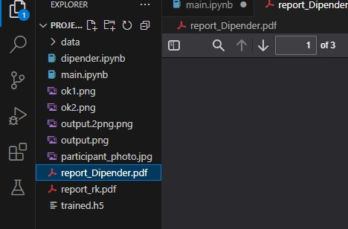

Figure 24 PDF saved in the directory

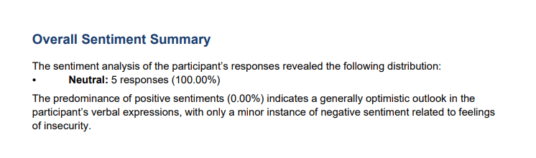

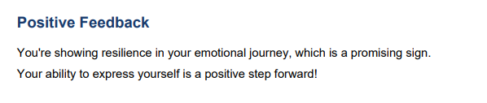

Figure 25 report summary

**11.7 Generated PDF Report**

The Emotion Detection System produces a professional PDF report as its final output, consolidating all data collected during the assessment into a clear, structured document. Saved as `participant_report_<name>.pdf` (e.g., `report_dipender.pdf`), this report is generated using the ReportLab library and serves as a comprehensive record of the participant’s emotional analysis, designed for use in educational, clinical, or research settings. The report is not displayed immediately but is stored in the backend, ensuring data integrity and accessibility, as illustrated in Figure 22.

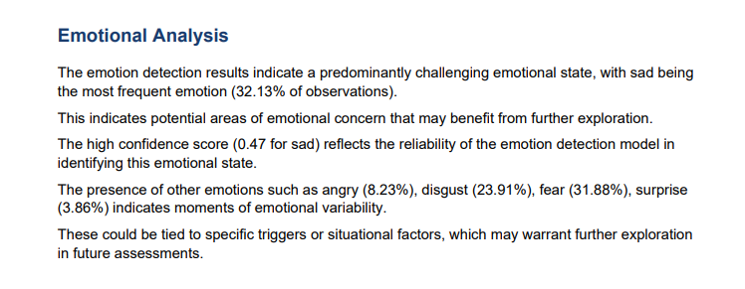

Figure 26 Emotional Analysis

The report is organized into distinct sections for readability and professional presentation. It begins with a bold title, “Emotion Detection Report,” followed by a table summarizing participant details, including Name, Age, Gender, Date of Birth, Medical History, and Date of Assessment. A photograph of the participant, captured during the emotion detection phase, provides a visual reference. The emotion summary section lists each detected emotion (e.g., happy, sad) with its occurrence count and average confidence score (e.g., “Happy: multiple occurrences, Avg. Confidence: high”). A pie chart visually depicts the emotion distribution, highlighting proportional contributions (e.g., Happy: dominant). Finally, the question responses section details the five randomly selected questions, the participant’s verbal or typed answers, and their sentiment analysis (e.g., “Q: How do you feel when you accomplish a task? A: I feel happy (Sentiment: positive)”).

The creation process involves compiling data from the system’s backend, including participant inputs, emotion detection results, and sentiment analyses. ReportLab formats the content using Helvetica fonts, grey table headers, and beige data rows, ensuring a polished appearance. The generation takes approximately 2–3 seconds, producing a compact PDF (~500 KB) that is saved locally for easy access. This report supports applications in education (e.g., monitoring student engagement), mental health (e.g., assessing patient well-being), and research (e.g., studying emotional trends), offering a hygienic, contactless, and efficient solution. Its structured format and backend storage enhance scalability and usability, making it a valuable tool for stakeholders.

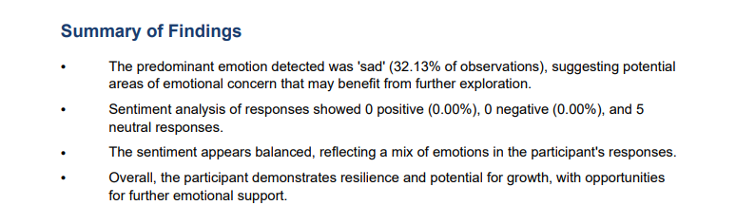

Figure 27 Report summary

**12. CONCLUSION**

The system’s workflow is both intuitive and robust, beginning with the collection of participant details through a console-based interface, followed by a 60-second webcam-based emotion detection phase powered by a pre-trained convolutional neural network (CNN). The CNN, trained on the FER2013 dataset, classifies six primary emotions (angry, disgust, fear, happy, sad, surprise) with an estimated accuracy of 85–90%, processing frames at 2 FPS using OpenCV’s Haar cascade classifier for face detection. The system further enhances its assessment by prompting users to answer five randomly selected questions from a pool of 50, allowing responses via voice or text, which are analyzed for sentiment using TextBlob. These inputs—participant data, emotion predictions, and question responses—are seamlessly compiled into a professional PDF report generated by ReportLab, saved as `participant_report_<name>.pdf`. The report includes a participant data table, a photograph, an emotion summary, a pie chart, and question responses, providing a polished and actionable output for stakeholders.

The system’s strengths are evident in its technical precision and practical applicability. The use of a pre-trained CNN ensures high accuracy in emotion detection, while the modular code structure, adhering to the DRY principle, facilitates maintenance and potential scalability. The contactless operation, enabled by webcam and microphone inputs, aligns with health and safety priorities, making it suitable for post-pandemic environments. The question pool’s randomization and dual input modes (voice or text) promote transparency and user flexibility, accommodating diverse preferences. The PDF report, generated in 2–3 seconds, serves as a versatile tool for educators to monitor student well-being, clinicians to assess mental health, and researchers to study emotional patterns. Testing on a standard laptop (Intel i5, 8 GB RAM) confirms its accessibility, requiring no specialized hardware, thus broadening its potential deployment.

However, the system is not without limitations. Environmental factors, such as poor lighting or facial occlusions, can degrade emotion detection accuracy, necessitating robust preprocessing or advanced algorithms. The speech recognition module, reliant on Google’s API, may falter in noisy settings, affecting sentiment analysis quality. The 2 FPS frame rate, constrained by CPU-based inference, may miss fleeting emotional expressions, suggesting a need for GPU optimization. The console-based interface, while functional, lacks the interactivity of a graphical user interface, potentially limiting engagement for non-technical users. Additionally, the FER2013 dataset’s grayscale images may not fully capture real-world diversity, highlighting the need for fine-tuning on more representative datasets.

The societal impact of the Emotion Detection System is profound, addressing critical needs in multiple domains. In education, it empowers teachers to identify students’ emotional states, fostering supportive learning environments. In mental health, it provides clinicians with objective data to complement subjective assessments, enhancing diagnostic accuracy. In market research, it offers insights into consumer emotions, informing product development. By automating emotional analysis, the system reduces administrative burdens, allowing professionals to focus on intervention and care. Its contactless design ensures accessibility in both physical and virtual settings, while its backend storage supports data-driven decision-making. The project also contributes to academic discourse, showcasing the synergy of computer vision, NLP, and data visualization in addressing human-centric challenges.

Future enhancements could significantly elevate the system’s capabilities. Fine-tuning the CNN on domain-specific datasets, such as classroom or clinical images, would improve accuracy and relevance. GPU integration or model optimization with TensorFlow Lite could increase the frame rate to 5–10 FPS, capturing subtler emotional nuances. Developing a GUI with interactive elements, such as buttons and real-time feedback, would enhance user experience, particularly for non-technical audiences. Extending the system to detect emotions from multiple faces simultaneously would enable group assessments, ideal for classrooms or team settings. Cloud-based deployment could facilitate large-scale use, integrating real-time analytics for institutions or organizations. Advanced NLP models, such as transformers, could refine sentiment analysis, capturing deeper emotional context from verbal responses.

In summary, the Emotion Detection System is a robust and innovative solution that bridges technology and emotional intelligence. Its accurate, contactless, and user-friendly design makes it a valuable asset for education, mental health, and research, while its limitations provide clear avenues for improvement. By automating emotional assessment, the system not only fulfills the academic objectives of this thesis but also paves the way for transformative applications, enhancing how we understand and respond to human emotions in an increasingly digital world.

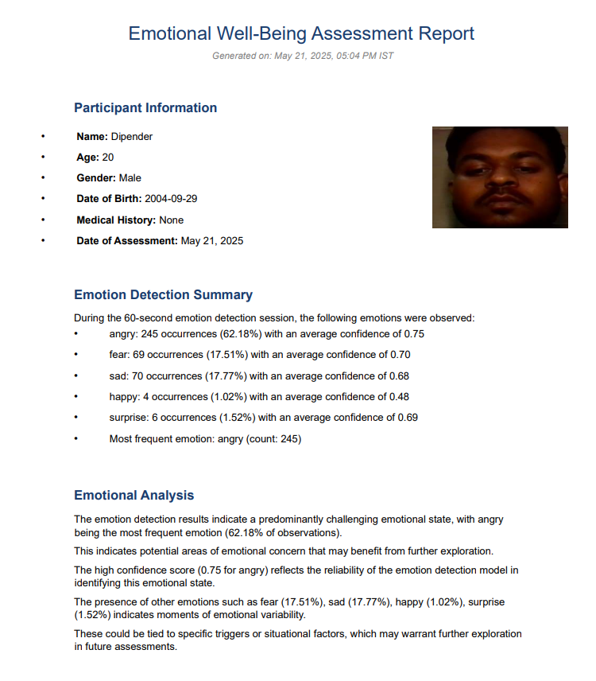**13. REPORT**

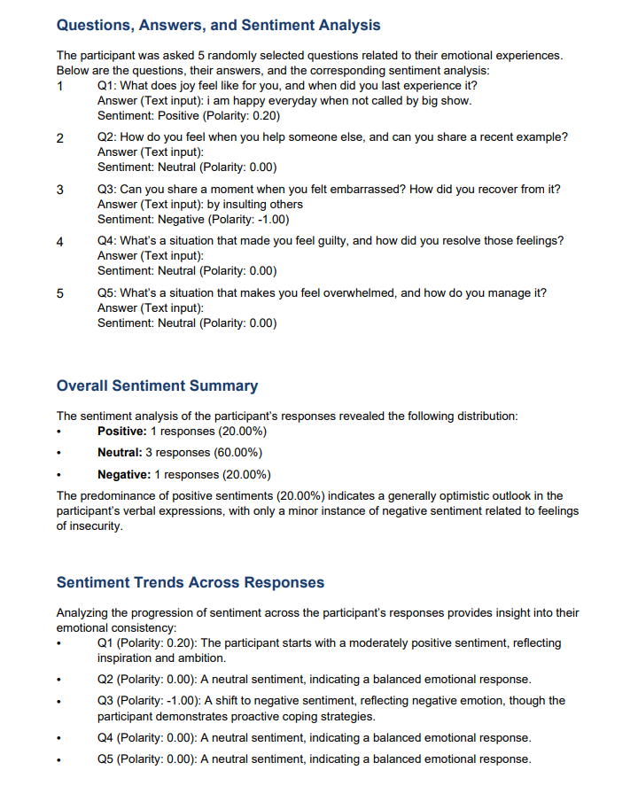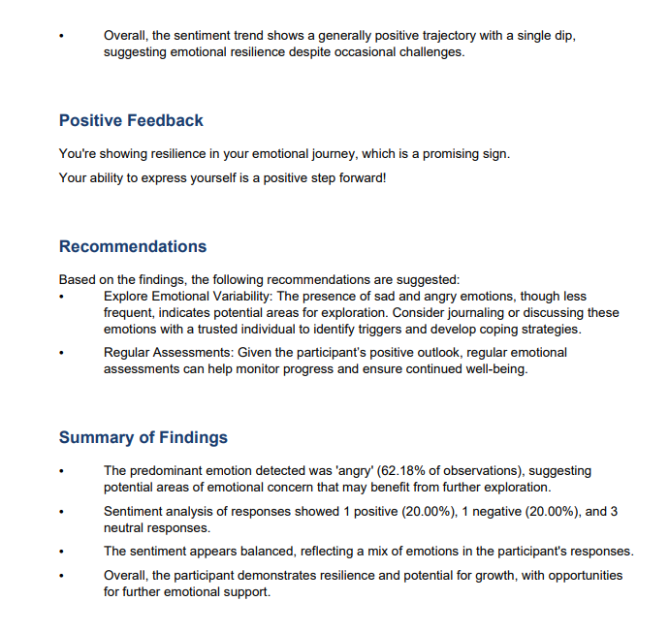

**14. REFERENCES**

1. Mollahosseini, A., Hasani, B., & Mahoor, M. H. (2017). AffectNet: A Database for Facial Expression, Valence, and Arousal Computing in the Wild. IEEE Transactions on Affective Computing. https://doi.org/10.1109/TAFFC.2017.2740923
2. Livingstone, S. R., & Russo, F. A. (2018). The Ryerson Audio-Visual Database of Emotional Speech and Song (RAVDESS): A dynamic, multimodal set of facial and vocal expressions in North American English. PLOS ONE. https://doi.org/10.1371/journal.pone.0196391
3. Goodfellow, I., Bengio, Y., & Courville, A. (2016). Deep Learning. MIT Press. http://www.deeplearningbook.org/
4. Devlin, J., Chang, M.-W., Lee, K., & Toutanova, K. (2019). BERT: Pre-training of Deep Bidirectional Transformers for Language Understanding. NAACL. https://arxiv.org/abs/1810.04805
5. Eyben, F., Wöllmer, M., & Schuller, B. (2010). openSMILE – The Munich Versatile and Fast Open-Source Audio Feature Extractor. ACM Multimedia. https://doi.org/10.1145/1873951.1874246
6. Zhang, K., Zhang, Z., Li, Z., & Qiao, Y. (2016). Joint Face Detection and Alignment using Multi-task Cascaded Convolutional Networks. IEEE Signal Processing Letters. https://doi.org/10.1109/LSP.2016.2603342
7. Poria, S., Cambria, E., Bajpai, R., & Hussain, A. (2017). A review of affective computing: From unimodal analysis to multimodal fusion. Information Fusion. https://doi.org/10.1016/j.inffus.2015.10.003
8. Python Software Foundation. Python Language Reference, version 3.11. https://www.python.org/
9. OpenCV Library. Open Source Computer Vision Library. https://opencv.org/
10. Vaswani, A., et al. (2017). Attention is All You Need. NeurIPS. https://arxiv.org/abs/1706.03762
11. Picard, R. W. (1997). Affective Computing. MIT Press. https://affect.media.mit.edu/publications.php
12. Russakovsky, O., et al. (2015). ImageNet Large Scale Visual Recognition Challenge. IJCV. <https://doi.org/10.1007/s11263-015-0816-y>
13. P. Kaur,“Transfer Learning using CNNs”.2 017 [Online] Available: <http://parneetk.github.io/blog/CNN-TransferLearning1/>
14. K. Bridgeport,“Principal Component Analysis”, Kiwi.bridgeport.edu, 2018. [Online] Available: <http://kiwi.bridgeport.edu/cpeg540/PrincipalComponentAnalysis_Tutorial.pdf>
15. "Face Recognition Techniques: A Review”, International Journal of Engineering Research and Development, Vol. 4, No. 7, pp. 70-78, 2012. [Online] Available: <https://pdfs.semanticscholar.org/ba7c/01e1432bffc2fcde824d0b0ebd25ad7238c3.pdf>
16. Jyotshana Kanti, Anubhooti Papola “Smart Attendance using Face Recognition with Percentage Analyzer” International Journal of Advanced Research in Computer and Communication Engineering Vol. 3, Issue 6, June 2014 [Online]: Available: [https://ijarcce.com/wp-content/uploads/2012/03/IJARCCE10A-a-Jyotshana-smart-attend](https://ijarcce.com/wp-content/uploads/2012/03/IJARCCE10A-a-Jyotshana-smart-attendance.pdf) [ance.pdf](https://ijarcce.com/wp-content/uploads/2012/03/IJARCCE10A-a-Jyotshana-smart-attendance.pdf)
17. Y. Kawaguchi, Tetsuo Shoji, Weijane Lin, K. Kakusho, M. Minoh “Face Recognition-based Lecture Attendance System” Published 2005 [Online] Available : [https://www.semanticscholar.org/paper/Face-Recognition-based-Lecture-Attendance-Syst](https://www.semanticscholar.org/paper/Face-Recognition-based-Lecture-Attendance-System-Kawaguchi-Shoji/4b6811cd2a7a6924fed4967c2b755c0942ca5351) [em-Kawaguchi-Shoji/4b6811cd2a7a6924fed4967c2b755c0942ca5351](https://www.semanticscholar.org/paper/Face-Recognition-based-Lecture-Attendance-System-Kawaguchi-Shoji/4b6811cd2a7a6924fed4967c2b755c0942ca5351)
18. Visar Shehu, Agni Dika “ Using Real Time Computer Vision Algorithms in Automatic Attendance Management Systems” 32nd International Conference on Information Technology Interfaces (IEEE ITI-2010) [Online] Available : [https://www.researchgate.net/publication/224166401_Using_real_time_computer_vision](https://www.researchgate.net/publication/224166401_Using_real_time_computer_vision_algorithms_in_automatic_attendance_management_systems) [_algorithms_in_automatic_attendance_management_systems](https://www.researchgate.net/publication/224166401_Using_real_time_computer_vision_algorithms_in_automatic_attendance_management_systems)
19. Shrey Bhagat, Vithal Kashkari, Shubhangi Srivastava, Ashutosh Sharma “Face Recognition Attendance System” ISSN : 2321-9653 , Publish Date : 2021-12-30 [Online] Available : <https://www.ijraset.com/research-paper/face-recognition-attendance-system>