

**Data Mining**

**Lab Terminal Project**

|  |  |
| --- | --- |
| **NAME:** | **SAMAN SAJID, FAIQ ABBASI** |
| **CLASS/SECTION:** | **BDS-5A** |
| **REGISTRATION NO.:** | **SP22-BDS-045, FA22-BDS-011** |
| **INSTRUCTOR’S NAME:** | **Maam Hilal Jan** |

Contents

Question: 01 4

Problem Description 5

Significance and Practical Applications 5

Why a Data Mining Approach is required??? 5

Question: 02 6

Dataset Selection 6

Question: 03 7

*Data Cleaning:* 7

Why Random Forest? 8

Evaluation: 8

Dimensionality Reduction: 8

Question: 04 9

Data Mining Technique Selection: Classification 9

Why Classification is Suitable for the Problem: 9

Reasoning for Classification Selection: 9

Why Classification Over Other Techniques: 10

Model Training and Testing 10

Challenges and Solutions: 10

User Manual for Data Mining GUI 11

1. Launching the Application 11

2. Operating the GUI 11

Step 1: Upload Dataset 11

Step 2: Download Dataset from Kaggle 11

Step 3: Show Data Summary 12

Step 4: Run Classification Model 12

Step 5: Plot Feature Importance 12

3. Interpreting Output 12

4. Error Handling & Troubleshooting 13

5. Additional Features 13

Clustering for US Accidents Analysis 13

Why Use Clustering for Accident Analysis? 13

Importance of Clustering in Accident Analysis 14

What Clustering Will Achieve in This Dataset??? 14

Clustering Techniques Applied 15

K-Means Clustering 15

DBSCAN (Density-Based Spatial Clustering of Applications with Noise) 15

Expected Outcomes for US Accidents Dataset 15

Graphs 16

Table of Figures

*Figure* *1 Average Severity by Road Feature* 16

*Figure 2 Average Severity by Road Feature* 16

*Figure 3 Accidents by Weather Condition* 17

*Figure 4 Temperature vs Severity by Accidents* 17

*Figure 5 Top 20 Weather Conditions at Time of Accident Occurrence* 18

*Figure 6 Severity at Start Lat* 18

*Figure 7 Start Lat vs Start Longitude* 19

*Figure 8 End Lat vs End longitude* 19

*Figure 9 Visibility vs Number of Accidents* 20

*Figure 10 Accident Severity By Weather Condition* 20

*Figure 11 Confusion Matrix for Model Evaluation using Grid Search* 21

*Figure 12 K-Means Clustering: Age vs Salary* 21

*Figure 13 DBSCAN Clustering: Age vs Salary* 22

*Figure 14 Accidents by Precipitation* 22

*Figure 15 Accidents by Humidity and Severity* 23

*Figure 16 Accidents by Bump and Severity* 23

*Figure 17 Accidents by Crossing and Severity* 24

*Figure 18 Accidents by Turning Loop and Severity* 24

# 

# Question: 01

## Problem Description

In the United States, road accidents pose a significant threat to public safety, causing loss of life, injuries, and substantial economic costs. Understanding patterns and factors contributing to these accidents can inform policies and preventive measures to reduce accident rates. By analyzing accident data, authorities and policymakers can identify high-risk areas, times, and conditions, thereby enabling more targeted and effective interventions.

The dataset chosen for this analysis, the "US Accidents" dataset from Kaggle, provides extensive information on accidents across various states. The primary goal is to predict accident conditions, including weather-related factors, using machine learning techniques. The dataset includes details such as the location, time, weather conditions, and severity of accidents and we apply data mining methods, specifically **classification with Random Forest**, to predict accident outcomes like weather conditions, which may influence accident occurrences.

## Significance and Practical Applications

This problem is crucial because road accidents impact not only the individuals involved but also the broader society through healthcare costs, insurance claims, infrastructure repair, and lost productivity. By using data mining to uncover trends and correlations within accident data, stakeholders can implement strategies that potentially save lives, reduce injuries, and mitigate economic impacts. Practical applications of this analysis include:

* **Urban Planning and Traffic Management:** Identifying accident-prone areas can help city planners design safer road layouts and deploy traffic management resources more effectively.
* **Weather Forecasting Integration:** Analyzing correlations between weather conditions and accident rates can help meteorological services issue warnings or suggest alternate routes in high-risk weather conditions.
* **Policy Development:** Insights from the analysis can guide policymakers to establish regulations, such as adjusting speed limits or installing safety measures in high-risk areas.

## Why a Data Mining Approach is required???

The problem of analyzing U.S. road accidents requires data mining for several reasons:

1. **Large Volume of Data**: The dataset contains hundreds of thousands of accident records, each with numerous attributes (e.g., location, weather, time, road conditions). Manually analyzing such a large volume of data is impractical, and traditional statistical methods may not efficiently uncover complex insights. Data mining techniques can handle vast datasets, processing and analyzing large amounts of information quickly.
2. **High Dimensionality**: This dataset includes various attributes, from geographical data to environmental conditions and accident severity. Data mining techniques can identify meaningful relationships among these multiple attributes and dimensions, which would be challenging to interpret without advanced analytical tools.
3. **Complex Relationships**: Factors contributing to accidents often interact in non-linear and complex ways. For example, weather conditions, time of day, road type, and traffic volume can together influence accident risk. Data mining models, such as clustering, classification, and association rule mining, can detect intricate relationships that are not easily observable through simple analysis.
4. **Pattern Recognition**: One of the primary goals in analyzing accident data is to recognize patterns and trends, such as identifying accident-prone locations, high-risk conditions, or recurrent accident causes. Data mining excels at identifying patterns across large and complex datasets, enabling the discovery of accident hotspots, common contributing factors, and other actionable insights.
5. **Predictive Modeling**: Data mining techniques allow us to build predictive models that can forecast the likelihood of accidents under specific conditions (e.g., weather or time of day). Predictive analysis can be used to develop proactive strategies, such as alerting drivers of high-risk conditions or improving traffic management during certain times.
6. **Data-Driven Decision Making**: Data mining supports data-driven decision-making by providing quantitative insights that policymakers, city planners, and public safety officials can use to implement effective measures. For instance, if data mining reveals that certain weather conditions significantly increase accident risks, authorities might increase safety warnings or implement countermeasures during adverse weather.

……………………………………………………………………………………………………………......

# Question: 02

## Dataset Selection

* **Dataset Name**: **US Accidents Dataset**
* **Description**: This dataset contains detailed information on over 2.8 million traffic accidents across the United States from February 2016 to March 2023. It includes various attributes related to the time, location, environmental conditions, and severity of each accident. The dataset offers a comprehensive view of the factors contributing to accidents and enables analysis for identifying high-risk areas, seasonal trends, and correlations with environmental conditions.
* **Origin**: The dataset is available on **Kaggle** (US Accidents Dataset), a popular public data repository. It was compiled from multiple sources, including traffic information providers and public data on road conditions, and has been cleaned and organized by Kaggle contributors for research and analysis purposes.
* **Dataset Size**:
  + **Number of Rows (Records)**: Approximately 2.8 million accident records
  + **Number of Features (Columns)**: 49 features that include detailed data about each accident's time, location, environmental conditions, and accident severity.

**Sample-Size**  
For this project, a sample of **10,000 rows** was taken from the original dataset, focusing on **21 features**. This subset enables efficient analysis while retaining key variables.

**Key Attributes**

1. **End_Lat** and **End_Lng**: Coordinates marking the end location of each accident.
2. **Street**, **City**, **Zipcode**: Provide specific location details, which are useful for geographic and demographic analysis.
3. **Timezone**: Indicates the time zone of each accident, allowing for time-based analysis across regions.
4. **Airport_Code**: Nearest airport, providing context on high-traffic areas potentially influenced by airport proximity.
5. **Weather_Timestamp**: Timestamp of weather data recording, correlating environmental conditions with accident occurrences.
6. **Temperature(F)**, **Wind_Chill(F)**: Reflect temperature and wind chill at the accident time, impacting road conditions and driver behavior.
7. **Humidity(%)**: Relative humidity, associated with visibility and road traction issues.
8. **Pressure(in)**: Atmospheric pressure, which can indicate stormy or high-wind conditions.
9. **Visibility(mi)**: Visibility distance in miles, an important factor in driving safety.
10. **Wind_Direction** and **Wind_Speed(mph)**: Details on wind conditions, affecting vehicle control.
11. **Precipitation(in)**: Amount of precipitation, providing insight into road surface conditions.
12. **Weather_Condition**: General weather conditions, such as rain or fog, which can impact accident likelihood.
13. **Sunrise_Sunset**: Indicates whether it was daylight or nighttime, affecting driver visibility.
14. **Civil_Twilight**, **Nautical_Twilight**, **Astronomical_Twilight**: Phases of twilight, providing further detail on natural light conditions.

………………………………………………………………………………………………………

# Question: 03

#### **Data Cleaning:**

1. **Data Cleaning**:
   * **Missing Values**: Missing values are handled by imputing the median for numerical columns and the most frequent value for categorical columns using SimpleImputer.
2. **Data Transformation**:
   * **Label Encoding**: Categorical variables like Street, City, and Weather_Condition are encoded into numerical values using LabelEncoder. This is necessary for machine learning algorithms since they expect numerical data.
   * **Normalization**:

**Min-Max Scaling** is applied to all **numerical columns** (e.g., 'End_Lat', 'End_Lng', 'Weather_Timestamp', 'Temperature(F)', etc.) using the MinMaxScaler. This scales the values of each numerical column into the range [0, 1].

* + **One-Hot Encoding for Categorical Variables**:

**One-hot encoding** is performed on all categorical columns (e.g., 'Street', 'City', 'Timezone', etc.) using pd.get_dummies(). This method converts categorical variables into a series of binary columns, where each category is represented by a separate column with a value of 1 or 0, depending on the category the observation belongs to.

1. **Train-Test Split**: The dataset is split into a training set (80%) and a testing set (20%) using train_test_split.
2. **Random Forest Classifier**: A **Random Forest Classifier** is trained on the training data, which is a powerful and flexible model for classification tasks. The model is then evaluated on the test set.
3. **Evaluation**: The model's performance is evaluated using **accuracy score** and a **classification report**, which includes precision, recall, and F1-score for each class.

## ****Why Random Forest?****

* **Robustness**: Random Forest is known for its robustness and ability to handle both numerical and categorical features.
* **Feature Importance**: It can handle large datasets with many features, and can also assess feature importance, which helps in understanding which features contribute most to the prediction.
* **No Need for Feature Scaling**: Random Forest does not require feature scaling, making it simpler to apply.

## ****Evaluation****:

* After training and testing the model, the **accuracy score** will tell you how well the classifier is performing.
* The **classification report** gives more detailed metrics like precision, recall, and F1-score, which provide insights into how well the model performs for each class (e.g., predicting different weather conditions).

Dimensionality Reduction:

* **Principal Component Analysis (PCA)**:
  + PCA is applied to reduce the dimensionality of the dataset. This technique helps in extracting the most important features (principal components) that explain the maximum variance in the data while reducing the number of features in the dataset.
  + **PCA** is particularly useful when the dataset has many features (after one-hot encoding), which could lead to overfitting or computational inefficiencies. By reducing the dimensionality, PCA makes the dataset more manageable and helps improve the performance of machine learning models.
  + In this code, PCA is set to retain **95% of the variance** (n_components=0.95). This means that PCA will select the smallest number of components that together explain at least 95% of the total variance in the data.

………………………………………………………………………………………………………………..

# Question: 04

## ****Data Mining Technique Selection: Classification****

**Chosen Technique**: **Classification (Random Forest Classifier)**

## ****Why Classification is Suitable for the Problem:****

The problem at hand appears to involve predicting or categorizing data points based on various input features. Given the structure of the dataset, which includes both categorical (e.g., 'Street', 'City', 'Weather_Condition') and numerical features (e.g., 'Temperature(F)', 'Humidity(%)', 'Wind_Speed(mph)'), **classification** is an appropriate technique if the goal is to classify instances into predefined categories.

For instance, if the objective is to predict weather conditions (or any other categorical output), classification would enable the model to learn patterns in the data and assign each observation to one of the predefined categories (such as different weather conditions like "Clear", "Rainy", "Cloudy", etc.). The dependent variable (target) is categorical, making classification a fitting approach.

## ****Reasoning for Classification Selection:****

* **Nature of the Target Variable**:
  + Since the target variable in this case (e.g., 'Weather_Condition') is categorical, classification is naturally suited for predicting discrete categories or classes.
  + For example, if we aim to predict the weather condition based on features like temperature, wind speed, humidity, etc., classification will allow us to output the probability of different weather conditions for each input set.
* **Handling of Categorical and Numerical Features**:
  + The dataset consists of both **categorical features** (like 'City', 'Street', 'Timezone') and **numerical features** (like 'Temperature(F)', 'Pressure(in)', 'Wind_Speed(mph)'). Classification techniques, such as decision trees, logistic regression, or random forests, handle both types of features well. Categorical features are usually processed via techniques like one-hot encoding, and numerical features can be normalized or standardized.
* **Prediction of Discrete Outcomes**:
  + The objective seems to be predicting a specific class (e.g., weather condition, event classification, etc.). Classification algorithms excel in tasks where the goal is to predict a **discrete class label** based on input features.

## ****Why Classification Over Other Techniques:****

* **Vs. Clustering**:
  + **Clustering** is an unsupervised technique that groups data points based on similarity, but it doesn’t require a predefined target variable. This approach would be less suitable for problems where the goal is to make specific predictions or categorize new instances based on predefined classes (e.g., predicting a weather condition). Clustering could be useful for exploratory analysis or identifying patterns in data, but classification is more appropriate when you have a clear target variable to predict.
* **Vs. Association Analysis**:
  + **Association analysis** is used to identify relationships between variables, typically in the form of association rules (e.g., market basket analysis to see which items are frequently bought together). This technique is not suitable for prediction tasks, especially when dealing with a labeled dataset where the goal is to predict a categorical outcome based on various features.
  + While association analysis could reveal interesting patterns, classification is more effective for solving prediction problems.
* **Vs. Regression**:
  + **Regression** is used when the target variable is continuous, such as predicting house prices or stock market values. Since the target variable in this problem is categorical (e.g., 'Weather_Condition'), classification is more appropriate. Regression would be a better choice only if we were predicting continuous variables (e.g., predicting temperature, pressure, or wind speed).

………………………………………………………………………………………………………………..

# ****Model Training and Testing****

* After preprocessing, a **Random Forest Classifier** is trained on the training set.
* The model is evaluated using an **accuracy score** to determine overall performance.
* A **classification report** is generated to provide precision, recall, and F1-score for each category of the target variable (e.g., weather conditions).

## Challenges and Solutions:

1. **Handling Missing Data**:
   * **Challenge**: The dataset contained missing values that needed to be addressed.
   * **Solution**: Used **SimpleImputer** to impute missing values for numerical and categorical columns.
2. **Feature Selection**:
   * **Challenge**: The dataset had many features, some of which may not contribute significantly to predicting accident outcomes.
   * **Solution**: Applied **PCA** for dimensionality reduction, reducing the feature set to improve model efficiency and reduce the risk of overfitting.
3. **Model Overfitting**:
   * **Challenge**: With a large dataset and multiple features, the Random Forest model could potentially overfit to the training data.
   * **Solution**: Used cross-validation and feature importance analysis to mitigate overfitting and focus on the most relevant features.

## User Manual for Data Mining GUI

Welcome to the **Data Mining GUI** application! This user-friendly interface helps you upload a dataset, run data analysis, and visualize the results through a classification model (Random Forest) to predict and analyze key insights.

### 1. **Launching the Application**

* **Opening the Application**: Run the script to launch the GUI application. The window will appear with buttons for dataset upload, model execution, and feature visualization.
* **Main Window Overview**:
  + The application window consists of:
    - **Button Frame**: Contains buttons for various actions.
    - **Result Frame**: Displays the model's accuracy and results after running the classification model.

### 2**. Operating the GUI**

### ****Step 1: Upload Dataset****

* **Click the "Upload Dataset" Button**: This will open a file dialog allowing you to select and upload a CSV file containing your dataset.
  + **Input Requirements**: The dataset must be in CSV format, and it should contain both features and a target column (the column you want to predict).
  + **Example**: The dataset might contain columns like "temperature," "humidity," and "weather condition," with a target column like "accident severity."
  + After selecting the file, the dataset is loaded into the app, and a success message will appear.

### ****Step 2: Download Dataset from Kaggle****

* **Click the "Download from Kaggle" Button**: This option allows you to download a dataset directly from Kaggle.
  + **Input Requirements**: Ensure you have a Kaggle account and the Kaggle API set up with your credentials.
  + **Action**: The dataset will be downloaded to a local folder (data), and once downloaded, it will be loaded into the app for further use.

### ****Step 3: Show Data Summary****

* **Click the "Show Data Summary" Button**: This will display basic statistics of the dataset (such as mean, standard deviation, min, max values).
  + **Visualization**: A correlation matrix is generated to help identify relationships between features.
  + **Output**: You will see a summary of the dataset’s statistics in a popup window, and a heatmap of the correlation matrix will be displayed in a separate window.

### ****Step 4: Run Classification Model****

* **Click the "Run Classification Model" Button**: This will train a Random Forest Classifier model on your dataset.
  + **Model Behavior**:
    - The target column (e.g., accident severity) should be labeled as "target" in your dataset. The rest of the columns are considered features.
    - The dataset will be split into training and testing sets (80% training, 20% testing).
    - The model will be trained, and predictions will be made on the test data.
  + **Output**: After training, the accuracy of the model will be displayed as a percentage in the "Model Accuracy" label.
    - If the accuracy is high, it indicates that the model is making reliable predictions.
    - If the accuracy is low, consider adjusting the model or preprocessing the dataset differently.

### ****Step 5: Plot Feature Importance****

* **Click the "Show Feature Importance" Button**: After running the classification model, you can visualize the importance of each feature used in the model.
  + **Feature Importance Visualization**: A bar chart is displayed showing the importance of each feature based on the model’s training.
  + **Output**: The bar chart will highlight which features most influence the prediction, helping you identify key factors that drive your model's decisions.

## 3. ****Interpreting Output****

* **Model Accuracy**:
  + The accuracy score reflects how well the model performed on the test data. A higher score indicates a more reliable model.
  + If the accuracy is low, consider investigating:
    - Are there missing values in the dataset?
    - Are there irrelevant features or poor feature scaling?
* **Feature Importance**:
  + The **Feature Importance** graph helps you understand which features contribute most to the model’s predictions.
  + The features with higher bars are the most significant, while those with smaller bars are less influential.

## 4. ****Error Handling & Troubleshooting****

* **Dataset Upload Error**: If the file you select is not a valid CSV file or if the dataset doesn't load correctly, you will see an error message. Ensure your file is correctly formatted and try again.
* **Running the Model**: If no dataset is uploaded or if the target column is not defined, you will receive an error message prompting you to upload the dataset first.
* **Kaggle Download Error**: If there’s an issue with downloading the dataset from Kaggle (e.g., incorrect dataset name, authentication issues), the application will display an error message with the details.

## 5. ****Additional Features****

* **Data Visualizations**:
  + The GUI includes additional visualizations such as the **correlation matrix** and **feature importance** graphs to help you understand the data better.
* **Model Flexibility**:
  + Currently, the application uses the **Random Forest Classifier**, but you can easily modify the code to support other machine learning models or change hyper parameters.

………………………………………………………………………………………………………

# ****Clustering for US Accidents Analysis****

The goal of applying clustering techniques to the US Accidents dataset is to identify patterns and group accidents based on similarities in key attributes such as location, weather, time of occurrence, and road conditions. This process enables better understanding of accident trends and supports data-driven decision-making for traffic safety improvements.

## ****Why Use Clustering for Accident Analysis?****

1. **Discovering Accident Patterns**
   * Clustering reveals hidden trends, such as areas with high accident frequency, types of weather conditions most associated with accidents, or peak hours for accidents.
   * Understanding these patterns helps policymakers and transportation authorities implement targeted safety measures.
2. **Segmenting Accident Data**
   * By grouping similar accidents, clustering allows the identification of meaningful categories, such as accidents occurring under similar weather conditions, at specific times, or in particular regions.
   * These clusters can inform traffic control strategies, urban planning, and infrastructure improvements.
3. **Outlier Detection**
   * Clustering techniques like DBSCAN are robust against noise and can identify anomalies in the dataset.
   * For example, an unusually high number of accidents at a specific location might indicate a faulty traffic signal or poor road design.
4. **Improved Resource Allocation**
   * Understanding accident hotspots or high-risk conditions enables the optimized allocation of resources like traffic patrols, signage, or road repairs.
5. **Preparation for Predictive Modeling**
   * Cluster labels can be used as additional features in predictive models to enhance accuracy in predicting accident likelihood or severity.

## ****Importance of Clustering in Accident Analysis****

1. **Identifying Accident Hotspots**  
   Clustering helps pinpoint areas prone to frequent accidents (e.g., using geographic coordinates), enabling targeted interventions like improved signage or road redesign.
2. **Analyzing Weather and Time Effects**  
   Grouping accidents based on weather conditions (rain, fog, snow) or time (rush hours, late nights) allows for trend identification and planning. For instance:
   * Increased patrols during foggy mornings.
   * Better lighting on roads prone to nighttime accidents.
3. **Reducing Noise in the Dataset**
   * Clustering algorithms like DBSCAN can filter out anomalies (e.g., single, uncharacteristic accidents in otherwise safe zones), improving the dataset's quality for analysis.
4. **Insights into Accident Severity**  
   Clustering by factors like accident duration, number of vehicles involved, or impact on traffic can highlight commonalities in severe accidents, guiding preventive strategies.

## ****What Clustering Will Achieve in This Dataset???****

1. **Enhanced Data Understanding**
   * By categorizing accidents into groups, clustering provides an intuitive way to understand accident trends across regions, weather, and other variables.
2. **Risk Assessment**
   * Clusters can represent areas or conditions of high or low accident risk, supporting proactive measures.
3. **Actionable Insights for Policymakers**
   * Clustering outputs can guide decisions such as where to prioritize road safety campaigns, implement speed limits, or introduce advanced driver-assistance systems (ADAS).
4. **Data Simplification**
   * Clustering reduces the dataset's complexity by summarizing it into clusters, making it easier to interpret and analyze.

## ****Clustering Techniques Applied****

### ****K-Means Clustering****

* + **Purpose:** Groups accidents based on their proximity in feature space, such as geographic coordinates, weather, and time.
  + **Outcome:** Identifies accident-prone zones and common conditions under which accidents occur.

### ****DBSCAN (Density-Based Spatial Clustering of Applications with Noise)****

* + **Purpose:** Focuses on detecting dense regions of accidents while filtering out noise or outliers.
  + **Outcome:** Highlights dense clusters like urban hotspots and isolates rare events.

## ****Expected Outcomes for US Accidents Dataset****

1. **Accident Hotspot Identification:**
   * Geographic clustering to reveal high-accident areas.
   * Provides a foundation for location-specific interventions.
2. **Weather and Condition-Based Insights:**
   * Segmentation of accidents based on weather types to guide infrastructure changes like skid-resistant roads in rainy regions.
3. **Policy Recommendations:**
   * Actionable data for reducing accidents through optimized traffic flow, weather alerts, or stricter enforcement in high-risk zones.
4. **Improved Public Safety:**
   * Data-driven insights will support efforts to lower accident rates, mitigate their severity, and enhance public awareness.

# Graphs

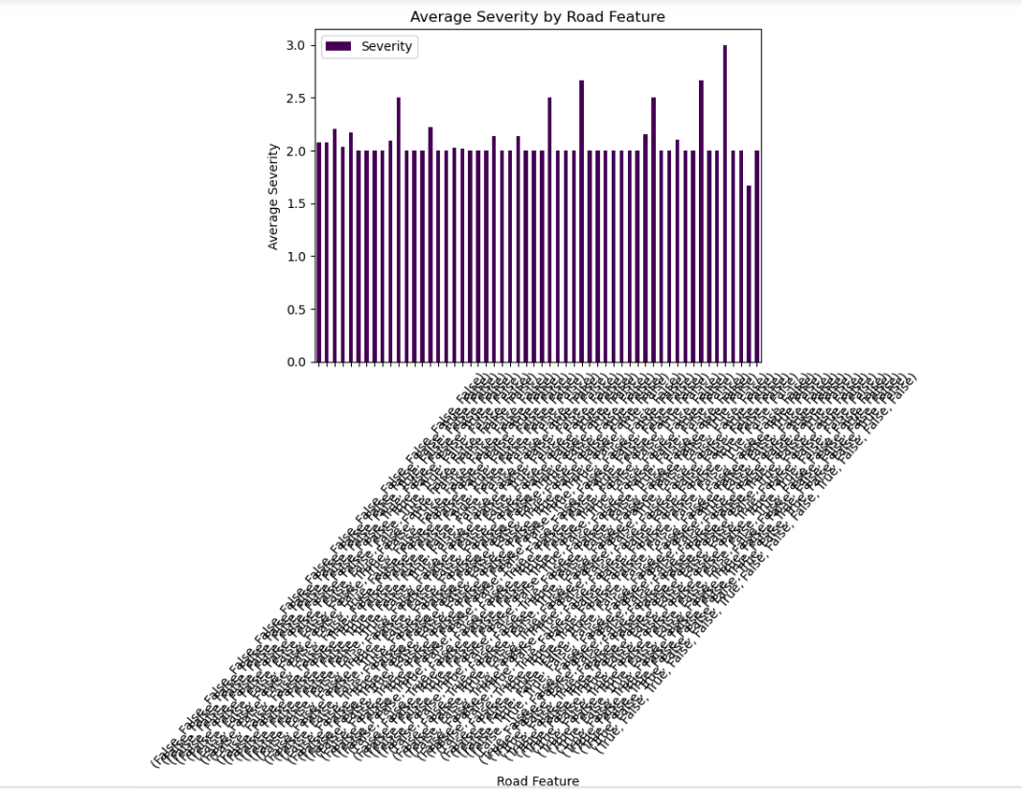

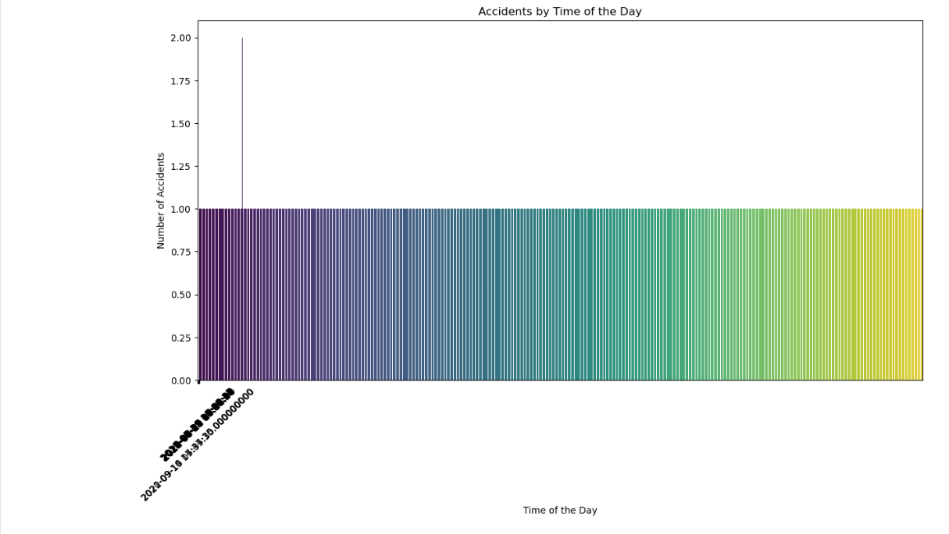*Figure* *1 Average Severity by Road Feature*

*Figure 2 Average Severity by Road Feature*

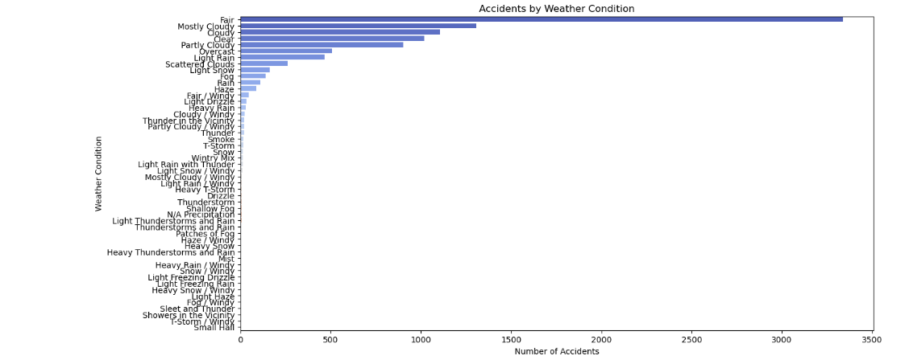

*Figure 3 Accidents by Weather Condition*

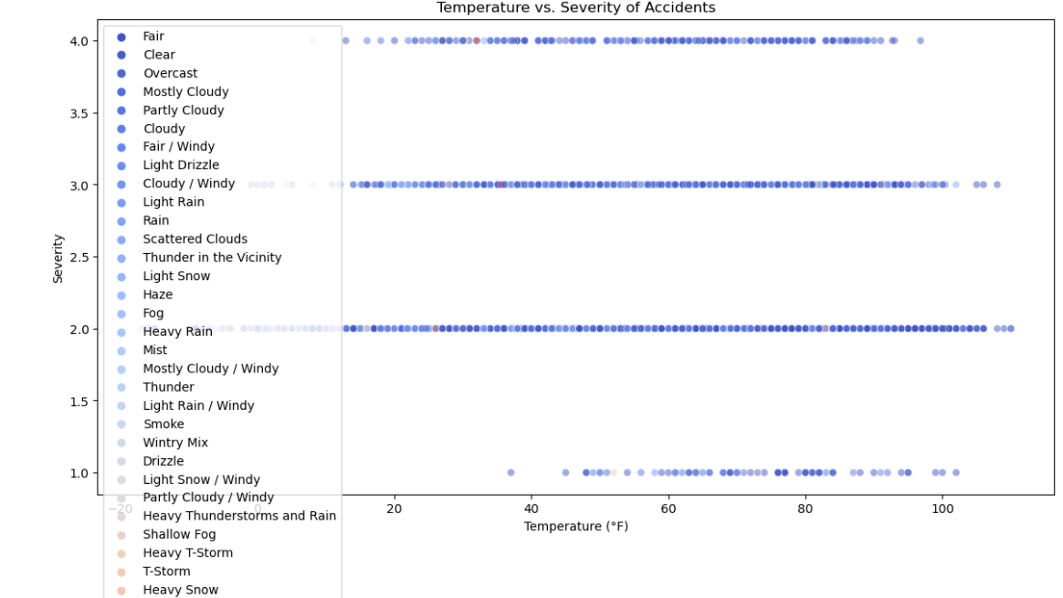

*Figure 4 Temperature vs Severity by Accidents*

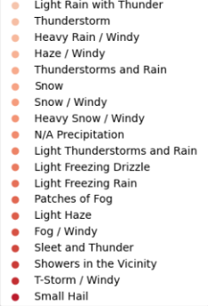

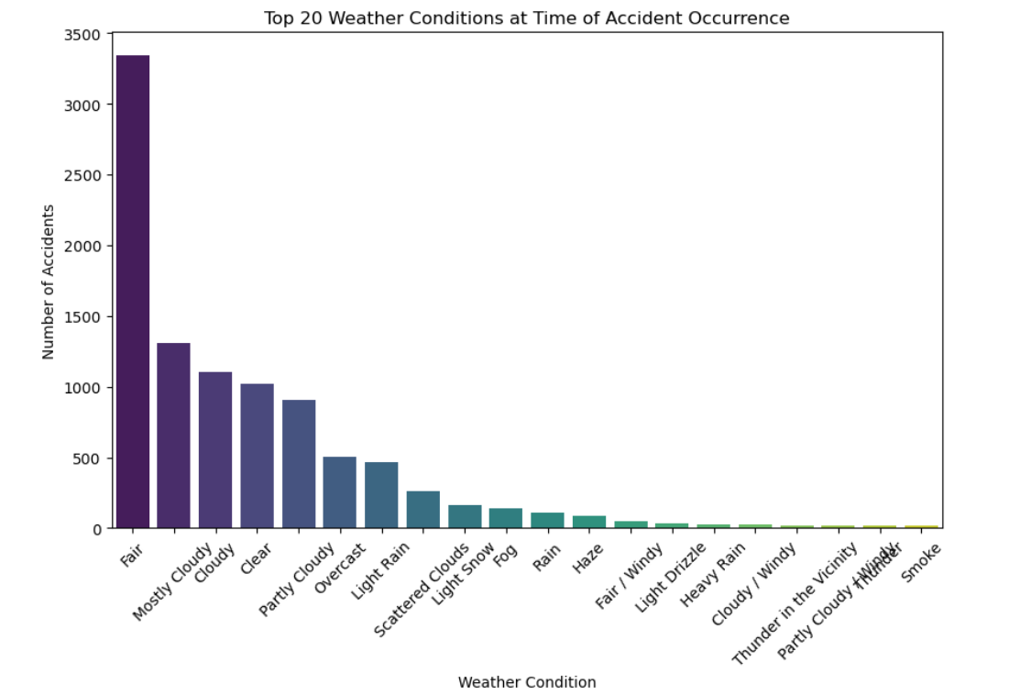

*Figure 5 Top 20 Weather Conditions at Time of Accident Occurrence*

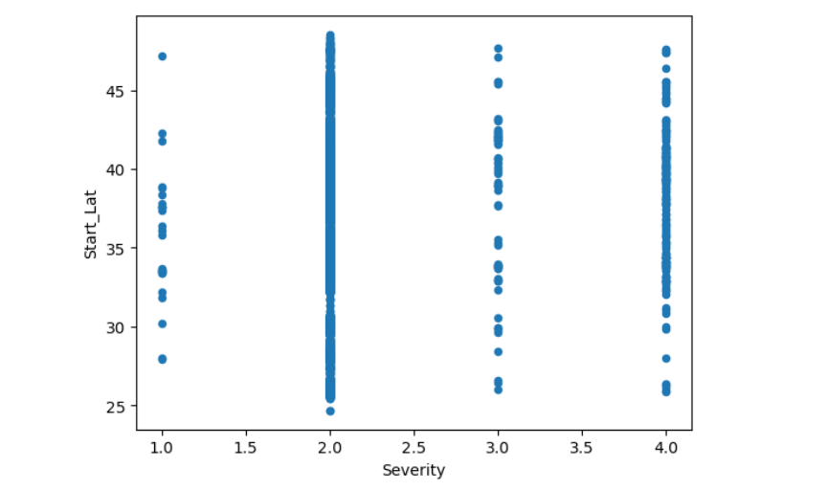

*Figure 6 Severity at Start Lat*

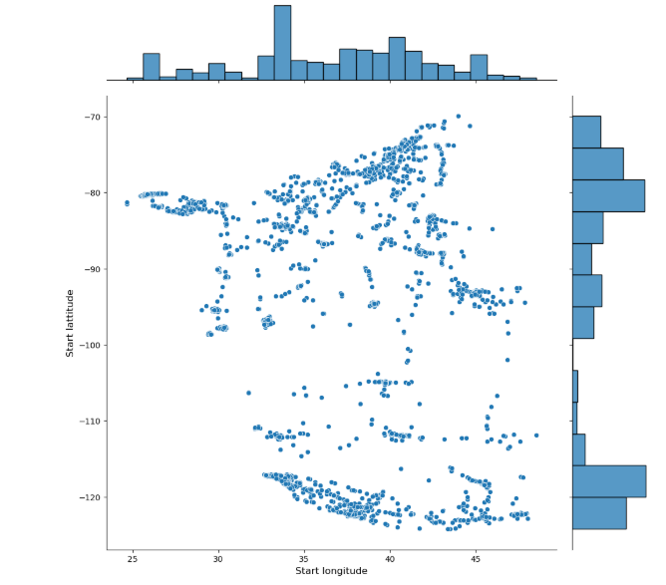

*Figure 7 Start Lat vs Start Longitude*

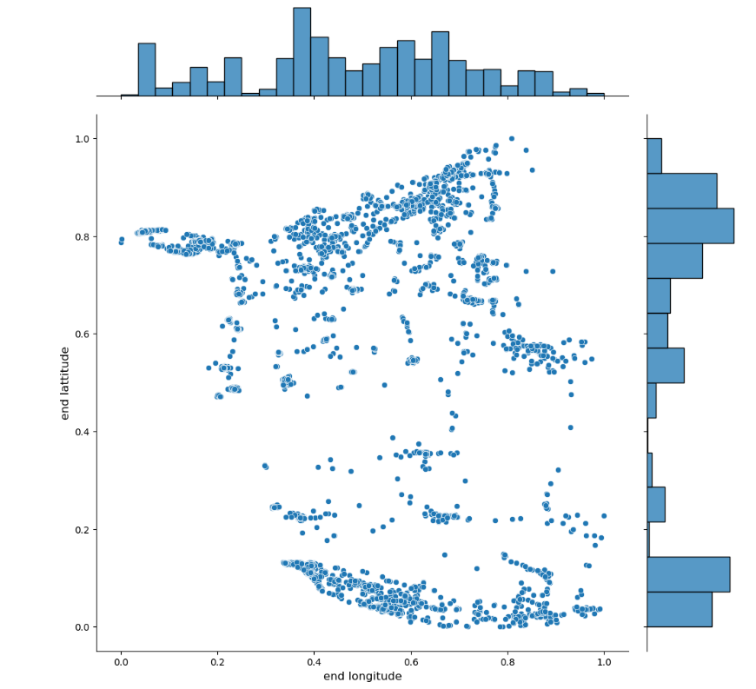

*Figure 8 End Lat vs End longitude*

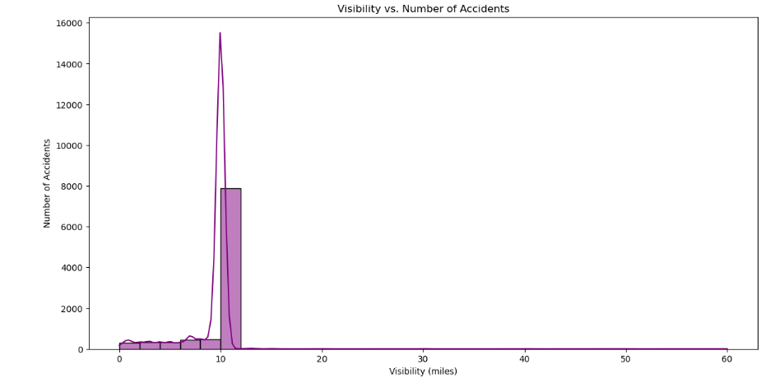

*Figure 9 Visibility vs Number of Accidents*

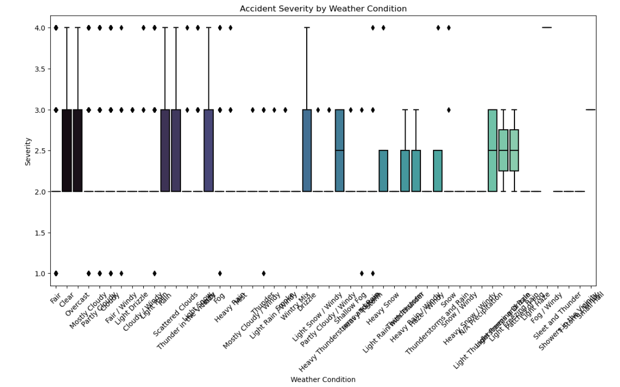

*Figure 10 Accident Severity By Weather Condition*

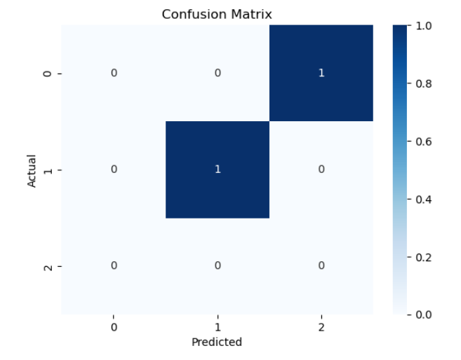

*Figure 11 Confusion Matrix for Model Evaluation using Grid Search*

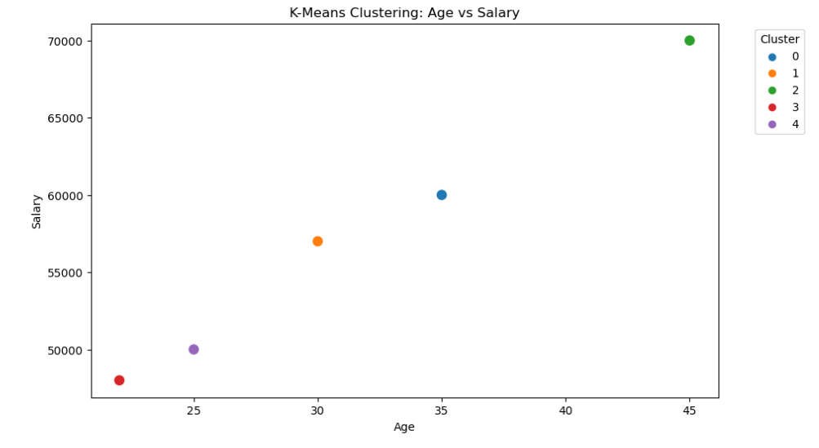

*Figure 12 K-Means Clustering: Age vs Salary*

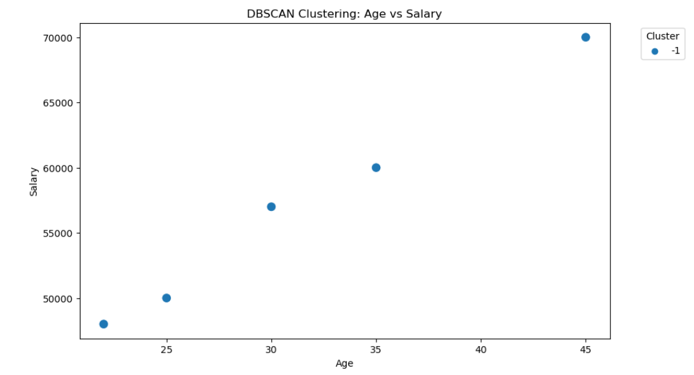

*Figure 13 DBSCAN Clustering: Age vs Salary*

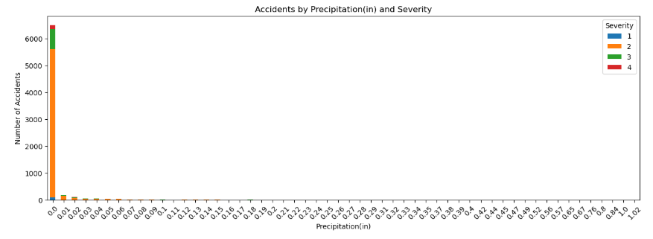

*Figure 14 Accidents by Precipitation*

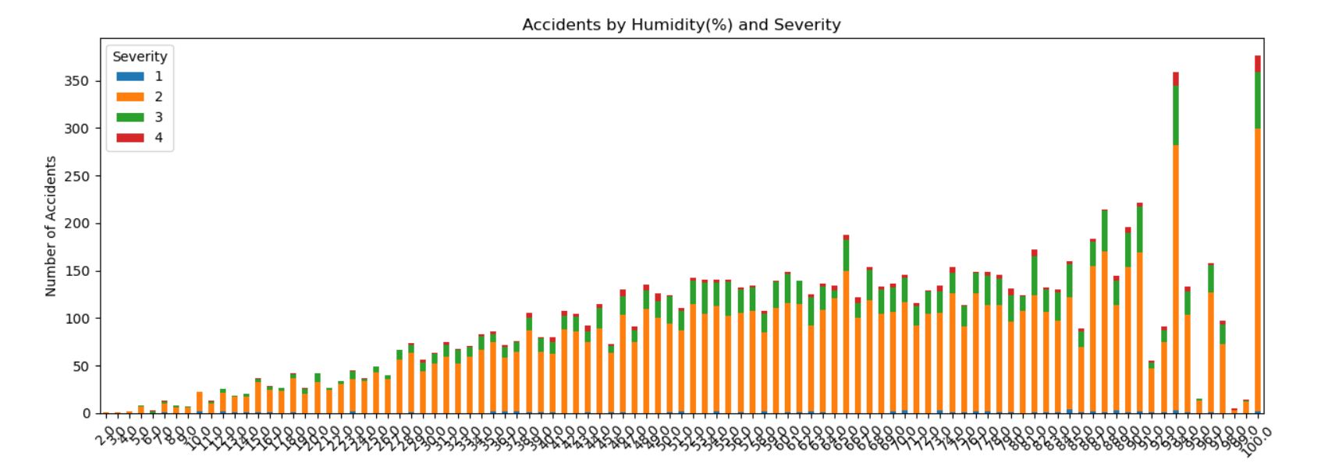

*Figure 15 Accidents by Humidity and Severity*

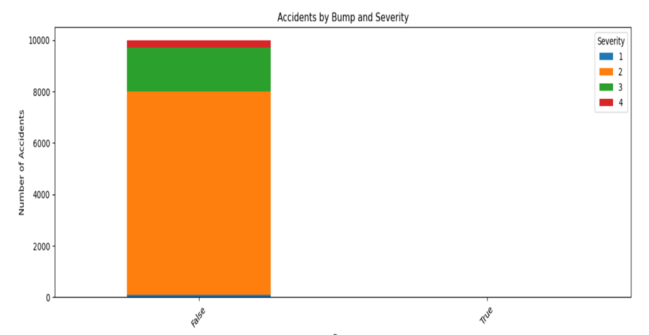

*Figure 16 Accidents by Bump and Severity*

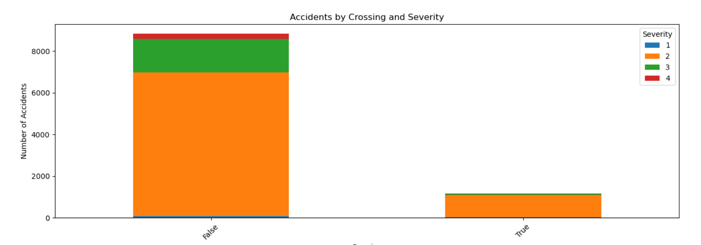

*Figure 17 Accidents by Crossing and Severity*

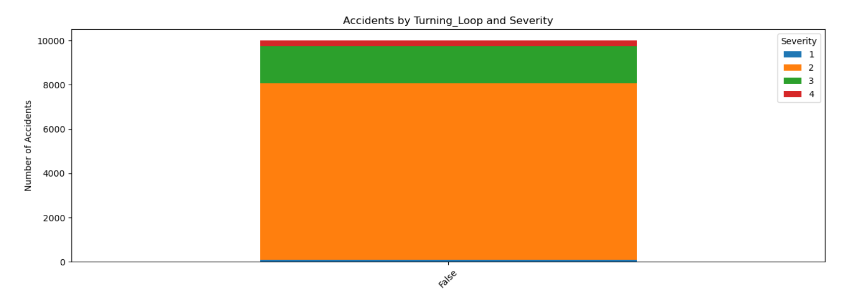

*Figure 18 Accidents by Turning Loop and Severity*