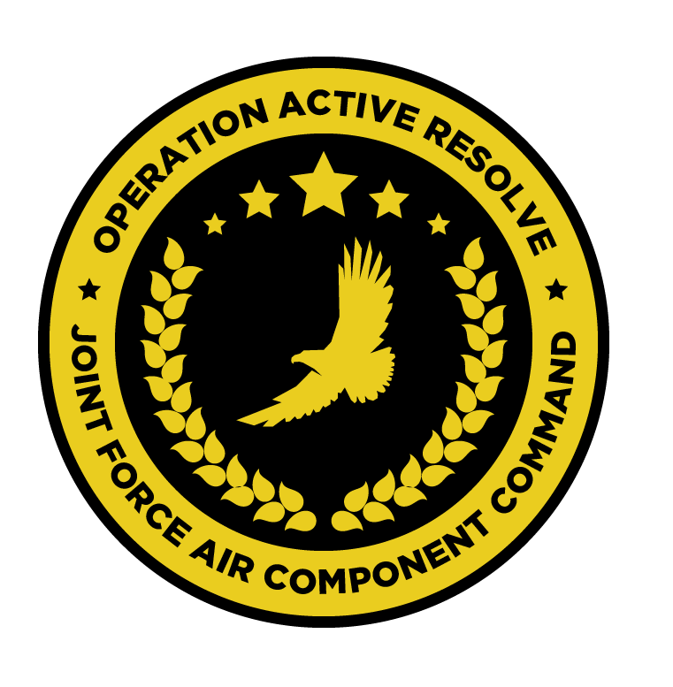

JFACC AIR OPERATIONS DIRECTIVE

OPERATION ACTIVE RESOLVE 2

D7

# 1. SITUATION

## a. JFC guidance (verbatim).

Priority of effort is on establishing Air Superiority in support of LCC and set conditions

for own operations.

* Start shaping for phase 2 in the operation (Create permissive environment).
* Continue support to LCC
* Be prepared to prepare contingency plans for striking Syrian WMD at short notice (regardless of phase). Expect this plan to be asked for prior to commencing phase 2. ALR: HIGH approved for such a plan.

## b. Enemy situation.

The current enemy situation is defined in VIS INTSUM D6, available at OPAR BRIEF.

## c. Friendly situation (by joint force component).

### Land Component Command (LCC)

#### IV Corps

The 55th Mechanized Division has secured HATAY and have moved forward battalions to screening positions along the FLOT.

The 56th Armor Division has its’ forward elements at the outskirt of Gaziantep. The 56th is conducting its offensive to capture Gazientep and free Turkish territory

#### Turkish local forces

The Turkish 33rd Brigade protecting the Ataturk Dam have been defeated by Syrian

forces despite heavy resistance and support from JFACC with CAS. They have withdrawn to the city of Sanliurfa in order to prevent Syrians capturing the airfield.

* Turkish local forces are in static defensive positions and are not in a position to assume offensive operations.
* Turkish local forces consist of BTR-80 and M-113s vehicles
* Turkish local forces are reinforced with coalition JTACs to support with CAS to defend
* against Syrian attacks.

### Maritime Component Command (MCC)

CSG-1 continues to support the mission from CSG-1 operations box.

SAG 1 remains outside the AO, having been directed to support shipping movements elsewhere.

### Special Operations Component Command (SOCC)

SOF teams are standing by to support with reconnaissance as required and requested by JFACC.

* Three SOF teams were inserted into theatre in support of the observation of strategic objectives.
* A fourth team is requested to perform recon.

# 2. MISSION - The JFACC’s mission statement (verbatim).

JFACC will establish air superiority in the area of operations and defeat Syrian offensive capability in support of CJTF-82’s offensive operations to neutralize Syrian’s capability to conduct offensives in the region.

# 3. EXECUTION – AIR OPERATIONS

|  |  |
| --- | --- |
| **JFACC’s Intent**   1. **Purpose** 2. **End State** | JFACC’s intent for this day is to continue to work toward air superiority and freedom of movement as well as providing the LCC with CAS flights in order to support the ground offensive to push out Syrian forces out Turkey  Priorities are:   1. Support the LCC with CAS flights, coordinate with LCC for information 2. Prosecute Syrian ground forces:    1. From Gazientep towards the East (KB BC, BD)    2. Near Minakh (MSR RED, KB CB)    3. East of FLOT in KB DA, keypad 2 and 4, KB DB keypad 1 and 3 3. Strike SCC EAST, SYTGT068 4. SEAD and SWEEP South of Abu-al-Duhur to provide intel on IADS picture near SYTGT062 (Air defence academy) 5. Strike SYTGT062, Syrian Air Defense Academy 6. Provide CAP for Turkish forces in and near Sanliurfa   The end state of this ATO sees the LCC been supported with CAS flight in order to support the ground offensive and achieve the goals set by the LCC for this day.  The SCC East, SYTGT068 will be destroyed, rendering the IADS in SCC east unusable.  Intel gained from the SEAD and SWEEP flights will allow for a planned strike on SYTGT062 as well as attrit SYAF MIG-23s from Shayrat AB and/or MIG-29s from Tiyas AB.  The neutralization of SYTGT062 will hinder or stop the build-up of additional SAM units.  The CAP will deter the SYAF to conduct bombing missions at and near Sanliurfa. |
| **Execution** What to do, when. – Any detailed instructions if needed | CAS flights will operate under JTAC control in ROZ Yellow within KB BC (vic Gazientep).  All other flights are to remain clear of ROZ Yellow as published in the D7 ACO  AR flights IVO ROZ Yellow needing to shoot in the direction of ROZ Yellow or fly into ROZ Yellow will contact the JTAC in charge.  For Minakh AB, KB CB will be used, overflying KB CA/CC to the west and east of CB is approved. Initial routing to KB CB is via KB BB.  Any flight may get retasked prior to the mission based on availability of flights and priorities to be fulfilled. |
| **Focus of effort by objective** | In accordance with JFACC objectives (JAOP) 3.2.2, this AOD supports the LCC in achieving its objectives as well as shape the environment for future flights and missions. |
| **Acceptable level of risk**. (including for AWACS and tankers: forward or rear) | As per SPINS**, MEDIUM** |
| **Collateral damage and civilian casualty guidance** | Every attempt should be taken to minimise collateral damage in the execution of these missions.  Suspected civilian casualties should be reported as soon as is practicable. |
| **TST guidance** | Where they are identified, items from the TST matrix must be prosecuted. The outcome should be reported on the in-flight report net. If prosecution is not possible, the location must be reported for re-tasking.   |  |  |  |  |  |  | | --- | --- | --- | --- | --- | --- | | **PRIORITY** | **TARGET** | **DESIRED EFFECT** | **RISK LEVEL** | **STATUS** | **RMKS** | | 1 | SCUD | Destroy | MEDIUM | Unlocated | N/A | | 2 | Fuel truck ATZ-10 | Destroy | MEDIUM | Likely SYTGT003/137 |  | |
| **Intelligence, Surveillance, Reconnaissance (ISR)** – If any effort should be done to support VIS with ISR to answer information gaps from VIS. | All intelligence and BDA should be submitted via Campaign Manager, and necessary images placed in #bda-reports on discord IAW SPINS.  The following IRs should be supported in this AOD:  IR24.1, 24.6, 24.7, 29, 35.1, 35.2, 35.3, 35.4, 35.5, 35.6, 35.8, 35.9, 35.10, 35.14, IR36, IR37, IR38, IR39, IR40  All VIS/VID Information Requests can be found [here](https://cloud.132virtualwing.org/apps/files/?dir=/wing/04 CAMPAIGNS/OPAR/VIS-JFACC COORDINATION/After D4-2&fileid=31205). |
| **Other issues** | Standard Combat Loadouts (SCL) are to be used in this misison. |
| **Direction and Guidance** | Aircrews must remain clear of Jordanian airspace at all times. Munitions must not be expended which may encroach on Jordanian airspace.  Munitions may not be expended in the direction of Basel Al Assad And Tartarus in order to avoid Russian involvement in the conflict. |

# 4. ADMINISTRATION AND LOGISTICS

Due to other ongoing major military operations, the munitions are limited in accordance with the ‘[available ordnance](https://132nd-vwing.github.io/OPAR-Brief/MISSION INFORMATION/OPAR Ordnance.pdf)’ publication available at OPAR Brief. **Further limitations may be imposed by JFACC and will be detailed in the ATO.**

**Active Tanker Tracks –** AR701 (ARCO-1), AR803 (SHELL-3) and AR804 (SHELL-4) as published in D7 ACO

# 5. COMMAND AND CONTROL

BULLSEYE NICOLE is defined at N 35 58.000 E 036 47.000.

There are no other specific C2 considerations for these missions. Refer to the Command, Control and Communications section of the JAOP.