Operating System HW3 Report

0416324 胡安鳳

1.How I accelerate the multi-thread programming

(1) Since there are many duplicated mathematical operation such as multiplication in the covolution process, we may save some value which have been calculated before to accelerated the process of filter algorithm, which is a bit close to the memorised algorithm.

(2) Use certain amount of thread for parallel processing.

(3) Use register variable to change the memory hierarchy for faster memory access since the register is much faster than the memory with respect to accessing speed.

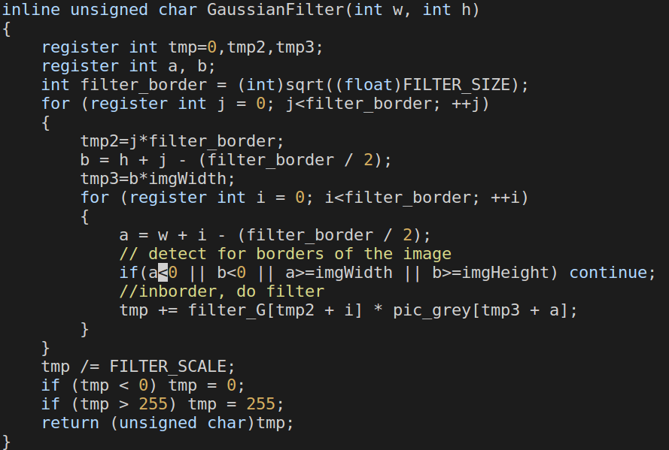Aforementioned is an example in Gaussain Filter, the same is true of Sobel Filter

(4) Use calloc insteal of malloc to trade a bit time faster.

2.How to use the semaphore or the mutex in the right time

Right before entering the critical section of the shared data, trywait it for semaphore to indicate that a certain process is going to enter the critical section and get the lock if there is no thread in the critical section.

The same idea can be implemented for mutex, where mutex is just a kind of binary semaphore

