Cranial Nerves Labeling Activity

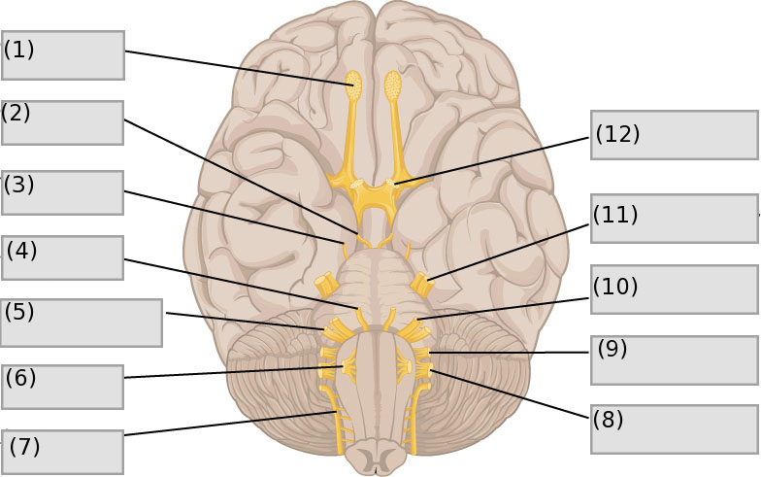

Word Bank

1. Accessory Nerve
2. Trochlea Nerve
3. Hypoglossal Nerve
4. Oculomotor Nerve
5. Trigeminal Nerve
6. Abducens Nerve
7. Olfactory Nerve
8. Facial Nerve
9. Optic Nerve
10. Vestibulocochlear Nerve
11. Vagus Nerve

Answer Key

1. Olfactory Nerve I
2. Oculomotor Nerve III
3. Trochlear Nerve IV
4. Abducens Nerve VI
5. Vestibulocochlear Nerve VIII
6. Hypoglossal Nerve XII
7. Accessory Nerve XI
8. Vagus Nerve X
9. Glossopharyngeal Nerve IX
10. Facial Nerve VII
11. Trigeminal Nerve V
12. Optic Nerve II