A Project Report
On
Facial Expression Recognition

For the partial fulfillment of Bachelor of technology in computer science and Engineering under Rajasthan Technical University.


Submitted to: Submitted by:
Prof. Dr. C.M. Choudhary Shubhrit Dhanawat (12ESKI082)
(H.O.D, -Computer Science) (Information Technology- 2016)
Shubhrit Dhanawat (12ESKIT082)

Under guidance of:
Mrs. Neha Janu
(Reader – CS/IT)

Department of Computer Science Engineering
Swami Keshvanand Institute of Technology, Management & Gramothan, Jaipur Rajasthan Technical University, Kota
April, 2015


SWAMI KESHVANAND INSTITUTE OF TECHNOLOGY, MANAGEMENT & GRAMOTHAN, JAIPUR

CERTIFICATE
I hereby declare that the work, which is being presented in the Minor Project Report, entitled “Facial Expression Recognition “in partial fulfillment for the award of Degree of Bachelor of Technology in Department of Information Technology submitted to the Swami Keshvanand Institute of Technology, Management & Gramothan, Jaipur, Rajasthan Technical University is a record of my own investigations carried under the Guidance of Mrs. Neha Janu, Reader, Department of Computer Science/Information Technology, Swami Keshvanand Institute of Technology, Management & Gramothan, Jaipur.

I have not submitted the matter presented in this report elsewhere for the award of any other degree.

Shubhrit Dhanawat (12ESKIT082)
B.Tech. (Information Technology)
Swami Keshvanand Institute of Technology, Management & Gramothan, Jaipur

Counter Signed by
Mrs. Neha Janu
Reader
Department of Information Technology

..................................
Mrs. Neha Janu
Reader
Department of Information Technology
Swami Keshvanand Institute of Technology, Management & Gramothan, Jaipur
ACKNOWLEDGEMENT

I feel immense pleasure in expressing my regards to the Chairman Mr. Surja Ram Meel, Director Mr. Jaipal Meel, Registrar Mrs. Rachana Meel, Director (Academics) Prof. (Dr.) S. L. Surana, Principal & Director (D&W) Prof. (Dr.) S. K. Calla, Principal Prof. (Dr.) Ramesh Pachar Swami Keshvanand Institute of Technology, Management & Gramothan, Jaipur for providing me necessary facilities during the various stages of this work.
I would like to thank Dr. Anil Choudhary, HOD, Department of Information Technology and Mrs. Neha Janu, Reader, Department of Information Technology for providing me opportunity to work in consistent direction and providing their valuable suggestions to improve project work.
I would like to thank my esteemed guide Mrs. Neha Janu, Reader, Department of Computer Science/Information Technology, Swami Keshvanand Institute of Technology, Management & Gramothan, Jaipur for her valuable guidance, keen interest, constant encouragement, incessant inspiration and continuous help throughout this work. Especially I acknowledge her support when I was stuck and she is suggesting me new ideas to solve the problems. Her vast experience and realistic approach have been of great help to me.
I would also like to express my thanks to my parents for their support and blessings. In addition, a very special thanks to all my colleagues and friends for their support in the completion of this work.

Shubhrit Dhanawat (12ESKIT082)
B.Tech. (Information Technology)
Swami Keshvanand Institute of Technology, Management & Gramothan, Jaipur

ABSTRACT

Human facial expression detection by computer systems has become a major field of interest. Facial expression detection algorithms are used in a wide range of applications, such as security control, video retrieving, biometric signal processing, human computer interface, face recognitions and image database management. However, it is difficult to develop a complete robust face detector due to various light conditions, face sizes, face orientations, background and skin colors. In this report, we propose a face detection method for color images. Our method detects skin regions over the entire image, and then generates face candidates based on a connected component analysis. Finally, the face candidates are divided into human face and non-face images by an enhanced version of the template-matching method.
Neural network based Facial expression detection has achieved enormous success in face recognition. A hybrid neural network solution for face recognition was addressed in which neural network is trained with Gabor features. Identifying a reliable feature is extremely important for all pattern recognition systems. A filter which is capable of simultaneously capturing spatial and frequency information plays a major role in numerous systems as a feature extractor. Here it is the Gabor filter. Magnitude, phase and orientation are the three basic features produced by Gabor filter Most face recognition methods based on Gabor filters use either the magnitude feature alone or a combination of the phase and magnitude features; purely based on the phase feature, in which orientation feature is ignored are very few. This system is commenced with convolving a face image with a series of Gabor filter coefficients at different scales and orientations. Gabor features are fed to feed forward neural network which is based on BAM for dimensional reduction and multi-layer perception with back propagation algorithm for training the Gabor features. Face dataset with images captured at different illumination conditions are collected and the effectiveness of the algorithm has been justified over that dataset.

CONTENTS

1. INTRODUCTION………………………………………………………………………………..6

1.1. Purpose

1.2. Scope

1.3. Definitions, Acronyms and Abbreviations.

1.4. Technologies Used

2. OVERALL DESCRIPTION…………………………………………………………………….10

3. DESIGN PROCESS…………...………………………………………………………………..15

4. UML DESIGNS……...…………………………………………………………………………..21

5. IMAGE DATASET ………………………………………………………….....................24

6. UI DESIGN COMPONENT......................................................................25

7. SUPPLEMENTARY REQUIREMENTS…………………………………………………..29

7.1. Software Requirement

7.2. Hardware Requirement

8. LIST OF REFERENCE…………………………………………………………………………..31

Chapter 1

INTRODUCTION
Facial expression recognition is one of the most relevant applications of image analysis. An automated system which equals human ability to recognize faces is a challenging module to build. Although humans are good enough in identifying known faces, but sometimes we may not that much skilled enough when we must deal with a large amount of unknown faces. Human’s limitations are overcome by the computers, which has large amount of memory and computational speed. The Gabor filter, which is derived from the uncertainty relation for information, can simultaneously capture spatial and frequency information to overcome the traditional signal representation in which a signal is represented either in the time domain or the frequency domain. Originally, it was designed for one-dimensional signal decomposition. However, since the 1980s, it has been extensively used as a spatial and convolution filter motivated by research results in biological vision systems. Although the Gabor filter has been involved in a wide range of components for pattern recognition systems, its major application is feature extraction. Gabor filters can exploit salient visual properties such as spatial localization, orientation selectivity and spatial frequency characteristics. Considering these overwhelming capacities and its great success in face recognition, in this paper Gabor features are used to represent the face image and produces recognition task in tandem with neural network. However, in reality, we do not get images with only faces. A system capable of detecting, locating and segregating faces in cluttered images is needed, after segregating faces they can be given as input to face recognition systems. Given an input scene, ultimate goal of a face detection algorithm is to identify the location and scale of all the faces in the image. Facial expression detection task is so trivial for the human brain, yet it still remains a challenging task to enable a computer for face detection, since the human face changes with internal factors like beard, facial expression and glasses etc. and it is also affected by external environmental factors like lightning conditions, scale, contrast between face and background and orientation of the face. For any face processing system first step is detecting the locations in images where the face is present. However, detecting the face from a single image is a challenging task because of variability in scale, location, orientation (up-right, rotated) and poses (frontal, profile). Facial expression, occlusion and lighting conditions also change the overall appearance of faces.

1.1 Objectives
1. Generate different feature matrices for different images in a dataset using feature extraction methods. This is done by applying Gabor filter equation on each image and filters the features accordingly.

2. Real time facial expression detection: Comparing the derived feature matrices to the neural network as input which is trained using general features for happy, sad, surprise and angry expressions and get the expression for the given image in real time.

1.2 Purpose

Facial expression recognition
Facial expression detection is used in biometrics, often as a part of (or together with) a facial recognition system. It is also used in video surveillance, human computer interface and image database management.

Photograph

Some recent digital cameras use facial expression detection for autofocus. Facial expression detection is also useful for selecting regions of interest in photo slideshows that use a pan-and-scale Ken Burns effect.

Marketing
Facial expression detection is gaining the interest of marketers. A webcam can be integrated into a television and detect any face that walks by. The system then calculates the race, gender, and age range of the face. Once the information is collected, a series of advertisements can be played that is specific toward the detected race/gender/age.
An example of such a system is Optimise and is integrated into the Amscreendigital signage system. The most recent innovation in the field was by, Miami Beach based, Ad Mobilize. Their Ad Beacon became the world's first 'plug and measure real time analytics device', allowing for any retailer to get the same facial detection technology large advertisers are using. They've also coined the term pay-per-face.

1.3 Scope
  - Facial expression recognition systems used today work very well under constrained conditions, although all systems work much better with frontal mug-shot images and constant lighting. All current facial expression recognition algorithms fail under the vastly varying conditions under which humans need to and are able to identify other people. Next generation person recognition systems will need to recognize people in real-time and in much less constrained situations.
- We believe that identification systems that are robust in natural environments, in the presence of noise and illumination changes, cannot rely on a single modality, so that fusion with other modalities is essential. Technology used in smart environments has to be unobtrusive and allow users to act freely. Wearable systems in particular require their sensing technology to be small, low powered and easily integral with the user's clothing. Considering all the requirements, identification systems that use facial expression recognition and speaker identification seem to us to have the most potential for wide-spread application.
- Cameras and microphones today are very small, light-weight and have been successfully integrated with wearable systems. Audio and video based recognition systems have the critical advantage that they use the modalities humans use for recognition. Finally, researchers are beginning to demonstrate that unobtrusive audio-and-video based person identification systems can achieve high recognition rates without requiring the user to be in highly controlled environments.
- Security at airports is of widespread importance. Detecting facial expressions of suspected persons lets the authorities guess of his/her intentions making its scope of widespread importance.

1.4Technologies used
MATLAB (matrix laboratory) is a multi-paradigm numerical computing environment and fourth-generation programming language. A proprietary programming language developed by Math Works, MATLAB allows matrix manipulations, plotting of functions and data, implementation of algorithms, creation of user interfaces, and interfacing with programs written in other languages, including C, C++, Java, Fortran and Python.
Although MATLAB is intended primarily for numerical computing, an optional toolbox uses the MPAD symbolic engine, allowing access to symbolic computing capabilities. An additional package, Simulink, adds graphical multi-domain simulation and model-based design for dynamic and embedded systems.
In 2004, MATLAB had around one million users across industry and academia .MATLAB users come from various backgrounds of engineering, science, and economics.
1.5 Project Perspective
Facial expression recognition systems are useful in law enforcement and justice solutions by staying one step ahead of the world's ever-advancing criminals. This includes acclaimed CABS-computerized arrest and booking system and the child base protection which is a software solution for global law enforcement agencies to help protect and recover missing and sexually exploited children, particularly as it relates to child pornography. It is also useful in Homeland defense which includes everything from preventing terrorists from boarding aircraft, to protecting critical infrastructure from attack or tampering (e.g. dams, bridges, water reservoirs, energy plants, etc.), to the identification of known terrorists. It is also applicable in airport and other transportation terminal security. Facial expression recognition software can enhance the effectiveness of immigration and customs personnel. The nancial services industry revolves around the concept of security. Facial expression recognition software, can improve the security of the financial services industry, saving the institution time and money both through a reduction of fraud case and the administration expenses of dealing with forgotten passwords. Furthermore, biometric-based access control units can safeguard vaults, teller areas, and safety deposit boxes to protect against theft. The use of biometrics can also ensure that confidential information remains while deterring identity theft, particularly as it relates to ATM terminals and card-not-present e-commerce transactions. It allows capturing, archiving, and retrieving identifying characteristics as tattoos, marks, or scars. It can also analyze scenes from either streaming or archived video, "looking" for out-of-the-ordinary occurrences, and the presence of certain vehicles.

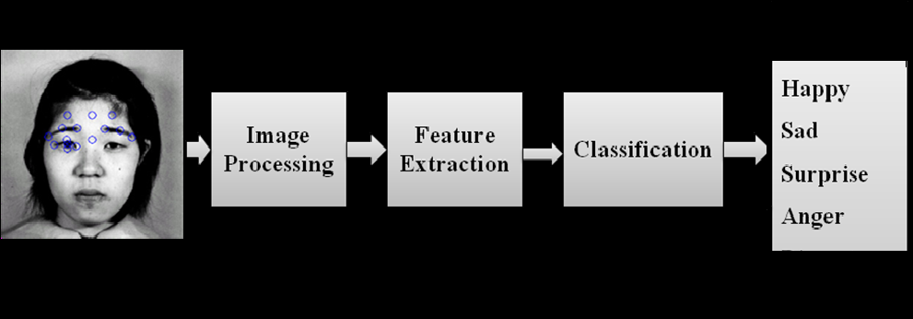

Chapter-2

OVERALL DESCRIPTION
Numerous methods have been proposed to detect facial expressions in an in-age. Image detection methods can be classified into four categories.

A. Knowledge-Based Methods
These rule-based methods encode human knowledge of what constitutes a face. Usually, the rules that capture the relationships between facial features are used. These methods mainly used for face localization. Yang and Huang used a hierarchical knowledge-based method to detect faces.

B. Feature Invariant Approaches
These algorithms aim to find structural features that exist even when the pose, viewpoint, or lighting properties vary and then use these to locate faces. These methods are developed mainly for face localization. In early face detection system by Sakai et al, edge representation was applied.

C. Template Matching Methods
Several standard patterns of a face are stored to describe the face as a whole or the facial features separately. Input image and the stored patterns are collected and the correlations between them are computed for detection. For both face localization and detection these methods have been used for. An early attempt to detect frontal faces in photographs is reported by Sakai et al. They used several sub templates for the eyes, nose, and mouth and face contour to model a face.

D. Appearance-Based Methods
In contrast to template matching, the models or templates are known from a set of training images, which should capture the representative variability of facial appearance. These learned models are then used for detection. Among all the face detection methods that used neural networks, the most challenging work is done by Henry A. Rowley, Shumeet Belugas and Takeo Kaonde.
System Architecture
The system proposed in this research is designed for recognition of facial expressions of images. The system consists of five modules:

a) Face extraction
b) Face preprocessing
c) Facial feature extraction using Gabor filter
d) Binarization using patterning
e) Face recognition using BAM and back propagation algorithm (BPNN).
The overall system architecture is shown in [Fig-1].

Image Pre-Processing
The original images are first converted into gray-scale images. The centers of two eyes on each face image are made as central point and all images are properly scaled, rotated, translated and cropped into 100×100 pixels. Images are then subjected to some image pre-processing operations. The image preprocessing phase includes histogram equalization, contrast and illumination equalization and fuzzy filtering.

Contrast and Illumination Equalization- Contrast is a measure of the human visual system sensitivity. To achieve an efficient and psychologically-meaningful representation, all images are converted to the images with same illumination and rms contrast. The standard deviation of luminance is nothing but rms contrast metric.
Images of different human faces have the same contrast if their rms contrast is equal. The rms contrast does not depend on spatial frequency contrast of the image or the spatial distribution of contrast in the image. All images are maintained with the same illumination and same rms contrast using the following equation:

g = α ƒ + β

Where α is the contrast and β is the brightness to be increased or decreased from the original image f to the new image g. α and β values are chosen empirically. The rms contrast equalization process is illustrated in [Fig-2].

Histogram Equalization- The face images may be of poor contrast because of the limitations of the lighting conditions. To compensate for the lighting conditions and to improve the contrast of the image by Peli histogram equalization is used.

Implementation of Methodology Used

Introduction to Gabor Filters
The functionality of the Gabor filters are very near to the neurons of the visual system and also it serves as a solution for mutual information maximization problem. Maximum information from local image regions can be extracted using Gabor receptive field. For facial expression recognition applications, the number of Gabor filters used to convolve face images varies with applications, but usually 40 filters (5 scales and 8 orientations) are used.

Gabor Equation:
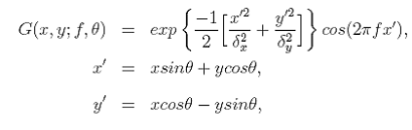

Introduction to Neural Networks
Neural network is a parallel distributed process which is made up of simple processing units for storing experiential knowledge and making it available for use in future. In the present system neural networks are used to classify the set of images with faces and set of images without faces.

Implementation Details
Implementation of system in neural networks divided into four main areas.
Present system operations are as follows:
a. Creation of dataset (Detection of facial features by Gabor filters)
b. Initialization of network (Design and creation of a Neural Net-work)
c. Training (Choice of training data, parameters and training)
d. Classification (Scanning images to locate faces)

Creation of Dataset
A dataset consisting of images pertaining to different facial expressions viz. happy, sad, surprise, angry are stored which are used to train the neural network. Facial features of the given images are extracted using Gabor filter, with this features face images and non-face images feature matrices are created.

Initialization of Neural Network
A custom network is created and its properties are set as:
De-sired.net = network // Creates a custom neural net-work.
The various properties of the network are set. These properties determine the number of network sub objects (which include in-puts, layers, outputs, targets, biases and weights) and how they are connected.

Training the Neural Network
The feature matrices of the image dataset are ready to train the neural network on them.
But random images are taken from training set and fed into the system. Training occurs according to the trainscg's training parameters shown here with their default values.

Classification
Here the trained network that has been trained is used to test a particular image to find out the particular facial expression on that image. Any image to be tested is first converted into gray scale. When a new image is presented to the network, the image divided into windows that are individually presented to the network for classification. Windows thought to contain a face are outlined with a red bounding box of size 127X127 and on completion a copy of the image is displayed.

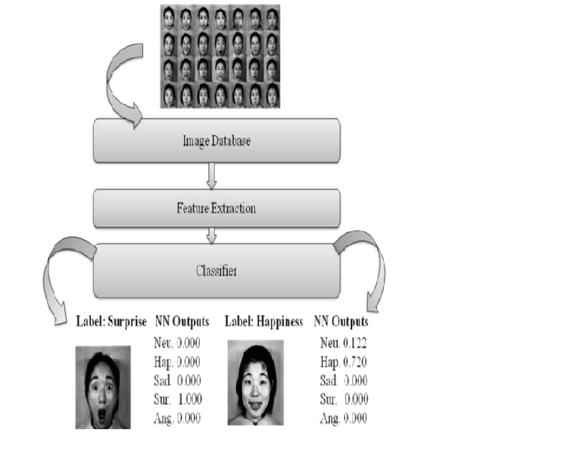

Chapter 3

DESIGN PROCESS
I. Human facial expression detection and recognition is an active area of research spanning several disciplines such as image processing, pattern recognition and computer vision. Facial expression detection and recognition are preliminary steps to a wide range of applications such as personal identity verification, video-surveillance, lip tracking, facial expression extraction, gender classification, advanced human and computer interaction. Most methods are based on neural network approaches, feature extraction, Markov chain, skin color, and others are based on template matching. Pattern localization and classification is the step, which is used to classify face and non- face patterns. Many systems dealing with object classification are based on skin color.
II. Classification for facial expression detection while numerous methods have been proposed to detect face in a single image of intensity or color images. A related and important problem is how to evaluate the performance of the proposed detection methods. Many recent facial expression detection papers compare the performance of several methods, usually in terms of detection and false alarm rates. It is also worth noticing that many metrics have been adopted to evaluate algorithms, such as learning time, execution time, the number of samples required in training, and the ratio between detection rates and false alarms. In general, detectors can make two types of errors: false negatives in which faces are missed resulting in low detection rates and false positives in which an image is declared to be facial expression.
Facial expression detection can be viewed as two-class Recognition problem in which an image region is classified as being a “Face” or “on-Face”. Consequently, facial expression detection is one of the few attempts to recognize from images a class of objects for which there is a great deal of within-class variability. Facial expression detection also provide interesting challenges to the underlying pattern classification and learning techniques. The class of face and no face image are decidedly characterized by multimodal distribution function and effective decision boundaries are likely to be nonlinear in the image space. Pattern localization and classification are CPU time intensive being normally implemented in software, however with lower performance than custom implementations. Custom implementation in hardware allows real-time processing, having higher cost and time-to market than software implementation. Some works [2, 3, 4] uses ANN for classification, and the system is implemented in software, resulting in a good performance (10 sec for localization and classification). A similar work is presented in aiming to object localization and classification. We are interested in the implementation of an ANN algorithm design of a Gabor filter in order to provide better image classification. The MLP (Multi-layer Perception) algorithms used to classify face and non-face patterns before the recognition step.

III. The MLP neural network [1] has feed forward architecture within input layer, a hidden layer, and an output layer. The input layer of this network has N units for an N dimensional input vector. The input units are fully connected to theI hidden layer units, which are in turn, connected to the J output layers units, where J is the number of output classes. A Multi-Layers Perception (MLP) is a particular of artificial neural network.
We will assume that we have access to a training dataset of lpairs (xi, yi) where xi is a vector containing the pattern, while yiis the class of the corresponding pattern. In our case a 2-classtask, yi can be coded 1 and -1.
Fig.1 The neuron of supervised training [8]

We considered a MLP (Multi-Layers Perception) with a 3 layers, the input layer is a vector constituted by n2 units of neurons (nx n pixel input images). The hidden layer has n neurons, and the output layer is a single neuron which is active to 1 if the face is presented and to otherwise. The activity of a particular neuron j in the hidden layer is written bya sigmoid function.

Where W1i is the set of weights of neuron i, b1(i) is the threshold and xi is an input of the neuron. Similarly the output layer activity is:

Sj = Σ w j_{i} x i

Fig.2 (a) Architecture of proposed System

We are designing a feed forward neural network with one hundred neurons in the hidden layer and one neuron in the output layer which prepares images for training phase. Each column will represent the features of an image, which could be a feature value.
Rows are as follows:
Row 1: File name
Row 2: Desired output of the network corresponded to the feature vector.
Row 3: Prepared vector for the training phase
We will adjust the histogram of the image for better contrast. Then the image will be convolved with Gabor filters by multiplying the image by Gabor filters in frequency domain. To save time they have been saved in frequency domain before Features is a cell array contains the result of the convolution of the image with each of the forty Gabor filters. These matrices have been concated to form a bif 135x144 matrix of complex numbers. We only need the magnitude of the result. That is why “abs” is used.135x144 has 10,400 pixels. It means that the input vector of the network would have 19,400 values, which means a large amount of computation. So we have reduced the matrix size to one-third of its original size by deleting some rows and columns. Deleting isnot the best way but it save more time compare to other methods like PCA.We should optimize this function as possible as we can.
First training the neural network and then it will return the trained network. The examples were taken from the Internet database. The MLP will be trained on 500 face and 200 non-face examples.

IV. Training Methodology
The MLP with the training algorithm of feed propagation is universal mappers, which can in theory, approximate any continuous decision region arbitrarily well. Yet the convergence of feed forward algorithms is still an open problem. It is well known that the time cost of feed forward training often exhibits a remarkable variability. It has been demonstrated that, in most cases, rapid restart method can prominently suppress the heavy-tailed nature of training instances and improve efficiency of computation.
Multi-Layer Perception (MLP) with a feed forward learning algorithms was chosen for the proposed system because of its simplicity and its capability in supervised pattern matching.
It has been successfully applied to many pattern classification problems. Our problem has been considered to be suitable with the supervised rule since the pairs of input-output are available. For training the network, we used the classical feed forward algorithm. An example is picked from the training set, the output is computed.

V. Algorithm Development & Results

Fig. 4 Steps involved in Feature extraction

VI. 2D Gabor Wavelet Representation of Faces Since face recognition is not a difficult task for human beings, selection of biologically motivated Gabor filters is well suited to this problem. Gabor filters, modeling the responses of simple cells in the primary visual cortex, are simply plane waves restricted by a Gaussian envelope function.
An image can be represented by the Gabor wavelet transform allowing the description of both the spatial frequency structure and spatial relations. Convolving the image with complex Gabor filters with 5 spatial frequency (v = 0…..4) and 8 orientation (μ = 0…7) captures the whole frequency spectrum, both amplitude and phase. One of the techniques used in the literature for Gabor based face recognition is based on using the response of a grid representing the facial topography for coding the face. [19, 20, 21, 22]. Instead of using the graph nodes, high-energized points can be used in comparisons which forms the basis of this work. This approach not only reduces computational complexity, but also improves the performance in the presence of occlusions.

A. Feature extraction
Feature extraction algorithm for the proposed method has two main steps
(1) Feature point localization
(2) Feature vector computation.

1. Feature point localization
In this step, feature vectors are extracted from points with high information content on the face image. In most feature based methods, facial features are assumed to be the eyes, nose and mouth. However, we do not fix the locations and also the number of feature points in this work. The number of feature vectors and their locations can vary in order to better represent diverse facial characteristics of different faces, such as dimples, moles, etc., which are also the features that people might use for recognizing faces
From the responses of the face image to Gabor filters, peaks are found by searching the locations in a window W0 of size W*W by the following procedure:
A feature point is located at (x0, y0), if (3-4)
j=1…40 where, R_{j} is the response of the face image to the j^{th} Gabor filter
N1 N2 is the size of face image, the center of the window, W0 is at (x0, y0). Window size W is one of the important parameters of proposed algorithm, and it must be chosen small enough to capture the important features and large enough to avoid redundancy. Equation (4) is applied in order not to get stuck on a local maximum, instead of finding the peaks of the responses. In our experiments a 9*9 window is used to search feature points on Gabor filter responses. A feature map is constructed for the face by applying above process to each of 40 Gabor filters.

2. Feature vector generation
Feature vectors are generated at the feature points as a composition of Gabor wavelet transform coefficients. K^{th} feature vector of i^{th} reference face is defined as,
While there are 40 Gabor filters, feature vectors have 42 components. The first two components represent the location of that feature point by storing (x, y) coordinates. Since we have no other information about the locations of the feature vectors, the first two components of feature vectors are very important during matching (comparison) process. The remaining 40 components are the samples of the Gabor filter responses at that point. Although one may use some edge information for feature point selection, here it is important to construct feature vectors as the coefficients of Gabor wavelet transform. Feature vectors, as the samples of Gabor wavelet transform at feature points, allow representing both the spatial frequency structure and spatial relations of the local image region around the corresponding feature point.

Chapter 4
UML DESIGNS
  - Use case diagram:

Actors:-
i) User
ii) System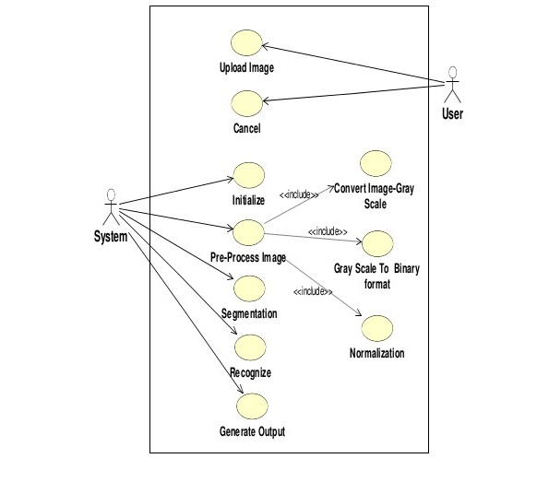
  - Activity diagram

  - Sequence Diagram:

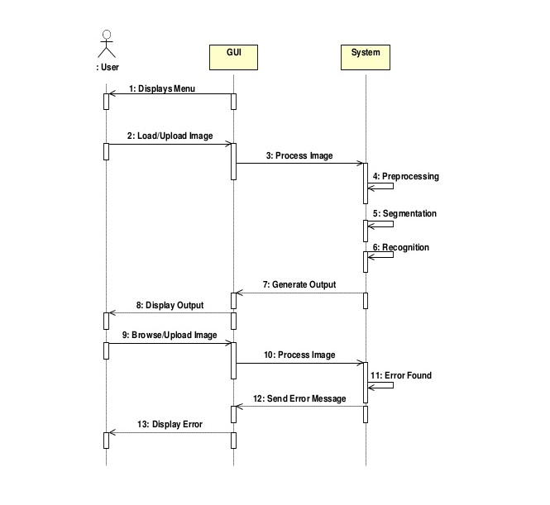

Chapter-5

IMAGE DATASET

Surprised Images dataset
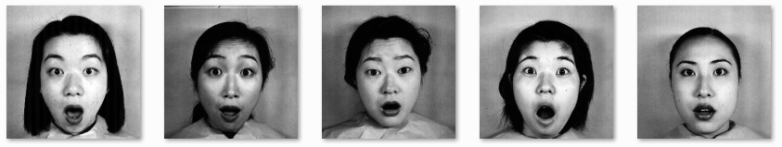

Happy images dataset
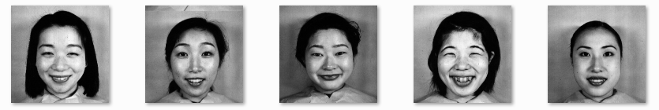

Sad images dataset
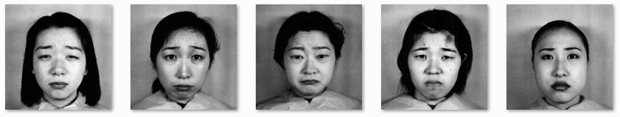

Fear images dataset
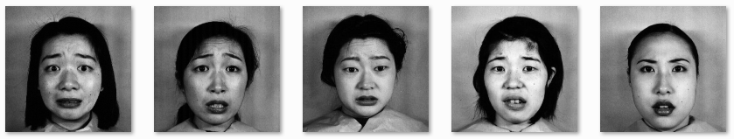
CHAPTER 6

UI DESIGN COMPONENT
INPUT
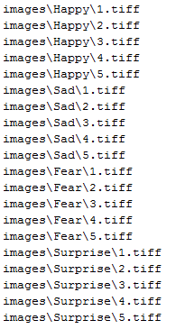

FEATURE MATRIX
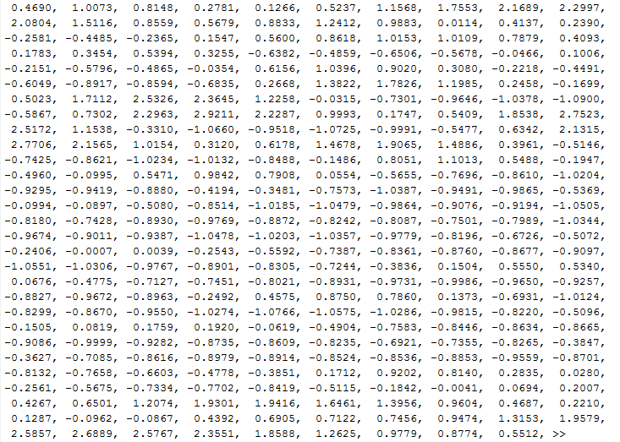

NEURAL NETWORK UI WINDOW
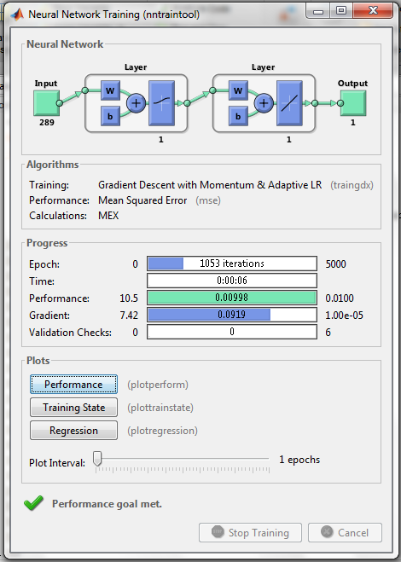

OUTPUT 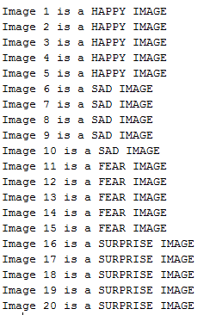
Chapter 7

SUPPLEMENTARY REQUIREMENTS

  - Software requirement
Some software is required to develop the system. They are-
User on Internet:
Web Browser, Operating System (any)
User on Intranet:
Web Browser, Operating System (any)
Web Server:
WAS, Operating System (any)
Data Base Server:
MYSQL, Operating System (any)
Development End:
Adobe-Dreamweaver (HTML, CSS, JS, JSP), MYSQL, OS (Windows)

  - Hardware requirement

Minimum Requirements:
User Side
 | Processor | RAM | Disk Space
IE/Firefox | Pentium 3 | 128 MB | 100 MB

Server Side
 | Processor | RAM | Disk Space
RAD | Pentium 3 | 1 GB | 3.5 GB
DB2- 9.5 |  | 256 MB | 500 MB (Excluding data size)

Recommended Requirement:-
User Side
 | Processor | RAM | Disk Space
IE/Firefox | All Intel- 1 GHz | 256 MB | 500 MB

Server Side
 | Processor | RAM | Disk Space
RAD | All intel-1 GHz | 2 GB | 3.5 GB
DB2- 9.5 |  | 500 MB | 500 MB (Excluding data size)

Chapter 8

List of References
There are many references which are used in development of this document and proposed system. Some of them are as follows-

1. Rafael C.Gonzalez, Richard Elwood’s and Steven L.Eddins, “Digital Image
Processing Using MATLAB”, PEARSON EDUCATION (SINGAPORE) PTE
LTD., INDIAN BRANCH, 482 F.I.E. PATPARGANJ, DELHI 110092, INDIA, 2004.

2. Ying-Chun Li, Zhan-Chun Li, Yun-Huan Mei and Jinxing Zhang, “Detecting
Algorithms based Gabor in Microscopic image” pp.5410-5415, PROCEEDINGS
OF THE FOURTH INTERNATIONAL CONFERENCE ON MACHIN
LEARNING AND CYBERNETICS, GUANGZHOU, 2005.

3. Jiang Wen, You Zhisherg and Li Hui, “Segment the Metallograph Images Using
Gabor Filter” pp.25-28,vol.1,1994 INTERNATIONAL SYMPOSIUM ON
SPEECH, IMAGE PROCESSING AND NEURAL NETWORKS, 1994, Hong Kong.

4. Rong Lu and Yi Shen, “Image segmentation Based on Random Neural Network
Model and Gabor filters” pp. 6464-6467, PROCEEDINGS OF 2005 IEEE
ENGINEERING IN MEDICINE AND BIOLOGY 27TH ANNUAL CONFERENCE, 2005.

5. Javier R. Movellan, “Tutorials on Gabor Filters”, pp.1-20, GNU Free
Documentation License 1.1, Kolmogorv Project, 2002.

6. C.Klimanee and DT Nguyen, “On the design of 2-D Gabor filtering of
Fingerprint Images”pp.430-435, CONSUMERUMER COMMUNICATIONS
AND NETWORKING CONFERENCE, 2004. CCNC 2004. FIRST IEEE, 2004.

