作业9  
1131190111-唐川淇

注：请周二24:00前提交至钉钉群相应文件夹中  
任务：

1. 编写一个类，声明一个private的数据成员和一个private的静态数据成员。让构造函数初始化数据成员，并把静态数据成员加1，让析构函数把静态数据成员减1。编写main函数，创建三个对象，显示他们的数据成员和静态数据成员，再析构每个对象，并显示静态数据成员所受的影响。
2. 编写一个静态成员函数，访问静态数据成员。
3. 编写一个友元函数，访问类中受保护的数据成员。

要求：针对(1)、(2)、(3)，分别将代码粘贴在下方，并将运行结果分别粘贴在下方

|  |
| --- |
| Question 1 |
| #include<iostream>  using namespace std;  class Student{  private:  int id;  static int countNumber;  public:  Student(int id){  this->id = id;  countNumber++;  }  int getId(){return id;}  int getNum(){return countNumber;}  ~Student(){  countNumber--;  }  };  int Student::countNumber=0;  int main(){  Student liu_yu_peng(1);  cout<<liu_yu_peng.getId()<<" "<<liu_yu_peng.getNum()<<endl;  Student li_ming(13);  cout<<liu_yu_peng.getId()<<" "<<liu_yu_peng.getNum()<<endl;  Student wang_yang(13);  cout<<liu_yu_peng.getId()<<" "<<liu_yu_peng.getNum()<<endl;  liu_yu_peng.~Student();  cout<<li_ming.getNum()<<endl;  li_ming.~Student();  cout<<wang_yang.getNum()<<endl;  wang_yang.~Student();  } |

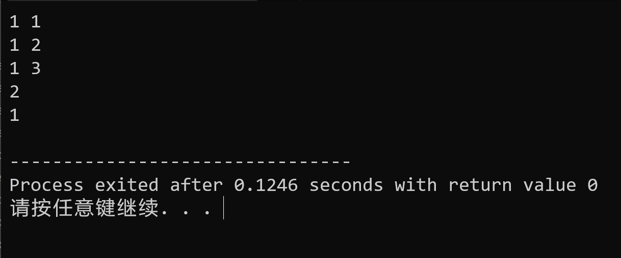

|  |
| --- |
| Question 2 |
| #include<iostream>  using namespace std;  class Student{  private:  int id;  static int countNumber;  public:  Student(int id){  this->id = id;  countNumber++;  }  int getId(){return id;}  static int getNum(){return countNumber;}  ~Student(){  countNumber--;  }  };  int Student::countNumber=0;  int main(){  Student liu_yu_peng(1);  cout<<liu_yu_peng.getId()<<" "<<liu_yu_peng.getNum()<<endl;  Student li_ming(13);  cout<<liu_yu_peng.getId()<<" "<<liu_yu_peng.getNum()<<endl;  Student wang_yang(13);  cout<<liu_yu_peng.getId()<<" "<<liu_yu_peng.getNum()<<endl;  liu_yu_peng.~Student();  cout<<li_ming.getNum()<<endl;  li_ming.~Student();  cout<<wang_yang.getNum()<<endl;  wang_yang.~Student();  cout<<Student::getNum()<<endl;  } |

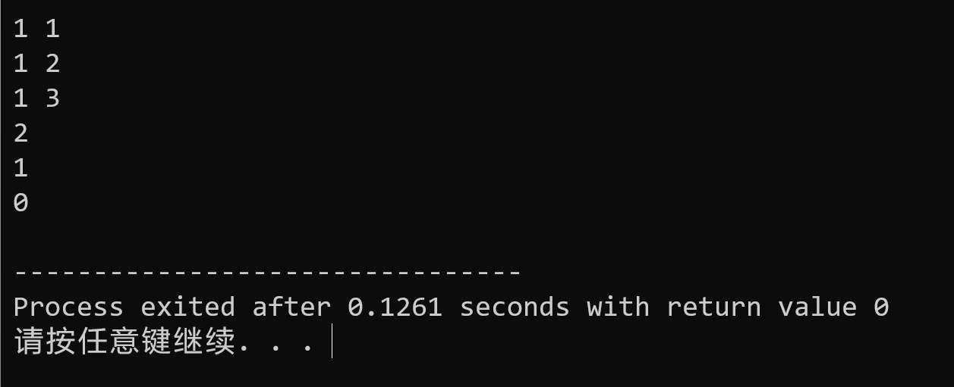

|  |
| --- |
| Question 3 |
| #include<iostream>  using namespace std;  class Student{  private:  int id;  static int countNumber;  friend class Teacher;  public:  Student(int id){  this->id = id;  countNumber++;  }  int getId(){return id;}  static int getNum(){return countNumber;}  ~Student(){  countNumber--;  }  };  int Student::countNumber=0;  class Teacher{  private:  int tid;  public:  Teacher(int tid){this->tid = tid;}  void changeId(Student& stu,int id){stu.id = id;}  ~Teacher(){}  };  int main(){  Student liu_yu_peng(1);  cout<<liu_yu_peng.getId()<<" "<<liu_yu_peng.getNum()<<endl;  Teacher cang(11);  cang.changeId(liu_yu_peng,2);  cout<<liu_yu_peng.getId()<<" "<<liu_yu_peng.getNum()<<endl;  } |

