作业8  
1131190111-唐川淇

注：请周二24:00前提交至钉钉群相应文件夹中  
任务：下面的代码是本节课讲过的示例，请大家补全下面的“TODO”中的拷贝函数的定义和实现，并运行程序，将结果截图。

#include<iostream>

using namespace std;

class CAT

{

public:

CAT();

//TODO 拷贝构造函数声明

~CAT();

int GetAge() const { return *itsAge; }

void SetAge(int age){ *itsAge=age; }

protected:

int* itsAge;

};

CAT::CAT()

{

itsAge=new int;

*itsAge =5;

}

//TODO 拷贝构造函数实现

CAT::~CAT()

{

delete itsAge;

itsAge =0;

}

int main()

{

CAT frisky;

cout<<"frisky's age:"<<frisky.GetAge()<<endl;

cout<<"Setting frisky to 6...\n";

frisky.SetAge(6);

cout<<"Creating boots from frisky\n";

CAT boots(frisky); //拷贝构造函数使用

cout<<"frisky's age:"<<frisky.GetAge()<<endl;

cout<<"boots'age:"<<boots.GetAge()<<endl;

cout<<"setting frisky to 7...\n";

frisky.SetAge(7);

cout<<"frisky's age:"<<frisky.GetAge()<<endl;

cout<<"boots'age:"<<boots.GetAge()<<endl;

}//--------------------------

要求：将TODO部分补全（粘贴在下方），并将运行结果粘贴在下方

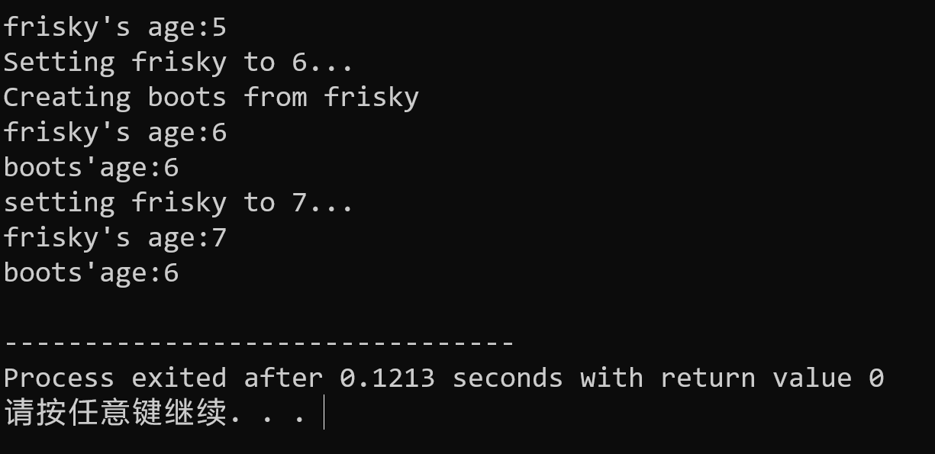

|  |
| --- |
| 代码 |
| #include<iostream>  using namespace std;  class CAT  {  public:  CAT();  //TODO 拷贝构造函数声明  CAT(const CAT& cat);  ~CAT();  int GetAge() const { return *itsAge; }  void SetAge(int age){ *itsAge=age; }  protected:  int* itsAge;  };  CAT::CAT()  {  itsAge=new int;  *itsAge =5;  }  //TODO 拷贝构造函数实现  CAT::CAT(const CAT& cat){  itsAge=new int;  *itsAge=cat.GetAge();  }  CAT::~CAT()  {  delete itsAge;  itsAge =0;  }  int main()  {  CAT frisky;  cout<<"frisky's age:"<<frisky.GetAge()<<endl;  cout<<"Setting frisky to 6...\n";  frisky.SetAge(6);  cout<<"Creating boots from frisky\n";  CAT boots(frisky); //拷贝构造函数使用  cout<<"frisky's age:"<<frisky.GetAge()<<endl;  cout<<"boots'age:"<<boots.GetAge()<<endl;  cout<<"setting frisky to 7...\n";  frisky.SetAge(7);  cout<<"frisky's age:"<<frisky.GetAge()<<endl;  cout<<"boots'age:"<<boots.GetAge()<<endl;  }//-------------------------- |