AI Usage DISCLOSURE FORM

1. Team Details
Team Name: LockedIn
Project / Product Name: LockedIn — Interruptible AI Agents
Organization / Institution (if any): SRM Institute of Science and Technology
Submission Date: 30 September 2026

2. AI Usage Declaration
Did your team use any Artificial Intelligence (AI) in developing this project?
__YES__

3. Purpose of AI Usage ( Brief Details)
Idea generation / brainstorming: Yes — AI-assisted exploration and refinement of project concepts.
Code generation or assistance: Yes — implementation assistance, refactoring and code review.
UI / UX design: Yes — AI-assisted interface structure and UX iteration.
Content creation: Yes — README/documentation and demo wording assistance.
Data analysis: Limited — AI-assisted inspection of test/evaluation outputs.
Testing / debugging: Yes — debugging guidance, test-case generation and validation.
Other: Architecture discussion, codebase review and deployment guidance.

4. Feature Origin Classification ( Please add/delete based on the number of the feature)
1. Feature Name: Interruptible Real-Time Agent Runtime
2. Self-Generated/AI-Generated/Both: Both
3. Description: AI tools/platforms used: ChatGPT, Claude, and Cline. AI was used for architecture discussion, implementation assistance, debugging, test generation and code review. Prompts focused on building an interruptible real-time agent runtime with dual-path processing, state versioning, task cancellation, stale-result rejection and WebSocket event streaming. The generated suggestions/code were reviewed, adapted and tested by the team.

1. Feature Name: Interruptible Real-Time Agent Runtime
2. Self-Generated/AI-Generated/Both: Both
3. Description: AI tools/platforms used: ChatGPT, Claude, and Cline. AI was used for architecture discussion, implementation assistance, debugging, test generation and code review. Prompts focused on building an interruptible real-time agent runtime with dual-path processing, state versioning, task cancellation, stale-result rejection and WebSocket event streaming. The generated suggestions/code were reviewed, adapted and tested by the team.
…

5. Ethical & Compliance Confirmation
AI usage complies with guidelines and policies. Yes
No proprietary or copyrighted data misused. I Agree

6. Declaration & Sign-Off
Name of Team Representative: Pranav Pooviah KH Pranav Pooviah KH
Role: Team Representative
Signature:
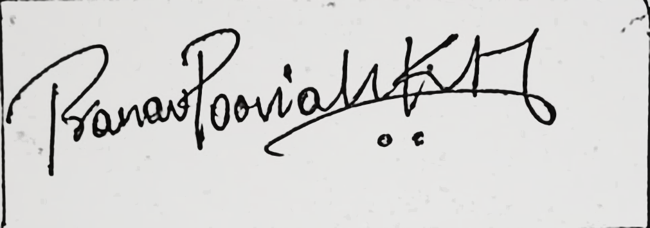
Date: 30 September 2026 30 September 2026

