启动类加注解
@EnableCaching //缓存
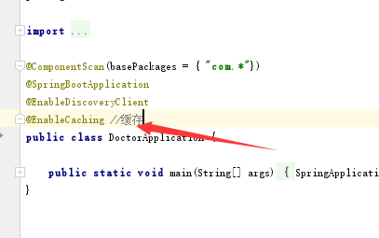
需要缓存的接口加注解
@Cacheable(cacheNames = "orderDiagList",key = "123")
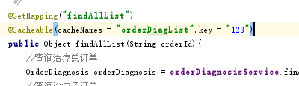

启动访问会报错
org.springframework.data.redis.serializer.SerializationException: Cannot serialize; nested exception is org.springframework.core.serializer.support.SerializationFailedException: Failed to serialize object using DefaultSerializer; nested exception is java.lang.IllegalArgumentException: DefaultSerializer requires a Serializable payload but received an object of type [com.imooc.VO.ResultVO]

不能序列化
在返回的类上继承Serializable
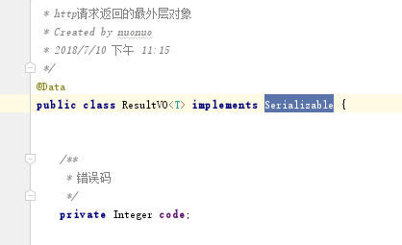
安装插件
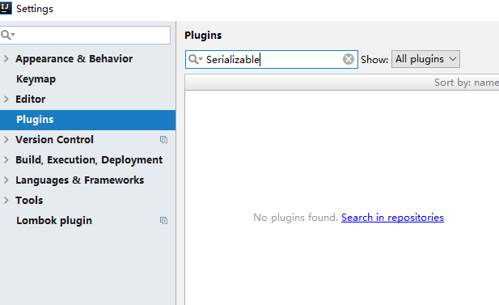
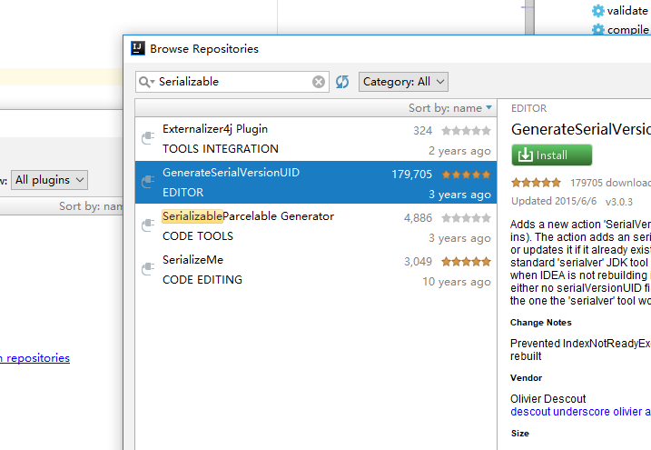
安装好按照提示重启idea

搜索刚刚的插件添加快捷键
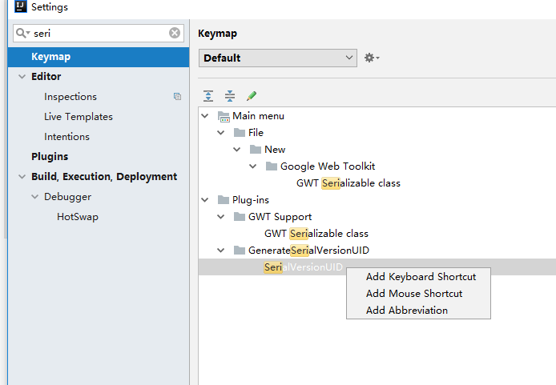
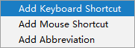
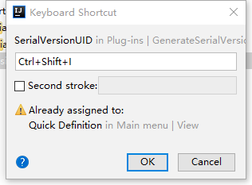
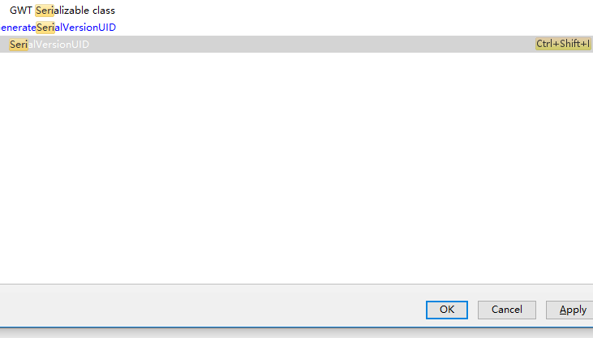
成功保存

在类里面按快捷键
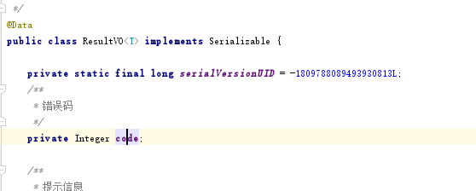
Ok成功生成uid

那么在执行添加方法上加上
@CacheEvict(cacheNames = "orderDiagList",key = "123")
缓存清除，再次访问会读取缓存的
