安装docker

配置镜像加速地址
vim /etc/docker/daemon.json
文件里写入
{
"registry-mirrors": ["https://fy707np5.mirror.aliyuncs.com"]
}

重启docker
systemctl daemon-reload
systemctl restart docker

rancher最新下载地址
https://rancher.com/quick-start/
例如：
$ sudo docker run -d --restart=unless-stopped -p 80:80 -p 443:443 rancher/rancher

重启docker
systemctl restart docker
启动应用：
sudo docker run -d --restart=unless-stopped -p 80:80 -p 443:443 rancher/rancher

可以会提示端口占用

0478923fd6af3f679a8322551349e3d04351a2d1ff9dcd4894dc1dbd3e651588
docker: Error response from daemon: driver failed programming external connectivity on endpoint xenodochial_swirles (65d46f119d76f894a8732b42989ce0058bc9bb54248e322ca7e095cd2438d402): Bind for 0.0.0.0:443 failed: port is already allocated.

输入docker ps 查看后台会发现应用已经是启动状态

CONTAINER ID IMAGE COMMAND CREATED STATUS PORTS NAMES
c9ebe9a08acf rancher/rancher "rancher --http-list猞" 4 minutes ago Up About a minute 0.0.0.0:80->80/tcp, 0.0.0.0:443->443/tcp reverent_lalande

添加集群

选择custom
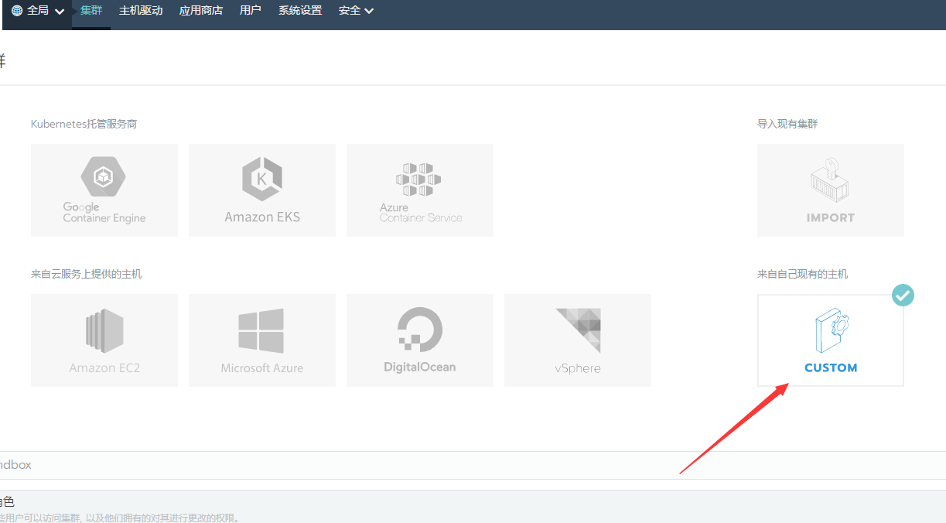
命名


添加另一台docker服务ip地址
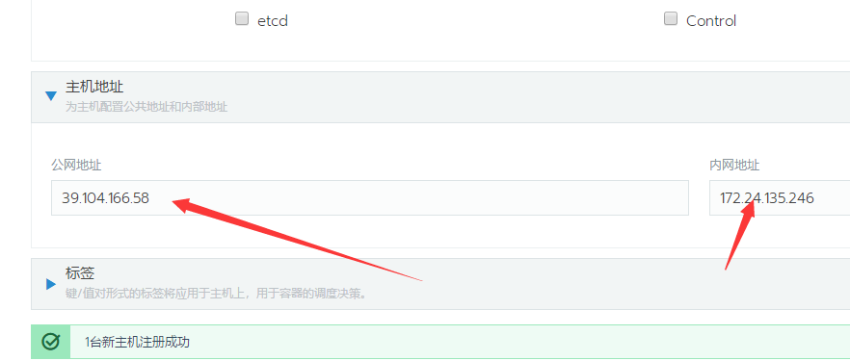
复制这个命令在另一台服务器执行
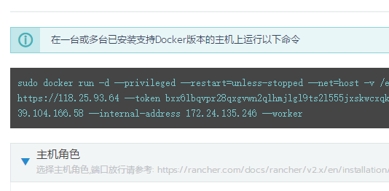
成功会提示

已经完成了
