Pom文件里添加

<!--热部署-->
<dependency>
<groupId>org.springframework.boot</groupId>
<artifactId>spring-boot-devtools</artifactId>
<optional>true</optional>
<scope>true</scope>
</dependency>

<plugin>
<groupId>org.springframework.boot</groupId>
<artifactId>spring-boot-maven-plugin</artifactId>
<!--热部署-->
<configuration>
<fork>true</fork>
</configuration>
</plugin>

File----Settings-----Compliler Build project automatically 勾上
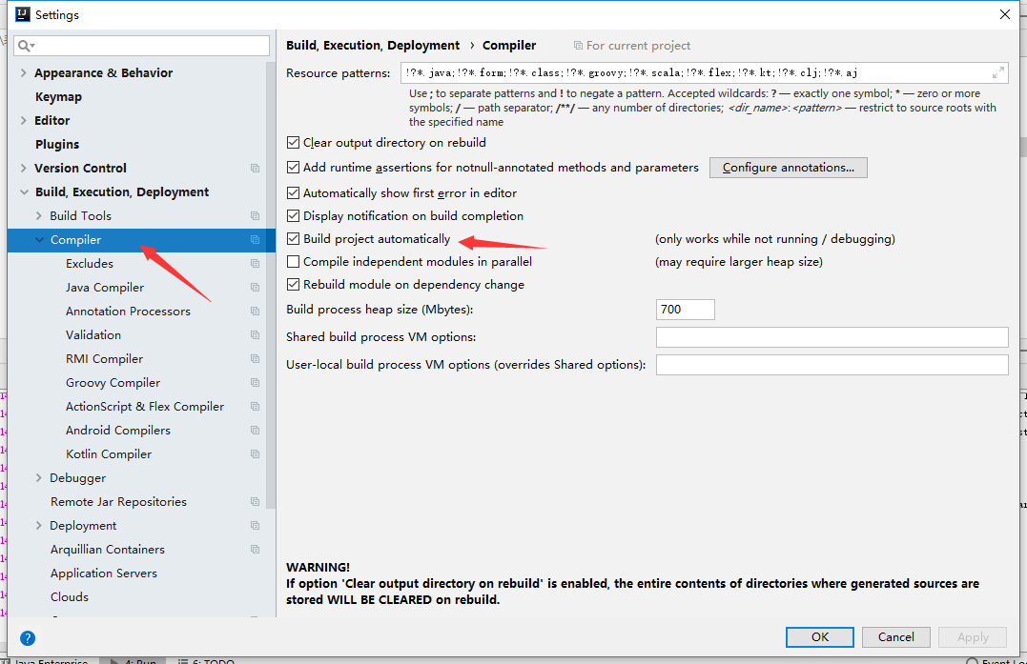

Ctrl+Shift+A 搜索registry
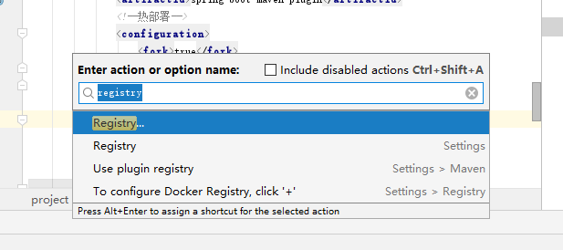

勾上这个就行了
