在美妆镜和智能音箱 写的接口 都把参数放到header中了,
如图：
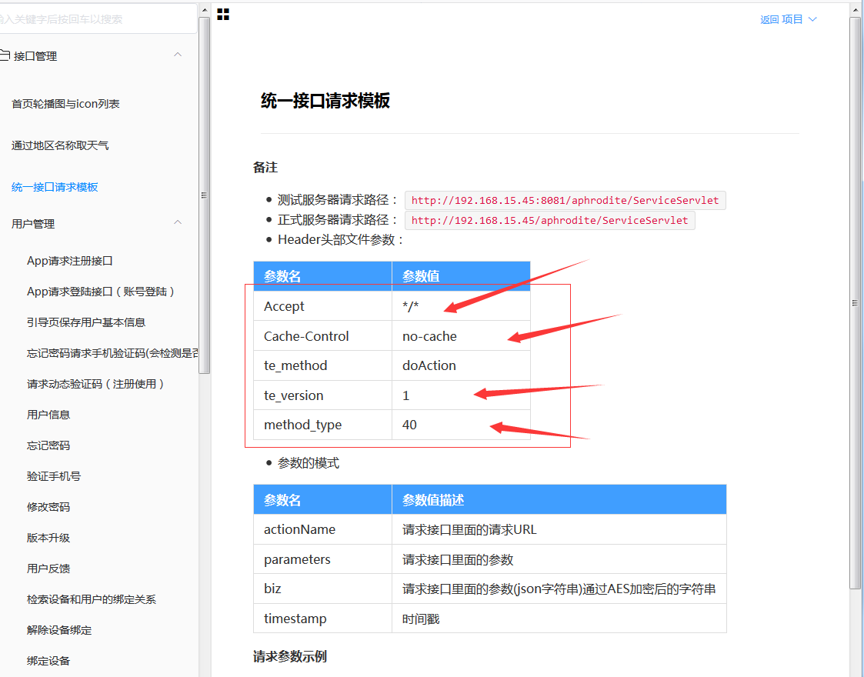

导致配置nginx时候总是不通，用ip是可以正常访问
最后配置好了，参考了一遍文章
https://blog.csdn.net/qzc78/article/details/79150503
加上一句好就好了:underscores_in_headers on;
截图为：
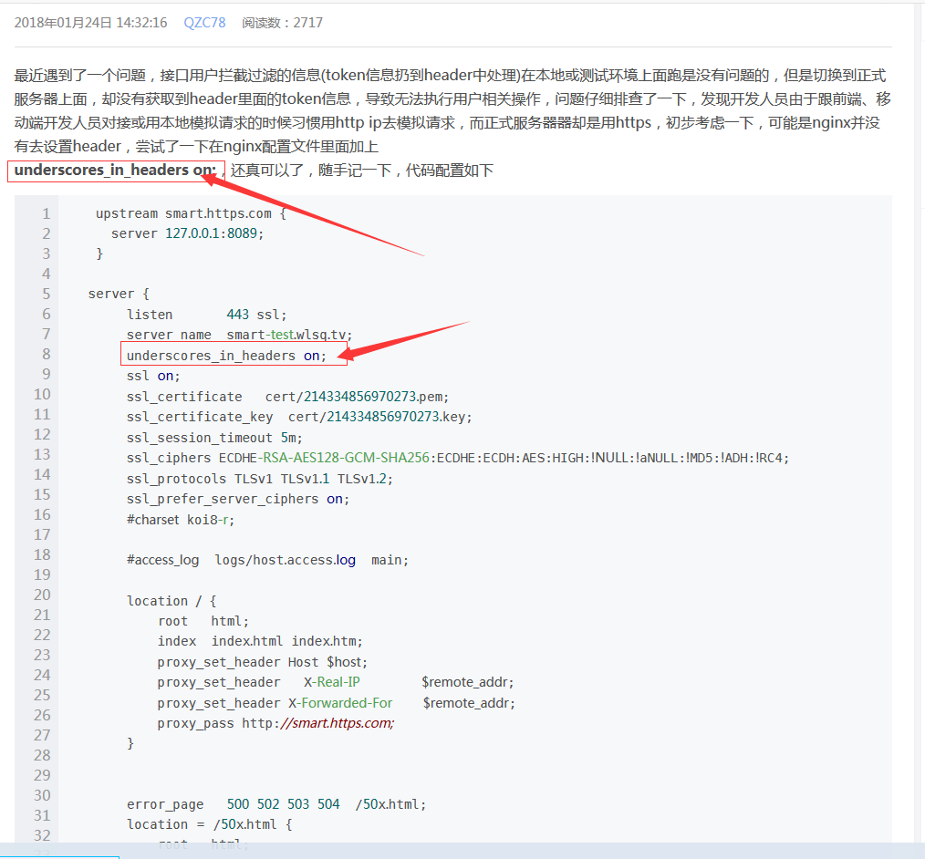

最后重启nginx就好了。

我的配置的nginx 文件如下


加上一句好就好了:underscores_in_headers on;

部分代码如下
server {
listen 444;
server_name we-electron.com;
underscores_in_headers on;
ssl on;
root html;
index index.html index.htm;
ssl_certificate cert/we-electron.com.pem;
ssl_certificate_key cert/we-electron.com.key;
ssl_session_timeout 5m;
ssl_ciphers ECDHE-RSA-AES128-GCM-SHA256:ECDHE:ECDH:AES:HIGH:!NULL:!aNULL:!MD5:!ADH:!RC4;
ssl_protocols TLSv1 TLSv1.1 TLSv1.2;
ssl_prefer_server_ciphers on;
location / {
root html;
index index.html index.htm;
}

location ^~/management/ {
proxy_pass http://127.0.0.1:8184/management/;
proxy_redirect off;
proxy_set_header Host $host;
proxy_set_header X-Real-IP $remote_addr;
proxy_set_header X-Forwarded-For $proxy_add_x_forwarded_for;
client_max_body_size 10m;
client_body_buffer_size 128k;
proxy_connect_timeout 90;
proxy_send_timeout 90;
proxy_read_timeout 90;
proxy_buffer_size 4k;
proxy_buffers 4 32k;
proxy_busy_buffers_size 64k;
proxy_temp_file_write_size 64k;
rewrite ^(.*)\;jsessionid=(.*)$ $1 break;
}

location ^~/aphrodite/ {
proxy_pass http://127.0.0.1:8184/aphrodite/;
proxy_redirect off;
proxy_set_header Host $host;
proxy_set_header X-Real-IP $remote_addr;
proxy_set_header X-Forwarded-For $proxy_add_x_forwarded_for;
client_max_body_size 10m;
client_body_buffer_size 128k;
proxy_connect_timeout 90;
proxy_send_timeout 90;
proxy_read_timeout 90;
proxy_buffer_size 4k;
proxy_buffers 4 32k;
proxy_busy_buffers_size 64k;
proxy_temp_file_write_size 64k;
rewrite ^(.*)\;jsessionid=(.*)$ $1 break;
}

location ^~/FirstServlet/ {
proxy_pass http://127.0.0.1:8184/FirstServlet/;
proxy_redirect off;
proxy_set_header Host $host;
proxy_set_header X-Real-IP $remote_addr;
proxy_set_header X-Forwarded-For $proxy_add_x_forwarded_for;
client_max_body_size 10m;
client_body_buffer_size 128k;
proxy_connect_timeout 90;
proxy_send_timeout 90;
proxy_read_timeout 90;
proxy_buffer_size 4k;
proxy_buffers 4 32k;
proxy_busy_buffers_size 64k;
proxy_temp_file_write_size 64k;
rewrite ^(.*)\;jsessionid=(.*)$ $1 break;
}

location ^~/sxdz_cash/ {
proxy_pass http://localhost:8301/;
proxy_redirect off;
proxy_set_header Host $host;
proxy_set_header X-Real-IP $remote_addr;
proxy_set_header X-Forwarded-For $proxy_add_x_forwarded_for;
client_max_body_size 10m;
client_body_buffer_size 128k;
proxy_connect_timeout 90;
proxy_send_timeout 90;
proxy_read_timeout 90;
proxy_buffer_size 4k;
proxy_buffers 4 32k;
proxy_busy_buffers_size 64k;
proxy_temp_file_write_size 64k;
rewrite ^(.*)\;jsessionid=(.*)$ $1 break;
}

error_page 500 502 503 504 /50x.html;
location = /50x.html {
root /usr/share/nginx/html;
}
}

