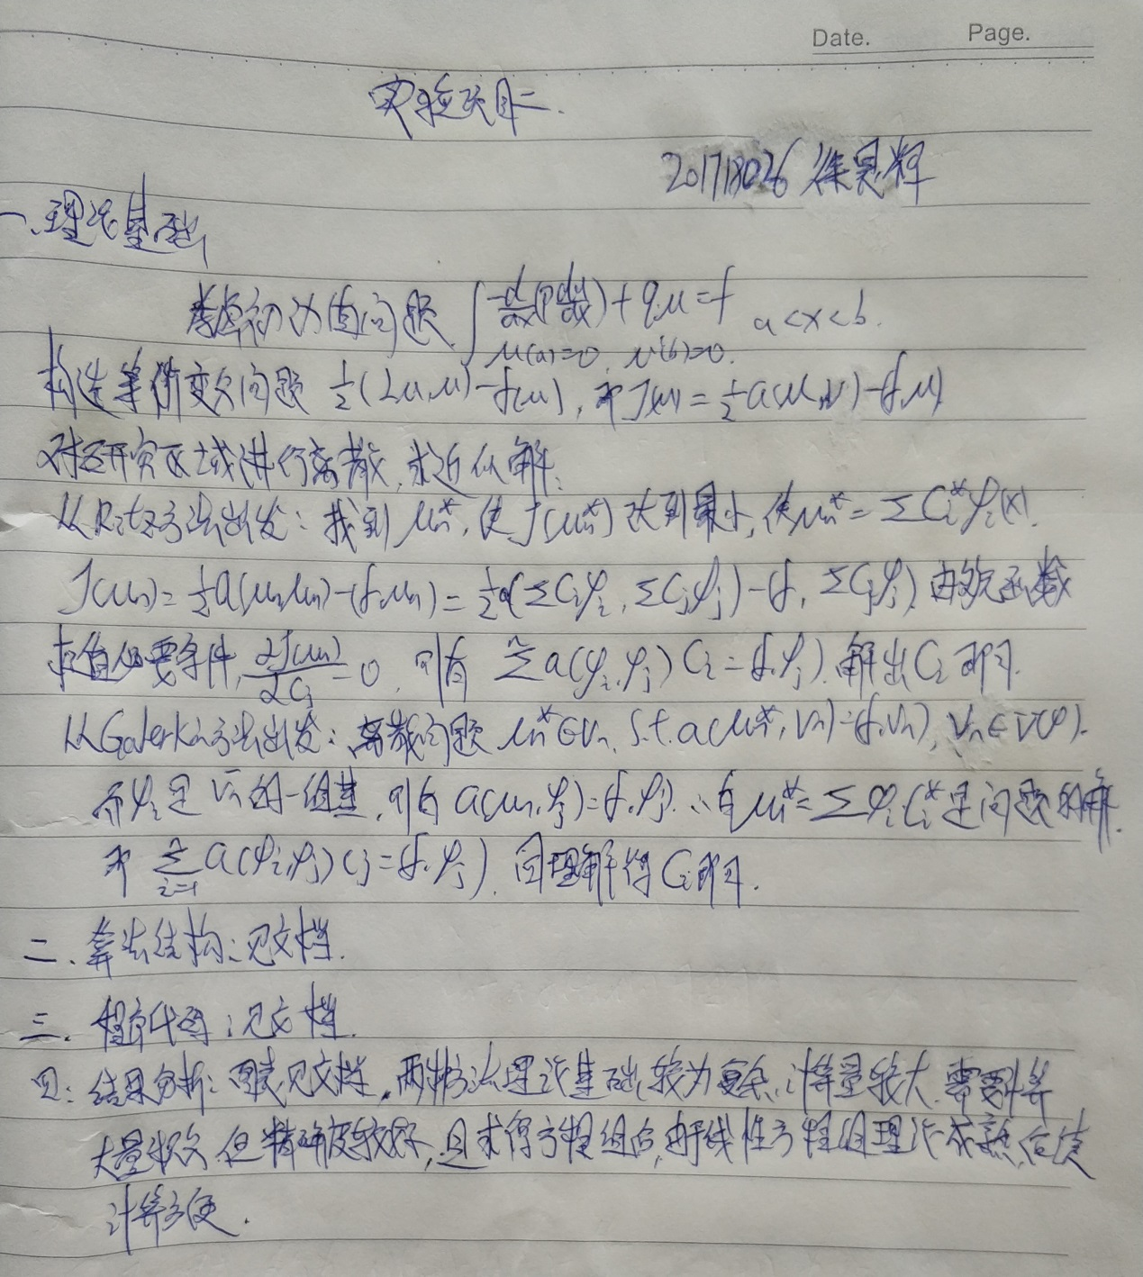

算法结构

$$考虑微分方程:\left\{\begin{aligned}\frac{-d(p\frac{du}{dx})}{dx}+qu=f,a<x<b \\ u\left(a\right)=0,u^{'}\left(b\right)=0 or其他条件\end{aligned}\right.$$

对自变量取值范围进行离散化

构造双线性形式a(u,v)以及J(u)

选择合适基函数

Ritz方法:根据极小位能原理,构造方程组使得J(u)达到最小;

Galerkin方法:根据虚功原理构造方程组使得J(u)达到最小;

$得到基函数$ 具体形式

代码

**1.计算a $({φ_{i},φ}_{j})$**

%基函数是sin(i*pi*x)

%计算a(φi,φj)

function result_integral_a = Ritz_Galerkin_integral_a(i,j)

syms x

fail = sin(i*pi*x)*sin(j*pi*x) + i*pi*cos(i*pi*x)*j*pi*cos(j*pi*x);

result_integral_a = int(fail,x,0,1);

end

**2.计算a $(f,φ_{j})$**

%基函数是sin(i*pi*x),f = x^2

%注题初边值条件非齐次,构造u0(x) = x

function result_integral_f = Ritz_Galerkin_integral_f(i)

syms x

u = x^2*sin(i*pi*x);%(f,φi)

w = x*sin(i*pi*x) + i*pi*cos(i*pi*x);%a(u(0),φi)

result_integral_f = int(u,x,0,1) - ( int(w,x,0,1) );%

end

**3.** **主程序**

function result = Ritz_Galerkin(n)

%主程序

%推导可得a(u,v) = uv+u'v'

%f(x) = x^2

for i = 1:n

for j = 1:i

a(i,j) = Ritz_Galerkin_integral_a(i,j);

a(j,i) = a(i,j);

end

end

for i = 1:n

f(i) = Ritz_Galerkin_integral_f(i);

end

c = a\f';%解出c

syms x

result = 0;

for i = 1:n

result = result + c(i)*sin(i*pi*x);%输出表达式

end

result = result + x;

end

结果

取n=2时,得到的n次近似 $u_{n}(x)$:

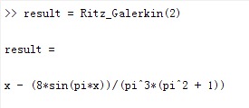

取n=3时,得到的n次近似 $u_{n}(x)$:

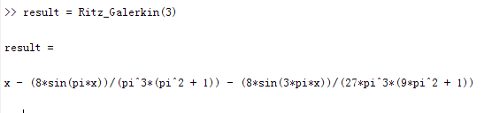

选取n=2,3时,得到的n次近似 $u_{n}(x)$ 来计算 $u_{i}$,如下表(x取0:0.1:1):

|  |  |  |  |  |  |  |  |  |  |  |  |
| --- | --- | --- | --- | --- | --- | --- | --- | --- | --- | --- | --- |
| x | 0 | 0.1 | 0.2 | 0.3 | 0.4 | 0.5 | 0.6 | 0.7 | 0.8 | 0.9 | 1 |
| n=2 | 0 | 0.092665 | 0.186048 | 0.280796 | 0.377425 | 0.476263 | 0.577425 | 0.680796 | 0.786048 | 0.892665 | 1 |
| n=3 | 0 | 0.092579 | 0.185947 | 0.280763 | 0.377487 | 0.476369 | 0.577487 | 0.680763 | 0.785947 | 0.892579 | 1 |
| 真解 | 0 | 0.092569 | 0.185948 | 0.280771 | 0.377487 | 0.476362 | 0.577487 | 0.680771 | 0.785948 | 0.892569 | 1 |

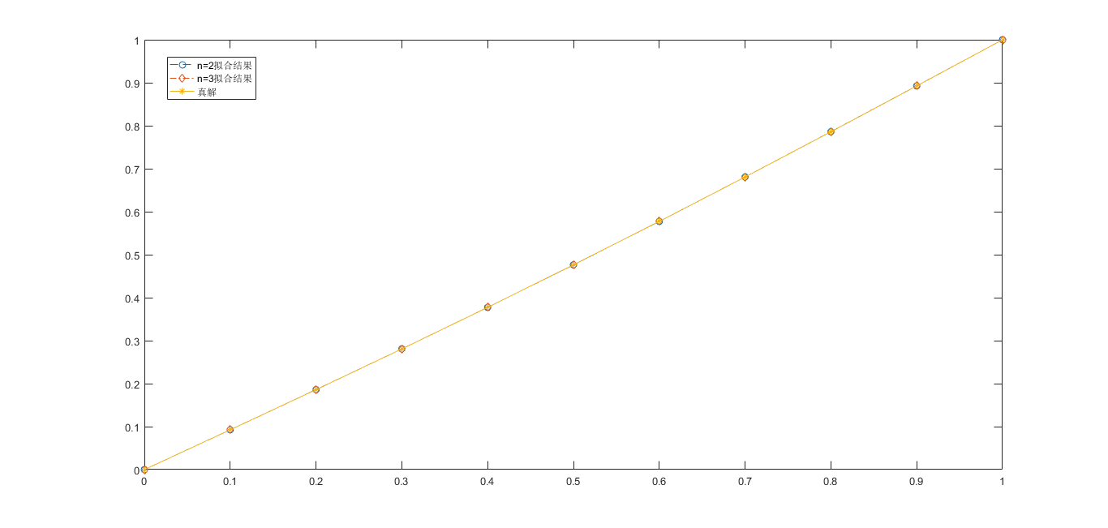作出n=2,3以及真解的图像: