# Test1：

Input :{2,3}

Output:{ad,ae,af,bd,be,bf,cd,ce,cf}

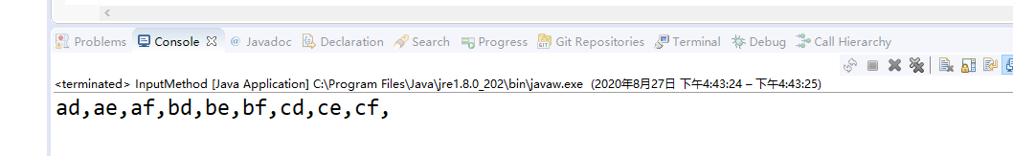

# Test2:

Input : {2,3,4}

Output:{adg,adh,adi,aeg,aeh,aei,afg,afh,afi,bdg,bdh,bdi,beg,beh,bei,bfg,bfh,bfi,cdg,cdh,cdi,ceg,ceh,cei,cfg,cfh,cfi}

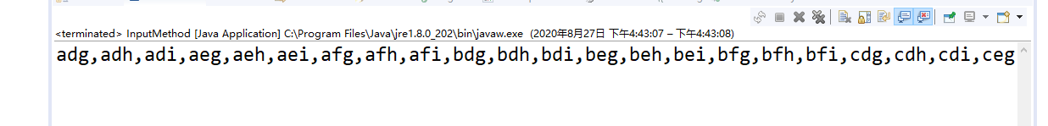

# Test3:

Input : {1}

Output: {a,b,c}

