公司实力展示板块
排版布局： Z字型布局 (Zig-Zag Layout)
Z字型布局效果图：
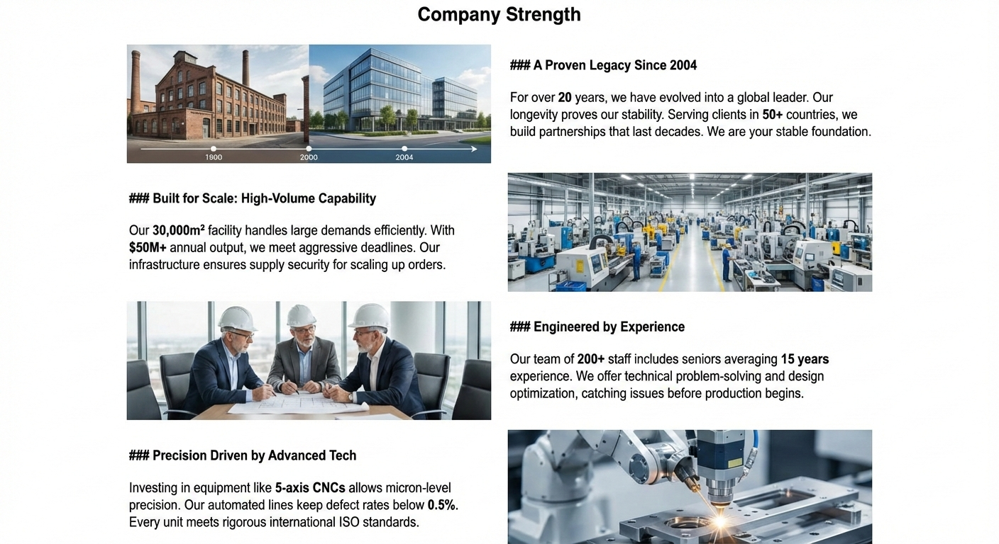
- 历史与积淀：30载匠心传承 (History & Legacy)
布局： [ 左图 ] + [ 右文 ]
配图：左侧放一张公司大门角度的全景横图或厂区的全景俯瞰图。

EN: Founded in 1992 in Zhoushan, China’s "Screw Capital," Weida Machinery operates from a self-owned 15-mu (10,000 sqm) manufacturing base. With over 30 years of heritage, we have evolved from a local pioneer into a leading specialist in screw barrel engineering. Our deep-rooted expertise ensures the technical resilience and long-term stability required for high-performance extrusion machinery.

CN: 1992年创立于“中国螺杆之都”舟山，伟达机械拥有15亩（10,000平方米）自持生产基地。凭借30余年的制造底蕴，我们已从行业先锋成长为机筒螺杆领域的资深专家。深厚的技术积淀，为高性能挤出设备提供了必不可少的稳定性和技术韧性。

- 规模与产能 (Scale & Capacity)
布局： [ 左文 ] + [ 右图 ]
配图：车间内景或者是装配区的螺杆有序堆叠照片。

EN: Weida Machinery is defined by consistent production and a proven track record of reliable delivery. With an annual output of thousands of precision sets, we maintain a stable manufacturing rhythm that ensures quality never fluctuates. As a long-term partner for diverse industry leaders, we provide the supply chain security required for global markets, offering a dependable foundation for your continuous production.

CN: 伟达机械以稳健的产能与可靠的交付记录见证实力。我们保持着每年数千套精密组件的稳定产出节奏，确保品质始终如一。作为众多行业领先企业的长期合作伙伴，我们为全球市场提供了稳固的供应链保障。我们致力于为您提供最值得信赖的生产基石。

- 团队与经验 (Team & Expertise)
布局： [ 左图 ] + [ 右文 ]
配图： 左侧放一张检验在测量螺杆或者员工记录数据的近景特写。

EN：Our veteran engineers offer 30 years of specialized know-how, particularly in PS and PE foam extruders. We excel in bespoke manufacturing—provide your drawings, and we deliver precision-engineered solutions. We optimize screw geometry and metallurgy to solve complex processing challenges, ensuring high performance and a maximized ROI for our global partners.

CN: 资深工程师团队拥有30年行业经验，尤其精于PS及PE发泡挤出领域。我们擅长定制化生产——只需提供图纸，即可交付精准的工程方案。通过优化材质与结构，我们为您解决加工难题，实现投资回报最大化。

- 设备与工艺 (Technology & Precision)
布局： [ 左文 ] + [ 右图 ]
配图： 右图最好是加工中心的图片，因为加工中心图片得4月，可向生产商要一份原图。

EN: Engineering excellence at Weida is defined by precise tolerance control and superior processing. Our advanced CNC facilities ensure the exact alignment of every rotor, maximizing plasticizing efficiency and melt homogeneity. By integrating premium wear-resistant alloys, we guarantee exceptional longevity and consistent output. At Weida, precision is our baseline, ensuring every component delivers peak performance in high-speed production.

CN: 伟达的卓越品质源于严苛的公差控制与卓越的加工工艺。我们通过先进的数控设备确保每个部件的精准对齐，从而最大化塑化效率与熔体均化效果。结合优质耐磨合金材质，我们保障了机器持久的使用寿命与稳定的产能输出。在伟达，精密是我们的底线标准，确保每一件产品在高速生产中表现出色。

