1:去http://connect.qq.com 申请 APP
注意回调地址是个人中心或者其他文件，回调地址要写全域名，www和不加www的

- 下载SDK http://wiki.connect.qq.com/sdk%e4%b8%8b%e8%bd%bd

3在需要登陆QQ的页面
<script>
function qq_login(){
var A=window.open("oauth/index.php","TencentLogin","width=450,height=320,menubar=0,scrollbars=1,resizable=1,status=1,titlebar=0,toolbar=0,location=1");

}
</script>

<a onclick="qq_login()"><img src="Connect_logo_5.png" width="230" height="48" /></a>

Oauth/index:
<?php
session_start();
/* PHP SDK
* @version 2.0.0
* @author connect@qq.com
* @copyright © 2013, Tencent Corporation. All rights reserved.
*/

require_once(dirname(__FILE__)."/comm/config.php");
require_once(CLASS_PATH."QC.class.php");

回调地址：
<?php
require_once("Connect2.0/API/qqConnectAPI.php");
$qc = new QC();
$access_token=$qc->qq_callback();
$openid=$qc->get_openid();
$qc = new QC($access_token, $openid);
print_r($qc->get_user_info());
?>

get_user_info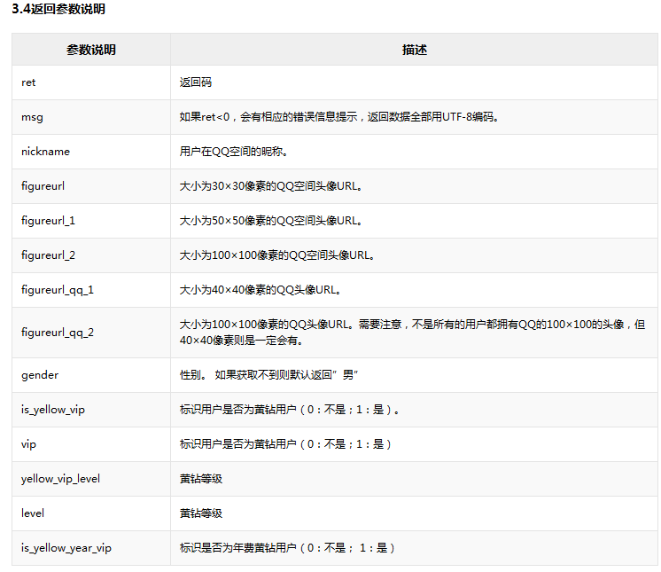

开发API http://wiki.connect.qq.com/api%e5%88%97%e8%a1%a8

