Streamplay Studio User Guide
  - English edition
Use this guide to install Studio, sign in, add Cast members, connect OBS, run all five game modes and finish a LIVE session. Follow the contents in order for your first session, or go directly to the section you need.
Content revision 2026-10-22 · 13
Use screenshots to locate controls. Exact labels may vary with the installed version.
Open the web guide
Software downloads and release notes

Contents
Click a section title to jump to it.
01 Download and install
02 Sign in and switch accounts
03 Workspace overview
04 Add Cast members
05 Connect camera and OBS
06 Choose a game
07 Map representative gifts
08 Start your first interaction
09 Group Sticker
10 Group PK
11 1v1 PK
12 Solo Stage
13 Multi PK
14 Other scene tools
15 Finish and review records
16 Troubleshooting

01 Download and install
Install the desktop app, then sign in with your Studio account.
1. Choose the latest stable release
Open the official download page ↗, find the release marked Latest and expand Assets.
2. Choose the installer for your computer
For Windows 64-bit, choose the x64 .exe installer. For an Apple Silicon Mac, choose the Apple Silicon / arm64 .dmg. Source code, .yml and .blockmap files are not installers.
3. Install and open Studio
On Windows, run the installer and follow its prompts. On Mac, open the DMG, drag the app into Applications, then open it from there.
Release notes list Windows x64 and Apple Silicon Mac installers. For an Intel Mac, check for a compatible installer. Use the files currently offered on the download page.
Check before continuing: Studio opens normally and shows the sign-in screen or your signed-in workspace.

02 Sign in and switch accounts
Sign in to Studio, then confirm that the top-right account is the one you will use for this LIVE.

Sign in for the first time
1. Open the sign-in screen
Launch Studio. Enter your Studio account in ID and your password in Password, then click Sign In.
2. Check the active account
On the home screen, open the top-right account menu and check Active Profile. Signing in to Studio and connecting TikTok LIVE are separate steps.

Switch to another account
1. End the current connection
End the round and stop the game mode. If Studio is connecting to or connected to LIVE, click the top End button and wait for it to finish.
2. Click Switch Account
Open the top-right account menu and choose Switch Account to return to account selection.
3. Select a saved account or add one
Click a saved account to try signing in directly. For a new account, click Add another account and enter ID and Password. If a saved sign-in has expired, enter its password to continue.
4. Check the new account setup
Confirm Active Profile, Cast roster, selected players, gifts and the OBS overlay before reconnecting LIVE for that account.
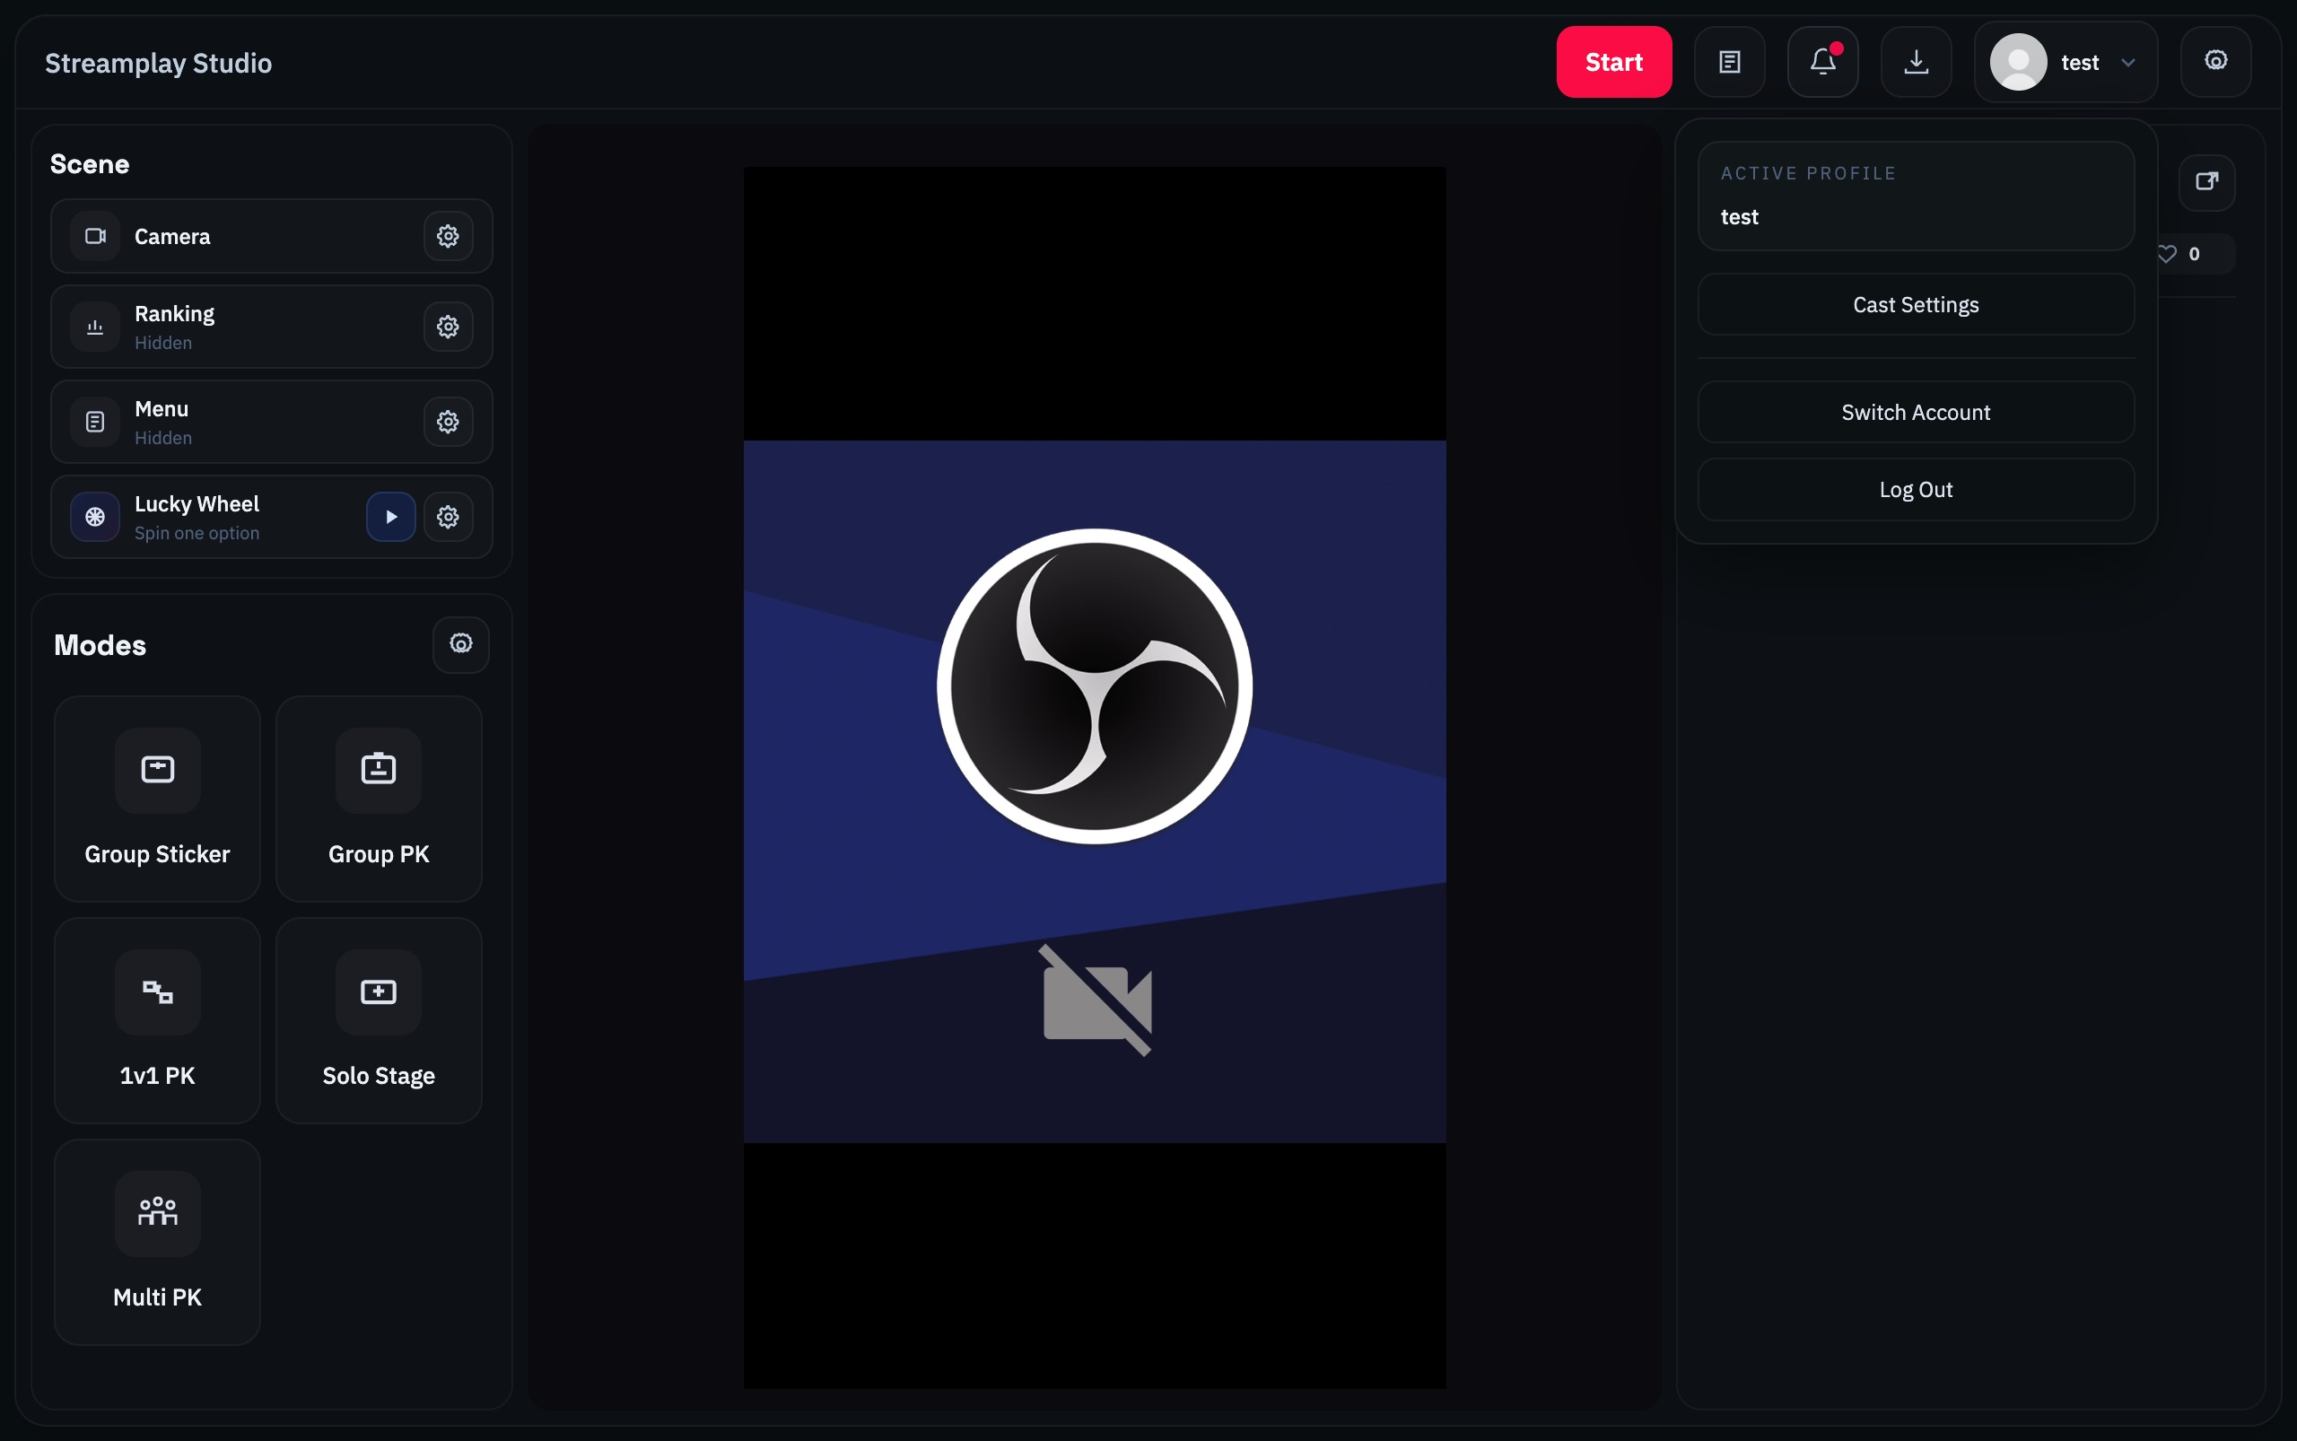
Account menu reference: Cast Settings and Switch Account are in this menu

What if sign in fails
Check your ID and password. If Authentication service is unavailable appears, check the network and retry later. Contact your account administrator if it continues.

What does Log Out do
Log Out in the account menu signs out of the current Studio session. To move to another account, use Switch Account.
Check before continuing: Active Profile shows the account you intend to use for this LIVE.
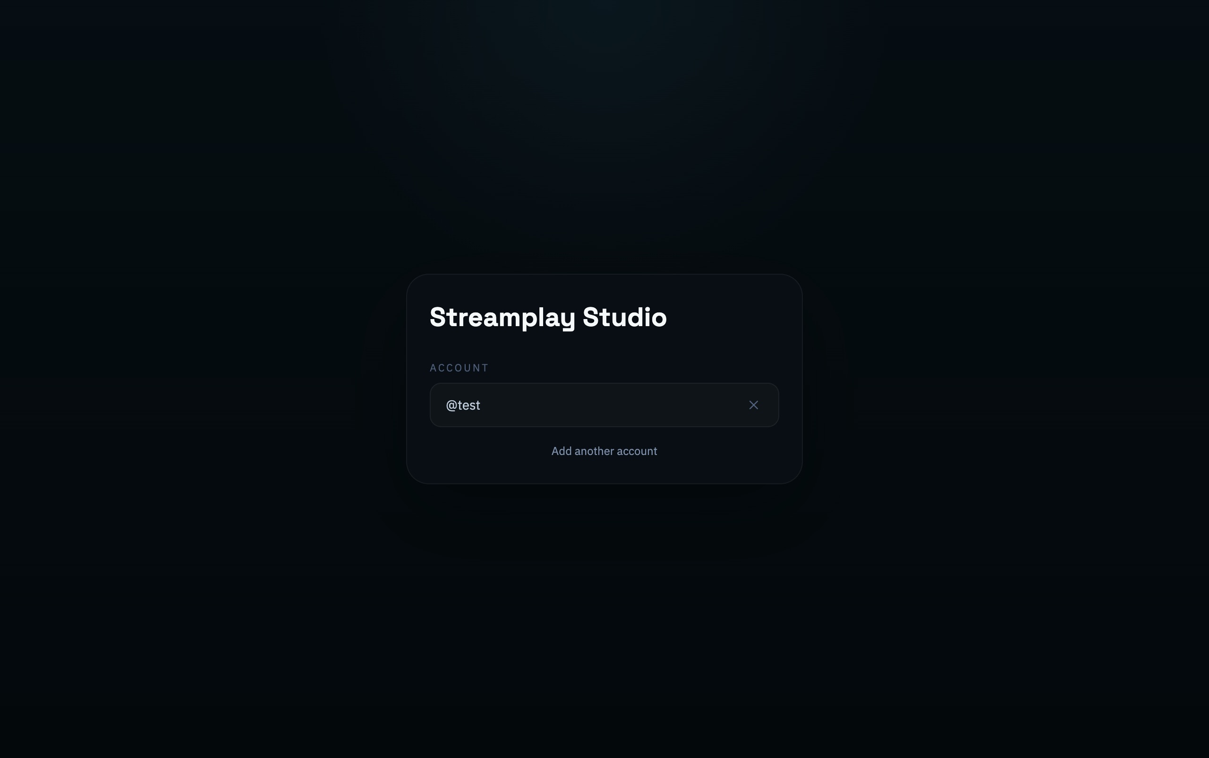
Switch Account opens the saved account list. Add another account opens the ID and password form.
After Log Out, the account can remain in the list, but its saved sign-in has ended and a password is required. Switch Account keeps a valid saved sign-in available for quick return. An expired sign-in still needs a password.

03 Workspace overview
Get to know the main areas in Studio. Then use the contents to set up members, video and games.

Get to know the workspace
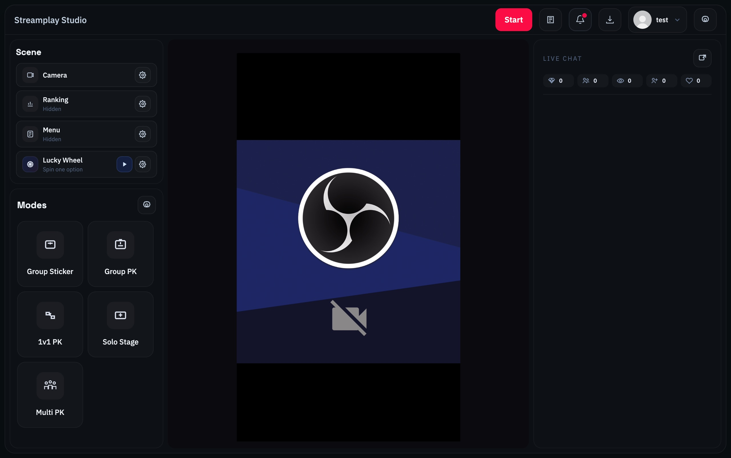
Studio workspace: scenes and games on the left, preview in the middle, LIVE Chat on the right
Account menu | Manage Cast members and switch accounts.
Scene | Configure the camera, rankings, wheel and other overlays.
Modes | Choose and configure an interactive game.
Center preview | Check the camera feed. Add the separate game overlay to OBS.
LIVE Chat | Read chat and LIVE statistics after connecting.

There are three separate starts: your streaming software goes live; the top Start button connects LIVE data; Play and Start round start a game.

04 Add Cast members
Cast members are the people who take part in your games. Create the roster first, then select participants inside each game.

1 Open Cast Settings
Open the top-right account menu. Under the active profile, click Cast Settings.
Where to add members: account menu → Cast Settings

2 Enter the member details
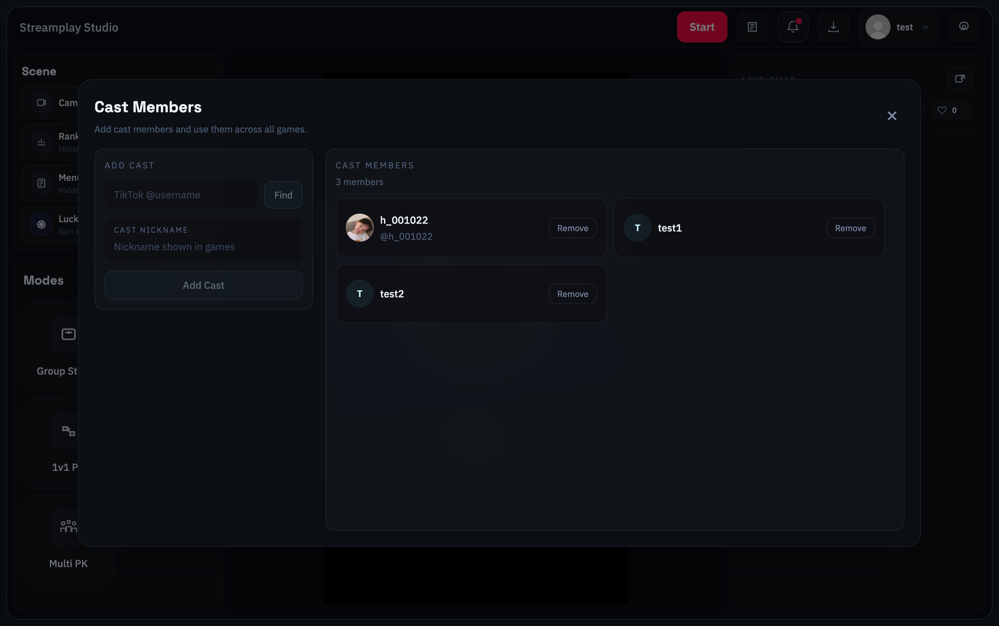
Added Cast members: h_001022 has a retrieved avatar; test1 and test2 use nickname avatars
1. Enter the TikTok username
Use TikTok @username, not the display name on the profile. The screenshot uses h_001022 for account lookup; test1 and test2 are nickname-only examples.
2. Click Find
Check the returned avatar and name. If the lookup fails, you can enter Cast Nickname manually before adding.
3. Enter Cast Nickname and click Add Cast
This name appears in the game. After adding, confirm the member appears in the Cast Members list on the right.

Why can t I edit members
Stop the running game mode before opening Cast Settings. Member settings may be locked while a mode is running.
Check before continuing: The required members appear in Cast Members. Select the participants again inside the game you choose.

05 Connect camera and OBS
Connect the camera feed to Studio, then add the separate interactive overlay to OBS.

1 Show the camera in Studio
1. Prepare the scene in OBS
Set up your camera and scene, then start OBS Virtual Camera. You may also use an available physical camera.
2. Select the source in Studio
Click the gear next to Camera. In Camera Source, select OBS Virtual Camera or your camera.
3. Check the center preview
If the device is missing, click Refresh Sources. Continue when the video preview works.
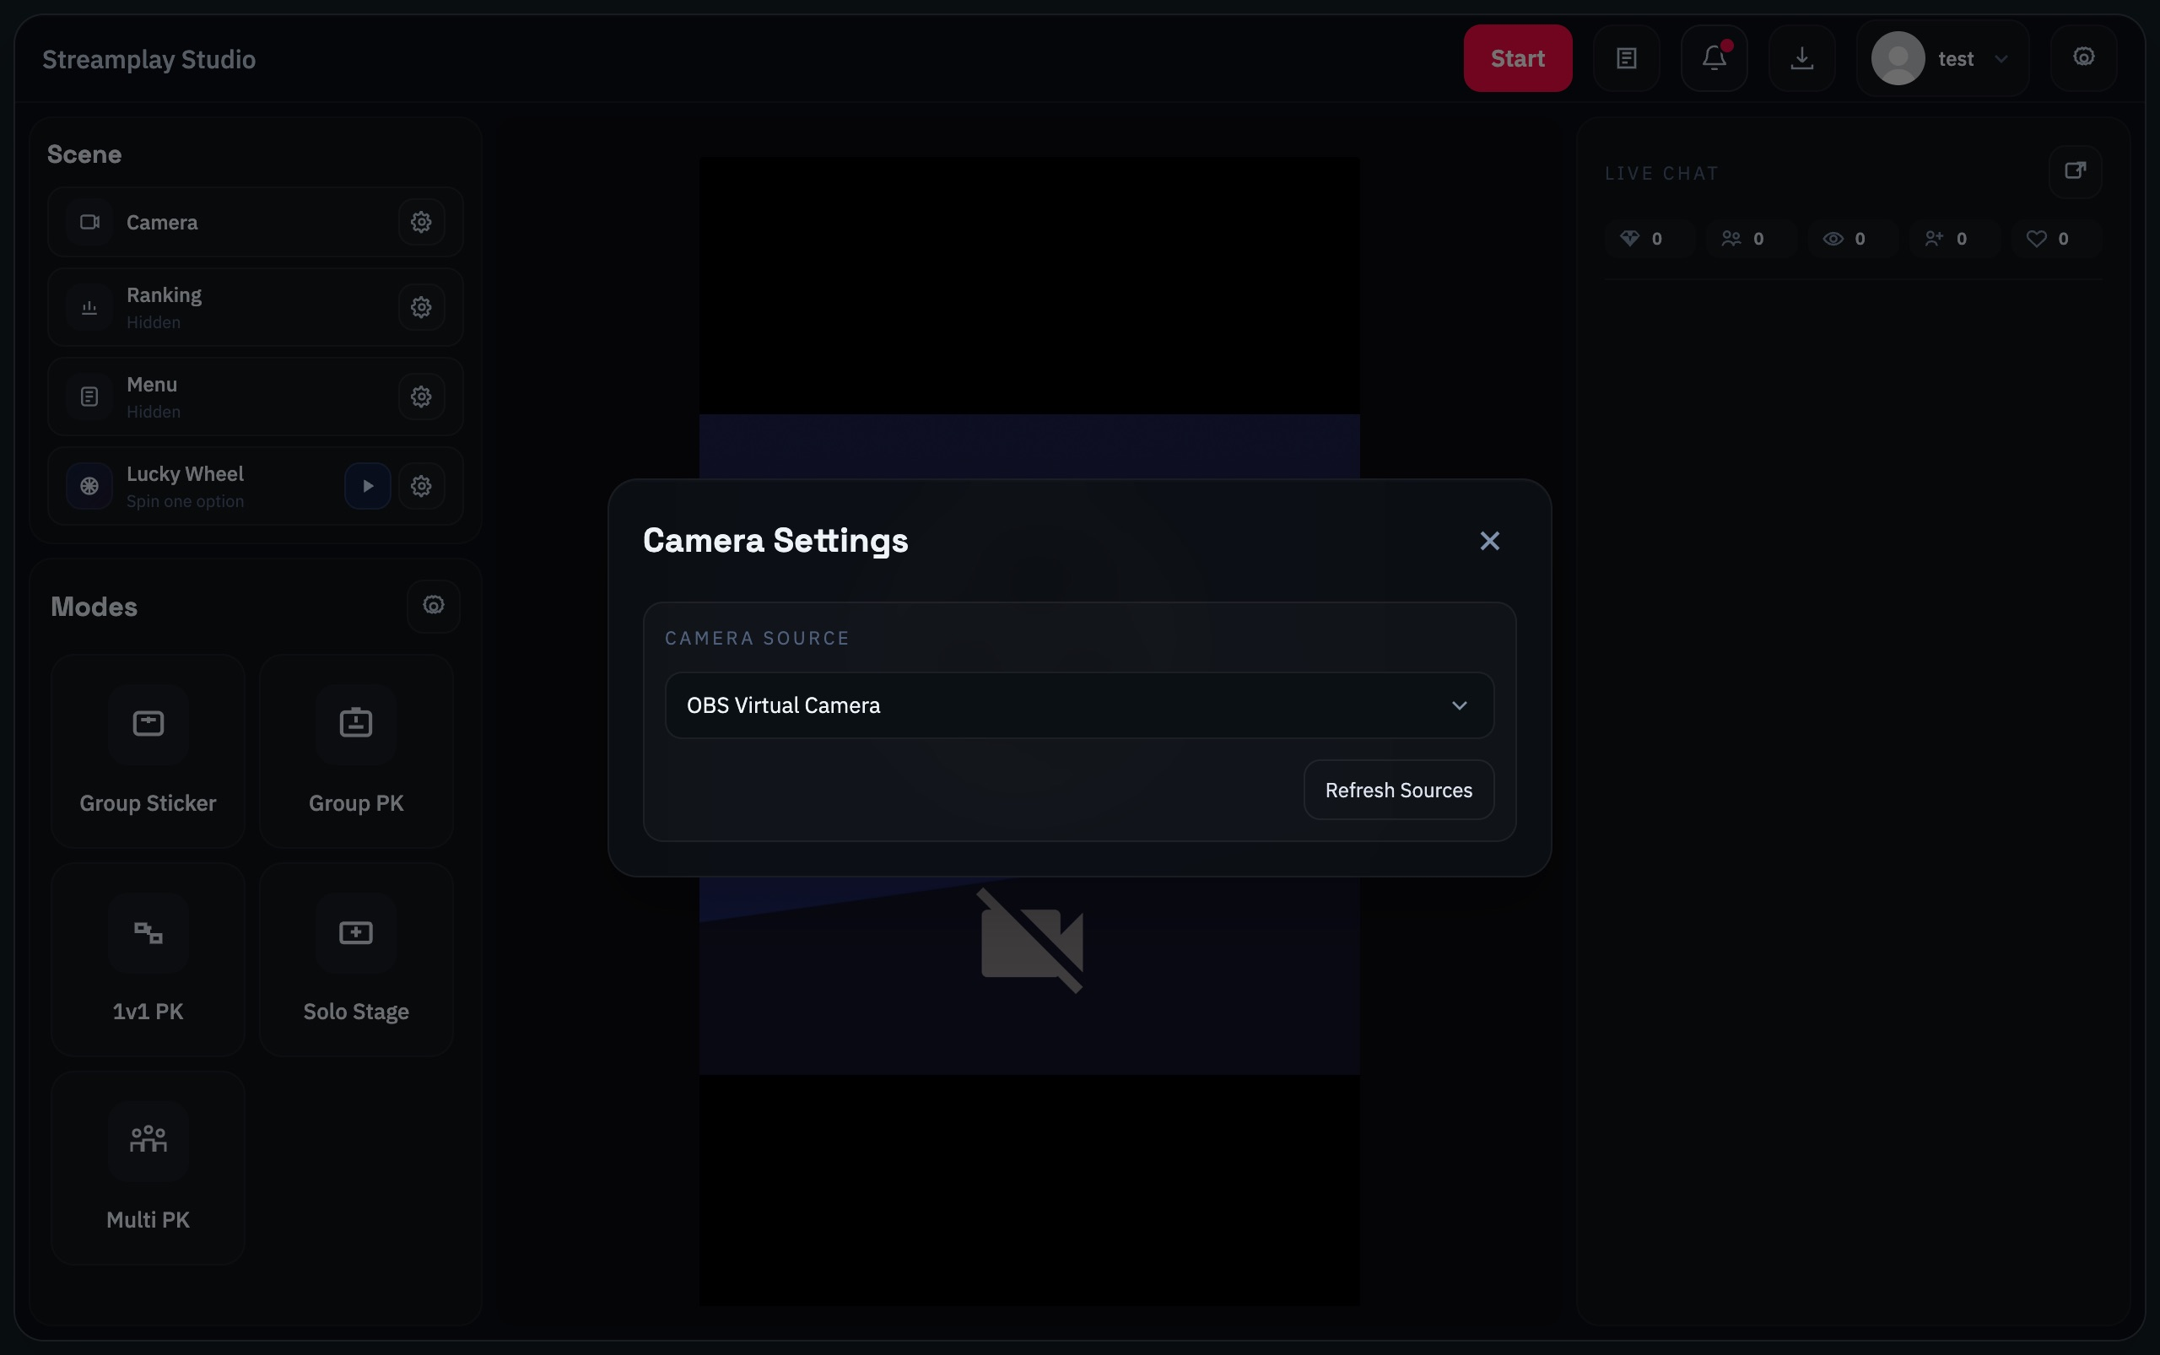
Camera Settings: select a source and refresh devices if needed

2 Show game content in OBS
1. Copy the overlay link
Open the top-right Studio settings gear. Copy the OBS Overlay Runtime link.
2. Add a Browser source in OBS
Paste that link into an OBS Browser source. Match its dimensions to the final canvas, for example 1080 × 1920 for portrait video.
3. Place it above the camera
Keep the Browser source above the camera source. Start the chosen mode and check member cards, scores and timers in OBS.
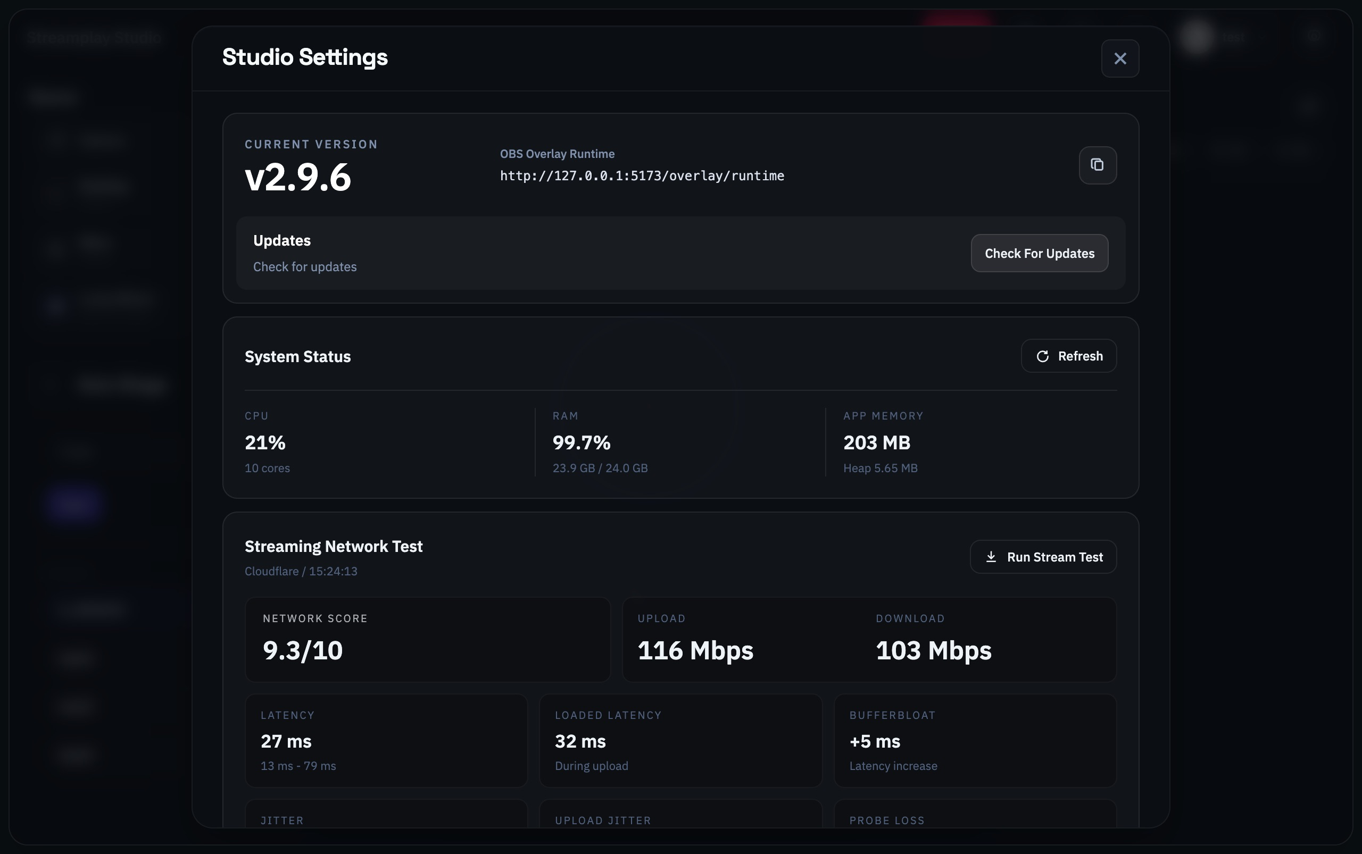
Studio Settings: copy the OBS Overlay Runtime link from your own app
A localhost link works on the same computer. Copy the link from your own Studio; do not type the address from this screenshot.
Check before continuing: The center preview shows video. When a mode runs, its members and scores appear in the OBS Browser source.

06 Choose a game
Try Group Sticker first to learn how members and gifts match. Then explore timed rounds and queue rotation.

Group Sticker
Member cards with continuous scoring

Group PK
Members compete together in a timed round

1v1 PK
Two players compete and the winner stays

Solo Stage
Members take turns on a timed solo stage

Multi PK
Multiple players compete with a bench queue

The usual sequence
1. Choose a mode and open settings
Click a mode card, then its settings gear. Select members, set the timer where available, and map gifts in modes with Gift Mapping. Solo Stage does not need representative gifts for members.
2. Save the setup
Click Save Settings. Open Map representative gifts from the contents if you need help.
3. Start when LIVE is ready
Confirm the broadcast is live and Studio is connected, then follow Start your first interaction to start the mode and round.

07 Map representative gifts
In modes with Gift Mapping, select a representative gift for each member. Scoring follows the active game’s rules.
1. Open the game settings
Find Gift Mapping and check the member’s name.
2. Click the gift next to a member
Search in Select Gift. Check the icon, name and point value.
3. Save the completed setup
Map all participants, including waiting members where required, then click Save Settings.
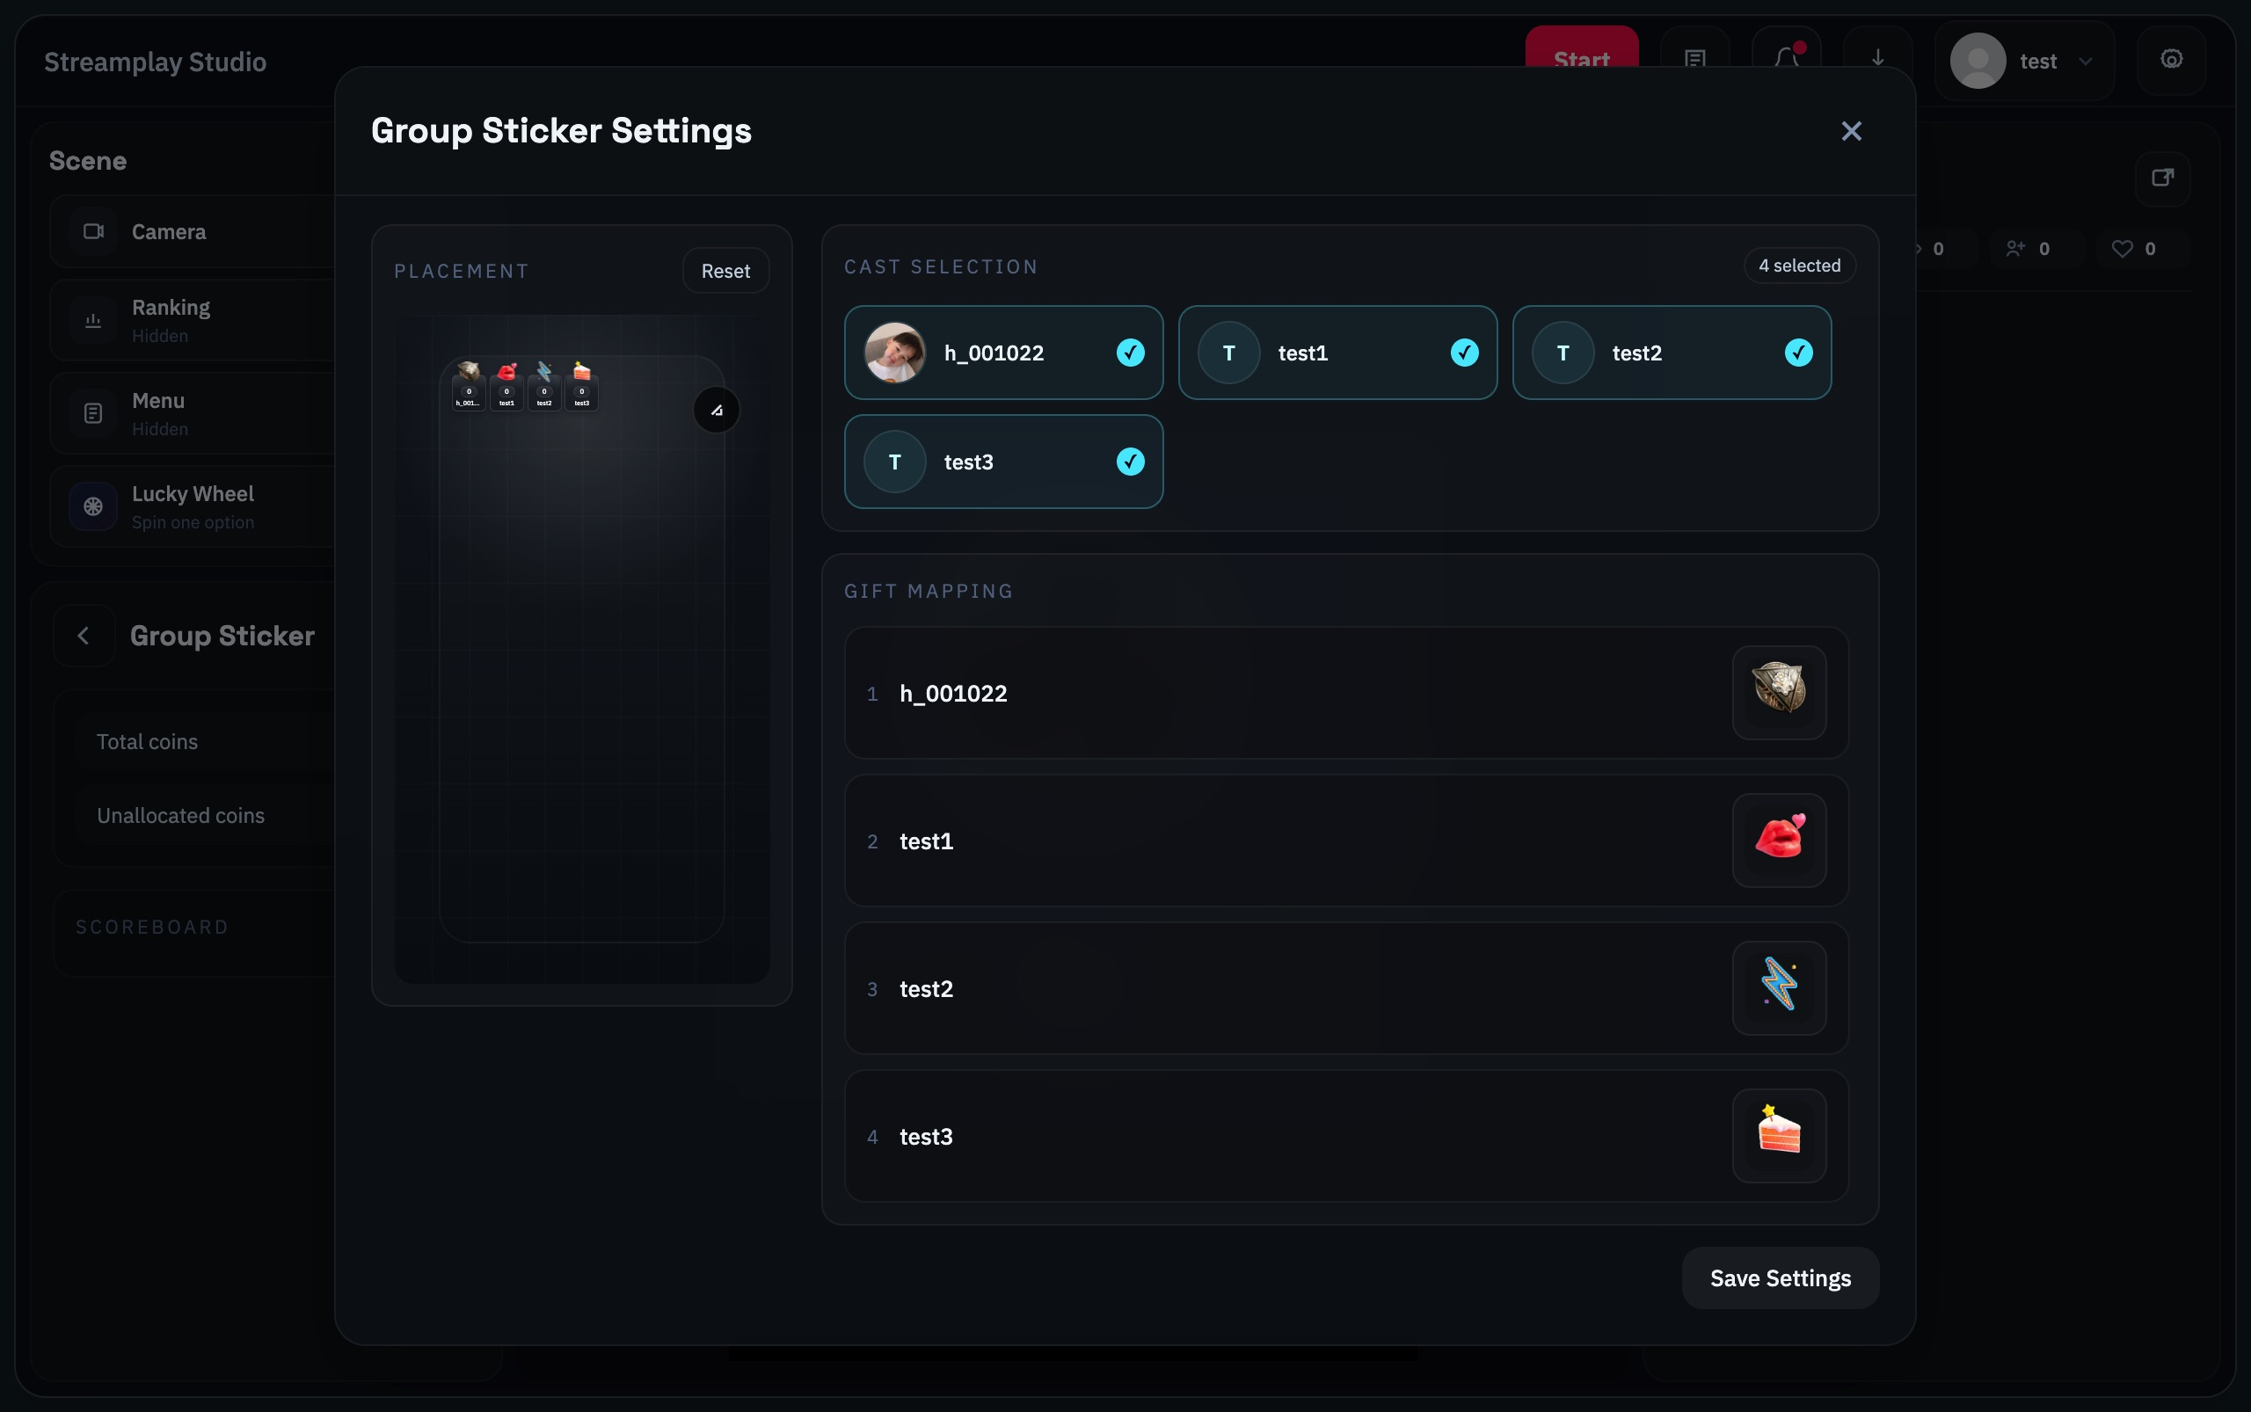
Gift Mapping: each row pairs a member with a gift
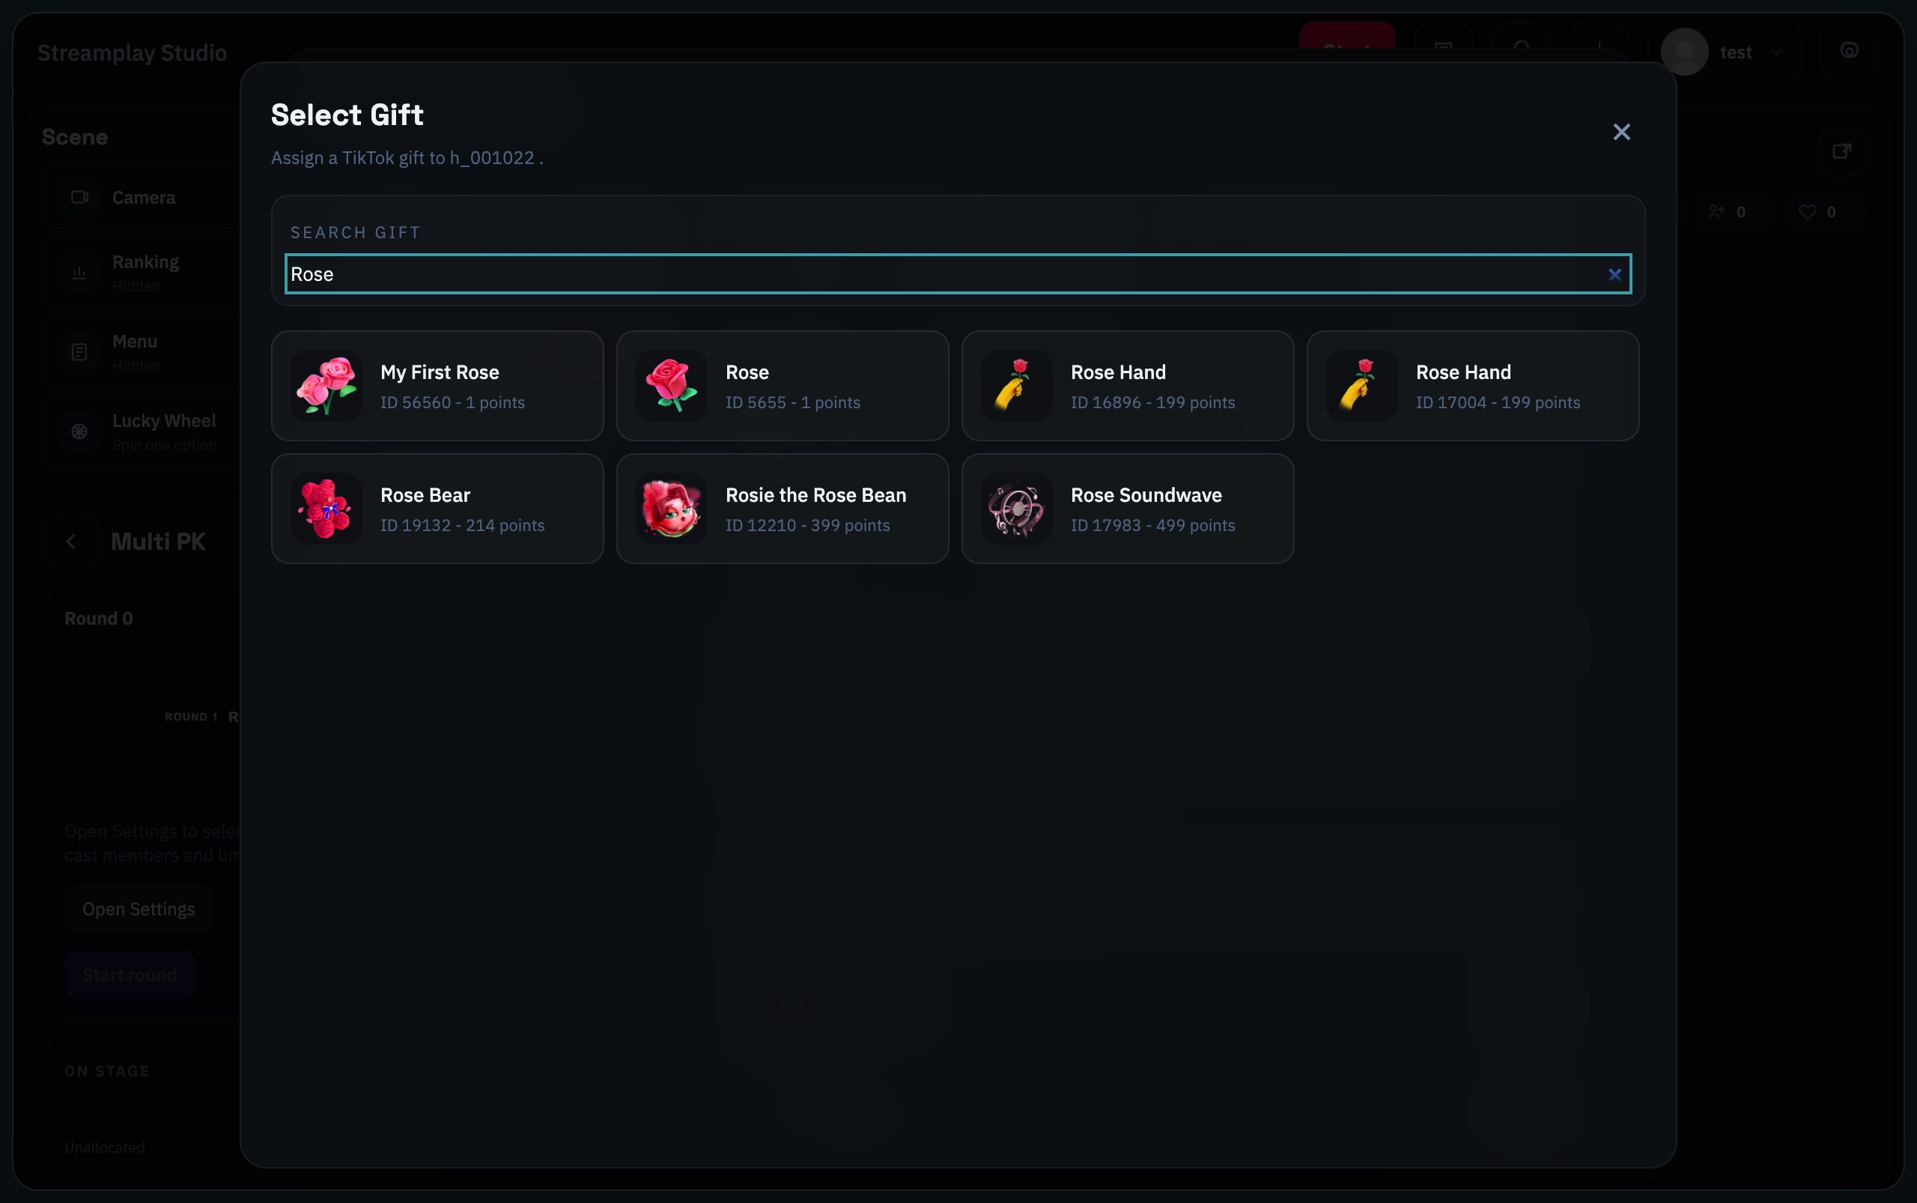
Select Gift: an example search for Rose
In Multi PK, every on-stage and bench member needs a unique representative gift. Check the mapping before going live.

What happens to other gifts
You can enable Gifter Binding in Modes settings when needed. Once a viewer has a member binding, it provides fallback attribution for later unmatched gifts. Review gifts already marked unallocated in the LIVE log.
Check before continuing: Each member matches the intended gift icon and name, and settings are saved. In Multi PK, bench members are configured too.

08 Start your first interaction
Once members, video and game settings are ready, start in this order.
1. Go live in your streaming software
Start TikTok LIVE with your streaming software and confirm the room is online.
2. Click the top Start button in Studio
Connect to the current TikTok LIVE. Check that LIVE Chat and statistics begin updating.
3. Start the chosen mode
Click ▶ Play. In timed modes, also click Start round or Start. Check the game overlay in OBS.
4. Verify a real interaction
Check the viewer, gift, assigned member and score before continuing the activity.
The top Start button does not start a broadcast. It connects LIVE data. Go live in your streaming software first.

Quick check before starting
Members | Added to Cast and selected in the game.
Gifts | Mapped correctly, including any waiting members.
Video | Camera preview works and OBS shows the game overlay.
LIVE | The room is live, Studio is connected and interactions arrive.

09 Group Sticker
Member cards with continuous scoring

How it works
Viewers send a member’s mapped gift to support that member. This mode suits ongoing interaction without timed rounds.

Follow these steps
1. Select members
Open the game settings and choose the Cast members to display.
2. Map their gifts
Use Gift Mapping to choose each member’s gift, then click Save Settings.
3. Start the mode
Return to the mode panel and click ▶ Play. Check the member scores when mapped gifts arrive.
Need help choosing gifts? Open the gift mapping guide →
Group Sticker settings

Read the settings
Placement — Drag the overlay to move it; drag its corner to resize it. Reset restores the placement.
Cast Selection — Select the members who will appear in this game.
Gift Mapping — Click each member’s gift to choose the representative gift, then Save Settings.
Play — Play starts continuous scoring. There is no separate Start round.

How to stop
There is no separate Start round button. Group Sticker keeps scoring after Play; stop the mode when you finish.
Check each member’s gift before starting so viewers can support the intended person.

10 Group PK
Members compete together in a timed round

How it works
Members join the same timed round. Viewers support them with mapped gifts; use the round scores to review the result.

Follow these steps
1. Set the round time
Open settings, select members and enter the duration in seconds.
2. Map gifts and save
Choose representative gifts in Gift Mapping, then click Save Settings.
3. Start the round
Click ▶ Play to enter the mode, then Start round to begin the countdown.
Need help choosing gifts? Open the gift mapping guide →
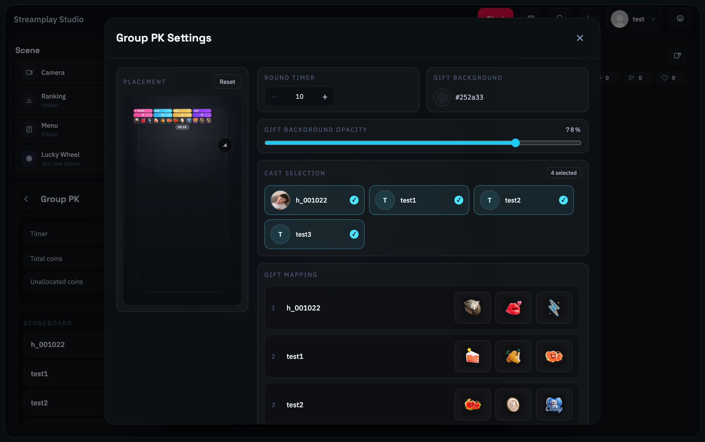
Group PK settings

Read the settings
Round Timer — Set the round length in seconds.
Gift Background / Opacity — Adjust the background colour and opacity behind gift icons.
Cast Selection / Gift Mapping — Select members and check the gifts shown for each member.
Save Settings → Play → Start round — Save the setup, open the game, then start the timed round.

Ending the round and continuing
The timer or End round ends the round. After an 8-second buffer, click Start round to begin another round.
Group PK does not automatically eliminate or replace members using Multi PK rules.

11 1v1 PK
Two players compete and the winner stays

How it works
The first two queued members take the LEFT and RIGHT positions. Viewers send the gifts mapped to each member.

Follow these steps
1. Arrange the queue
Select members in settings and save. Back in the mode panel, drag members in ROUND QUEUE to set the order. The first two play first.
2. Set time and gifts
Set the round duration and map each participant’s gift. Click Save Settings.
3. Start the match
Click ▶ Play, then Start round.
Need help choosing gifts? Open the gift mapping guide →
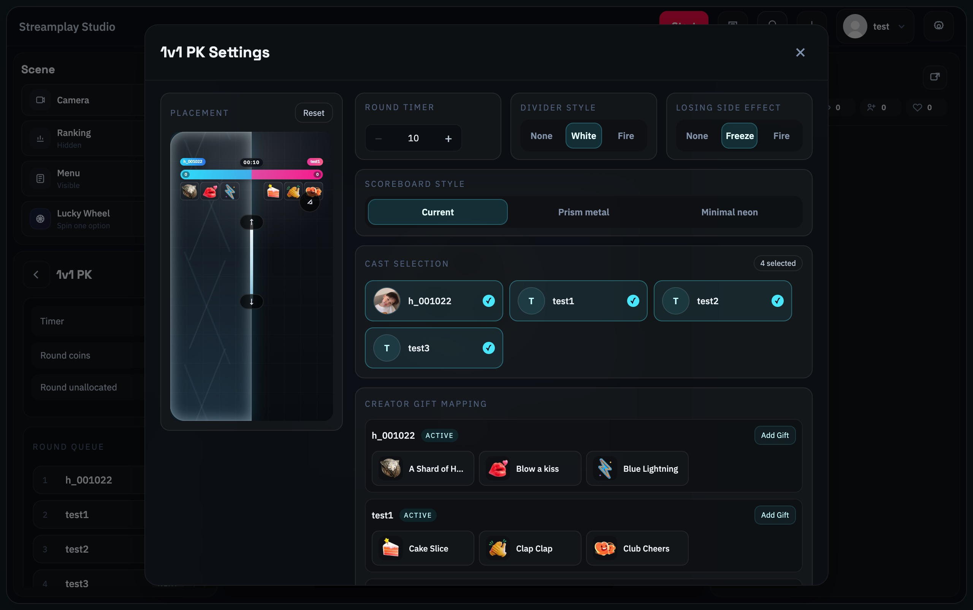
1v1 PK settings
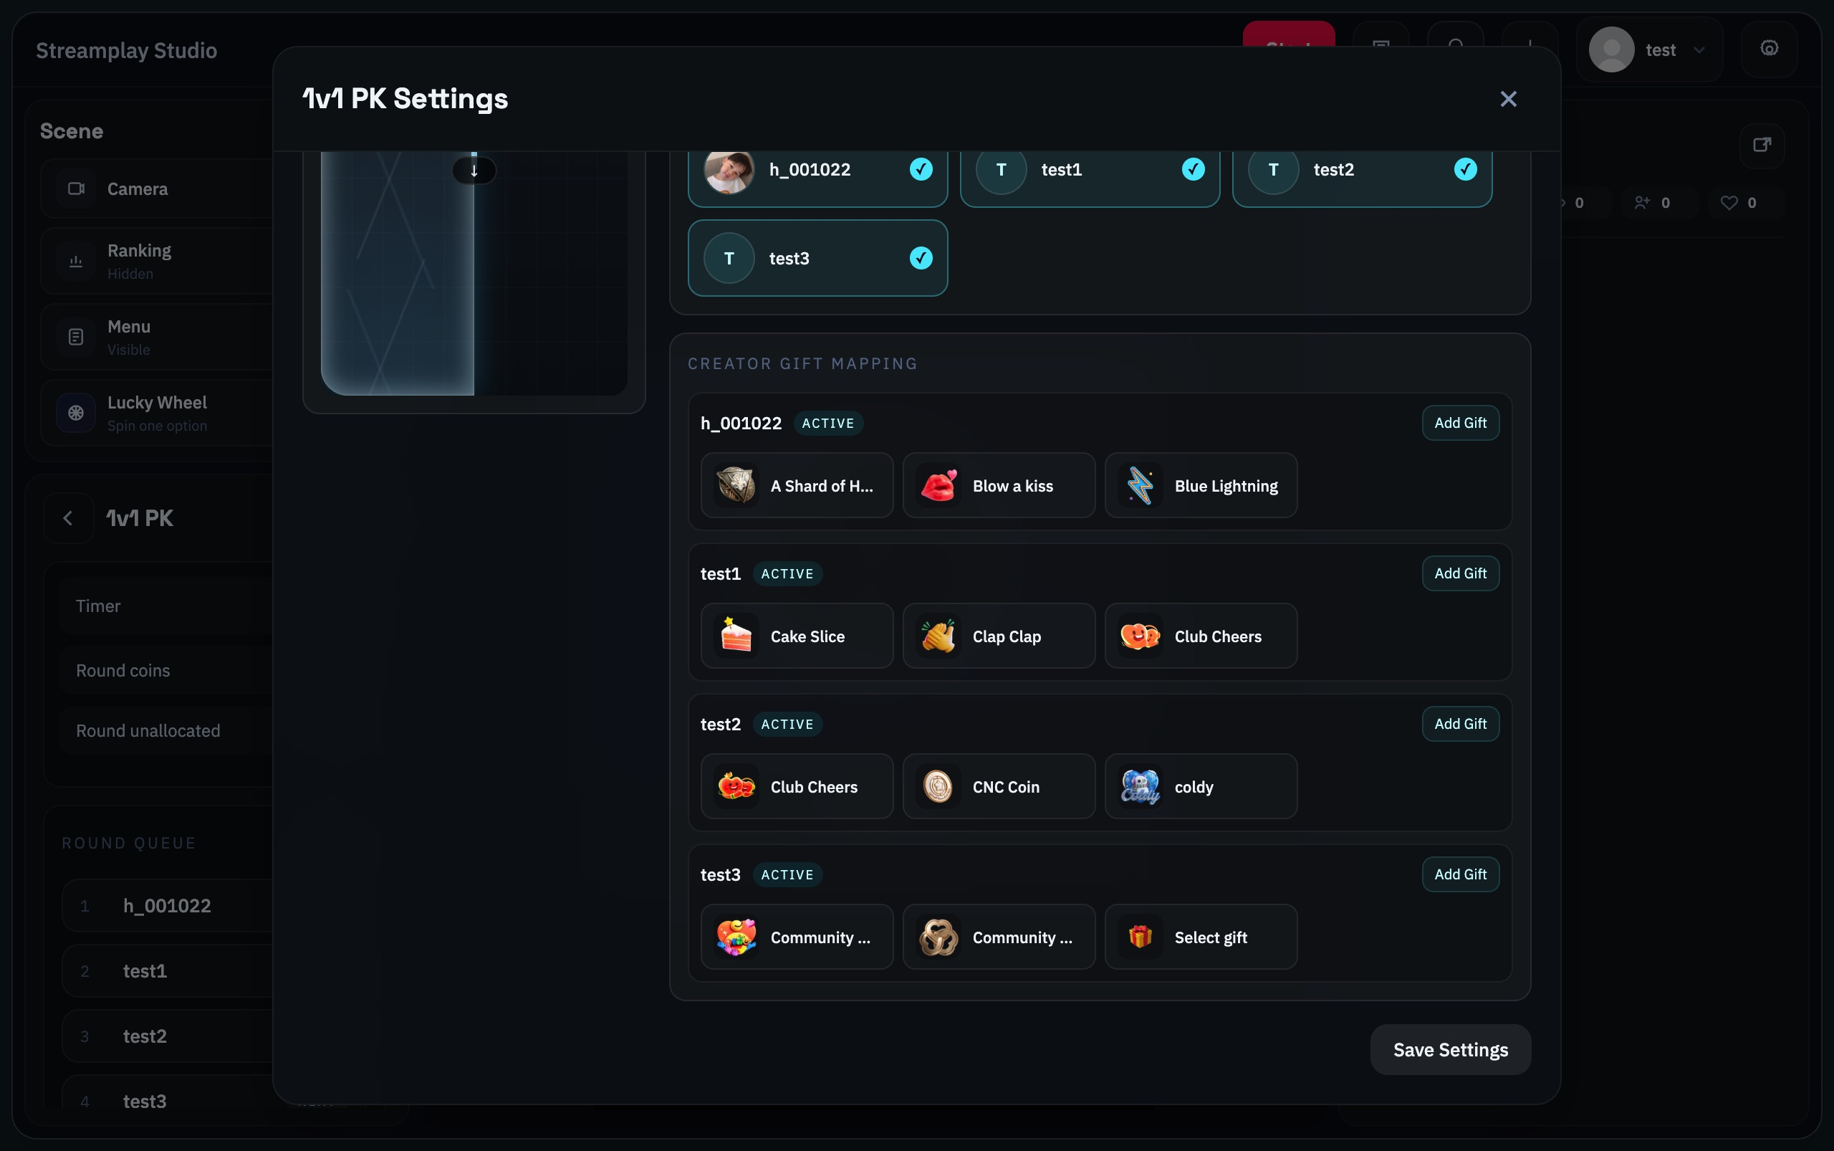
1v1 PK settings 2 of 2: member gifts and Save Settings

Read the settings
Round Timer — Set each matchup’s length in seconds.
Divider Style — Choose None, White or Fire for the divider.
Losing Side Effect — Choose the visual effect for the losing side.
Scoreboard Style — Choose Current, Prism metal or Minimal neon.
Cast Selection / Creator Gift Mapping — Select participants and configure each member’s gifts. The first two in the queue play first.
Save Settings → Play → Start round — Save, open the game and begin the matchup.

Ending the round and continuing
The winner stays on the same side. The loser moves to the end of the queue and the next waiting member enters. A tie keeps the same matchup. With only two members, there is no replacement.
Check the names on LEFT and RIGHT so your spoken instructions match the gift mapping.

12 Solo Stage
Members take turns on a timed solo stage

How it works
One member performs at a time. Eligible support is credited to the active member. Choose Target or Freedom.

Follow these steps
1. Choose the format and queue
Select Target or Freedom and arrange the member order.
2. Set the time and display
For Target, set target A below target B. Choose Original or Avatar as needed. Freedom also uses a timer.
3. Start the stage
Save settings, click ▶ Play, then Start for the active member.
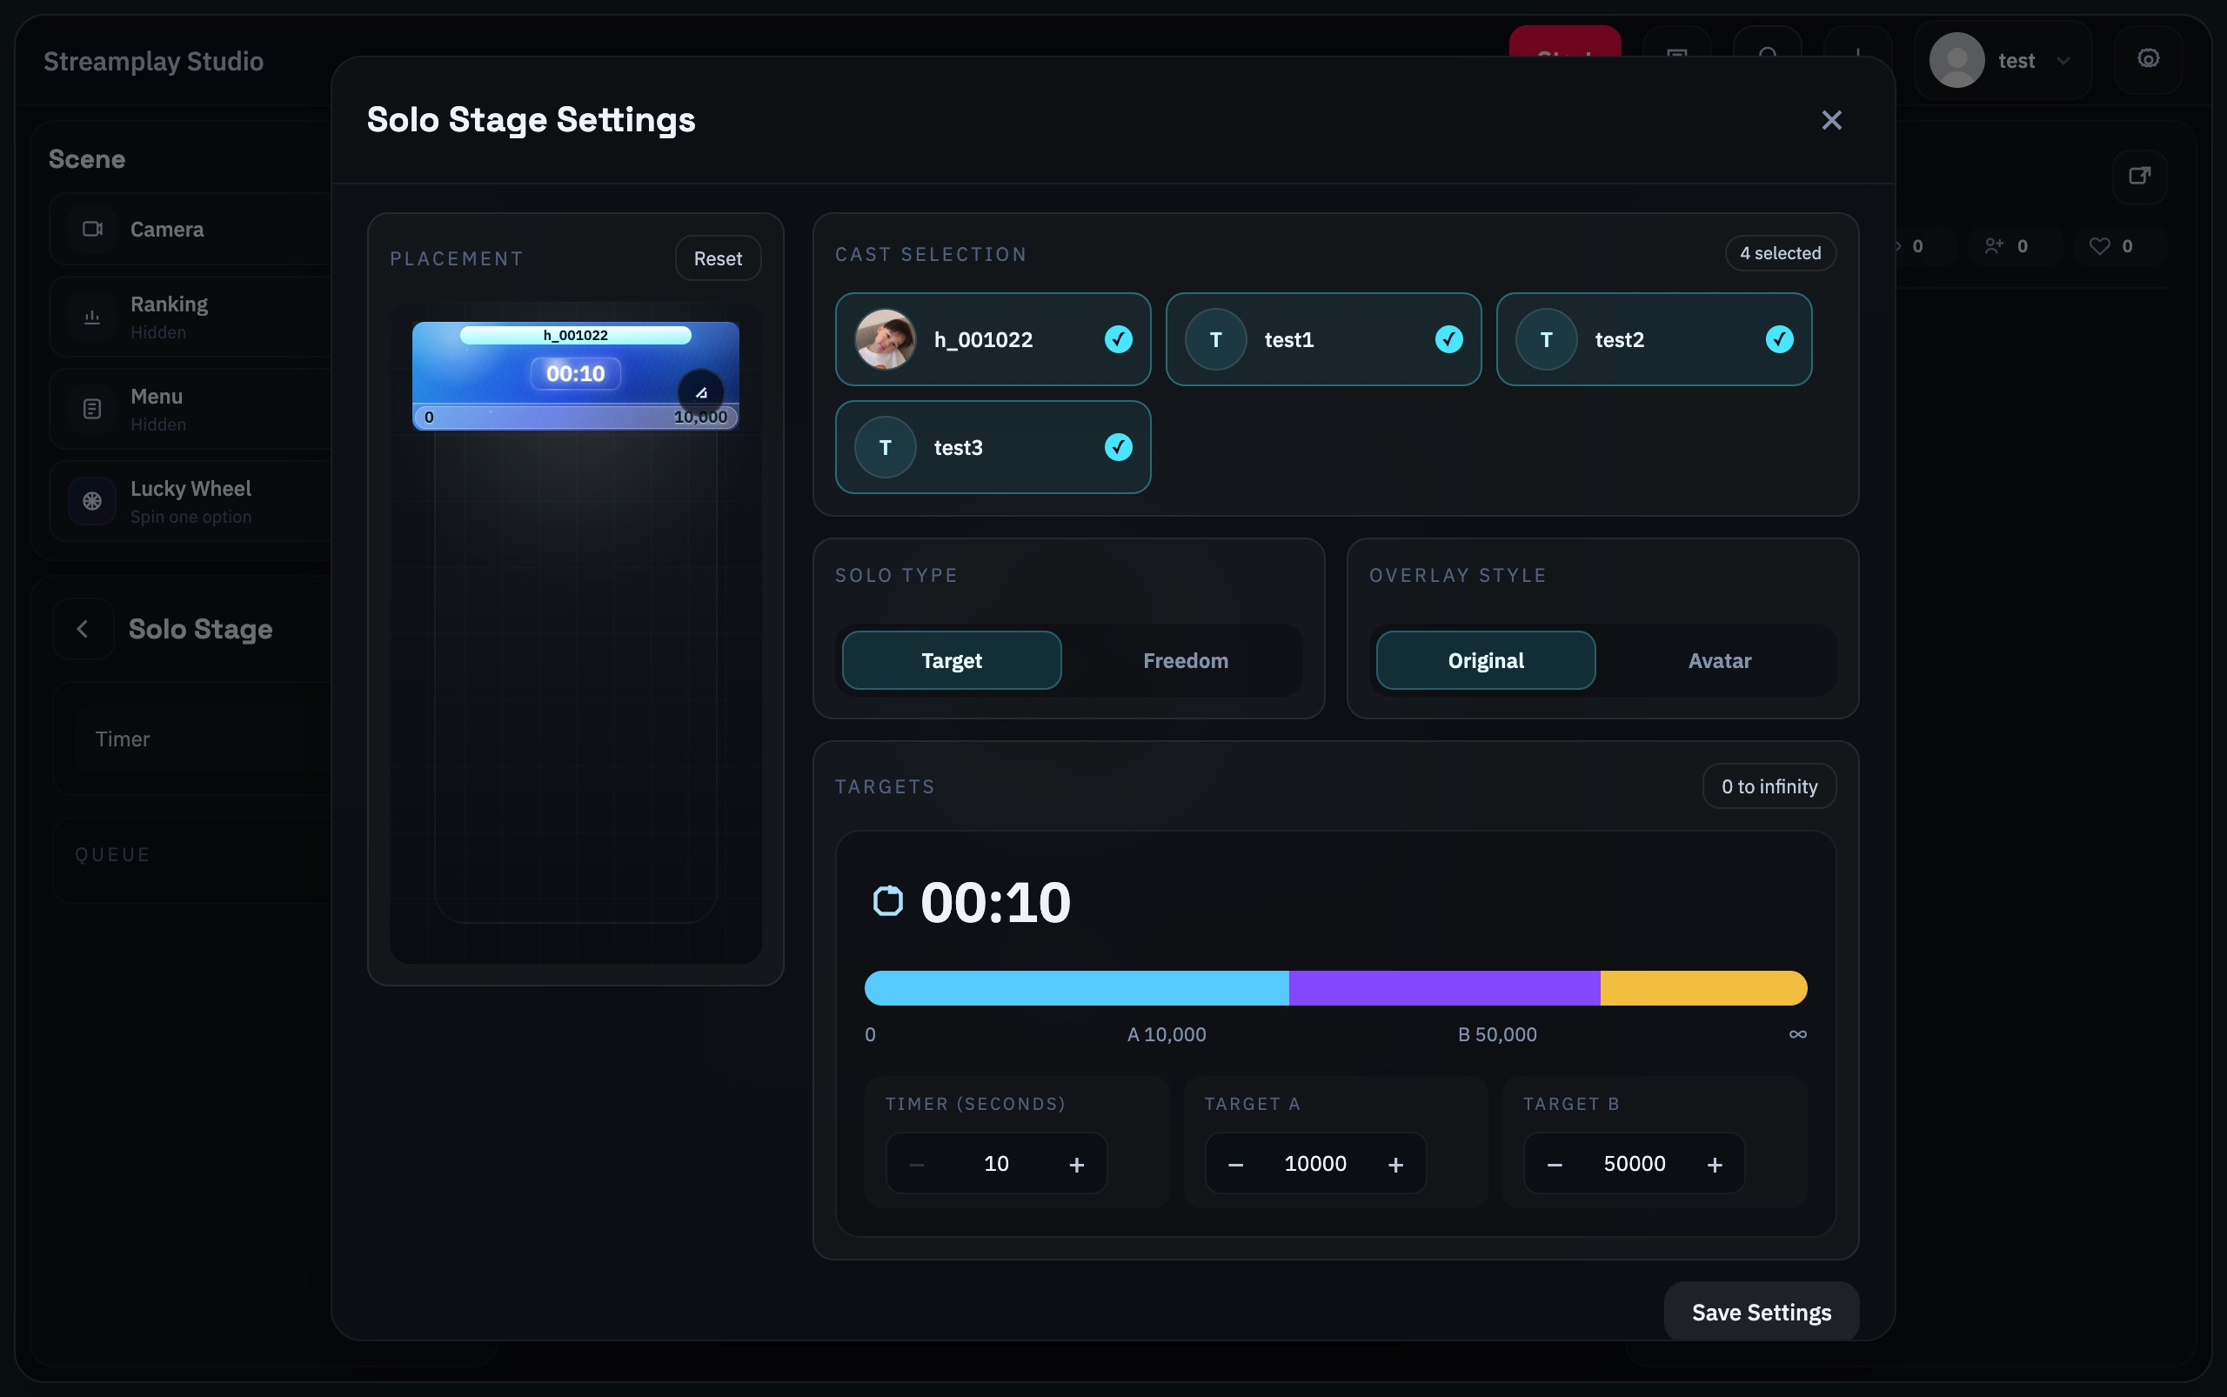
Solo Stage settings
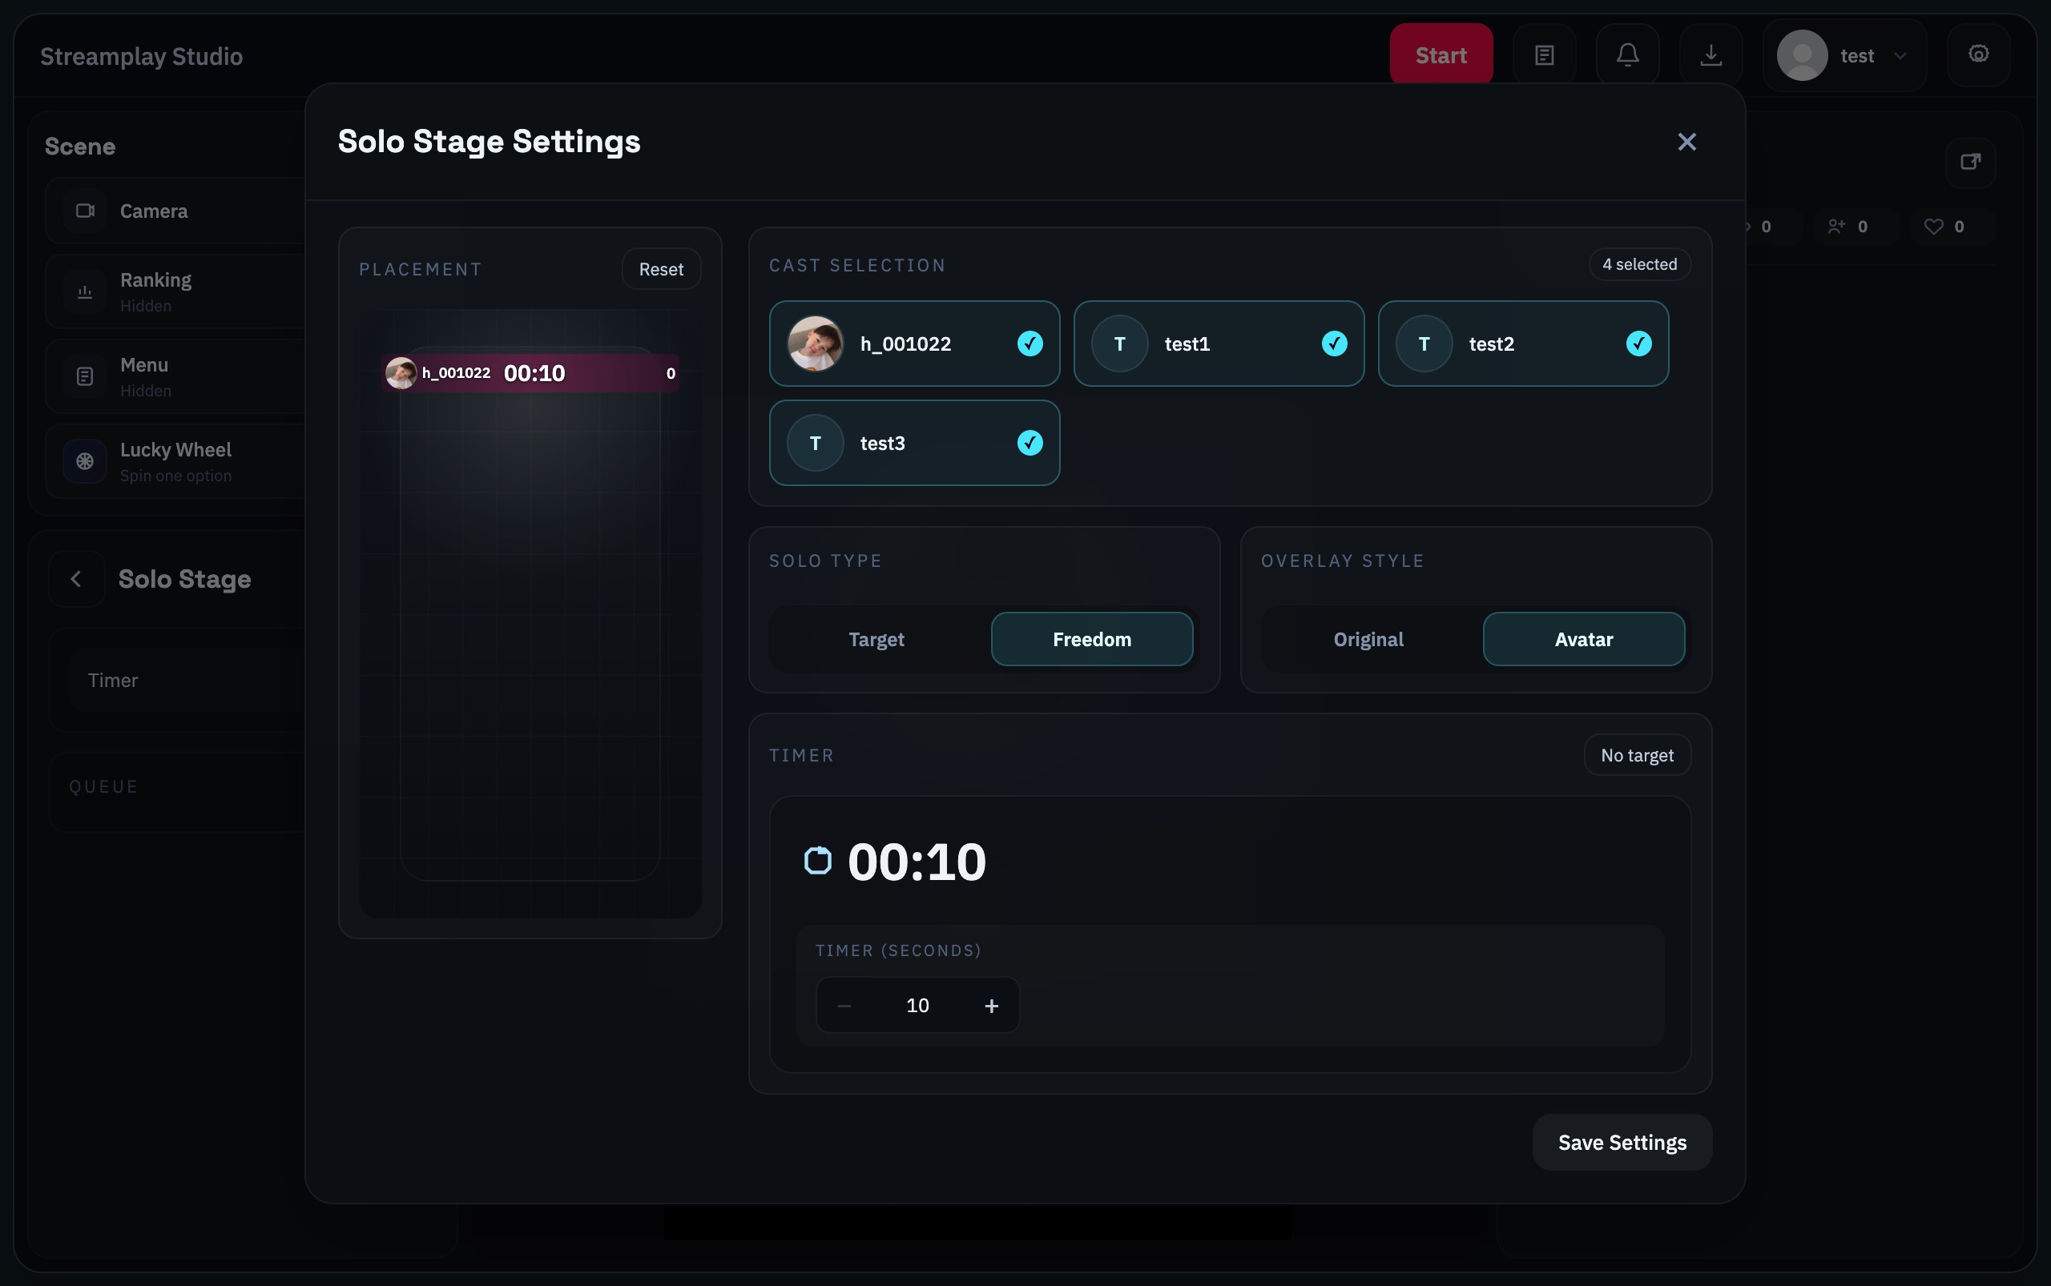
Solo Stage: Freedom and Avatar settings

Read the settings
Cast Selection — Select the members who will take turns.
Solo Type — Target shows target milestones; Freedom has no target milestones. Both use a timer.
Overlay Style — Choose Original or Avatar.
Timer / Target A / Target B — Set seconds. In Target mode, set A lower than B.
Save Settings → Play → Start — Save and open the mode, then Start. After the round, Start again rotates to the next member.

Ending the round and continuing
When the timer ends or you end the round, the result stays visible. The next Start rotates to the next member. Reaching a target does not automatically change the member.
Some settings are locked during a live round. End the round before changing them.

13 Multi PK
Multiple players compete with a bench queue

How it works
Members compete together. At the end of a round, the lowest-scoring member can be replaced by the next waiting member.

Follow these steps
1. Set the stage and bench
Set On-stage count from 2 to 21. Select exactly that many members in On Stage and place waiting members in Bench Queue.
2. Set time and unique gifts
Choose 10–3600 seconds. Every on-stage and bench member needs a unique representative gift. Save settings.
3. Start the first round
Click ▶ Play, then Start round.
Need help choosing gifts? Open the gift mapping guide →
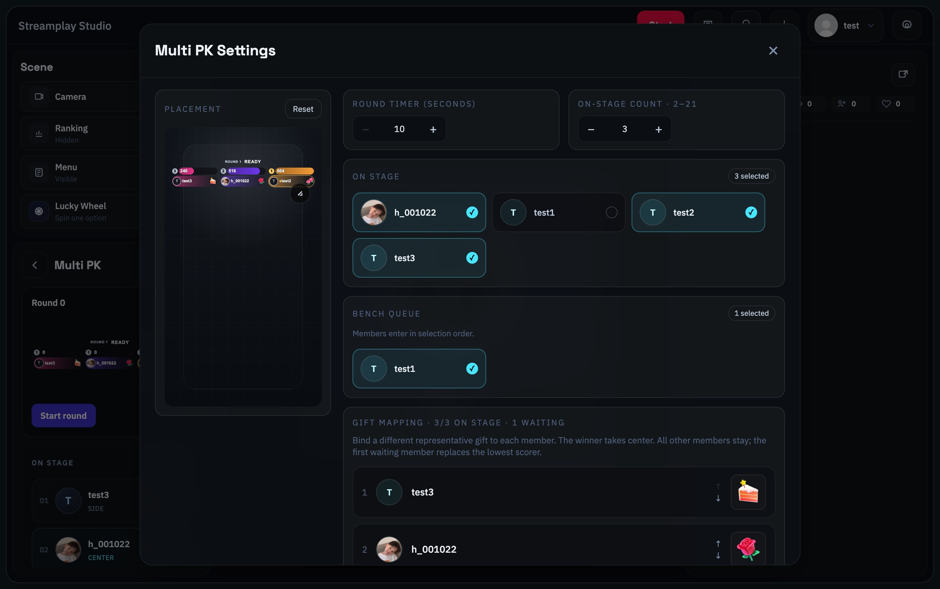
Multi PK settings 1 of 2: timer, stage count, members and bench
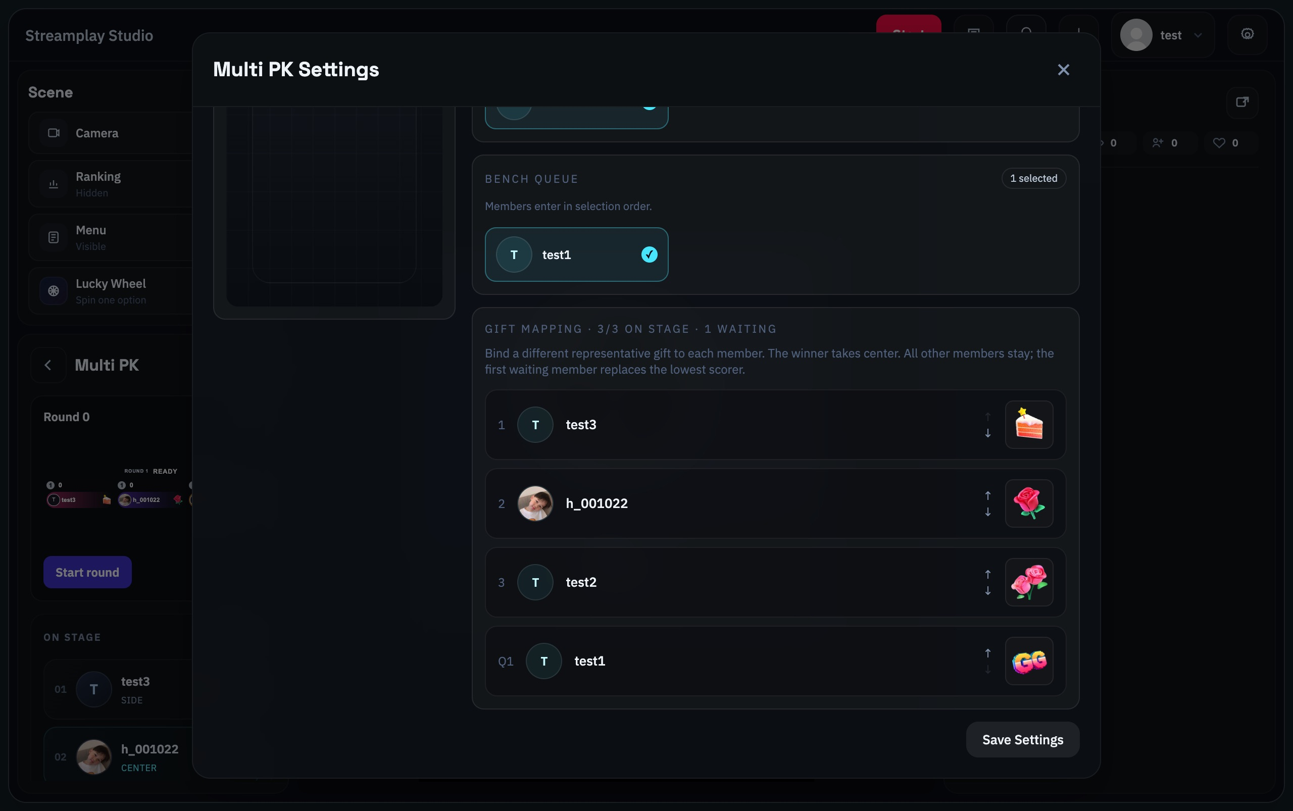
Multi PK settings 2 of 2: all gift mappings and Save Settings

Read the settings
Round Timer / On-stage Count — Set seconds and the number of members on stage (2–21).
On Stage — Select exactly the number specified by On-stage Count.
Bench Queue — Select waiting members. Their queue order determines who enters next.
Gift Mapping — Every on-stage and waiting member needs a different representative gift.
Save Settings → Play → Start round — Save, start the mode and start a round. If the lowest scores tie, choose who leaves before Next round.

Ending the round and continuing
With members waiting, the lowest-scoring member leaves and joins the end of the bench queue. The next waiting member enters; everyone else stays. With no bench members, no replacement occurs.
If the lowest score is tied, use Choose who leaves before the next round. A tie for highest score does not add a single-player win streak.
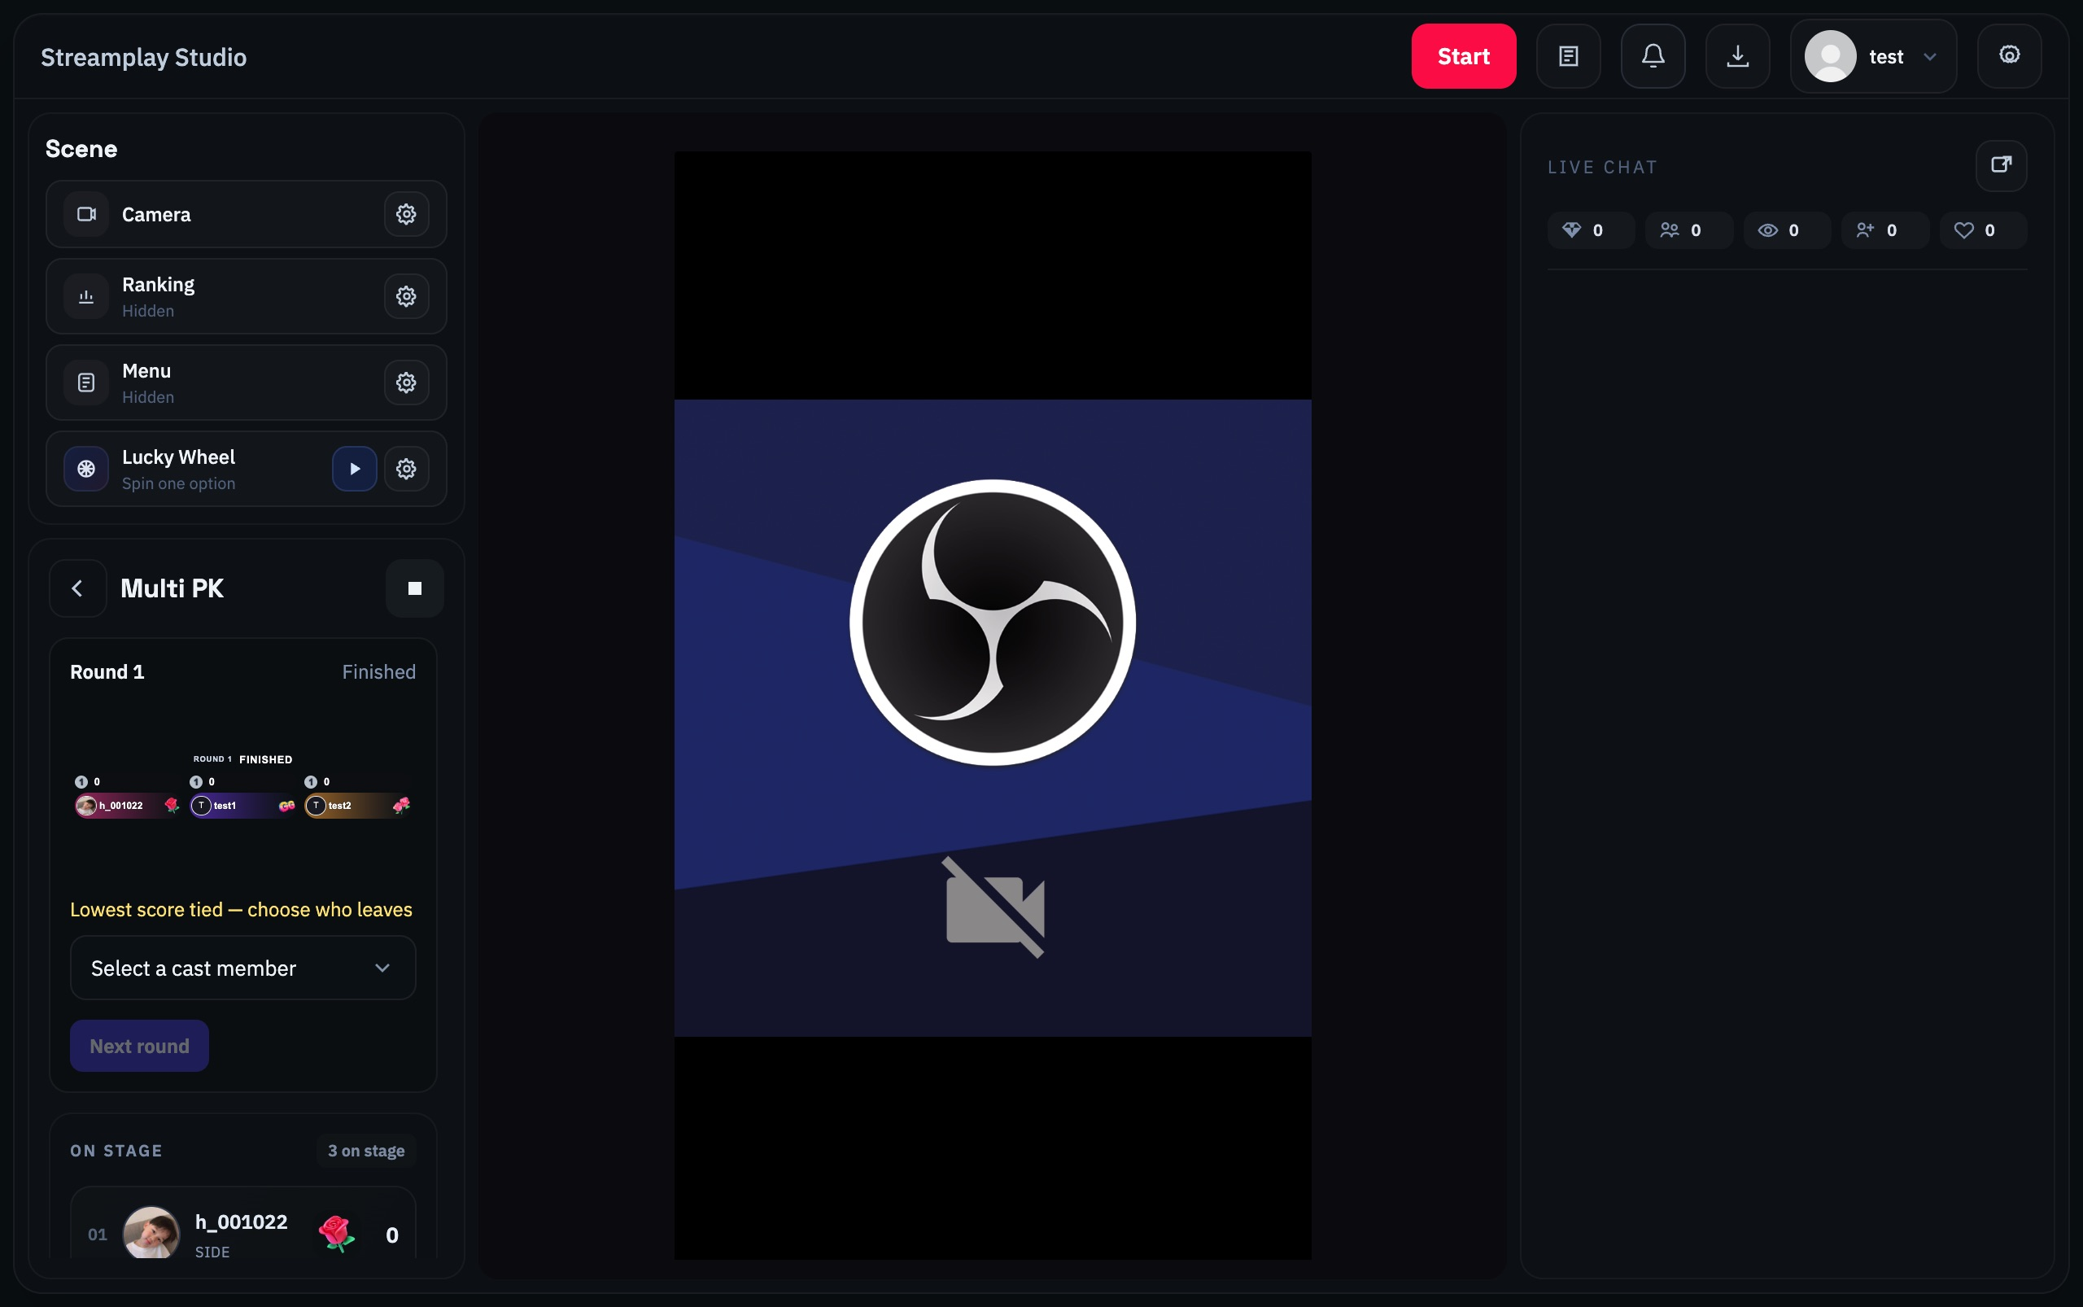
When the lowest score is tied, choose who leaves before continuing

14 Other scene tools
Finish the basic setup first, then use these tools to suit your broadcast.

Ranking
Open the gear next to Ranking, choose a list and enable its display. Available configurations include member totals, top gifters and likers. Goals can show gift-sender, like and new-follower targets.
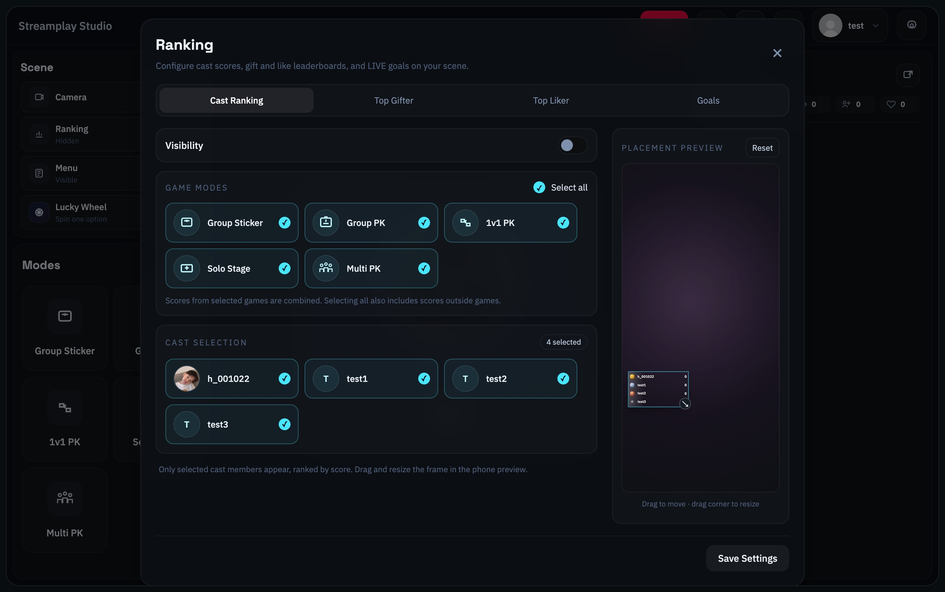
Ranking: select game scores and Cast members to display

Lucky Wheel
Enter one option per line in Options, set the result hold time from 1 to 15 seconds, and save. Click the play button beside Lucky Wheel to spin. The result does not automatically change game scores or members.
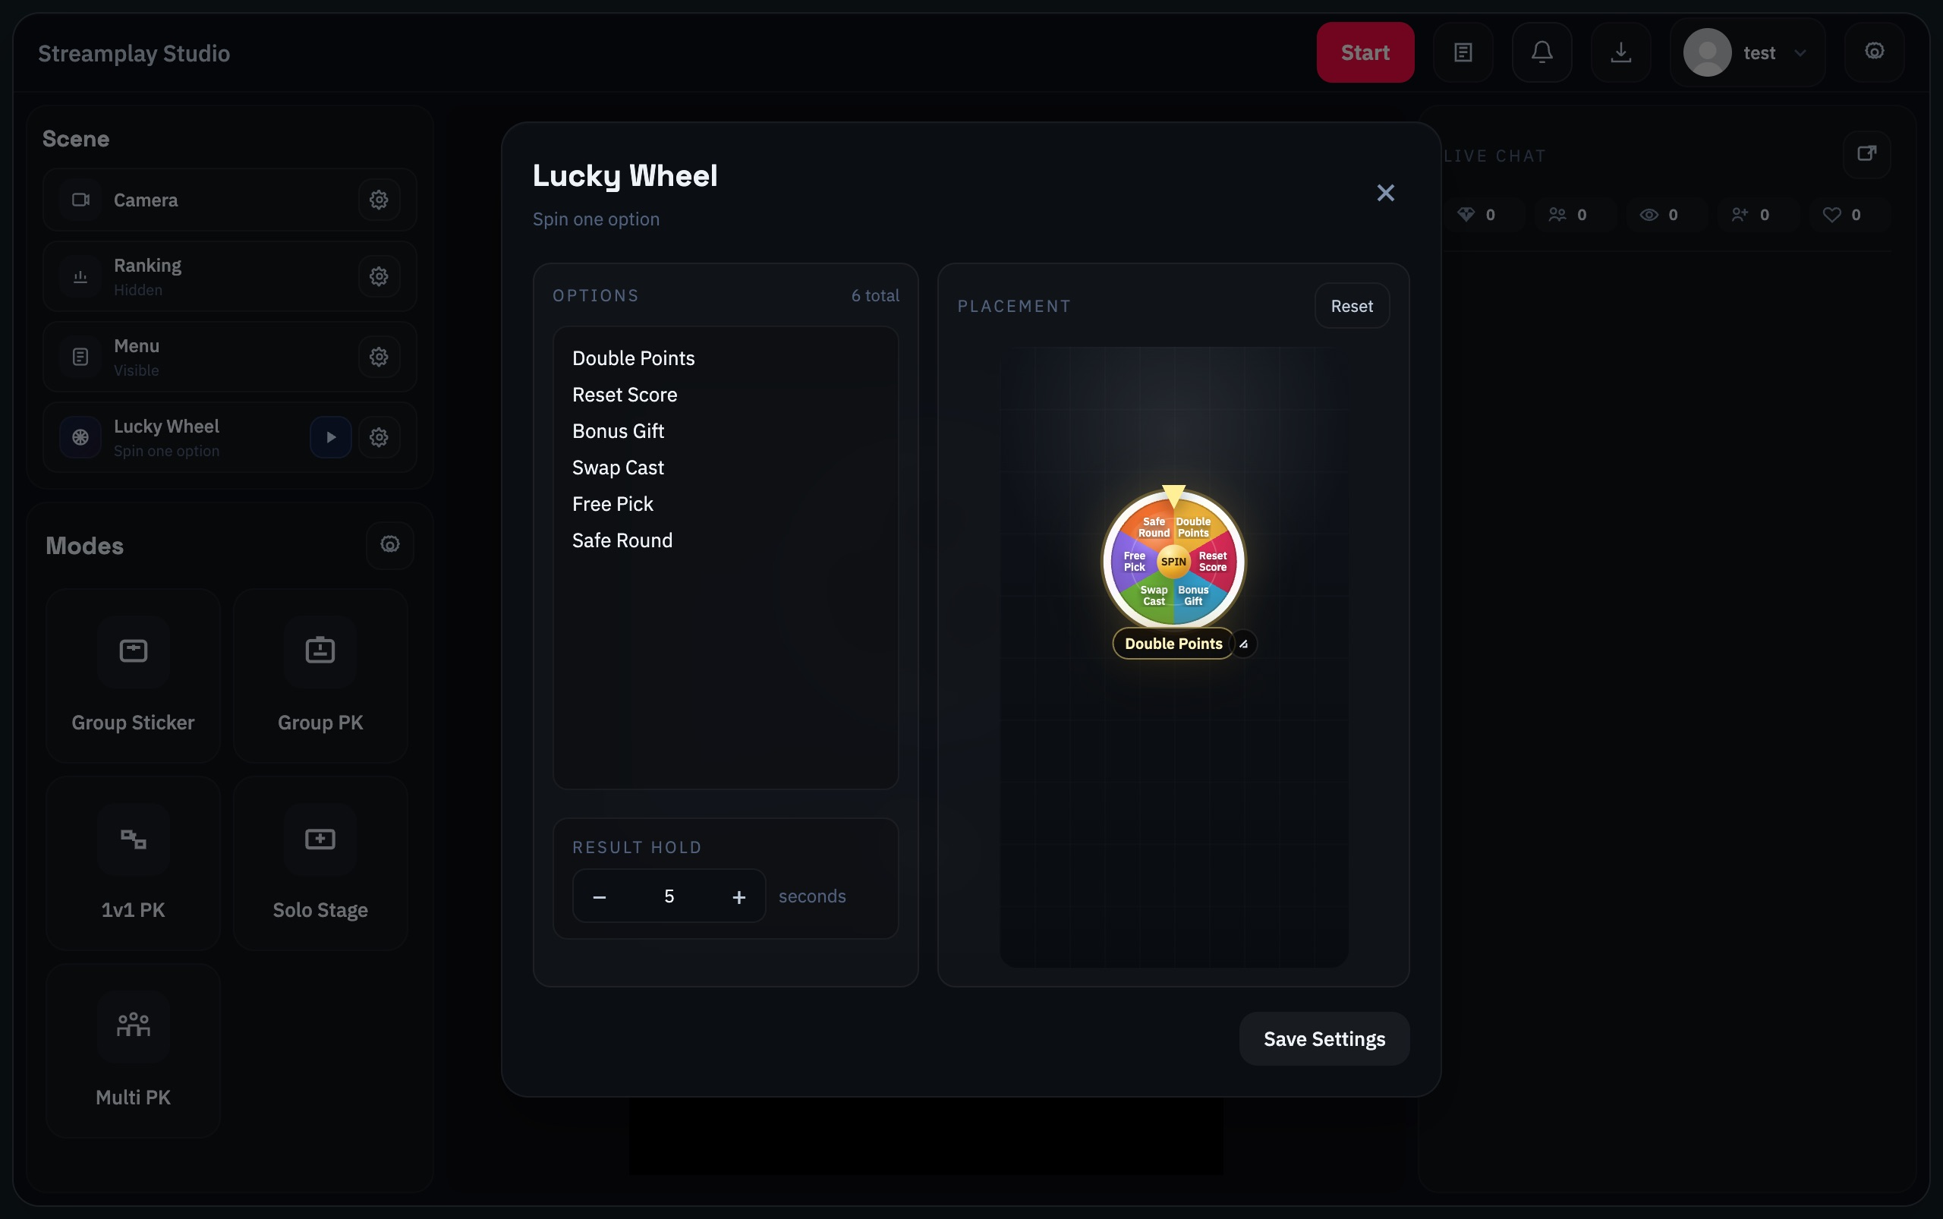
Lucky Wheel: one option per line and result hold time

Menu
Menu displays gifts alongside custom names. Open the settings gear beside Menu in Scene.
Visibility shows or hides the menu. Layout selects vertical or horizontal order. Text opacity changes label transparency. Click the gift to replace it, enter a Name, use Add Item for more entries, or × to remove an entry. Drag the preview to move or resize the menu, then Save Settings.
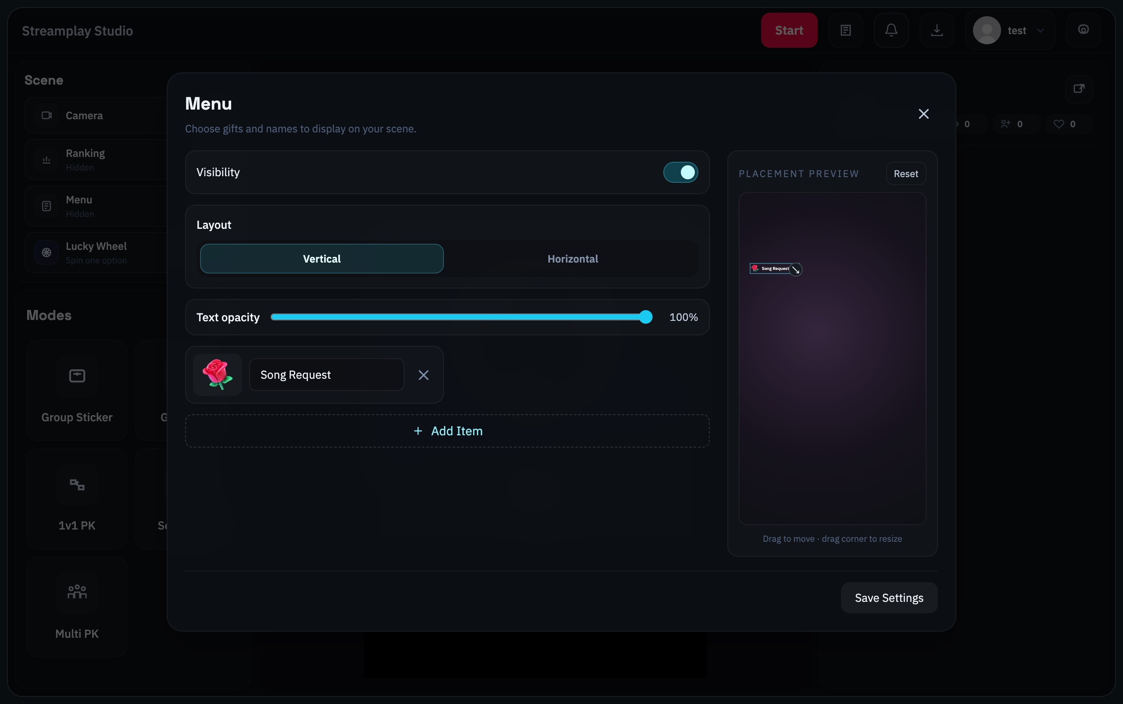
Menu: visibility, layout, custom names and gift selection

Gifter Binding
Enable it from Modes settings if needed. It establishes viewer-to-member attribution and provides a fallback for later unmatched gifts. Check representative gift mappings first.
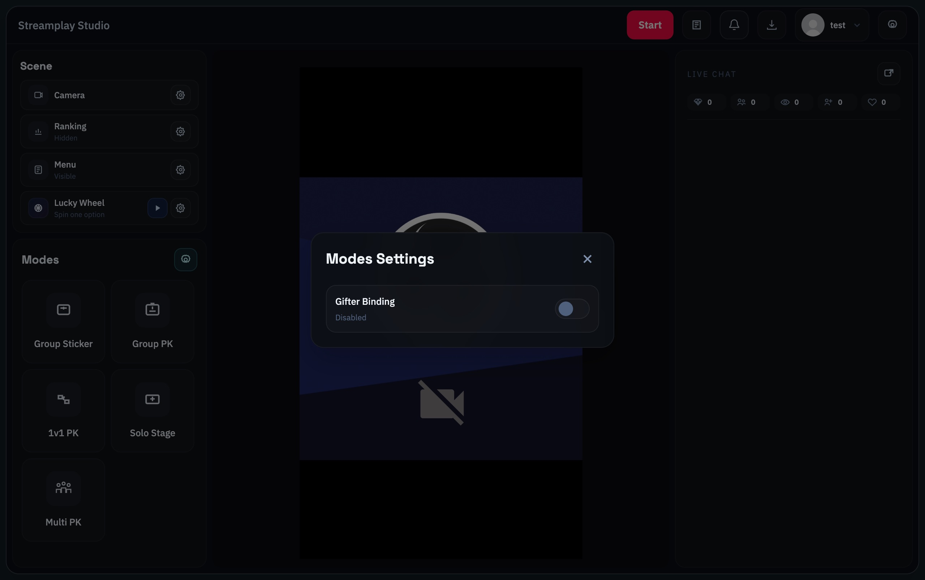
Modes Settings: Gifter Binding switch

15 Finish and review records
End the game, disconnect Studio and end the broadcast in your streaming software.
1. End the round and stop the mode
In timed games, end the current round, then stop the mode.
2. Click the top End button
Disconnect Studio from the LIVE data feed.
3. End the broadcast in your streaming software
Disconnecting Studio does not close your TikTok LIVE. Confirm the broadcast has actually ended.

Review gifts and attribution
Open the top record icon, LIVE data and allocation audit, to view the Current LIVE log or history.

How do I assign an unallocated gift
Click Allocate on the unallocated entry, select the correct member, then use Allocate Full Gift. Check the entry first to avoid handling it twice.

How do I correct the assigned member
Click the existing assigned name and use Move Full Gift to transfer the gift to the correct member. This moves existing score; do not add another copy.

What format is the export
The current session export is JSON. It saves session data; it is not an Excel workbook or a backup of software settings.
Check after finishing: The game has stopped, Studio is disconnected, and the broadcast has ended in your streaming software.

16 Troubleshooting
Choose the symptom that matches what you see.

The camera preview is black
Check that OBS Virtual Camera is running. Refresh Camera Settings and select the device again. For a physical camera, check availability and system permission.

Studio shows video but OBS has no game content
Check the OBS Overlay Runtime Browser source, the link copied from your current Studio, its position above the camera, and whether you clicked Play in the game mode.

No LIVE data after Start
Confirm the correct TikTok LIVE room is actually online. Check Studio’s connection status and network. Studio Start does not create a broadcast.

A gift arrived but the score did not change
Check whether the mode and round have started, the gift mapping and the active member. Then review the original gift and unallocated entries in the LIVE log.

A Cast member is missing from the game
Open that game’s settings, select the member and save. In Multi PK, also check On Stage and Bench Queue.

I can t edit Cast or switch accounts
End the round and stop the mode before editing members. End the current Studio LIVE connection before switching accounts.

Multi PK will not start the next round
Check that the round has ended. If the lowest score is tied, use Choose who leaves first.

Solo Stage did not rotate after a target
Reaching a target does not rotate members. End the round, then click the next Start.

