**假设我们有这样一个待处理的文件data.txt，内容如下:**

|  |
| --- |
| Steve Blenheim:238-923-7366:95 Latham Lane, Easton, PA 83755:11/12/56:20300 Betty Boop:245-836-8357:635 Cutesy Lane, Hollywood, CA ,91464:6/23/23:14500 Igor Chevsky:385-375-8395:3567 Populus Place, Caldwell, NJ 23875:6/18/68:23400 Norma Corder:397-857-2735:74 Pine Street, Dearborn, MI 23874:3/28/45:245700 Jennifer Cowan:548-834-2348:583 Laurel Ave., Kingsville, TX 83745:10/1/35:58900 Jon DeLoach:408-253-3122:123 Park St., San Jose, CA 04086:7/25/53:85100 Karen Evich:284-758-2857:23 Edgecliff Place, Lincoln, NB 92086:7/25/53:85100 Karen Evich:284-758-2867:23 Edgecliff Place, Lincoln, NB 92743:11/3/35:58200 Karen Evich:284-758-2867:23 Edgecliff Place, Lincoln, NB 92743:11/3/35:58200 Fred Fardbarkle:674-843-1385:20 Parak Lane, DeLuth, MN 23850:4/12/23:780900 Fred Fardbarkle:674-843-1385:20 Parak Lane, DeLuth, MN 23850:4/12/23:780900 Lori Gortz:327-832-5728:3465 Mirlo Street, Peabody, MA 34756:10/2/65:35200 Paco Gutierrez:835-365-1284:454 Easy Street, Decatur, IL 75732:2/28/53:123500 Ephram Hardy:293-259-5395:235 CarltonLane, Joliet, IL 73858:8/12/20:56700 James Ikeda:834-938-8376:23445 Aster Ave., Allentown, NJ 83745:12/1/38:45000 Barbara Kertz:385-573-8326:832 Ponce Drive, Gary, IN 83756:12/1/46:268500 Lesley Kirstin:408-456-1234:4 Harvard Square, Boston, MA 02133:4/22/62:52600 William Kopf:846-836-2837:6937 Ware Road, Milton, PA 93756:9/21/46:43500 Sir Lancelot:837-835-8257:474 Camelot Boulevard, Bath, WY 28356:5/13/69:24500 Jesse Neal:408-233-8971:45 Rose Terrace, San Francisco, CA 92303:2/3/36:25000 Zippy Pinhead:834-823-8319:2356 Bizarro Ave., Farmount, IL 84357:1/1/67:89500 Arthur Putie:923-835-8745:23 Wimp Lane, Kensington, DL 38758:8/31/69:126000 Popeye Sailor:156-454-3322:945 Bluto Street, Anywhere, USA 29358:3/19/35:22350 Jose Santiago:385-898-8357:38 Fife Way, Abilene, TX 39673:1/5/58:95600 Tommy Savage:408-724-0140:1222 Oxbow Court, Sunnyvale, CA 94087:5/19/66:34200 Yukio Takeshida:387-827-1095:13 Uno Lane, Ashville, NC 23556:7/1/29:57000 Vinh Tranh:438-910-7449:8235 Maple Street, Wilmington, VM 29085:9/23/63:68900 |

**题目1：显示包含San的行**

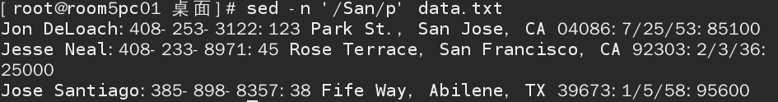

**题目2：显示以J开头的人名所在的行**

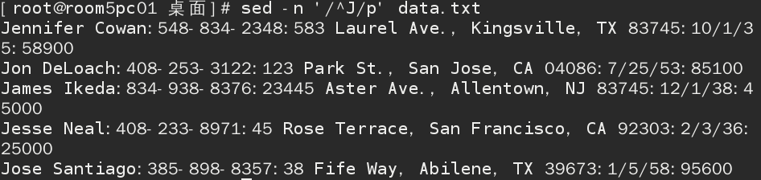

**题目3：显示700结尾的行**

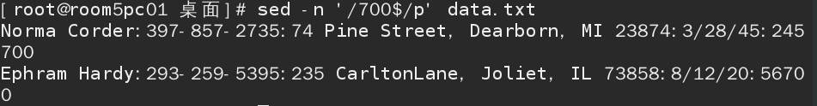

**题目4：显示不包834的行**



**题目5：显示电话号码的区号为834的行**

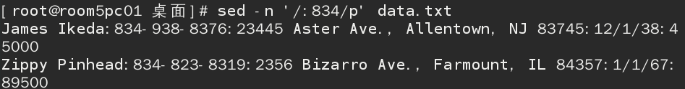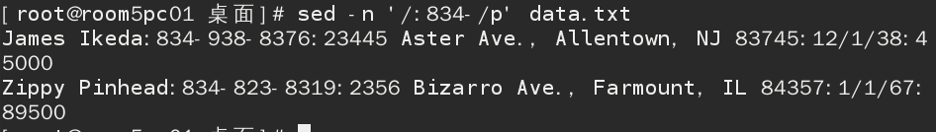

**题目6：显示这样的行:它包含一个大写字后跟四个小写字母,逗号,空格,和一个大写字母**

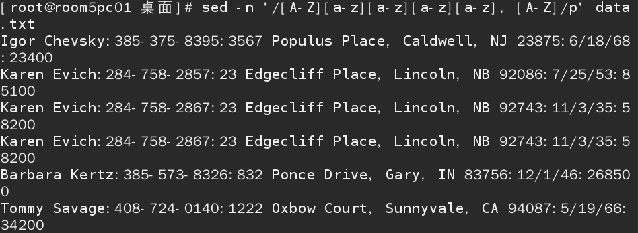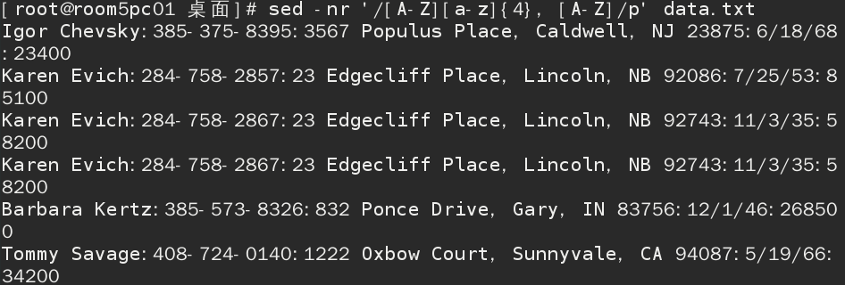

**题目7：显示以K或k开头的行**

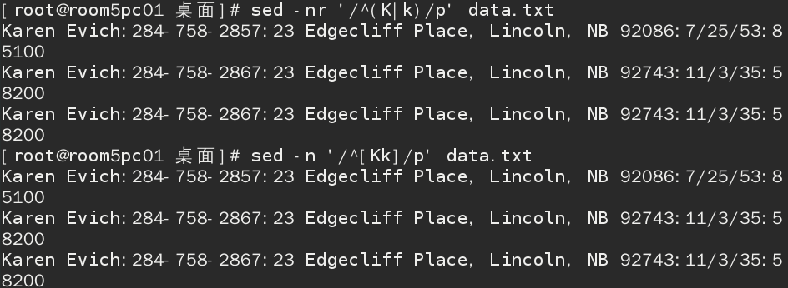

**题目8：显示工资为六位数的行**

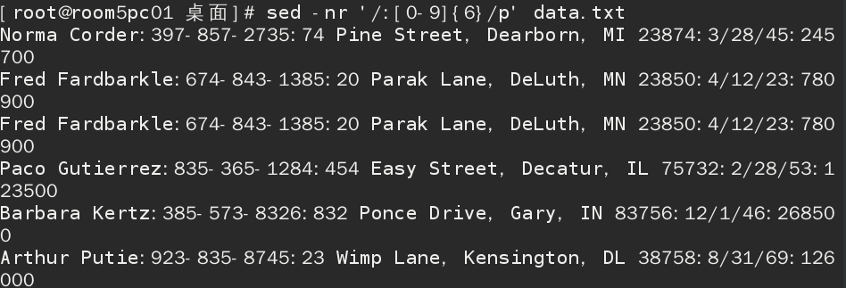

**题目9：显示包括Lincoln或lincoln的行**

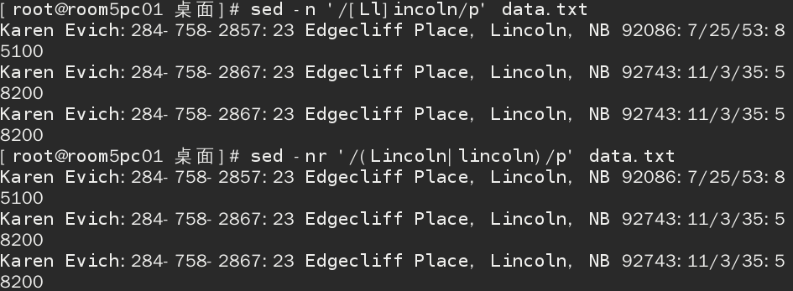

**题目10：把Jon的名字改成Jonathan**



**题目11：删除文件头3行内容**



**题目12：显示5-10行**

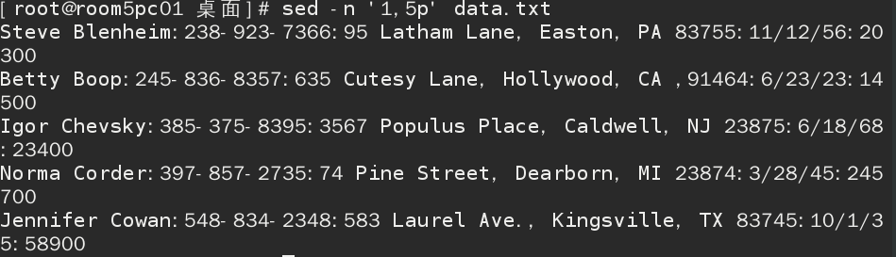

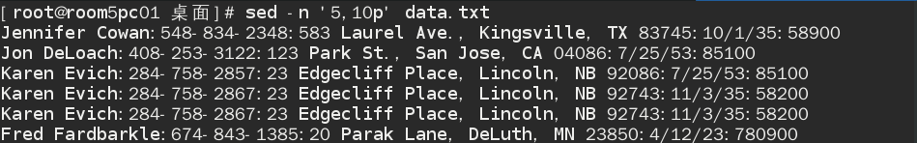

**题目13：把三个星***添加到有Fred的行**

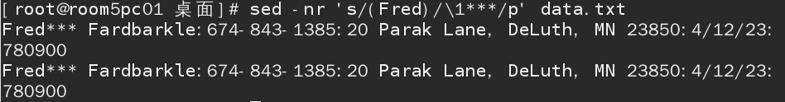



**题目14：删除空白行**

