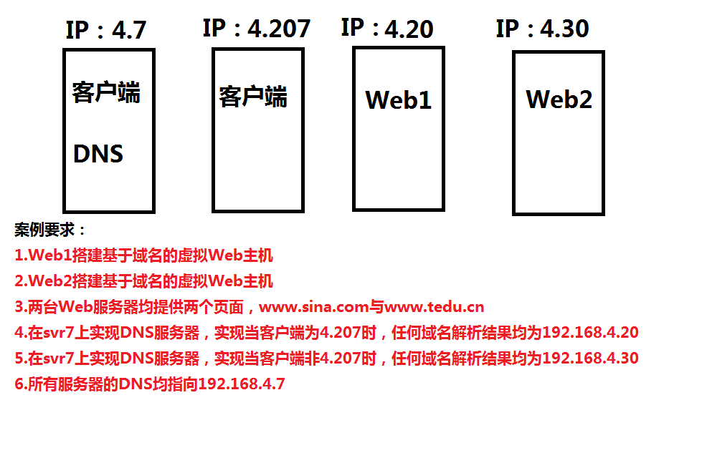

$$$$$$$$$$$$$$$$$$$$$$$$$$$$$$$$$$$$$$$$$$$$$$$$$$$$$$$$$$$$$$

**克隆新机-->配置ip-->防火墙、SELinux-->搭建Yum**





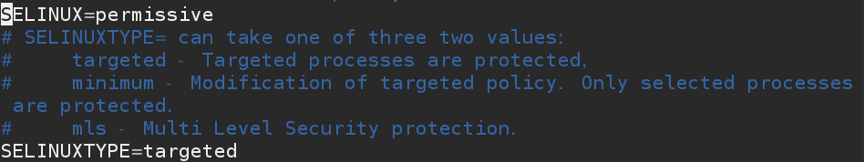



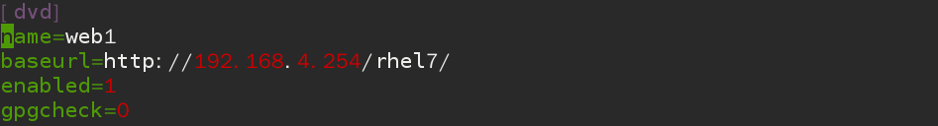



**Web1**



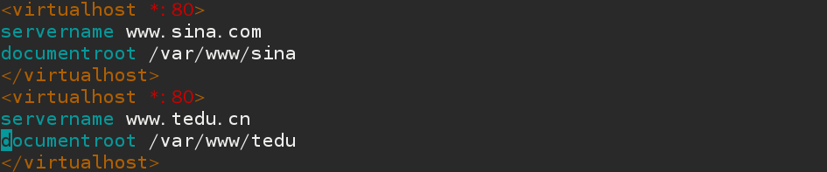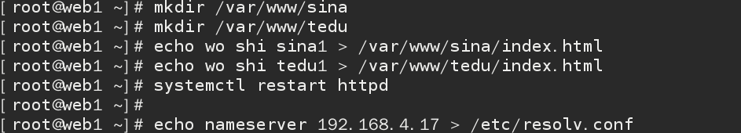

**Web2**

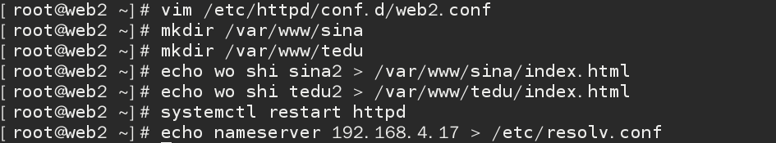

**Svr7**

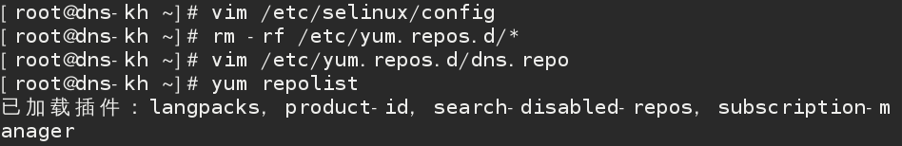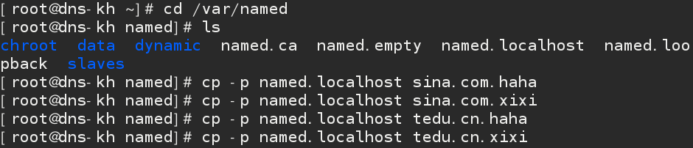

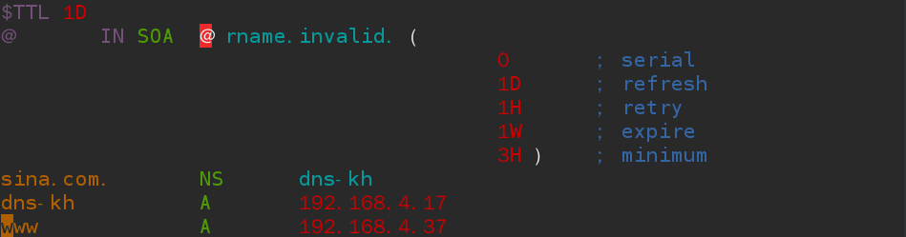



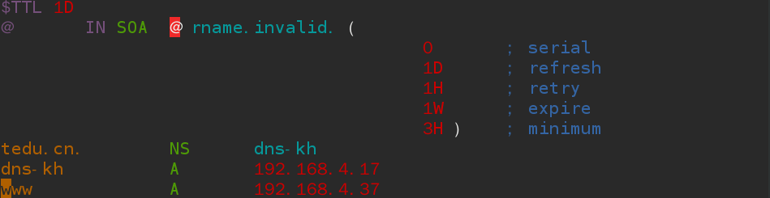



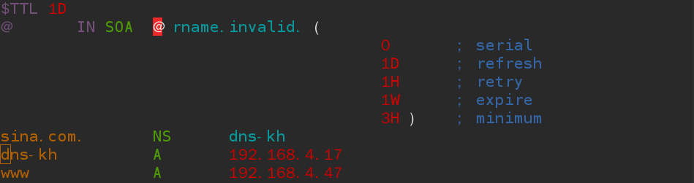



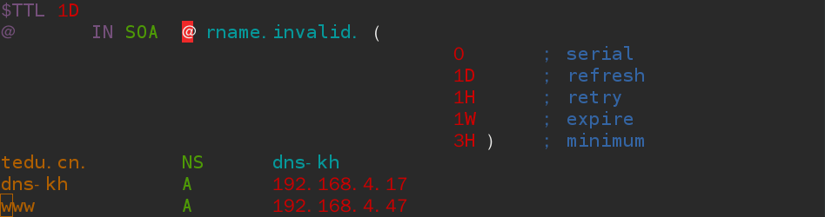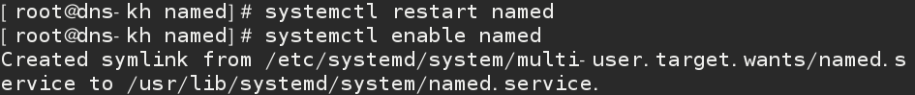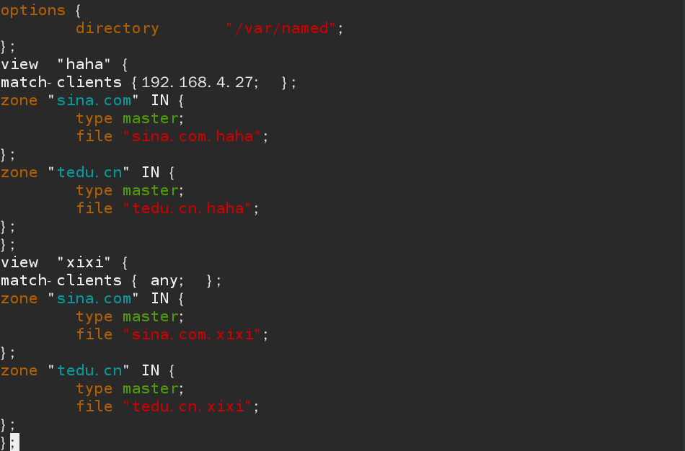

**验证**

