Digital Biosignal Processing

MATLAB Laboratory 7

The EEG signal reflects the activity of large populations of cortical neurons. This activity can be modeled as a random process.

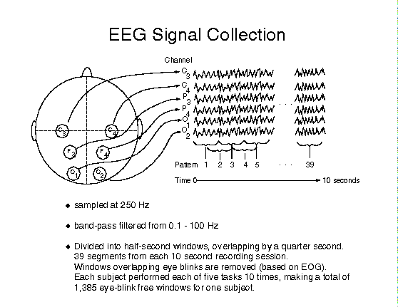

In order to derive the characteristics of a random signal, we need to perform estimates that have an associated variability due to the availability of only a finite number of signal samples. These estimates approximate the ensemble averages. For instance, to provide information on the amplitude of an EEG recording, we can estimate the standard deviation of the signal samples.

The objective of this exercise is to get familiar with the task of deriving estimates of properties of random signals and analyse their associated variability. You have been provided with an EEG signal recording stored as “EEG.mat”. Study the Matlab script provided below. This script divides the signal into windows and for each window estimates the mean and variance of the signal samples within the window. Since the process is random, the estimates will vary across windows. Get acquainted with the effects of different window sizes (number of samples on which the estimate is derived). on the estimates of the mean and standard deviation of the signal.

**In your report, please provide the following:**

* Plot the estimates of the mean and variance of the signal over time for the window durations of 0.5, 1, and 1.5 s. Report their variability quantitatively (in a table) and comment.
* Plot the average values for the estimates of the mean and variance as a function of the window length.
* Plot the estimated probability density function of the random signal PDF.

*PLEASE NOTICE: The report is limited to one A4 page, including all graphs and comments.*% Seventh tutorial.

close all; clear all; clc

load('EEG.mat') % Load the EEG signal

fs = 200; % Sample frequency in Hz

L = length(EEG); % Duration of the signal in samples

winStep = 0.025; % window size increase in seconds

winSizeVector = floor([1:(L)/(winStep*fs)]*winStep*fs); % Vector containing window sizes ranging in 25ms step increases

% Iterate over different window lengths to compute the estimations of mean

% and variance

for iter_winSize = 1:numel(winSizeVector)

% calculate the remaining values for the same window size

for iterSig=1:floor((length(EEG))/winSizeVector(iter_winSize))

start_idx=(iterSig-1)*winSizeVector(iter_winSize)+1; %starting sample index of the extracted window

end_idx = iterSig*winSizeVector(iter_winSize); %ending sample index of the extracted window

V_fixWin(iterSig) = var(EEG(start_idx:end_idx));% Calculate variance for the given window length

M_fixWin(iterSig) = mean(EEG(start_idx:end_idx));% Calculate mean for the given window length

end

V{iter_winSize,:} = V_fixWin;% store variance for the given window length

M{iter_winSize,:} = M_fixWin;% store mean for the given window length

V_avg(iter_winSize) = mean(V_fixWin);% calculate the mean value of the variance for the given window length

M_avg(iter_winSize) = mean(M_fixWin);% calculate the mean value of the mean for the given window length

V_fixWin=[];

M_fixWin=[];

end

%%

winSizeIdx=**[Here please complete with instructions for selecting the correct window size]**;

x_axis=[1:length(V{winSizeIdx,:})].*(winSizeVector(winSizeIdx)/fs);

figure, plot(x_axis,V{winSizeIdx,:},'k','LineWidth',2);

xlabel('Time [s]'), ylabel('[AU]')

title('Estimates of the variance for the given fixed window length')

**[Here please complete with instructions for plotting the Estimates of the mean for the given fixed window length]**

x_ax_length = [1:(L)/(winStep*fs)]*winStep; %build the x axis for the plot

% Plot the variance with respect to the window length

figure, plot(x_ax_length,V_avg,'k','LineWidth',2),hold on

xlabel('Duraition of the windows [s]'), ylabel('[AU]')

title('Values of variance depending on the window size')

**[Here please complete with instructions for plotting the values of means depending on the window size]**

figure

histogram(EEG,'Normalization','probability');

xlabel('EEG [AU]'), ylabel('Estimate of the probability')